**COMPSCI 7417 Applied Natural Language Processing (Trimester 1 2025)**

**Assignment 2 - Mini Project**

**BERTopic Final Model Results Appendix**

Group:

- Craig Atkinson a1669436

- Lalitphan Sae-teoh a1932456

- Pratham Maharjan a1944180

The final model is implemented from BERTopic with bigram (2,2) only embedding and default settings of dimensional reduction (UMAP) and clustering (DBSCAN). KeyBERTInspired, MaximalMarginalRelevance (MRR), and PartOfSpeech (POS) Tagging were applied as a representation model to tune the performance of topic modelling.

Final model result as follows:

|  |  |  |
| --- | --- | --- |
| Topics | # Classified Posts | # Topics with >100 Posts |
| 207 | 13,298 (56%) | 33 |

Example of 33 most prominent topics (each with over 100 posts)

|  |  |  |  |  |
| --- | --- | --- | --- | --- |
| **Topics** | **Topic Name** | **Top 10 words** | **Example** | **Link** |
| 0 | 0_text file_txt file_line text_read text | ['text file', 'txt file', 'line text', 'read text', 'line file', 'line line', 'file text', 'file using', 'file line', 'log file'] | counting the number of lines in a text file | <https://stackoverflow.com/questions/3482064/counting-the-number-of-lines-in-a-text-file> |
| 1 | 1_text classification_scikit learn_test set_training set | ['text classification', 'scikit learn', 'test set', 'training set', 'machine learning', 'random forest', 'multi label', 'test data', 'classify text', 'training data'] | How to train a model to classify input to one or more classes | <https://stackoverflow.com/questions/62677043/how-to-train-a-model-to-classify-input-to-one-or-more-classes> |
| 2 | 2_import nltk_install nltk_nltk download_nltk data | ['import nltk', 'install nltk', 'nltk download', 'nltk data', 'nltk package', 'nltk corpus', 'following error', 'use nltk', 'installing nltk', 'nltk python'] | Installing megam for NLTK on Windows | <https://stackoverflow.com/questions/46852316/installing-megam-for-nltk-on-windows> |
| 3 | 3_using jquery_text input_input field_get text | ['using jquery', 'text input', 'input field', 'get text', 'change text', 'text jquery', 'jquery text', 'text box', 'text node', 'javascript jquery'] | Remove all HTMLtags in a string (with the jquery text() function) | <https://stackoverflow.com/questions/7889765/remove-all-htmltags-in-a-string-with-the-jquery-text-function> |
| 4 | 4_sentiment analysis_positive negative_sentiment score_analysis using | ['sentiment analysis', 'positive negative', 'sentiment score', 'analysis using', 'negative neutral', 'negative word', 'naive bayes', 'stanford nlp', 'negative sentiment', 'negative positive'] | How to calculate the quality of comments using NLP | <https://stackoverflow.com/questions/76927485/how-to-calculate-the-quality-of-comments-using-nlp> |
| 5 | 5_html cs_center text_align text_text overflow | ['html cs', 'center text', 'align text', 'text overflow', 'text wrap', 'text align', 'image text', 'nbsp nbsp', 'using cs', 'make text'] | How to center text vertically in HTML using CSS only | <https://stackoverflow.com/questions/2943234/how-to-center-text-vertically-in-html-using-css-only> |
| 6 | 6_parse tree_nltk tree_tree tree_stanford parser | ['parse tree', 'nltk tree', 'tree tree', 'stanford parser', 'dependency parser', 'dependency tree', 'stanford dependency', 'typed dependency', 'using stanford', 'np tree'] | How to do a Tree Transfer in prolog for MT | <https://stackoverflow.com/questions/19580566/how-to-do-a-tree-transfer-in-prolog-for-mt> |
| 7 | 7_ner model_spacy ner_named entity_using spacy | ['ner model', 'spacy ner', 'named entity', 'using spacy', 'spacy model', 'custom ner', 'entity recognition', 'model spacy', 'training data', 'custom entity'] | Remove training data from spacy model | <https://stackoverflow.com/questions/60970109/remove-training-data-from-spacy-model> |
| 8 | 8_po tag_po tagger_part speech_po tagging | ['po tag', 'po tagger', 'part speech', 'po tagging', 'tag word', 'none none', 'stanford po', 'nltk po', 'using nltk', 'word tag'] | NLTK POS tags extraction, tried key, values but not there yet | <https://stackoverflow.com/questions/37234753/nltk-pos-tags-extraction-tried-key-values-but-not-there-yet> |
| 9 | 9_sentence tokenizer_using nltk_nltk tokenize_tokenize sentence | ['sentence tokenizer', 'using nltk', 'nltk tokenize', 'tokenize sentence', 'nltk sentence', 'nltk word_tokenize', 'one token', 'sentence word', 'word tokenize', 'want tokenize'] | Why can&#39;t I tokenize text in languages other than English using NLTK? | <https://stackoverflow.com/questions/72279174/why-cant-i-tokenize-text-in-languages-other-than-english-using-nltk> |
| 10 | 10_unicode text_unicode character_utf encoding_codec decode | ['unicode text', 'unicode character', 'utf encoding', 'codec decode', 'decode byte', 'code point', 'text file', 'text encoding', 'special character', 'character encoding'] | (HTML5) cannot display Chinese characters when using UTF-8 | <https://stackoverflow.com/questions/11738217/html5-cannot-display-chinese-characters-when-using-utf-8> |
| 11 | 11_lda model_topic modeling_topic modelling_topic model | ['lda model', 'topic modeling', 'topic modelling', 'topic model', 'gensim lda', 'topic distribution', 'lda topic', 'latent dirichlet', 'number topic', 'using gensim'] | LdaModel - random_state parameter not recognized - gensim | <https://stackoverflow.com/questions/39294921/ldamodel-random-state-parameter-not-recognized-gensim> |
| 12 | 12_program file_file microsoft_install spacy_appdata local | ['program file', 'file microsoft', 'install spacy', 'appdata local', 'lib site', 'site package', 'microsoft visual', 'microsoft sql', 'file user', 'visual studio'] | install issue with python - spacy package in anaconda environment | <https://stackoverflow.com/questions/28399340/install-issue-with-python-spacy-package-in-anaconda-environment> |
| 13 | 13_stop word_remove stopwords_remove stop_removing stopwords | ['stop word', 'remove stopwords', 'remove stop', 'removing stopwords', 'stopwords list', 'trying remove', 'remove word', 'list stopwords', 'word list', 'want remove'] | Is there a way to remove a word from a KeyedVectors vocab? | <https://stackoverflow.com/questions/54697748/is-there-a-way-to-remove-a-word-from-a-keyedvectors-vocab> |
| 14 | 14_count number_word count_count word_word frequency | ['count number', 'word count', 'count word', 'word frequency', 'number time', 'number word', 'bla bla', 'count many', 'frequency word', 'time word'] | Coding Matrix with overlap counts in R | <https://stackoverflow.com/questions/40470933/coding-matrix-with-overlap-counts-in-r> |
| 15 | 15_bigram trigram_get bigram_unigrams bigram_bi gram | ['bigram trigram', 'get bigram', 'unigrams bigram', 'bi gram', 'unigram bigram', 'find bigram', 'nltk bigram', 'bigram list', 'nltk collocation', 'extract bigram'] | Generate unigrams and bigrams from a trigram list | <https://stackoverflow.com/questions/20035974/generate-unigrams-and-bigrams-from-a-trigram-list> |
| 16 | 16_embedding layer_output shape_input shape_kera model | ['embedding layer', 'output shape', 'input shape', 'kera model', 'attention layer', 'shape none', 'using kera', 'kera embedding', 'input layer', 'functional api'] | Concatenation of list of 3-dimensional tensors along a specific axis in Keras | <https://stackoverflow.com/questions/47325813/concatenation-of-list-of-3-dimensional-tensors-along-a-specific-axis-in-keras> |
| 17 | 17_using wordnet_nltk wordnet_wordnet synset_synonym word | ['using wordnet', 'nltk wordnet', 'wordnet synset', 'synonym word', 'get synonym', 'get synset', 'word wordnet', 'using nltk', 'wordnet nltk', 'list synset'] | Python wordnet from nltk.corpus. How can I get the definition of each word in several sentences using wordnet? | <https://stackoverflow.com/questions/62287379/python-wordnet-from-nltk-corpus-how-can-i-get-the-definition-of-each-word-in-se> |
| 18 | 18_bert model_fine tuning_using bert_hidden state | ['bert model', 'fine tuning', 'using bert', 'hidden state', 'use bert', 'pre trained', 'fine tuned', 'trained bert', 'fine tune', 'train bert'] | Bert NER model start and end position None after fine-tuning | <https://stackoverflow.com/questions/76393971/bert-ner-model-start-and-end-position-none-after-fine-tuning> |
| 19 | 19_stanford nlp_edu stanford_java edu_stanford corenlp | ['stanford nlp', 'edu stanford', 'java edu', 'stanford corenlp', 'nlp pipeline', 'corenlp server', 'jar file', 'java lang', 'pipeline stanfordcorenlp', 'tagger maxent'] | Import Stanford nlp Intellij | <https://stackoverflow.com/questions/40625438/import-stanford-nlp-intellij> |
| 20 | 20_using php_text file_file php_php file | ['using php', 'text file', 'file php', 'php file', 'php text', 'php script', 'php code', 'txt file', 'file using', 'script php'] | Parsing a formatted text file in PHP | <https://stackoverflow.com/questions/14875886/parsing-a-formatted-text-file-in-php> |
| 21 | 21_stem word_stemmed word_snowball stemmer_store result | ['stem word', 'stemmed word', 'snowball stemmer', 'store result', 'word stem', 'stemming word', 'stemming algorithm', 'porter stemmer', 'word stemming', 'nltk stem'] | Compute word n-grams on original text or after lemma/stemming process? | <https://stackoverflow.com/questions/47219389/compute-word-n-grams-on-original-text-or-after-lemma-stemming-process> |
| 22 | 22_naive bayes_bayes classifier_nltk naive_using naive | ['naive bayes', 'bayes classifier', 'nltk naive', 'using naive', 'text classification', 'multinomial naive', 'term exists', 'bayes text', 'confusion matrix', 'test document'] | python nltk naive bayes probabilities | <https://stackoverflow.com/questions/20773200/python-nltk-naive-bayes-probabilities> |
| 23 | 23_api ai_wit ai_chat bot_api call | ['api ai', 'wit ai', 'chat bot', 'api call', 'using dialogflow', 'chat message', 'rasa nlu', 'firstname lastname', 'bot framework', 'square root'] | how add a required filed to context parameters in dialog flow | <https://stackoverflow.com/questions/50980489/how-add-a-required-filed-to-context-parameters-in-dialog-flow> |
| 24 | 24_html document_html tag_web page_text html | ['html document', 'html tag', 'web page', 'text html', 'beautiful soup', 'extract text', 'html file', 'text webpage', 'html page', 'using python'] | Web Scraping Rap lyrics on Rap Genius w/ Python | <https://stackoverflow.com/questions/24873773/web-scraping-rap-lyrics-on-rap-genius-w-python> |
| 25 | 25_pdf file_text pdf_pdf document_extract text | ['pdf file', 'text pdf', 'pdf document', 'extract text', 'pdf text', 'cosfloat pdfoperator', 'pdfoperator tj', 'cosint pdfoperator', 'cosint cosint', 'tc cosstring'] | how to extract text from a selection of pages in a larger pdf using pymupdf? | <https://stackoverflow.com/questions/67782158/how-to-extract-text-from-a-selection-of-pages-in-a-larger-pdf-using-pymupdf> |
| 26 | 26_seaside seaside_extract word_longest common_list word | ['seaside seaside', 'extract word', 'longest common', 'list word', 'string list', 'word list', 'word word', 'want check', 'check string', 'word sentence'] | Python searching for two words regex | <https://stackoverflow.com/questions/28004731/python-searching-for-two-words-regex> |
| 27 | 27_tokenizer parser_symbol symbol_next token_source file | ['tokenizer parser', 'symbol symbol', 'next token', 'source file', 'lexical analysis', 'identifier symbol', 'token type', 'explicit string', 'ling tokensregex', 'lexer parser'] | Referencing a definition name in flex | <https://stackoverflow.com/questions/35159776/referencing-a-definition-name-in-flex> |
| 28 | 28_detect language_language detection_google translate_language text | ['detect language', 'language detection', 'google translate', 'language text', 'different language', 'english arabic', 'text language', 'language recognition', 'language would', 'american english'] | A PHP Library / Class to Count Words in Various Languages? | <https://stackoverflow.com/questions/2935544/a-php-library-class-to-count-words-in-various-languages> |
| 29 | 29_tf idf_idf score_idf value_scikit learn | ['tf idf', 'idf score', 'idf value', 'scikit learn', 'idf matrix', 'calculate tf', 'learn tfidfvectorizer', 'idf vectorizer', 'tfidf vectorizer', 'using tfidfvectorizer'] | Updating the feature names into scikit TFIdfVectorizer | <https://stackoverflow.com/questions/25154231/updating-the-feature-names-into-scikit-tfidfvectorizer> |
| 30 | 30_natural language_language processing_nlp library_quick add | ['natural language', 'language processing', 'nlp library', 'quick add', 'information extraction', 'nlp tool', 'semantic network', 'get started', 'processing tool', 'open source'] | What are the prerequisites to learning natural language processing? | <https://stackoverflow.com/questions/2006763/what-are-the-prerequisites-to-learning-natural-language-processing> |
| 31 | 31_word vec_vec model_gensim word_using gensim | ['word vec', 'vec model', 'gensim word', 'using gensim', 'gensim model', 'fasttext model', 'model gensim', 'load model', 'doc vec', 'model wv'] | Gensim: how to load precomputed word vectors from text file | <https://stackoverflow.com/questions/49750112/gensim-how-to-load-precomputed-word-vectors-from-text-file> |
| 32 | 32_data type_text field_sql server_text blob | ['data type', 'text field', 'sql server', 'text blob', 'text column', 'text type', 'text varchar', 'mysql text', 'varchar text', 'blob text'] | Convert BLOB into TEXT with foreign characters | <https://stackoverflow.com/questions/3457414/convert-blob-into-text-with-foreign-characters> |

More 10 example links of each topics could be found at [bertopic_topic_example.html](https://github.com/lalitphan-rainie/COMPSCI7417_NLP_Assignment2/blob/main/classifications%20examples/bertopic_topic_examples.html)

**Distribution of Top 33 Topics**

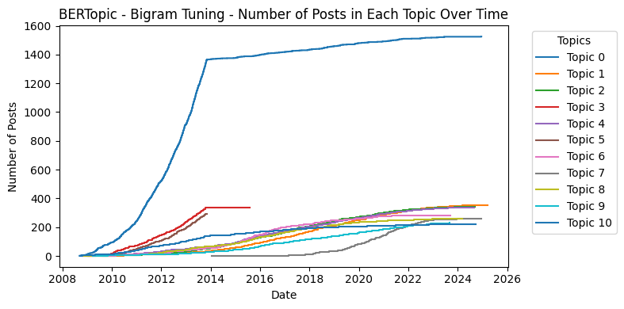**Visualization of post over time**

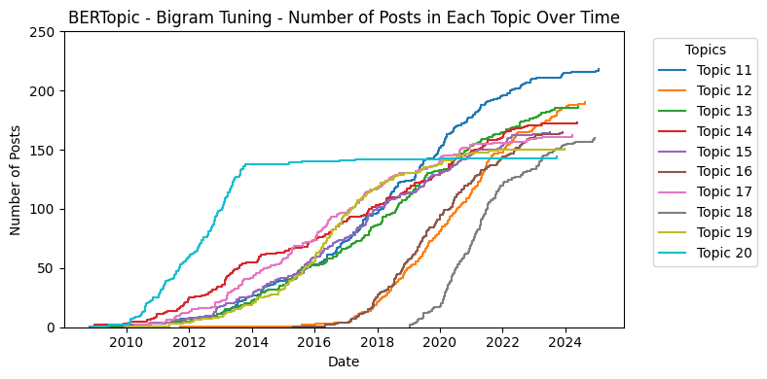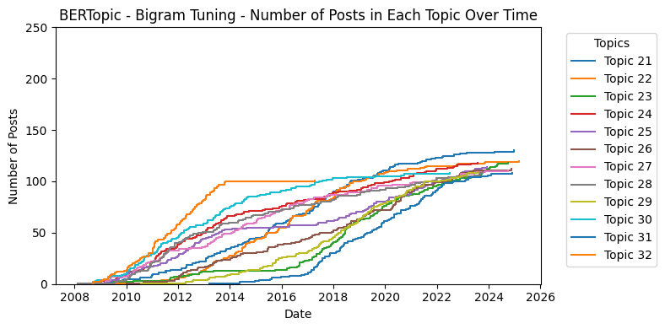

**Visualization of Intertopic Distance Map**

