**Project Synopsis**

**Title: Planify – A Project Planning and Task Management System using MERN Stack**

**Team Members:**

* Lalit Kumar Rajawat (Leader)
* Pratishtha Uniyal
* Keshav Kumar
* Shreya Sinha

**College:** KCC Institute of Technology and Management (KCCITM), Greater Noida  
**Department:** Computer Science & Engineering  
**Session:** 2025–26  
**Guide:** [Faculty Guide Name]

**1. Project Title**

Planify – A Project Planning and Task Management System using MERN Stack

**2. Introduction / Abstract**

Project management is fundamental for teamwork, yet most solutions are either too complex or expensive for students and small academic teams. Planify is a web-based platform using the MERN stack (MongoDB, ExpressJS, ReactJS, NodeJS) that allows teams to create/manage projects, assign tasks, track progress in real-time, and collaborate seamlessly. Features like Gantt charts, calendar view, secure authentication, and role-based access ensure a platform that is lightweight, scalable, and tailored for the needs of groups in academia.

**3. Objectives**

* To provide a user-friendly project management platform tailored for students and small teams.
* To facilitate real-time task creation, assignment, and progress tracking.
* To implement secure authentication and authorization for user roles.
* To offer visual progress tracking (Gantt charts, calendar views).
* To support efficient collaboration and communication.
* To design a lightweight, affordable, and customizable alternative to enterprise tools.

**4. Problem Statement**

Academic and small startup teams face challenges managing their projects due to:

* Complexity of enterprise tools (like Jira or MS Project).
* High costs of subscription platforms (such as Asana or Trello).
* Lack of customization for small or student-centric projects.  
  Therefore, a simple, cost-effective, and customizable project management solution is needed specifically for small teams and academic use.

**5. Proposed System / Methodology**

Planify overcomes enterprise tool limitations, providing a streamlined platform with essential features.

**Technology Stack:**

* Frontend: ReactJS
* Backend: NodeJS + ExpressJS
* Database: MongoDB
* Authentication: Secure, JWT-based

**Core Features:**

* Role-based Authentication (Admin, Leader, Member)
* Task & Project Management (Create, Assign, Track)
* Progress Tracking (Gantt, Calendar)
* Collaboration Features
* Admin Dashboard

**Development Methodology (Agile):**

1. Requirement Gathering
2. Design (UI/UX, architecture, database schema)
3. Development (frontend, backend, APIs)
4. Testing (functionality, usability, performance)
5. Deployment (cloud hosting)
6. Maintenance and ongoing updates

**6. Scope of the Project**

**Applications:**

* Group project management for students/colleges
* Internal project handling for small businesses/startups
* Academic project teams under faculty supervision

**Future Scope:**

* Mobile app development (React Native)
* Integrations (Google Calendar, Slack, cloud storage)
* AI-driven suggestions for tasks
* Productivity/time tracking modules

**7. Modules of the Project**

* Authentication Module (JWT, role-based, secure)
* Task Management Module (CRUD tasks)
* Project Module (multi-project management)
* Progress Tracker (Gantt chart, calendar views)
* Team Collaboration (assignments, communication)
* Admin Dashboard (overview/statistics for leaders)

**8. Hardware & Software Requirements**

**Hardware:**

* Processor: Intel i3 or higher
* RAM: Minimum 4 GB
* Storage: 100 GB

**Software:**

* OS: Windows/Linux/Mac
* Frontend: ReactJS
* Backend: NodeJS + ExpressJS
* Database: MongoDB
* Tools: GitHub, VS Code, Postman

**9. Diagrams**

**a. User Flow Diagram**

**b. System Architecture Diagram**

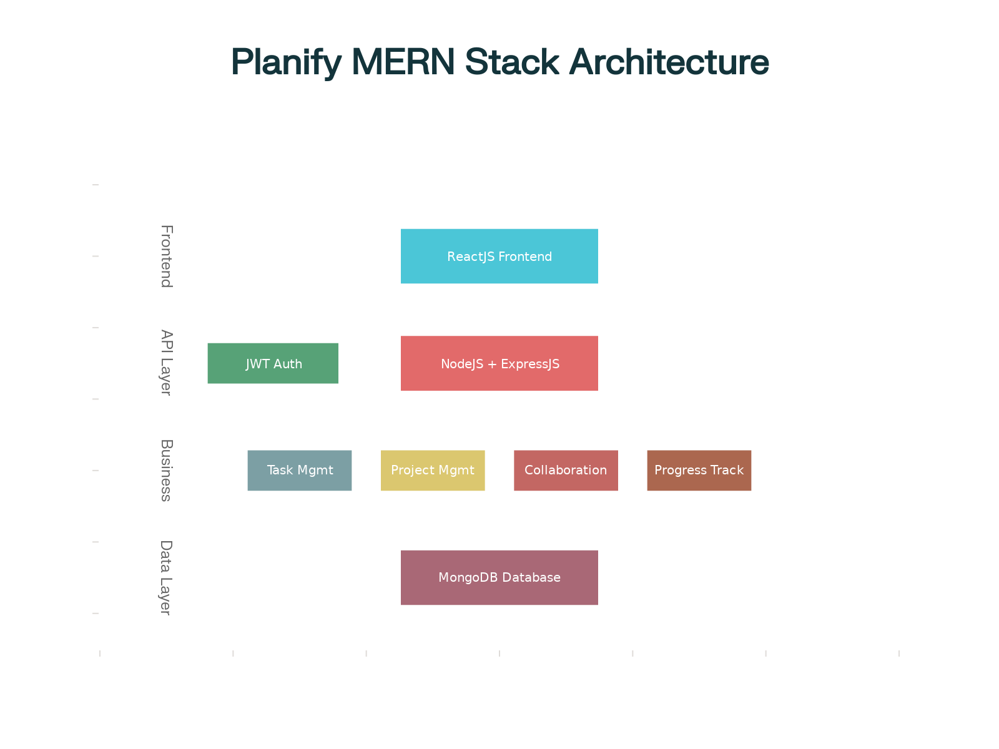

**c. Database Schema (ER Diagram)**

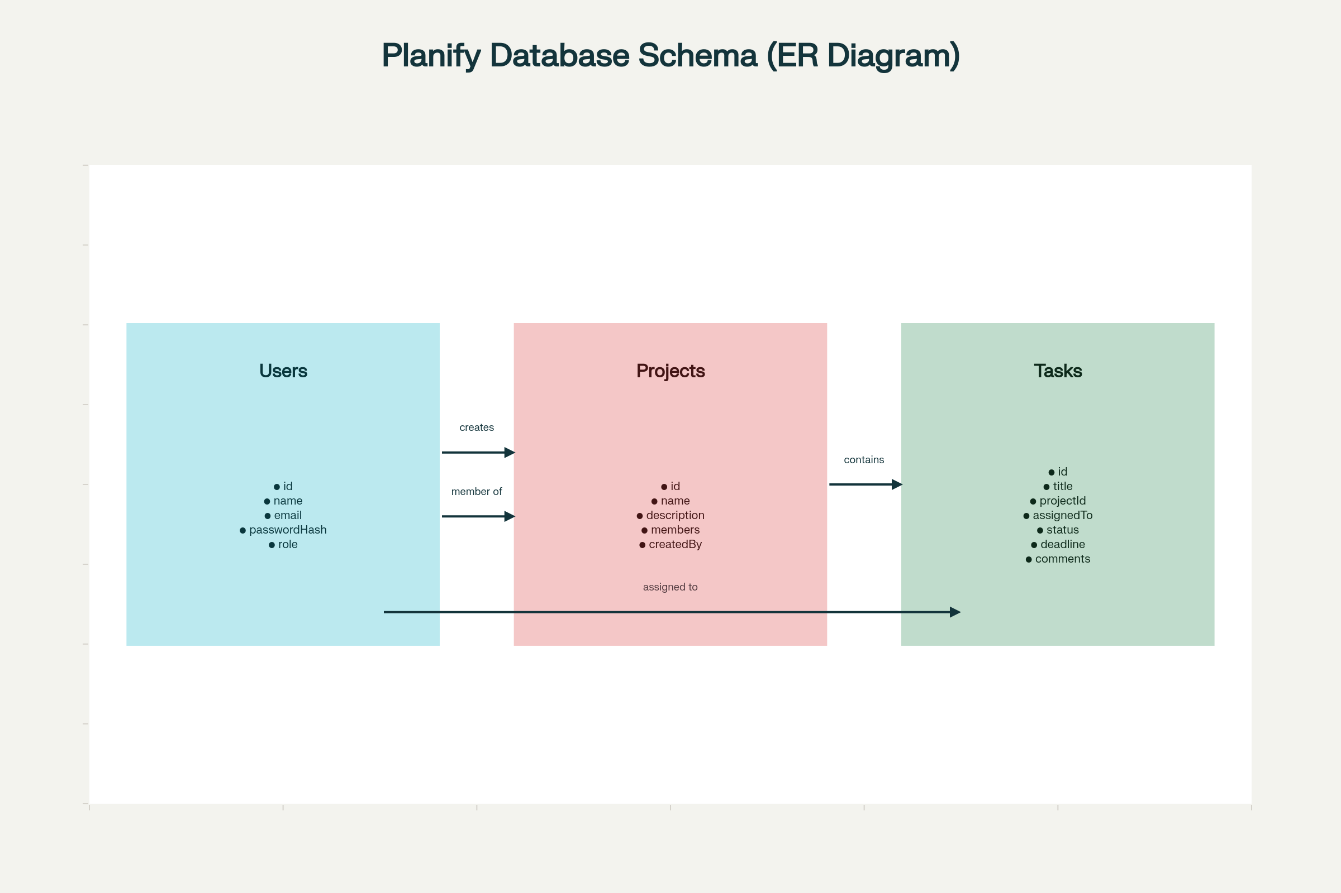

**10. Conclusion**

Planify is an accessible, effective, and efficient project management solution designed specifically for students and small teams. Its richness in essential features, user-friendly design, and low cost set it apart from enterprise options. With future enhancements such as mobile support, AI integration, and advanced analytics, Planify can be expanded to suit even broader professional needs.

# 11. References

1. ReactJS Documentation: <https://react.dev/>
2. NodeJS Documentation: <https://nodejs.org/>
3. ExpressJS Documentation: <https://expressjs.com/>
4. MongoDB Documentation: <https://www.mongodb.com/>