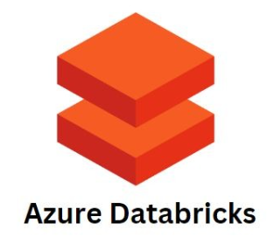



**PART - 3**

Contents

Data Security and Encryption 2

## Mounting Azure Blob Storage

<https://www.youtube.com/watch?v=8YL8T0kw75M>

## Secret Scopes

<https://www.youtube.com/watch?v=c0t5CRK95cs&list=PLMWaZteqtEaKi4WAePWtCSQCfQpvBT2U1&index=23>

<https://www.youtube.com/watch?v=ul4Gqehas0w&list=PLMWaZteqtEaKi4WAePWtCSQCfQpvBT2U1&index=25>

<https://www.youtube.com/watch?v=BT4TTRzEiWo&list=PLMWaZteqtEaKi4WAePWtCSQCfQpvBT2U1&index=26>

Azure Databricks

<https://www.youtube.com/watch?v=bO7Xad1gOFQ&list=PLMWaZteqtEaKi4WAePWtCSQCfQpvBT2U1>

## Data Security and Encryption

Azure Databricks

<https://learn.microsoft.com/en-us/azure/databricks/security/keys/>

<https://learn.microsoft.com/en-us/azure/databricks/security/keys/cmk-managed-services-azure/customer-managed-key-managed-services-azure>

<https://learn.microsoft.com/en-us/azure/databricks/repos/repos-setup>

Azure Storage Account

<https://learn.microsoft.com/en-us/azure/storage/common/customer-managed-keys-overview>

Accessing ADLS Container using

<https://www.youtube.com/watch?v=zAzM0wCLtFo>