# **Project: - Nearby_Seattle_food_choice_exploration**

**Project Background**: -

Hi everyone,

I would like to take this opportunity for completing the capstone project with the case study of Washington. Mainly because of SEATTLE.

Why SEATLLE? :-

https://www.tripsavvy.com/biggest-seattle-area-employers-2965051

SEATTLE host top employers like Boeing, Amazon, Microsoft, Walmart.

The Seattle metropolitan area has more than 3.5 million inhabitants, making it the 15th largest metro area in the country. http://worldpopulationreview.com/us-cities/seattle-population/

Whereas Washington hosts the population of 7,530,552.

Seattle being mostly workplace the most of population resides in nearby divisions: Bellevue, Everett metro division and the Tacoma metro division.

Due to increasingly big job opportunities the population of this area is increasing rapidly.

This includes people from different countries Indian, Chinese, Korean including native Americans.

This indicates that there is definite diversity in food choices.

--------------------------------------------------------------------------------------------------------------------------------------

**Who would be interested in this project / Target Audience:** -

I feel, it would be really great to do analysis how food choices are spread across Seattle in these different divisions.

This analysis could be really helpful if someone is looking for opening a new restaurant nearby.

He/she could get clear picture where to open the restaurant of his/her category/cuisine like Indian, Chinese etc.

Suppose there is much concentration of Indian restaurants in area, we can infer that there are more Indian public residing nearby.

OR

Also if some newbie wants to know where can he/she get the good number of choices for particular category, this can be explored with above analysis.

--------------------------------------------------------------------------------------------------------------------------------------

**Data Source and how it would be used:** -

For Nearby_Seattle_food_choice_exploration, I would be EXTRACTING lat, lang co-ordinates of Seattle, Bellevue, Everett, Tacoma metro division from below: -

<http://worldpopulationreview.com/us-cities/seattle-population/>

<http://worldpopulationreview.com/us-cities/bellevue-population/>

<http://worldpopulationreview.com/us-cities/tacoma-population/>

<http://worldpopulationreview.com/us-cities/everett-wa-population/>

Then I will use Folium map and also Foursquare API to do the analysis, just like we did in our test assignment(week3) and compare the customer/categories.

--------------------------------------------------------------------------------------------------------------------------------------

**Methodology section:** -

I have used python throughout this analysis.

I have used beautiful soup library of python for extract latitude and longitude co-ordinates with some extra line of python code.

I used above parameters and passed them to Foursquare explore api to get the venue/restuarants nearby that latitude and longitude.

These were then clubbed together on the basis of category of the venue with the help of K-means clustering technique.

I have also visualized above for all the four metro divisions using folium map.

--------------------------------------------------------------------------------------------------------------------------------------

**Results and Discussions:** -

* SEATTLE ANALYSIS: - I started with Seattle location. Below is the screenshot of the folium map with clustered venues nearby.

As shown in below snippet: -

1. Orange colour is for cluster 4 which represents Italian Restaurant
2. Green colour is for cluster 3 which represents Coffee Shops
3. Navy blue colour is for cluster 2 which represents New American restaurants
4. Blue colour is for cluster 1 which represents Hotels.
5. Red colour is for cluster 0 which represents other venues categories such as salad, sandwich etc.

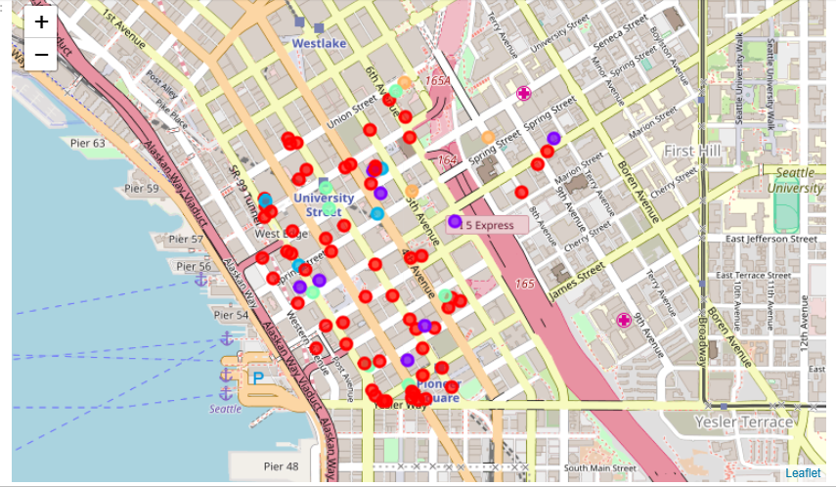

Discussion for Seattle location: -

1. As per our belief (mentioned in the background part of this project on GitHub - https://github.com/lalitsomnathe/Coursera_Capstone/blob/master/Nearby_Seattle_food_choice_exploration_lalitsomnathe_Intro.txt ) we can definitely see large variety of food categories namely Italian, New American, Asian etc. in radius of just 500 mtrs.

2. Also, as Seattle being mostly commercial place we see most number of cafe+coffee shops = 14, the maximum. Coffee shops are great places for meetups and catching up for short business talks.

3. Similarly, for employee accommodation for short visits there are good number of hotels (7) nearby.

4. We can see most of the venues are eateries, stores for home appliances, clothing stores are not there in the list. (as it is mostly a commercial place).

* Bellevue Analysis: -

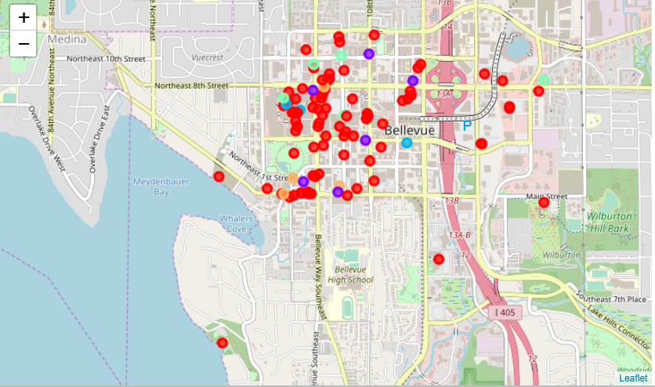

1. For Bellevue division, there are good number of coffee shops but almost half as compared to Seattle division.

2. We can see venues like "Clothing Store", "Furniture / Home Store", "Bakery" etc. which were not in the list for Seattle division.

These venues clearly suggest a good housing population as compared to Seattle. (as furniture store, clothing stores, bakery is for house hold goods).

3. I can see for this division as well, there are some Italian restaurants nearby just like Seattle.

4. We also see SteakHouse, Shopping Mall, Toy/Game Store, Bookstore which indicates a good number of population residing in this area just like point 2 above when compared to Seattle.

* Tacoma Analysis: -

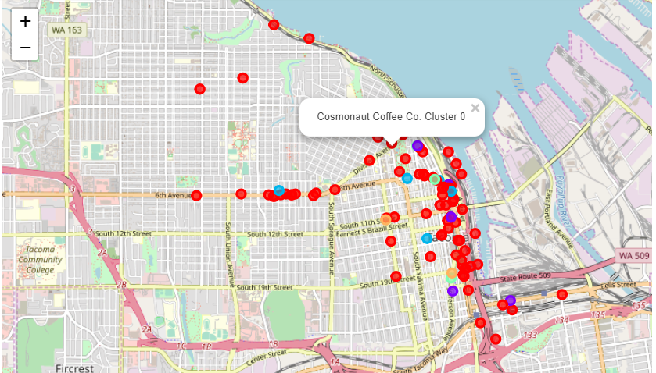

1. For Tacoma division, we see most of American restaurant. This clearly matches with our reference (http://worldpopulationreview.com/us-cities/tacoma-population/) which says Tacoma’s almost 65% population is white.

2. The link also says, Tacoma hosts around 8% of Asian people. This also matches as we found 2 Asian Restaurants in the vicinity.

3. There are some Museums (3+2), and Antique shops (2) suggests good place for the people to spend some calm quality time. This is also mentioned in wikipage:- https://en.wikipedia.org/wiki/Tacoma,_Washington referencing Tacoma's Museum District.

So, for history and art lovers Tacoma is good place to spare some time.

4. Presence of Grocery Store, Brewery, pub etc. suggests a housing population residing nearby.

5. Also, many venues are segregated nearby coastline. As we move further away from coastline, number of venues are decreasing.

* Everett Analysis: -

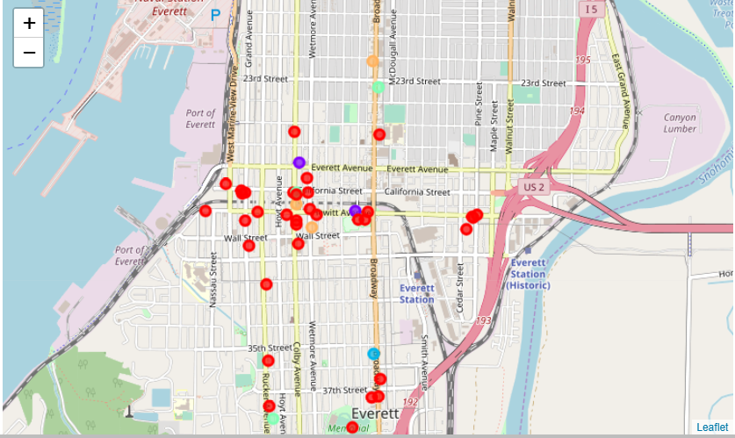

1. So this is first time we are seeing Mexican restaurants in the top. This suggest a good Mexican population surrounding Everett.

I check online and found https://www.quora.com/Where-do-the-most-Mexicans-live-in-Seattle which says around 7.7% of population in Everett are Mexicans.

So the data is matching. Hurray!

2. Also we see one Indian Restaurant in 500mtrs radius in Everett.

3. Little bit like Bellevue division, Everett shows good number of coffee shops but almost half as compared to Seattle division.

4. Grocery store, Park, Bar, Brewery, Gym etc. points that Everett is also a household place just like Bellevue.

5.Good options for Asian, Chinese and Mexican food lovers in this division. (unlike Seattle for Italian food).

--------------------------------------------------------------------------------------------------------------------------------------

**Conclusion Section:** -

* So for household purpose I would say, Bellevue and Everett metro divisions are on top as they suggest good grocery/eatery venues.
* For Asian food lovers, TACOMA and EVERETT divisions are must to visit.
* In almost every division, there are venues for Italian food. SO for Italian food lovers, not to worry about location :)
* In spite of being a good metro-Politian, in Bellevue there are very less Asian food choices. So if someone want to give a try to open an Asian restaurant, he/she could setup in Bellevue.

THIS ENDS THE REPORT OF THE PROJECTS.

Thank You,

Lalit Somnathe