Programming Fundamentals Assignment

Question No. 1
Step 1: Program Analysis
Variables
- marks
- total
- average
- scores
- subject
- attendance
- arr
- totalMarks
- grade
- prices
- inventory
- salary
- city
- result
Functions
- main()
Loops
- for loops
Arrays
- marks[5]
- scores[5]
- subject[5]
- attendance[5]
- arr[5]
- grade[5]
- prices[5]
- inventory[5]
- salary[5]
- city[10]
- result[5]
Structures
- No structures used.
File Operations
- No file operations used.
Pointers
- No pointers used.
Program Objective
This program is intended to perform operations on arrays such as storing marks, calculating totals and averages, handling attendance, displaying results, and working with strings.

Step 2: Syntax Errors
Line No. | Error | Correction
5 | Missing semicolon after array declaration | Add ; after int marks[5] = {80,90,70,60,50}
82 | String assigned using double quotes to character array element | Use 'A' instead of "A"
96 | Array assigned directly (inventory = prices) | Copy elements using loop or memcpy()
110 | String assigned directly to character array (city = "Jaipur") | Use strcpy(city,"Jaipur")

Step 3: Semantic Errors
Line No. | Error | Correction
21 | Wrong format specifier %d used for float variable | Use %f
51 | String used as array index (attendance["one"]) | Use integer index
53 | Float used as array index (attendance[2.5]) | Use integer index
70 | Missing address operator in scanf() | Use &arr[i]
103 | Wrong format specifier used for float value | Use %f

Step 4: Scope Errors
Line No. | Error | Correction
No Scope Errors Found | Variables are used within their valid scope | No correction required

Step 5: Linker Errors
Line No. | Error | Correction
No Linker Errors Found | All functions are properly defined | No correction required

Step 6: Runtime Errors
Line No. | Error | Correction
11 | Loop accesses marks[5] (out of bounds) | Use i < 5
31 | Array index out of bounds (scores[5]) | Use valid index 0–4
43 | Buffer overflow in strcpy() | Increase array size
61 | Loop accesses attendance[5] | Use i < 5
121 | Loop writes to result[5] | Use i < 5

Step 7: Logical Errors
Line No. | Error | Correction
19 | Integer division used for average calculation | Use (float)total / 5
89 | Assignment operator used instead of comparison operator | Use ==

Step 8: Array Errors
Line No. | Error | Correction
11 | Access beyond marks array size | Use valid index
31 | Access beyond scores array size | Use valid index
51 | Invalid string index used in array | Use integer index
53 | Invalid float index used in array | Use integer index
61 | Access beyond attendance array size | Use valid index
96 | Invalid array assignment | Copy elements individually
121 | Access beyond result array size | Use valid index

Step 9: Function Errors
Line No. | Error | Correction
No Function Errors Found | No user-defined functions are used | No correction required

Step 10: Structure Errors
No Structure Errors Found.

Total Errors Identified: 17
Correct program:
#include <stdio.h>
#include <string.h>

int main()
{
int marks[5] = {80,90,70,60,50};

printf("Student Marks System\n");

int total = 0;

for(int i=0;i<5;i++)
{
total += marks[i];
}

printf("Total = %d\n", total);

float average;

average = total / 5;

printf("Average = %.2f\n", average);

printf("\n");

int scores[5];

scores[0] = 10;
scores[1] = 20;
scores[2] = 30;
scores[3] = 40;
scores[4] = 50;

printf("Scores\n");

for(int i=0;i<5;i++)
{
printf("%d ", scores[i]);
}

printf("\n");

char subject[20];

strcpy(subject,"Programming");

printf("%s\n", subject);

printf("\n");

int attendance[5];

attendance[1] = 1;

attendance[2] = 1;

for(int i=0;i<5;i++)
{
attendance[i] = i;
}

printf("\nAttendance\n");

for(int i=0;i<5;i++)
{
printf("%d ", attendance[i]);
}

printf("\n");

int arr[5];

for(int i=0;i<5;i++)
{
scanf("%d", &arr[i]);
}

printf("\n");

int totalMarks = 0;

for(int i=0;i<5;i++)
{
totalMarks += arr[i];
}

printf("Total Marks = %d\n", totalMarks);

char grade[5];

grade[0] = 'A';
grade[1] = '+';
grade[2] = '\0';
printf("%s\n", grade);

printf("\n");

int prices[5] = {100,200,300,400,500};

if(prices[2] = 300)
{
printf("Price Found\n");
}

printf("\n");

int inventory[5];
for(int i=0;i<5;i++)
{
inventory[i] = prices[i];
}

printf("%d\n", inventory[0]);

printf("\n");

float salary[5];

salary[0] = 50000.50;

printf("%.2f\n", salary[0]);

printf("\n");

char city[10];

strcpy(city, "Jaipur");

printf("%s\n", city);

printf("\n");

int result[5];

for(int i=0;i<5;i++)
{
result[i] = i * 10;
}

printf("Results\n");

for(int i=0;i<5;i++)
{
printf("%d ", result[i]);
}

printf("\n");

printf("Program Finished\n");

return 0;
}
Output:

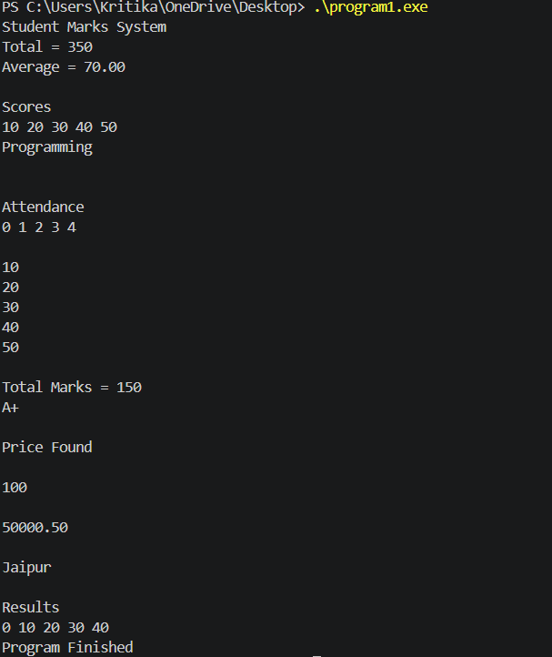

Question No. 2
Step 1: Program Analysis
Variables
- numbers
- sum
- average
- marks
- highest
- attendance
- present
- subject
- branch
- college
- fees
- result
- totalResult
- stock
- backup
- salary
- inventory
- city
- count
Functions
- main()
Loops
- for loops
Arrays
- numbers[10]
- marks[5]
- attendance[5]
- subject[10]
- branch[20]
- college[10]
- fees[5]
- result[5]
- stock[5]
- backup[5]
- salary[5]
- inventory[5]
- city[8]
- count[5]
Structures
- No structures used.
File Operations
- No file operations used.
Pointers
- No pointers used.
Program Objective
This program performs various array operations such as storing values, calculating sums and averages, handling attendance records, managing fees, inventory, stock information, and string operations.

Step 2: Syntax Errors
Line No. | Error | Correction
81 | Direct assignment to character array (branch = "IT") | Use strcpy(branch,"IT")
141 | Missing address operator in scanf() | Use scanf("%d",&result[i]);
167 | Direct array assignment (backup = stock) | Copy elements using loop or memcpy()
203 | Direct array assignment (count = inventory) | Copy elements using loop or memcpy()
209 | Missing semicolon after printf("Program Ended\n") | Add ;

Step 3: Semantic Errors
Line No. | Error | Correction
33 | Wrong format specifier %d used for float variable | Use %f
101 | String used as array index (fees["two"]) | Use integer index
103 | Float used as array index (fees[3.5]) | Use integer index
177 | Wrong format specifier %d used for float value | Use %f

Step 4: Scope Errors
No Scope Errors Found

Step 5: Linker Errors
No Linker Errors Found

Step 6: Runtime Errors
Line No. | Error | Correction
15 | Loop accesses numbers[10] (out of bounds) | Use i < 10
61 | Array index out of bounds (attendance[5]) | Use valid index 0–4
65 | Loop accesses attendance[5] | Use i < 5
75 | Buffer overflow in strcpy() | Increase array size
191 | Loop accesses inventory[5] | Use i < 5
201 | Buffer overflow in strcpy(city,"JaipurCity") | Increase array size

Step 7: Logical Errors
Line No. | Error | Correction
25 | Sum calculation incorrect (sum = numbers[i]) | Use sum += numbers[i]
31 | Integer division used for average calculation | Use (float)sum / 10
43 | Highest marks logic reversed | Use if(marks[i] > highest)
157 | Assignment operator used instead of comparison | Use ==

Step 8: Array Errors
Line No. | Error | Correction
15 | Access beyond numbers array size | Use valid index
61 | Access beyond attendance array size | Use valid index
65 | Loop accesses extra attendance element | Use proper loop condition
101 | Invalid string index used in array | Use integer index
103 | Invalid float index used in array | Use integer index
167 | Invalid array assignment | Copy array elements individually
191 | Access beyond inventory array size | Use valid index
203 | Invalid array assignment | Copy array elements individually

Step 9: Function Errors
Line No. | Error | Correction
No Function Errors Found | No user-defined function errors present | No correction required

Step 10: Structure Errors
No Structure Errors Found.

Total Errors Identified: 21
Correct Program:
#include <stdio.h>
#include <string.h>

int main()
{
int numbers[10];

printf("Array Operations Program\n");

for(int i=0;i<10;i++)
{
numbers[i] = (i+1) * 10;
}

printf("\nNumbers Array\n");

for(int i=0;i<10;i++)
{
printf("%d ", numbers[i]);
}

printf("\n");

int sum = 0;

for(int i=0;i<10;i++)
{
sum += numbers[i];
}

printf("Sum = %d\n", sum);

float average;

average = sum / 10;

printf("Average = %.2f\n", average);

printf("\n");

int marks[5] = {90,85,80,75,70};

printf("Highest Marks\n");

int highest = marks[0];

for(int i=1;i<5;i++)
{
if(marks[i] > highest)
{
highest = marks[i];
}
}

printf("%d\n", highest);

printf("\n");

int attendance[5];

attendance[0] = 1;
attendance[1] = 1;
attendance[2] = 1;
attendance[3] = 0;
attendance[4] = 1;

int present = 0;

for(int i=0;i<5;i++)
{
present += attendance[i];
}

printf("Present Days = %d\n", present);

printf("\n");

char subject[20];

strcpy(subject,"ComputerScience");

printf("%s\n", subject);

printf("\n");

char branch[20];

strcpy(branch, "IT");

printf("%s\n", branch);

printf("\n");

char college[10];

college[0] = 'A';
college[1] = 'C';
college[2] = 'E';
college[3] = 'I';
college[4] = 'T';
college[5] = '\0';
printf("%s\n", college);

printf("\n");

int fees[5];

fees[2] = 50000;

fees[3] = 60000;

for(int i=0;i<5;i++)
{
fees[i] = i * 10000;
}

printf("Fees Structure\n");

for(int i=0;i<5;i++)
{
printf("%d ", fees[i]);
}

printf("\n");

int result[5];

for(int i=0;i<5;i++)
{
scanf("%d", &result[i]);
}

printf("\n");

int totalResult = 0;

for(int i=0;i<5;i++)
{
totalResult += result[i];
}

printf("%d\n", totalResult);

printf("\n");

int stock[5] = {100,200,300,400,500};

if(stock[2] == 300)
{
printf("Stock Available\n");
}

printf("\n");

int backup[5];

for(int i=0;i<5;i++)
{
backup[i] = stock[i];
}

printf("%d\n", backup[0]);

printf("\n");

float salary[5];

salary[0] = 25000.75;

printf("%.2f\n", salary[0]);

printf("\n");

int inventory[5];

for(int i=0;i<5;i++)
{
inventory[i] = i;
}

printf("Inventory\n");

for(int i=0;i<5;i++)
{
printf("%d ", inventory[i]);
}

printf("\n");

char city[20];

strcpy(city,"JaipurCity");

printf("%s\n", city);

printf("\n");

int count[5];

for(int i=0;i<5;i++)
{
count[i] = inventory[i];
}

printf("%d\n", count[0]);

printf("\n");

printf("Program Ended\n");

return 0;

OUTPUT:
}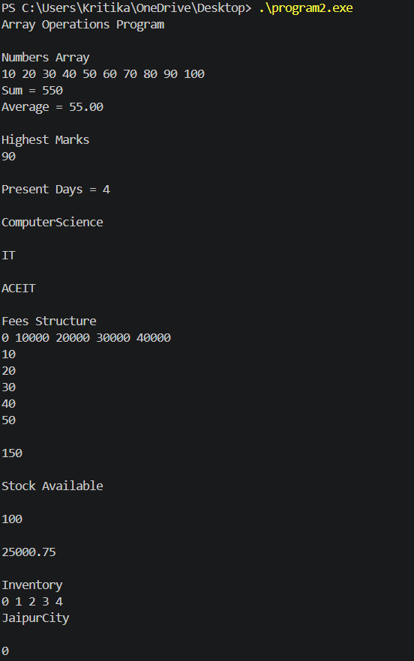

Question No. 3
Step 1: Program Analysis
Variables
- marks
- total
- average
- highest
- lowest
- attendance
- present
- subject
- branch
- fees
- stock
- backup
- salary
- result
- totalResult
- city
- inventory
- college
- count
- course
- numbers
Functions
- main()
Loops
- for loops
Arrays
- marks[5]
- attendance[5]
- subject[8]
- branch[10]
- fees[5]
- stock[5]
- backup[5]
- salary[5]
- result[5]
- inventory[5]
- college[5]
- count[5]
- course[6]
- numbers[5]
Structures
- No structures used.
File Operations
- No file operations used.
Pointers
- No pointers used.
Program Objective
This program performs student result analysis, attendance calculation, inventory management, array operations, and string handling.

Step 2: Syntax Errors
Line No. | Error | Correction
108 | Direct array assignment (backup = stock) | Copy elements using loop or memcpy()
140 | Direct string assignment (city = "Jaipur") | Use strcpy(city,"Jaipur")
175 | Direct array assignment (count = inventory) | Copy elements using loop or memcpy()
211 | Missing semicolon after return 0 | Use return 0;

Step 3: Semantic Errors
Line No. | Error | Correction
117 | Wrong format specifier %d used for float value | Use %f
125 | Missing address operator in scanf | Use &result[i]
146 | String used as array index (inventory["one"]) | Use integer index
148 | Float used as array index (inventory[2.5]) | Use integer index

Step 4: Scope Errors
No Scope Errors Found

Step 5: Linker Errors
No Linker Errors Found
Step 6: Runtime Errors
Line No. | Error | Correction
59 | Loop accesses attendance[5] | Use i < 5
69 | Buffer overflow in strcpy(subject,"Programming") | Increase array size
89 | Array index out of bounds (fees[5]) | Use valid index 0–4
161 | Loop accesses inventory[5] | Use i < 5
185 | Buffer overflow in strcpy(course,"Computer") | Increase array size
193 | Loop writes to numbers[5] | Use i < 5

Step 7: Logical Errors
Line No. | Error | Correction
19 | Integer division used for average calculation | Use (float)total / 5
39 | Lowest marks logic incorrect | Use if(marks[i] < lowest)
103 | Assignment operator used instead of comparison operator | Use ==

Step 8: Array Errors
Line No. | Error | Correction
59 | Access beyond attendance array size | Use valid index
89 | Access beyond fees array size | Use valid index
108 | Invalid array assignment | Copy elements individually
146 | Invalid string index used in array | Use integer index
148 | Invalid float index used in array | Use integer index
161 | Access beyond inventory array size | Use valid index
175 | Invalid array assignment | Copy elements individually
193 | Access beyond numbers array size | Use valid index

Step 9: Function Errors
No Function Errors Found

Step 10: Structure Errors
No Structure Errors Found.

Total Errors Identified: 18

Correct Program:

#include <stdio.h>
#include <string.h>

int main()
{
int marks[5] = {85,90,75,60,95};

printf("Student Result Analysis\n");

int total = 0;

for(int i=0;i<5;i++)
{
total += marks[i];
}

printf("Total = %d\n", total);

float average;

average = total / 5;

printf("Average = %f\n", average);

printf("\n");

int highest = marks[0];

for(int i=1;i<5;i++)
{
if(marks[i] > highest)
{
highest = marks[i];
}
}

printf("Highest = %d\n", highest);

printf("\n");

int lowest = marks[0];

for(int i=1;i<5;i++)
{
if(marks[i] < lowest)
{
lowest = marks[i];
}
}

printf("Lowest = %d\n", lowest);

printf("\n");

int attendance[5];

attendance[0] = 1;
attendance[1] = 1;
attendance[2] = 0;
attendance[3] = 1;
attendance[4] = 1;

int present = 0;

for(int i=0;i<5;i++)
{
present += attendance[i];
}

printf("Present = %d\n", present);

printf("\n");

char subject[20];

strcpy(subject,"Programming");

printf("%s\n", subject);

printf("\n");

char branch[10];

scanf("%s",branch);

printf("%s\n", branch);

printf("\n");

int fees[5];

fees[0] = 50000;
fees[1] = 60000;
fees[2] = 70000;
fees[3] = 80000;
fees[4] = 90000;

printf("\nFees\n");

for(int i=0;i<5;i++)
{
printf("%d ", fees[i]);
}

printf("\n");

int stock[5] = {10,20,30,40,50};

if(stock[2] == 30)
{
printf("Stock Available\n");
}

printf("\n");

int backup[5];

for(int i=0;i<5;i++)
{
backup[i] = stock[i];
}

printf("%d\n", backup[0]);

printf("\n");

float salary[5];

salary[0] = 45000.75;

printf("%.2f\n", salary[0]);

printf("\n");

int result[5];

for(int i=0;i<5;i++)
{
scanf("%d", &result[i]);
}

printf("\n");

int totalResult = 0;

for(int i=0;i<5;i++)
{
totalResult += result[i];
}

printf("Total Result = %d\n", totalResult);

printf("\n");

char city[10];

strcpy(city, "Jaipur");

printf("%s\n", city);

printf("\n");

int inventory[5];

inventory[1] = 100;

inventory[2] = 200;

for(int i=0;i<5;i++)
{
inventory[i] = i * 100;
}

printf("Inventory\n");

for(int i=0;i<5;i++)
{
printf("%d ", inventory[i]);
}

printf("\n");

char college[6];

college[0] = 'A';
college[1] = 'C';
college[2] = 'E';
college[3] = 'I';
college[4] = 'T';
college[5] = '\0';
printf("%s\n", college);

printf("\n");

int count[5];

for(int i=0;i<5;i++)
{
count[i] = inventory[i];
}

printf("%d\n", count[0]);

printf("\n");

char course[20];

strcpy(course,"Computer");

printf("%s\n", course);

printf("\n");

int numbers[5];

for(int i=0;i<=5;i++)
{
numbers[i] = i * 10;
}

printf("Numbers\n");

for(int i=0;i<5;i++)
{
printf("%d ", numbers[i]);
}

printf("\n");

printf("Program Finished\n");

return 0;
}

Output:
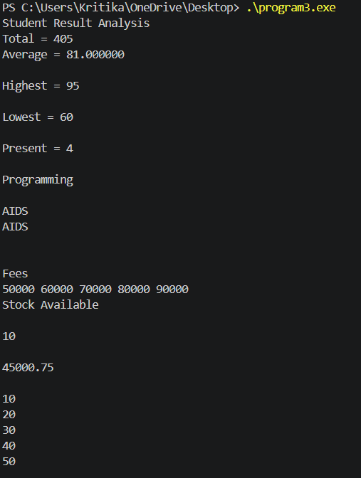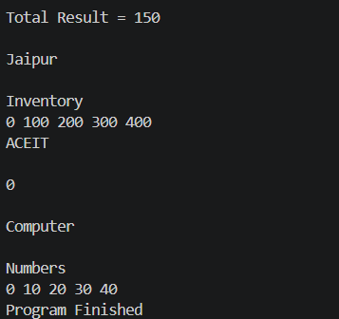
Question No. 4
Step 1: Program Analysis
Variables
- sales
- totalSales
- averageSales
- highestSale
- monthlySales
- product
- category
- stock
- orders
- totalOrders
- revenue
- backupRevenue
- commission
- city
- branch
- employees
- department
- expenses
- ratings
- feedback
Functions
- main()
Loops
- for loops
Arrays
- sales[5]
- monthlySales[5]
- product[8]
- category[15]
- stock[5]
- orders[5]
- revenue[5]
- backupRevenue[5]
- commission[5]
- city[10]
- branch[5]
- employees[5]
- department[6]
- expenses[5]
- ratings[5]
- feedback[5]
Structures
- No structures used.
File Operations
- No file operations used.
Pointers
- No pointers used.
Program Objective
This program is intended to generate a sales report, calculate totals and averages, manage stock, revenue, employee data, and perform array and string operations.

Step 2: Syntax Errors
Line No. | Error | Correction
64 | Direct assignment to character array (category = "Electronics") | Use strcpy(category,"Electronics")
114 | Direct array assignment (backupRevenue = revenue) | Copy elements using loop or memcpy()
128 | Direct string assignment (city = "Jaipur") | Use strcpy(city,"Jaipur")
164 | Direct array assignment (expenses = sales) | Copy elements using loop or memcpy()
188 | Missing semicolon after printf("Report Generated Successfully\n") | Add ;

Step 3: Semantic Errors
Line No. | Error | Correction
21 | Wrong format specifier %d used for float variable | Use %f
70 | String used as array index (stock["first"]) | Use integer index
72 | Float used as array index (stock[2.7]) | Use integer index
92 | Missing address operator in scanf() | Use &orders[i]
123 | Wrong format specifier %d used for float value | Use %f
184 | Integer value printed using %s | Use %d

Step 4: Scope Errors
No Scope Errors Found

Step 5: Linker Errors
No Linker Errors Found

Step 6: Runtime Errors
Line No. | Error | Correction
43 | Array index out of bounds (monthlySales[5]) | Use valid index 0–4
47 | Loop accesses monthlySales[5] | Use i < 5
55 | Buffer overflow in strcpy(product,"LaptopComputer") | Increase array size
145 | Loop writes to employees[5] | Use i < 5
159 | Buffer overflow in strcpy(department,"Marketing") | Increase array size
172 | Negative array index (ratings[-1]) | Use valid index

Step 7: Logical Errors
Line No. | Error | Correction
19 | Integer division used for average calculation | Use (float)totalSales / 5
29 | Highest sale logic reversed | Use if(sales[i] > highestSale)
108 | Assignment operator used instead of comparison operator | Use ==

Step 8: Array Errors
Line No. | Error | Correction
43 | Access beyond monthlySales array size | Use valid index
47 | Loop accesses extra monthlySales element | Use proper loop condition
70 | Invalid string index used in array | Use integer index
72 | Invalid float index used in array | Use integer index
114 | Invalid array assignment | Copy elements individually
145 | Access beyond employees array size | Use valid index
164 | Invalid array assignment | Copy elements individually
172 | Invalid negative array index | Use valid index

Step 9: Function Errors
No Function Errors Found
Step 10: Structure Errors
No Structure Errors Found.
Total Errors Identified: 19

Correct program :

#include <stdio.h>
#include <string.h>

int main()
{
int sales[5] = {100,200,300,400,500};

printf("Sales Report System\n");

int totalSales = 0;

for(int i=0;i<5;i++)
{
totalSales += sales[i];
}

printf("Total Sales = %d\n", totalSales);

float averageSales;

averageSales = totalSales / 5;

printf("Average Sales = %.2f\n", averageSales);

printf("\n");

int highestSale = sales[0];

for(int i=1;i<5;i++)
{
if(sales[i] > highestSale)
{
highestSale = sales[i];
}
}

printf("Highest Sale = %d\n", highestSale);

printf("\n");

int monthlySales[5];

monthlySales[0] = 120;
monthlySales[1] = 140;
monthlySales[2] = 160;
monthlySales[3] = 180;
monthlySales[4] = 200;

printf("Monthly Sales\n");

for(int i=0;i<5;i++)
{
printf("%d ", monthlySales[i]);
}

printf("\n");

char product[15];

strcpy(product,"LaptopComputer");

printf("%s\n", product);

printf("\n");

char category[15];

strcpy(category,"Electronics");

printf("%s\n", category);

printf("\n");

int stock[5];

stock[0] = 100;

stock[2] = 200;

for(int i=0;i<5;i++)
{
stock[i] = i * 50;
}

printf("Stock Details\n");

for(int i=0;i<5;i++)
{
printf("%d ", stock[i]);
}

printf("\n");

int orders[5];

for(int i=0;i<5;i++)
{
scanf("%d", &orders[i]);
}

printf("\n");

int totalOrders = 0;

for(int i=0;i<5;i++)
{
totalOrders += orders[i];
}

printf("Total Orders = %d\n", totalOrders);

printf("\n");

int revenue[5] = {1000,2000,3000,4000,5000};

if(revenue[2] == 3000)
{
printf("Revenue Matched\n");
}

printf("\n");

int backupRevenue[5];

for(int i=0;i<5;i++)
{
backupRevenue[i] = revenue[i];
}

printf("%d\n", backupRevenue[0]);

printf("\n");

float commission[5];

commission[0] = 2500.50;

printf("%.2f\n", commission[0]);

printf("\n");

char city[10];

strcpy(city, "Jaipur");

printf("%s\n", city);

printf("\n");

char branch[6];

branch[0] = 'I';
branch[1] = 'T';
branch[2] = '-';
branch[3] = 'A';
branch[4] = '\0';

printf("%s\n", branch);

printf("\n");

int employees[5];

for(int i=0;i<5;i++)
{
employees[i] = i * 100;
}

printf("Employees\n");

for(int i=0;i<5;i++)
{
printf("%d ", employees[i]);
}

printf("\n");

char department[10];

strcpy(department,"Marketing");

printf("%s\n", department);

printf("\n");

int expenses[5];

for(int i=0;i<5;i++)
{
expenses[i] = sales[i];
}

printf("%d\n", expenses[0]);

printf("\n");

int ratings[5];

ratings[0] = 5;

printf("%d\n", ratings[0]);

printf("\n");

int feedback[5];

feedback[0] = 10;
feedback[1] = 20;
feedback[2] = 30;
feedback[3] = 40;
feedback[4] = 50;

printf("%d\n", feedback[0]);

printf("\n");

printf("Report Generated Successfully\n");

return 0;
}
Output:
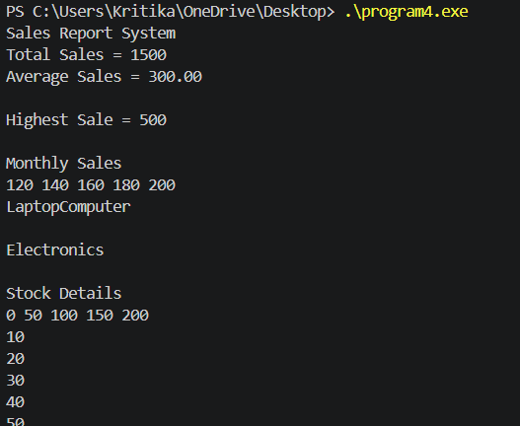
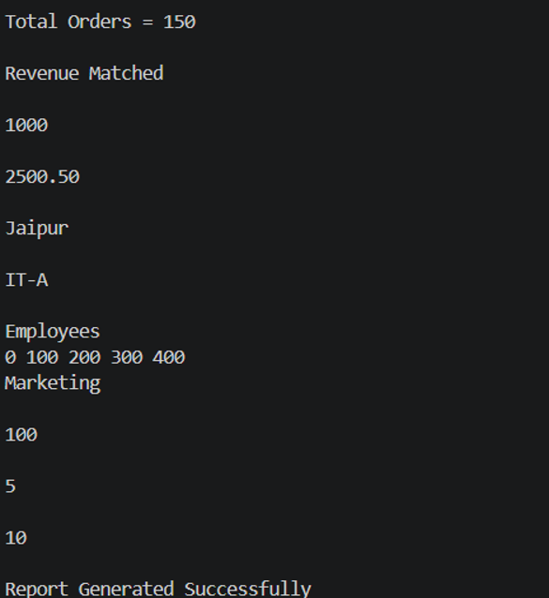

Question No. 5
Step 1: Program Analysis
Variables
- marks
- total
- average
- highest
- lowest
- attendance
- present
- subject
- department
- fees
- result
- totalResult
- inventory
- backup
- salary
- city
- branch
- stock
- course
- ratings
- feedback
- scores
- temp
Functions
- main()
Loops
- for loops
Arrays
- marks[10]
- attendance[10]
- subject[10]
- department[20]
- fees[5]
- result[5]
- inventory[5]
- backup[5]
- salary[5]
- city[10]
- branch[5]
- stock[5]
- course[8]
- ratings[5]
- feedback[5]
- scores[5]
- temp[5]
Structures
- No structures used.
File Operations
- No file operations used.
Pointers
- No pointers used.
Program Objective
This program is intended to analyze student performance, calculate averages, manage attendance records, handle inventory and stock data, and perform various array and string operations.

Step 2: Syntax Errors
Line No. | Error | Correction
75 | Direct assignment to character array (department = "InformationTechnology") | Use strcpy(department,"InformationTechnology")
125 | Direct array assignment (backup = inventory) | Copy elements using loop or memcpy()
139 | Direct string assignment (city = "Jaipur") | Use strcpy(city,"Jaipur")
189 | Direct array assignment (scores = marks) | Copy elements individually

Step 3: Semantic Errors
Line No. | Error | Correction
21 | Wrong format specifier %d used for float variable | Use %f
81 | String used as array index (fees["two"]) | Use integer index
83 | Float used as array index (fees[4.5]) | Use integer index
101 | Missing address operator in scanf() | Use &result[i]
134 | Wrong format specifier %d used for float value | Use %f
183 | Integer value printed using %s | Use %d

Step 4: Scope Errors
No Scope Errors Found

Step 5: Linker Errors
No Linker Errors Found

Step 6: Runtime Errors
Line No. | Error | Correction
55 | Array index out of bounds (attendance[10]) | Use valid index 0–9
59 | Loop accesses attendance[10] | Use i < 10
69 | Buffer overflow in strcpy(subject,"DataStructures") | Increase array size
159 | Loop writes to stock[5] | Use i < 5
173 | Buffer overflow in strcpy(course,"Programming") | Increase array size
179 | Negative array index (ratings[-1]) | Use valid index
203 | Access beyond array bounds (temp[5]) | Use valid index 0–4

Step 7: Logical Errors
Line No. | Error | Correction
19 | Integer division used for average calculation | Use (float)total / 10
29 | Highest value logic incorrect | Use if(marks[i] > highest)
41 | Lowest value logic incorrect | Use if(marks[i] < lowest)
119 | Assignment operator used instead of comparison operator | Use ==

Step 8: Array Errors
Line No. | Error | Correction
55 | Access beyond attendance array size | Use valid index
59 | Loop accesses extra attendance element | Use proper loop condition
81 | Invalid string index used in array | Use integer index
83 | Invalid float index used in array | Use integer index
125 | Invalid array assignment | Copy elements individually
159 | Access beyond stock array size | Use valid index
179 | Invalid negative array index | Use valid index
189 | Invalid array assignment | Copy elements individually
203 | Access beyond temp array size | Use valid index

Step 9: Function Errors
No Function Errors Found
Step 10: Structure Errors
No Structure Errors Found.
Total Errors Identified: 19
Correct program:
#include <stdio.h>
#include <string.h>

int main()
{
int marks[10] = {75,80,85,90,95,70,65,88,92,78};

printf("Student Performance Analysis\n");

int total = 0;

for(int i=0;i<10;i++)
{
total += marks[i];
}

printf("Total Marks = %d\n", total);

float average;

average = total / 10.0;

printf("Average = %.2f\n", average);

printf("\n");

int highest = marks[0];

for(int i=1;i<10;i++)
{
if(marks[i] > highest)
{
highest = marks[i];
}
}

printf("Highest = %d\n", highest);

printf("\n");

int lowest = marks[0];

for(int i=1;i<10;i++)
{
if(marks[i] < lowest)
{
lowest = marks[i];
}
}

printf("Lowest = %d\n", lowest);

printf("\n");

int attendance[10];

for(int i=0;i<10;i++)
{
attendance[i] = 1;
}

int present = 0;

for(int i=0;i<10;i++)
{
present += attendance[i];
}

printf("Present Days = %d\n", present);

printf("\n");

char subject[20];

strcpy(subject,"DataStructures");

printf("%s\n", subject);

printf("\n");

char department[30];

strcpy(department, "InformationTechnology");

printf("%s\n", department);

printf("\n");

int fees[5];

fees[2] = 50000;

fees[4] = 70000;

for(int i=0;i<5;i++)
{
fees[i] = i * 10000;
}

printf("Fees\n");

for(int i=0;i<5;i++)
{
printf("%d ", fees[i]);
}

printf("\n");

int result[5];

for(int i=0;i<5;i++)
{
scanf("%d",& result[i]);
}

printf("\n");

int totalResult = 0;

for(int i=0;i<5;i++)
{
totalResult += result[i];
}

printf("%d\n", totalResult);

printf("\n");

int inventory[5] = {10,20,30,40,50};

if(inventory[2] == 30)
{
printf("Item Found\n");
}

printf("\n");

int backup[5];

for(int i=0;i<5;i++)
{
backup[i] = inventory[i];
}

printf("%d\n", backup[0]);

printf("\n");

float salary[5];

salary[0] = 65000.75;

printf("%f\n", salary[0]);

printf("\n");

char city[10];

strcpy(city, "jaipur");

printf("%s\n", city);

printf("\n");

char branch[5];

branch[0] = 'I';
branch[1] = 'T';
branch[2] = '-';
branch[3] = 'A';

printf("%s\n", branch);

printf("\n");

int stock[5];

for(int i=0;i<5;i++)
{
stock[i] = i * 100;
}

printf("Stock\n");

for(int i=0;i<5;i++)
{
printf("%d ", stock[i]);
}

printf("\n");

char course[12];

strcpy(course,"Programming");

printf("%s\n", course);

printf("\n");

int ratings[5];

ratings[0] = 10;

printf("%d\n", ratings[0]);

printf("\n");

int feedback[5] = {1,2,3,4,5};

printf("%d\n", feedback[0]);

printf("\n");

int scores[5];

for(int i=0;i<5;i++)
{
scores[i] = marks[i];
}

printf("%d\n", scores[0]);

printf("\n");

int temp[5];

for(int i=0;i<5;i++)
{
temp[i] = i;
}

printf("%d\n", temp[4]);

printf("\n");

printf("Program Completed Successfully\n");

return 0;
}
Output:
