ONLINE QUIZ EXAMINATION SYSTEM (OQES)

Team:
- 1039 LALIT PARATAP SINGH TOMAR
- 1087 SHIVAM SINGH TOMAR

- Purpose:
It is a system by which students can appear in a quiz from anywhere of the world where
there is no interaction between pencil and paper rather interaction between computer and
human being.

we provide just a platform to be conduction online exam of enrolled students under any
course in a department of any institute.

Main purpose of the project deals with providing facility of solving quiz online. Teachers of
respective subjects can upload questions. Lab faculties also upload the programming
questions. Students can solve those in given time. Students can see their result.

The system will determine the student's performance depending on his/her score.
The system will show result after the examination is finished and also be able to provide
feedback according to the result.

Administrative control of the whole system is provided. A teacher has control in the
question bank and is suppose to make schedule for quiz.
Teachers can use the OQES for evaluating students effectively, efficiently and perfectly.

- Future Scope:
Any university, college, school or educational institute can use this system for their
organization to take quizzes. The system behaviour is same for all the organizations.
Just need to add some additional users or some characteristics that our systems use according to the organization.

- Definitions:
OQES: ONLINE QUIZ EXAMINATION SYSTEM
SRS: Software Requirement Specification
GUI: Graphical User Interface
Portal: Personalized Website
Stakeholder: The person who will participate in the System. And Owner of system
Ex. Teacher, university head , Student
UML: Software Engineering Notation for visualizing System in the form diagrams
SSL: Secure Socket Layer used for providing restricted access to application
RDBMS: Relational Database Management System.
CLUSTERS: Group of independent servers.

- Overview:
ONLINE QUIZ EXAMINATION SYSTEM is a Web based M.C.Q. Quiz System for evaluating students. This system is developed for considering educational institutes.

- Additional Information:
The system work on internet server, so it will be operated by any end user for conducting and participating quizzes .
This system creates provides a better environment for online quizzes.

- General Description:
This project is specifically for educational purposes so it helps the education faculty to conduct quizzes online.
It also helps students to give quiz from their preferred location.

-Functional Requirement:
This section provides requirement overview of the system. Various functional modules that can be implemented by
the system will be:
Roles:
there are six roles in our system

- University Head
- College Head
- Department Head
- Teacher
- Lab Faculty
- Student

-Description:
1.University head is responsible for registration of colleges/Institutes and college head. all registered institutes/colleges can use this application for conditioning online exam at any center as per scheduling time.

2.College head is responsible for registration of departments and department head. college head has authority to managing every thing inside the apllicatoin like department management. The college will prepare a quiz analysis report according to the department.

3.Department head is responsible for registration of students and teachers. Department head will add courses. department head will get quiz analysis reports from teachers. After verifying the report, send it to the College Head.The department head will check the questions sent by the students and approve them.

4.Teachers define the number of questions, time of the quiz, schedule for the quiz etc. According to these information question will be generated for students. Teachers are responsible for registration of lab faculty and add and edit questions from the question bank. The teachers will requeste the lab faculty to give a question bank. Questions sent by lab faculty must be approved or rejected by the teacher. Teacher will create quiz analysis reports and send them to department heads.

5.Lab faculty define the number of program,time duration etc.another role of lab faculty is that they view the solution of each student and according to their output they will provide the result.Lab faculty will also provide MCQ questions at the request from teachers.Lab faculty will upload MCQ questions after teacher approval.

6.There is seven options for student:
- Online MCQ Quiz
- Online Programming Test
- send Interview Question
- send MCQ Question
- get notification from department head that questions uploaded by students were appropriate
- Upload MCQ Question after approval
- Upload Interview Question after approval

- Technical Issues:
This system will work on client-Server architecture. It will require an internet server.
The system should support some commonly used browser such as Chrome etc.
Interface Requirement Various interfaces for the different actors could be:
1. Login Page
2. Registration form

The actors may select the different options which will be open in another screen as
1. Login Page
2. Registration Form
3. university head Page
4. quiz page
5. feedback page
And many others.

- Hardware Interface:
The System must run over the internet,
All the hardware shall require to connect to internet will be hardware interface for the system.
e.g. modem, WAN, LAN
Specialized Server Infrastructure Hardware
The system should use distributed servers i.e cloud for managing large amount of data so as to make it appear as single unit for end-user. The system should have proper clusters for backup.

Recommended Operating Systems
- Windows: 7 or newer
- MAC: OS X v10.7 or higher
- Linux: Ubuntu
- Hardware Requirements
We strongly recommend a computer fewer than 5 years old.
- Processor: Minimum 1 GHz; Recommended 2GHz or more
- Ethernet connection (LAN) OR a wireless adapter (Wi-Fi)
- Hard Drive: Minimum 32 GB; Recommended 64 GB or more
- Memory (RAM): Minimum 1 GB; Recommended 4 GB or above
- Sound card w/speakers
- Some classes require a camera and microphone

- Software Interface:
The system is on server so it requires the any scripting language like JS , TS etc
The system should be able to exchange data using , JSON or any advance technology.

The system require Data Base also for the store the any transaction of the system like MySql.
System also require DNS (Domain Name space) for the naming on the internet.
EX: http://www.amazon.in
At the end-user need web browser for interact with the system.

- Performance Requirement:
There is no performance requirement in this system, because the server request and response to client is totally based on internet connection of end user.

- Design Constrains:
This system should be developed using Standard Web Page Development Tool , which conforms GUI standards such like HTML,CSS, JSON, etc.
The system should support various RDMS and Cloud Technologies.

- Non-Functional Requirements

1.Security:
SSL
The System use SSL (Secure Socket Layer) in all truncations that include any confidential student information.
The system must automatically log out all customers after a period of inactivity.
The system should not leave any cookies on the customer's computer containing users’ password.
The system's back-end servers shall only be accessible to authenticated administrators.
Sensitive data will be encrypted before being sent over insecure connections like internet.
The proper firewalls should be developed to avoid intrusions from the internal or external sources.

2.Reliability:
The system provides storage of all databases on redundant computers with automatic switchover.
The main pillar of reliability of the system is the backup of the database
which is continuously maintained and update to reflect the most recent changes.

3: Availability:
The system should be available at all times. meaning the user can access it using web browser,
only restricted by the down time of the server on which the system runs.
In case of a of a hardware failure or database corruption, a replacement page will be shown.
Up time : It mean 24 * 7 availability
100%--------------
99.9%
99.999%
99.9999%

4: Maintainability:
A commercial database is used for maintaining the data base and application server takes care of the site.
The maintainability can be done efficiently.

5.Portability:
The application is HTML and scripting language based (JavaScript). So the end user part is fully portable and any system using
any web browser should be able to use the features of the system, including any hardware platform that is available
or will be available in the future.
An end-user is used this system on an OS; either it is Windows or Linux.
The System shall run on PC, Laptops etc.
The technology should be transferable to different environments easily.

6.Accessibility:
Only registered users should be allowed to process the orders after authentications.
Only GUI access of the system should be permitted to end users.

7.Policies:
The system should adhere to all the legal formalities of the particular countries.
The system should maintain security related to sensitive data.

8.Efficiency:
The system should provide good throughput and response to multiple users without burdening the system by using appropriate number of servers.

9.Safety:
Software should not harm ethical and environmental conditions of the end users machine.

10.Modulariy:
The system should have user friendly interface.
It should be easily updated, modified and reused

- Operational Scenario:
+ Student Interaction
Student login into the system with authentication. Student take a quiz after successful login at given time by the administrator. Student take a quiz, after successful submission student has a option to upload a supportive question and also give feedback to the administrator.

+ Lab Faculty Interaction:

+ Staff Interaction:

- ER Diagram:

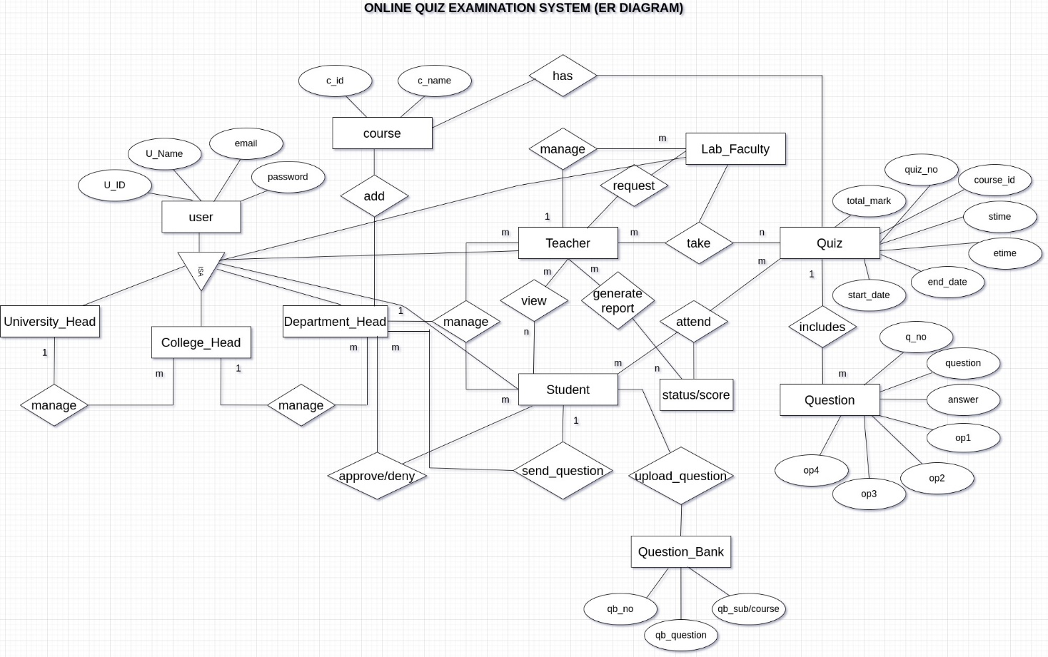

- UML Diagram:

- University Head
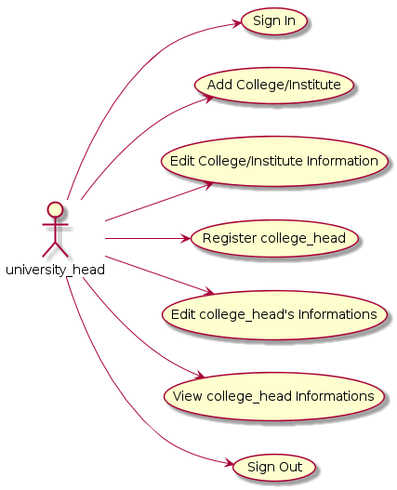
- College Head
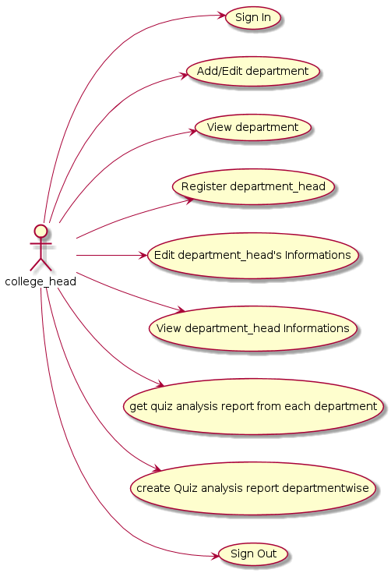
- Department Head

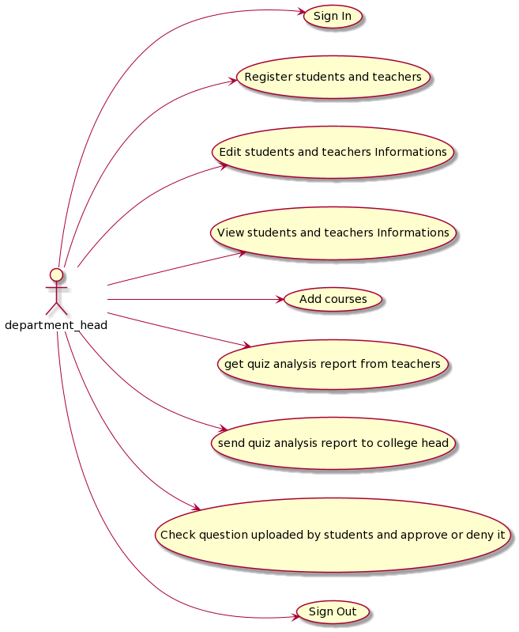

- Teacher
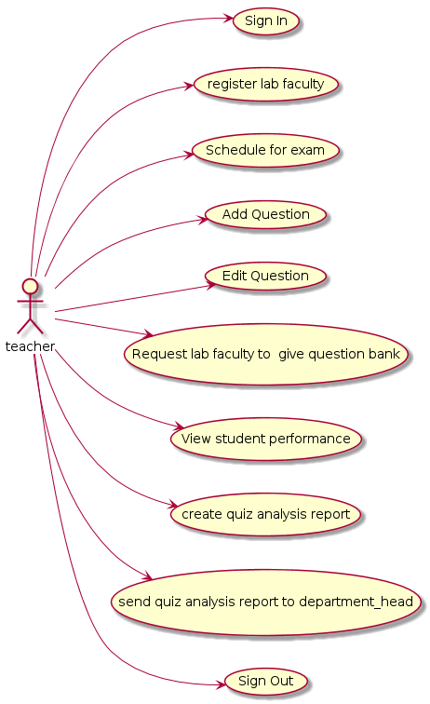
- Lab Faculty

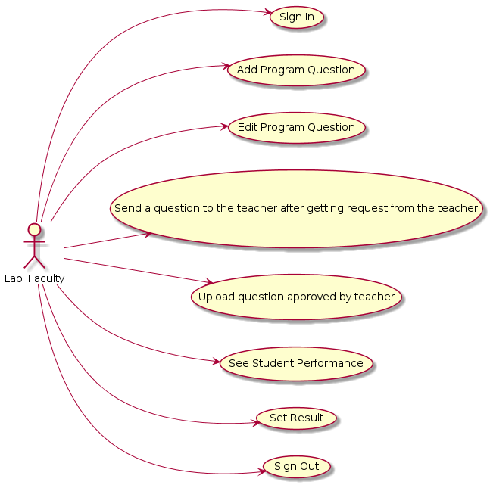
- Student

