SPU (PG) COLLEGE
Department Of Computer Science
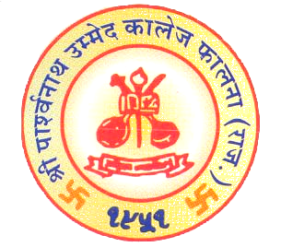

Certificate

Bachelor Of Science Information Technology

This is to certify that project entitled Intensity Care Of Mother and Kids has been successfully completed Lalit Kumar as partial fulfillment of Final Year BS-IT course as prescribed by JNVU Jodhpur during the year 2011-2014 under our guidance and supervision.

Lecturer-in-charge: Dr. Y Sharma
Mr. Purushottam Bhaskar (HOD, Comp. Science Dept.)

DATE OF EXAM: _____________________
EXAMINERS:
- ________________
- _______________________

SPU (PG) COLLEGE
Department Of Computer Science

Certificate

Bachelor Of Science Information Technology

This is to certify that project entitled Intensity Care Of Mother and Kids has been successfully completed Deepak Kumar as partial fulfillment of Final Year BS-IT course as prescribed by JNVU Jodhpur during the year 2011-2014 under our guidance and supervision.

Lecturer-in-charge: Dr. Y Sharma
Mr. Purushottam Bhaskar (HOD, Comp. Science Dept.)

DATE OF EXAM: _____________________
EXAMINERS:
- ________________
- _______________________

SPU (PG) COLLEGE
Department Of Computer Science

Certificate

Bachelor Of Science Information Technology

This is to certify that project entitled Intensity Care Of Mother and Kids has been successfully completed Ravindra Singh Rao as partial fulfillment of Final Year BS-IT course as prescribed by JNVU Jodhpur during the year 2011-2014 under our guidance and supervision.

Lecturer-in-charge: Dr. Y Sharma
Mr. Purushottam Bhaskar (HOD, Comp. Science Dept.)

DATE OF EXAM: _____________________
EXAMINERS:
- ________________
- _______________________

