

Safety Plan Lane Assistance

**Document Version: [Version]**

**Template Version 1.0, Released on 2017-06-21**



# Document history

**[Instructions: Fill in the date, version and description fields. You can fill out the Editor field with your name if you want to do so. Keep track of your editing as if this were a real world project.**

**For example, if this were your first draft or first submission, you might say version 1.0. If this is a second submission attempt, then you'd add a second line with a new date and version 2.0]**

|  |  |  |  |
| --- | --- | --- | --- |
| Date | Version | Editor | Description |
| 13.11.2018 | 1.0 | Suraj Lal Putta | First draft |
|  |  |  |  |
|  |  |  |  |
|  |  |  |  |
|  |  |  |  |

# Table of Contents

**[Instructions: We have provided a table of contents. If the table of contents is not showing up correctly in your word processor of choice, please update it. The table of contents should show each section of the document and page numbers or links. Most word processors can do this for you. In** [**Google Docs**](https://support.google.com/docs/answer/116338?co=GENIE.Platform%3DDesktop&hl=en)**, you can use headings for each section and then go to Insert > Table of Contents.** [**Microsoft Word**](https://support.microsoft.com/en-us/help/285059/how-to-create-a-table-of-contents-by-marking-text-in-word) **has similar capabilities]**

Document history

Table of Contents

Introduction

Purpose of the Safety Plan

Scope of the Project

Deliverables of the Project

Item Definition

Goals and Measures

Goals

Measures

Safety Culture

Safety Lifecycle Tailoring

Roles

Development Interface Agreement

Confirmation Measures

# Introduction

## Purpose of the Safety Plan

The safety plan document provides an overview of the safely related design activities that needs to be carried out in the project. It describes briefly the item under discussion. It provides a list of all parties/companies (OEM, Tier 1, Tier 2 Suppliers, etc.) involved in the project, the agreement between them and their roles. It provides a list of people (within the company) involved in the project and their role. It provides a project schedule which contains a timeline of tasks to be completed.

## Scope of the Project

For the lane assistance project, the following safety lifecycle phases are in scope:

Concept phase

Product Development at the System Level

Product Development at the Software Level

The following phases are out of scope:

Product Development at the Hardware Level

Production and Operation

## Deliverables of the Project

**[Instructions: Nothing to do here. This is for your information.]**

The deliverables of the project are:

Safety Plan

Hazard Analysis and Risk Assessment

Functional Safety Concept

Technical Safety Concept

Software Safety Requirements and Architecture

# Item Definition

**[Instructions:**

**REQUIRED**

**Discuss these key points about the system:**

**What is the item in question, and what does the item do?**

**What are its two main functions? How do they work?**

**Which subsystems are responsible for each function?**

**What are the boundaries of the item? What subsystems are inside the item? What elements or subsystems are outside of the item?**

**OPTIONAL**

**Optionally, include information about these points as well. These were not included in the lectures, but you might be able to find this information online:**

* **Operational and Environmental Constraints. This could especially be limited to camera performance; lane lines are difficult to detect in snow, fog, etc**
* **Legal requirements in your country for lane assistance technology**
* **National and International Standards Related to the Item**
* **Records of previously known safety-related incidents or behavioral shortfalls**

**]**

The item under consideration here is the Lane Assistance item. The two main function of the lane assistance are the Lane Departure Warning (LDW) function and the Lane Keeping Assistance (LKA) function. The lane departure warning function warns the driver with a haptic oscillating steering torque on the steering wheel when the vehicle leaves the ego lane without driver’s intention. The lane keeping assistance function provides a supporting steering torque to the keep the vehicle towards the center of the ego lane when the vehicle is about to leave the lane. The camera subsystem, electronic power steering subsystem and car display subsystem are all responsible for the lane departure warning and lane keeping assistance functions. The figure below shows the high level system architecture of the lane assistance item. It shows the item, system and the subsystem boundaries. All the camera subsystem, electronic power steering subsystem and the display subsystem are inside the item boundaries as they are responsible the lane assistance function in some way. The steering wheel component is outside the item as it is not directly responsible for implementing the lane assistance item.

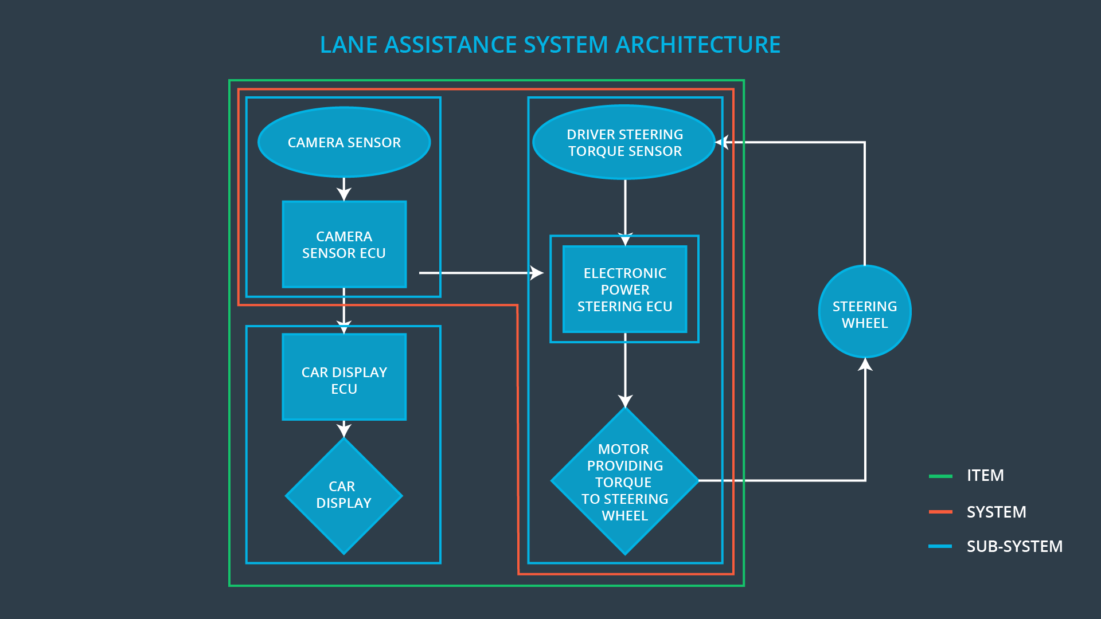

Figure : Lane Assistance Item system architecture

# Goals and Measures

## Goals

**[Instructions:**

**Describe the major goal of this project; what are we trying to accomplish by analyzing the lane assistance functions with ISO 26262?]**

The major goal of this project is to identify, analyze the risks and hazards of the lane assistance function of system cause by electronic (hardware and software) malfunctions and to bring the risks to an acceptable level.

## Measures

**[Instructions:**

**Fill in who will be responsible for each measure or activity. Hint: The lesson on Safety Management Roles and Responsibilities.**

**The options are:**

**All Team Members**

**Safety Manager**

**Project Manager**

**Safety Auditor**

**Safety Assessor**

**]**

|  |  |  |
| --- | --- | --- |
| Measures and Activities | Responsibility | Timeline |
| Follow safety processes | All Team members | Constantly |
| Create and sustain a safety culture | All Team members | Constantly |
| Coordinate and document the planned safety activities | Safety Manager | Constantly |
| Allocate resources with adequate functional safety competency | Project Manager | Within 2 weeks of start of project |
| Tailor the safety lifecycle | Safety Manager | Within 4 weeks of start of project |
| Plan the safety activities of the safety lifecycle | Safety Manager | Within 4 weeks of start of project |
| Perform regular functional safety audits | Safety Auditor | Once every 2 months |
| Perform functional safety pre-assessment prior to audit by external functional safety assessor | Safety Manager | 3 months prior to main assessment |
| Perform functional safety assessment | Safety Assessor | Conclusion of functional safety activities |

# Safety Culture

**[Instructions:**

**Describe the characteristics of your company's safety culture. How do these characteristics help maintain your safety culture. Hint: See the lesson about Safety Culture**

**]**

Characteristics of a good safety culture

* Highest priority for safety
* Accountability: processes ensure accountability such that design decisions are traceable back to the people and teams who made the decisions.
* **Rewards**: the organization motivates and supports the achievement of functional safety
* **Penalties**: the organization penalizes shortcuts that jeopardize safety or quality
* **Independence**: teams who design and develop a product should be independent from the teams who audit the work
* **Well defined processes**: company design and management processes should be clearly defined
* **Resources**: projects have necessary resources including people with appropriate skills
* **Diversity**: intellectual diversity is sought after, valued and integrated into processes
* **Communication**: communication channels encourage disclosure of problems

# Safety Lifecycle Tailoring

**[Instructions:**

**Describe which phases of the safety lifecycle are in scope and which are out of scope for this particular project. Hint: See the** **Intro section** **of this document**

**]**

In scope

* Concept Phase
  + Item Definition
  + Hazard and Risk assessment
  + Functional Safety Concept
* Product Development
  + HW Level
  + SW Level

Out of Scope

* Product Development
  + Safety Validation
  + Functional Safety Assessment
  + Release for production
* After Release for Production

# Roles

**[Instructions:**

**This section is here for your reference. You do not need to do anything here. It is provided to help with filling out the development interface agreement section.**

**]**

|  |  |
| --- | --- |
| Role | Org |
| Functional Safety Manager- Item Level | OEM |
| Functional Safety Engineer- Item Level | OEM |
| Project Manager - Item Level | OEM |
| Functional Safety Manager- Component Level | Tier-1 |
| Functional Safety Engineer- Component Level | Tier-1 |
| Functional Safety Auditor | OEM or external |
| Functional Safety Assessor | OEM or external |

# Development Interface Agreement

**[Instructions:**

**Assume in this project that you work for the tier-1 organization as described in the above roles table. You are taking on the role of both the functional safety manager and functional safety engineer.**

**Please answer the following questions:**

1. **What is the purpose of a development interface agreement?**
2. **What will be the responsibilities of your company versus the responsibilities of the OEM? Hint: In this project, the OEM is supplying a functioning lane assistance system. Your company needs to analyze and modify the various sub-systems from a functional safety viewpoint.**

**]**

A DIA (development interface agreement) defines the roles and responsibilities between companies involved in developing a product. All involved parties need to agree on the contents of the DIA before the project begins. The DIA also specifies what evidence and work products each party will provide to prove that work was done according to the agreement. The ultimate goal is to ensure that all parties are developing safe vehicles in compliance with ISO 26262.

The responsibilities of my company would be to support the OEM with all the functional safety activities from the concept to the product development phase. The responsibilities includes the following activities

* Risk and Hazard Assessment
  + Defining safety goals
* Functional Safety Concept
  + Deriving functional safety requirements
* Technical Safety Concept
  + Deriving technical safety requirements
* Functional Safety at software and hardware levels
  + Deriving hardware and software requirements

# Confirmation Measures

**[Instructions:**

**Please answer the following questions:**

1. **What is the main purpose of confirmation measures?**
2. **What is a confirmation review?**
3. **What is a functional safety audit?**
4. **What is a functional safety assessment?**

**]**

Confirmation measures serve two purposes:

* That a functional safety project conforms to ISO 26262, and
* That the project really does make the vehicle safer.

Confirmation review ensures that the project complies with ISO 26262. As the product is designed and developed, an independent person would review the work to make sure ISO 26262 is being followed.

Functional safety audit is done to make sure that the actual implementation of the project conforms to the safety plan.

Confirming that plans, designs and developed products actually achieve functional safety is called a functional safety assessment.

A safety plan could have other sections that we are not including here. For example, a safety plan would probably contain a complete project schedule.

There might also be a "Supporting Process Management" section that would cover "Part 8: Supporting Processes" of the ISO 26262 functional safety standard. This would include descriptions of how the company handles requirements management, change management, configuration management, documentation management, and software tool usage and confidence.

Similarly, a confirmation measures section would go into more detail about how each confirmation will be carried out.