

Technical Safety Concept Lane Assistance

**Document Version: [Version]**

**Template Version 1.0, Released on 2017-06-21**



# Document history

**[Instructions: Fill in the date, version and description fields. You can fill out the Editor field with your name if you want to do so. Keep track of your editing as if this were a real world project.**

**For example, if this were your first draft or first submission, you might say version 1.0. If this is a second submission attempt, then you'd add a second line with a new date and version 2.0]**

|  |  |  |  |
| --- | --- | --- | --- |
| Date | Version | Editor | Description |
| 15.11.2018 | 1.0 | Suraj Lal Putta | Initial draft |
|  |  |  |  |
|  |  |  |  |
|  |  |  |  |
|  |  |  |  |

# 

# Table of Contents

**[Instructions: We have provided a table of contents. If the table of contents is not showing up correctly in your word processor of choice, please update it. The table of contents should show each section of the document and page numbers or links. Most word processors can do this for you. In** [**Google Docs**](https://support.google.com/docs/answer/116338?co=GENIE.Platform%3DDesktop&hl=en)**, you can use headings for each section and then go to Insert > Table of Contents.** [**Microsoft Word**](https://support.microsoft.com/en-us/help/285059/how-to-create-a-table-of-contents-by-marking-text-in-word) **has similar capabilities]**

Document history

Table of Contents

Purpose of the Technical Safety Concept

Inputs to the Technical Safety Concept

Functional Safety Requirements

Refined System Architecture from Functional Safety Concept

Functional overview of architecture elements

Technical Safety Concept

Technical Safety Requirements

Refinement of the System Architecture

Allocation of Technical Safety Requirements to Architecture Elements

Warning and Degradation Concept

# Purpose of the Technical Safety Concept

ISO 26262 places the functional safety concept in the concept phase while the technical safety concept is part of the product development phase. The technical safety concept is more concrete and gets into the details of the item's technology. The product development phase is divided into two parts product development at the system level and product development at the hardware and software level. Before developing hardware or software, the technical safety requirements need to be determined for each of these systems. The technical safety concept involves:

* Turning functional safety requirements into technical safety requirements
* Allocating technical safety requirements to the system architecture

# Inputs to the Technical Safety Concept

## Functional Safety Requirements

|  |  |  |  |  |
| --- | --- | --- | --- | --- |
| **ID** | **Functional Safety Requirement** | **ASIL** | **Fault Tolerant Time Interval** | **Safe State** |
| Functional  Safety  Requirement  01-01 | The lane assistance item shall ensure that the lane departure oscillating torque amplitude is below “Max_Torque_Amplitude”. | C | 50ms | The lane departure warning (LDW) function is turned off. |
| Functional  Safety  Requirement  01-02 | The lane assistance item shall ensure that the lane departure oscillating torque frequency is below “Max_Torque_Frequency”. | C | 50ms | The lane departure warning function is turned off. |
| Functional  Safety  Requirement  02-01 | The electronic power steering ECU shall ensure that the lane keeping assistance torque is applied for only “Max_Duration”. | B | 500ms | The lane keeping assistance (LKA) function is turned off. |

## Refined System Architecture from Functional Safety Concept

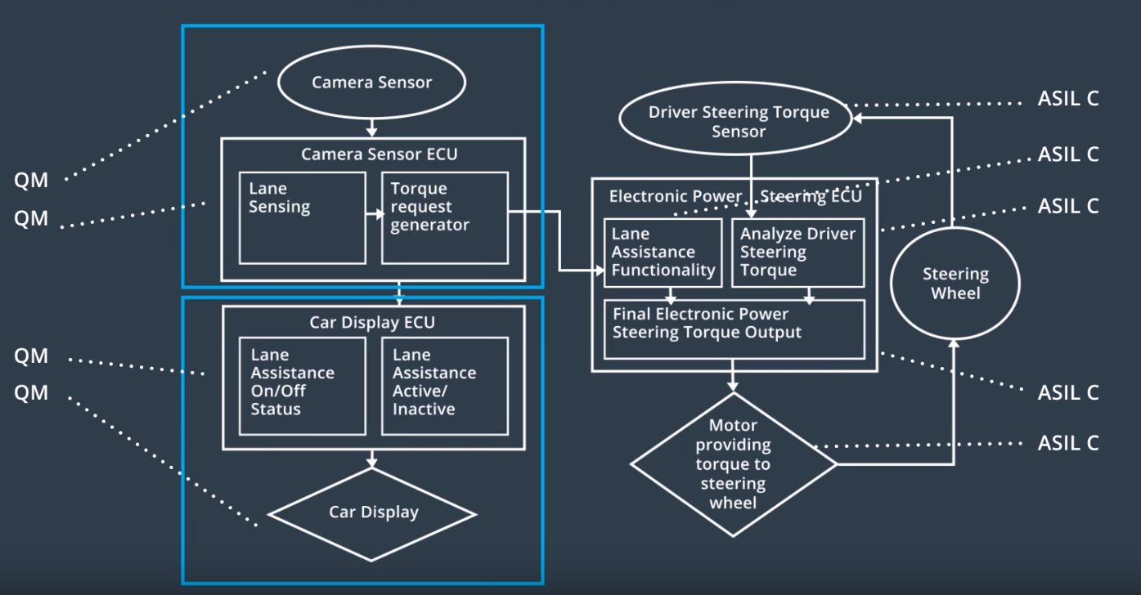

Figure : Refined Architecture of the Lane Assistance Item

The refined architecture of the lane assistance item derived from functional safety concept is shown in the picture Figure 1. The picture shows the components of the sub-systems of the lane assistance item. Their ASIL levels already allotted to the components from the functional safety concept. Now the technical safety concept takes the functional safety requirements and derives technical safety requirements and allots them the different components. There are additional technical safety requirements which are not directly derived from functional safety requirements. ISO26262 requires the following categories for additional technical safety requirements. They are also defined here.

### Functional overview of architecture elements

**[Instructions: Provide a description for each functional safety element; what is each element's purpose in the lane assistance item? ]**

|  |  |
| --- | --- |
| **Element** | **Description** |
| Camera Sensor | The camera sensor captures the image of the road ahead which the camera sensor ECU processes it. |
| Camera Sensor ECU - Lane Sensing | The lane sensing element of the camera sensor ECU processes the captured image and calculates the position of lanes and the ego vehicle. |
| Camera Sensor ECU - Torque request generator | The torque request generator part of the camera sensor ECU receives the lane and ego vehicle positions. Based on this information it calculates the oscillating steering torque for the LDW function and the supporting steering torque for the LKA function. The torque request is then sent to the power steering ECU. |
| Car Display | The car display is the HMI between the driver and the lane assistance item. It displays the status information of the lane assistance item to the driver. |
| Car Display ECU - Lane Assistance On/Off Status | The lane assistance on/off status part of the display ECU sends the on/off status of the lane assistance item to the car display. |
| Car Display ECU - Lane Assistant Active/Inactive | The lane assistance active/inactive part receives the information from camera ECU if lane assistance item is active or inactive. Then it sends it to the car display. |
| Car Display ECU - Lane Assistance malfunction warning | The lane assistance malfunction warning part receives the information if the lane assistance item has some malfunctions from the electronic power steering ECU. Then it sends the information to the car display to enable warning light. |
| Driver Steering Torque Sensor | The driver steering torque sensor measures the steering torque applied by the driver. |
| Electronic Power Steering (EPS) ECU - Driver Steering Torque | The EPS ECU Driver Steering Torque part calculates the steering torque which should be applied to the steering wheel based on the steering torque applied by the driver. |
| EPS ECU - Normal Lane Assistance Functionality | The EPS ECU Normal Lane Assistance Functionality part receives the steering torque request from Camera ECU for LDW and LKA functions. Based the request it calculates the steering torque which should be applied to the steering wheel. |
| EPS ECU - Lane Departure Warning Safety Functionality |  |
| EPS ECU - Lane Keeping Assistant Safety Functionality |  |
| EPS ECU - Final Torque |  |
| Motor |  |

# Technical Safety Concept

## Technical Safety Requirements

**[Instructions: Fill in the technical safety requirements for the lane departure warning first functional safety requirement. We have provided the associated functional safety requirement in the first table below. Hint: The technical safety requirements were discussed in the lesson videos. The architecture allocation column should contain element names such as LDW Safety block, Data Transmission Integrity Check, etc. Allocating the technical safety requirements to the "EPS ECU" does not provide enough detail for a technical safety concept.]**

**Lane Departure Warning (LDW) Requirements:**

Functional Safety Requirement 01-01 with its associated system elements

(derived in the functional safety concept)

|  |  |  |  |  |
| --- | --- | --- | --- | --- |
| **ID** | **Functional Safety Requirement** | **Electronic Power Steering ECU** | **Camera ECU** | **Car Display ECU** |
| Functional  Safety  Requirement  01-01 | The lane keeping item shall ensure that the lane departure oscillating torque amplitude is below Max_Torque_Amplitude | X |  |  |

Technical Safety Requirements related to Functional Safety Requirement 01-01 are:

|  |  |  |  |  |  |
| --- | --- | --- | --- | --- | --- |
| **ID** | **Technical Safety Requirement** | **ASIL** | **Fault Tolerant Time Interval** | **Architecture Allocation** | **Safe State** |
| Technical  Safety  Requirement  01 |  |  |  |  |  |
| Technical  Safety  Requirement  02 |  |  |  |  |  |
| Technical  Safety  Requirement  03 |  |  |  |  |  |
| Technical  Safety  Requirement  04 |  |  |  |  |  |
| Technical  Safety  Requirement  05 |  |  |  |  |  |

**[Instructions: Fill in the technical safety requirements for the lane departure warning second functional safety requirement. We have provided the associated functional safety requirement in the table below. Hint:. Most of the technical safety requirements will be the same. At least one technical safety requirement will have to be slightly modified because we are talking about frequency instead of amplitude. These requirements were not given in the lessons]**

Functional Safety Requirement 01-2 with its associated system elements

(Derived in the functional safety concept)

|  |  |  |  |  |
| --- | --- | --- | --- | --- |
| **ID** | **Functional Safety Requirement** | **Electronic Power Steering ECU** | **Camera ECU** | **Car Display ECU** |
| Functional  Safety  Requirement  01-02 | The lane keeping item shall ensure that the lane departure oscillating torque frequency is below Max_Torque_Frequency | X |  |  |

Technical Safety Requirements related to Functional Safety Requirement 01-02 are:

|  |  |  |  |  |  |
| --- | --- | --- | --- | --- | --- |
| **ID** | **Technical Safety Requirement** | **ASIL** | **Fault Tolerant Time Interval** | **Architecture Allocation** | **Safe State** |
| Technical  Safety  Requirement  01 |  |  |  |  |  |
| Technical  Safety  Requirement  02 |  |  |  |  |  |
| Technical  Safety  Requirement  03 |  |  |  |  |  |
| Technical  Safety  Requirement  04 |  |  |  |  |  |
| Technical  Safety  Requirement  05 |  |  |  |  |  |

**Lane Departure Warning (LDW) Verification and Validation Acceptance Criteria:**

**[OPTIONAL: For each technical safety requirement, identify both the verification and validation acceptance criteria. “Validation” asks whether or not you chose the appropriate parameters. “Verification” involves testing to make sure the vehicle behaves as expected when the parameter value is crossed. There is not necessarily one right answer. Look at your verification and validation acceptance criteria from the functional safety concept for inspiration.]**

**Lane Keeping Assistance (LKA) Requirements:**

**[Instructions: Fill in the technical safety requirements for the lane keeping assistance functional safety requirement 02-01. We have provided the associated functional safety requirement in the table below. Hint:. You can reuse the technical safety requirements from functional safety requirement 01-01. But you need to change the language because we are now looking at a different system. The ASIL and Fault Tolerant Time Interval are different as well.]**

Functional Safety Requirement 02-1 with its associated system elements

(derived in the functional safety concept)

|  |  |  |  |  |
| --- | --- | --- | --- | --- |
| **ID** | **Functional Safety Requirement** | **Electronic Power Steering ECU** | **Camera ECU** | **Car Display ECU** |
| Functional  Safety  Requirement  02-01 | The lane keeping item shall ensure that the lane keeping assistance torque is applied for only Max_Duration | X |  |  |

Technical Safety Requirements related to Functional Safety Requirement 02-01 are:

|  |  |  |  |  |  |
| --- | --- | --- | --- | --- | --- |
| **ID** | **Technical Safety Requirement** | **ASIL** | **Fault Tolerant Time Interval** | **Allocation to Architecture** | **Safe State** |
| Technical  Safety  Requirement  01 |  |  |  |  |  |
| Technical  Safety  Requirement  02 |  |  |  |  |  |
| Technical  Safety  Requirement  03 |  |  |  |  |  |
| Technical  Safety  Requirement  04 |  |  |  |  |  |
| Technical  Safety  Requirement  05 |  |  |  |  |  |

**Lane Keeping Assistance (LKA) Verification and Validation Acceptance Criteria:**

**[OPTIONAL: For each technical safety requirement, identify both the verification and validation acceptance criteria. “Validation” asks whether or not you chose the appropriate parameters. “Verification” involves testing to make sure the vehicle behaves as expected when the parameter value is crossed. There is not necessarily one right answer. Look at your verification and validation acceptance criteria from the functional safety concept for inspiration.]**

## Refinement of the System Architecture

**[Instructions: Include the refined system architecture. Hint: The refined system architecture should include the system architecture from the end of the technical safety lesson, including all of the ASIL labels.]**

## Allocation of Technical Safety Requirements to Architecture Elements

**[Instructions: We already included the allocation as part of the technical requirement tables. Here you can state that for this particular item, all technical safety requirements are allocated to the Electronic Power Steering ECU]**

## Warning and Degradation Concept

**[Instructions: We've already identified that for any system malfunction, the lane assistance functions will be turned off and the driver will receive a warning light indication. The technical safety requirements have not changed how functionality will be degraded or what the warning will be.**

**So in this case, the warning and degradation concept is the same for the technical safety requirements as for the functional safety requirements. You can copy the functional safety warning and degradation concept here.**

**Oftentimes, a technical safety analysis will lead to a more detailed warning and degradation concept. ]**