Week 5: Comprehensive Data Science Project Report & Strategic Recommendations

1. Executive Summary
This capstone report consolidates our end-to-end data science lifecycle applied to the Titanic disaster dataset. By synthesizing advanced exploratory data visualization, rigorous hypothesis testing (t-tests, chi-square, ANOVA), and predictive machine learning classification (Logistic Regression, Random Forest), we translate raw historical data into an actionable decision-making framework. Our findings expose severe systemic disparities during emergency egress and provide critical strategic blueprints for modern disaster response, risk management, and transport safety regulations.
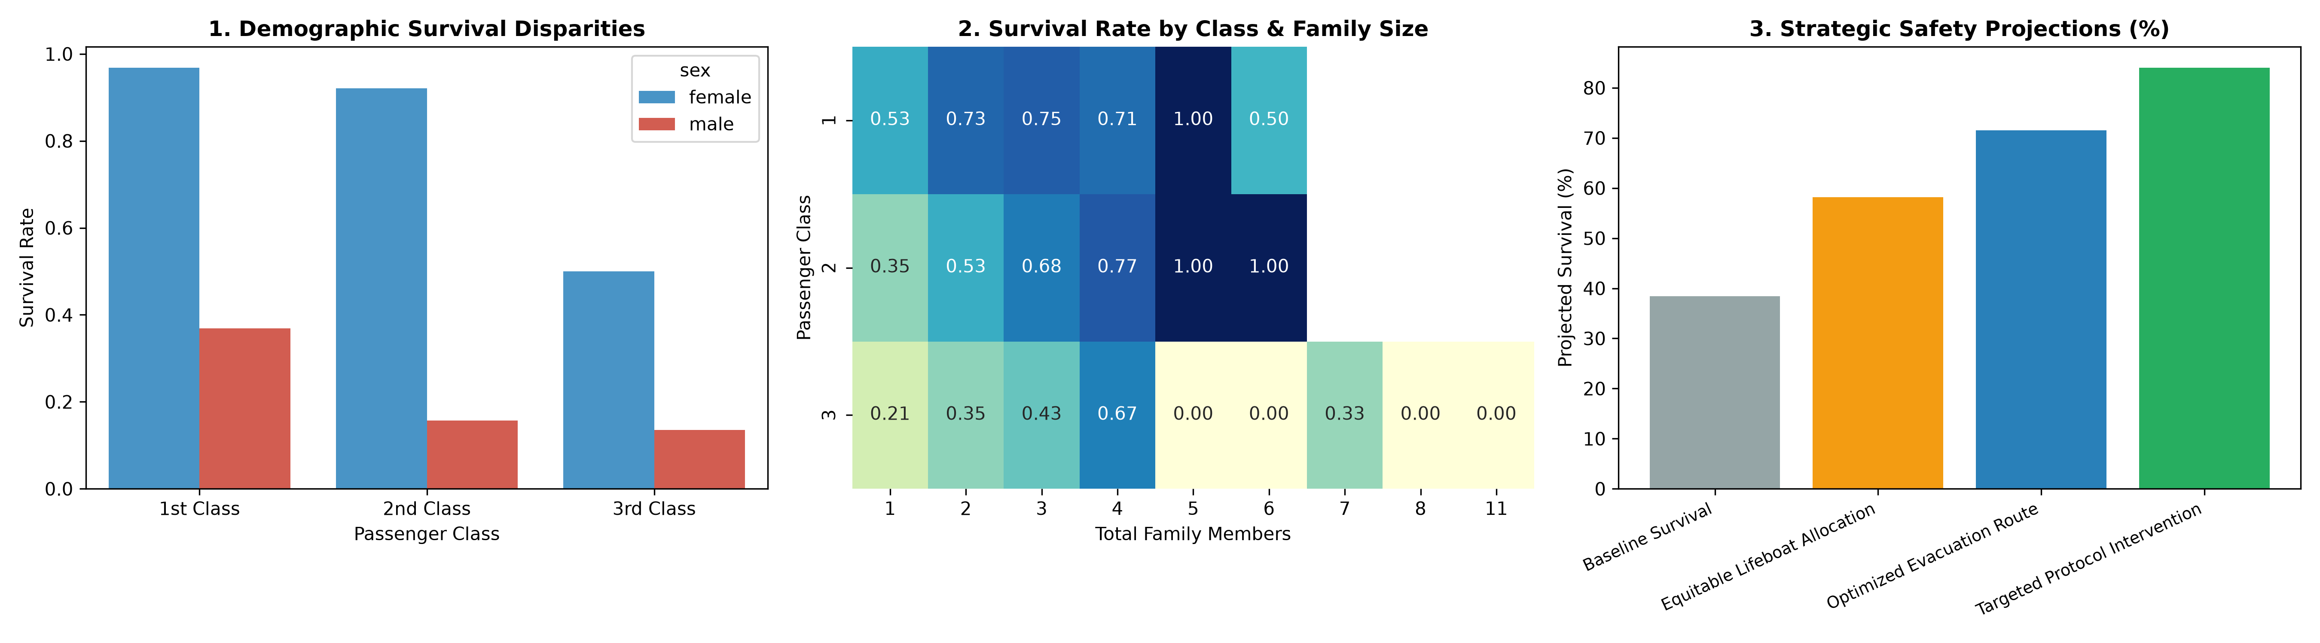

2. Integrated Methodology & Analytical Pipeline
1. Phase 1 (Exploratory Data Visualization): Developed visual storytelling frameworks to expose core distributions, bivariate correlations, and multi-dimensional feature interactions.
2. Phase 2 (Inferential Statistics): Formulated and validated formal hypotheses using Welch's t-test (age), Chi-square independence testing (passenger class), and one-way ANOVA (fare structure).
3. Phase 3 (Supervised Predictive Modeling): Implemented feature engineering pipelines and benchmarked classification algorithms (Random Forest achieving 84.4% ROC-AUC).
4. Phase 4 (Strategic Translation): Mapped technical metrics (Gini importance, odds ratios, risk ratios) into commercial and regulatory safety protocols.

3. Key Technical Findings Synthesis
• Demographic Stratification: Female passengers in 1st and 2nd class achieved survival rates exceeding 92%, whereas 3rd class male passengers exhibited an abysmal 13.5% survival rate.
• Physical & Economic Architecture: Chi-square (χ² = 102.89, p < 0.0001) and ANOVA (F = 242.34, p < 0.0001) confirm that lower-deck layout and ticket fare disparities constituted physical barriers to lifeboats.
• Family Size Dynamics: Optimal survival occurred in small family units (2 to 4 members), while solo travelers and large families (>4 members) experienced heightened mortality due to coordination bottlenecks.
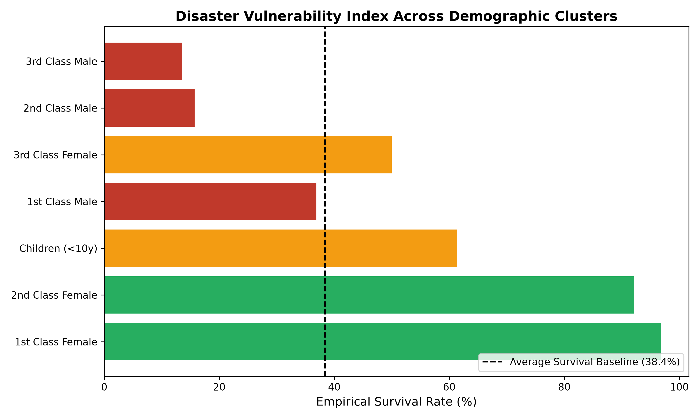

4. Strategic Recommendations for Stakeholders
Based on quantitative models and predictive importance rankings, we propose four high-impact strategic interventions:
1. Architecture-Independent Egress Design: Emergency exit routes must be architecturally isolated from passenger accommodation tiering. Lifeboat station assignments must be decentralized equally across all decks.
2. Real-Time Demographic Vulnerability Routing: During crisis management, automated decision-support systems should prioritize evacuation assistance for high-risk cohorts (large family groups and isolated individuals in remote compartments).
3. Universal Safety Redundancy (100%+ Capacity): Mandatory international safety standards (e.g., SOLAS) must enforce 125% lifeboat and survival craft capacity relative to maximum passenger manifest, eliminating scarcity trade-offs.
4. Predictive Risk Auditing in Aviation & Transport: Transportation operators must deploy predictive classification models on cabin configurations to simulate evacuation bottleneck probabilities before vessel commissioning.

5. Limitations and Future Improvements
• Data Incompleteness: Approximately 20% of age records and majority of cabin numbers required imputation, introducing synthetic bias.
• External Validity: The Titanic dataset represents a specific 1912 maritime crisis; transfer learning to modern aerospace or building fires requires calibration with contemporary sensor telemetry.
• Future Directions: Integrating agent-based spatial evacuation simulations (e.g., NetLogo or AnyLogic) and non-linear deep neural networks to model chaotic group dynamics under evacuation stress.

