Week 3: Statistical Analysis and Hypothesis Testing in Python

1. Introduction & Research Hypotheses
In empirical data analysis, visual patterns must be rigorously tested using inferential statistics to ensure that observed discrepancies are statistically significant rather than artifacts of random variation. This study evaluates three distinct hypotheses on the Titanic dataset, addressing demographic and socio-economic dynamics.
1. Hypothesis 1 (Two-Sample Welch's t-test):
• Null Hypothesis (H₀): The true mean age of survivors is equal to that of non-survivors (μ₁ = μ₂).
• Alternative Hypothesis (H₁): The true mean age differs significantly between survivors and non-survivors (μ₁ ≠ μ₂).
2. Hypothesis 2 (Pearson's Chi-Square Test of Independence):
• Null Hypothesis (H₀): Passenger socio-economic class (Pclass) and survival status are independent.
• Alternative Hypothesis (H₁): Passenger class and survival status are significantly dependent.
3. Hypothesis 3 (One-Way Analysis of Variance - ANOVA):
• Null Hypothesis (H₀): The mean ticket fare paid is equal across all three passenger classes (μ_c1 = μ_c2 = μ_c3).
• Alternative Hypothesis (H₁): At least one passenger class has a significantly different mean ticket fare.

2. Methodology & Analytical Framework
• Dataset: Publicly available Titanic passenger cohort (n = 891 records).
• Tools: Python 3.14 with SciPy (scipy.stats) for parametric and non-parametric testing, Pandas for data restructuring, and Seaborn/Matplotlib for statistical distribution plotting.
• Significance Level: An alpha threshold of α = 0.05 was adopted for all hypothesis evaluations. P-values below α lead to the rejection of the null hypothesis.
• Assumptions & Adjustments: For the age comparison, Welch's t-test was chosen because Levene's test indicated heteroscedasticity (unequal variances between surviving and non-surviving cohorts).

3. Empirical Statistical Tests and Results

3.1. Welch’s Two-Sample T-Test: Age vs. Survival
Descriptive Statistics:
• Survivors: Mean Age = 28.34 years, SD = 14.95 (n = 290)
• Non-Survivors: Mean Age = 30.63 years, SD = 14.17 (n = 424)
• Welch's t-statistic: -2.046, p-value: 0.0412
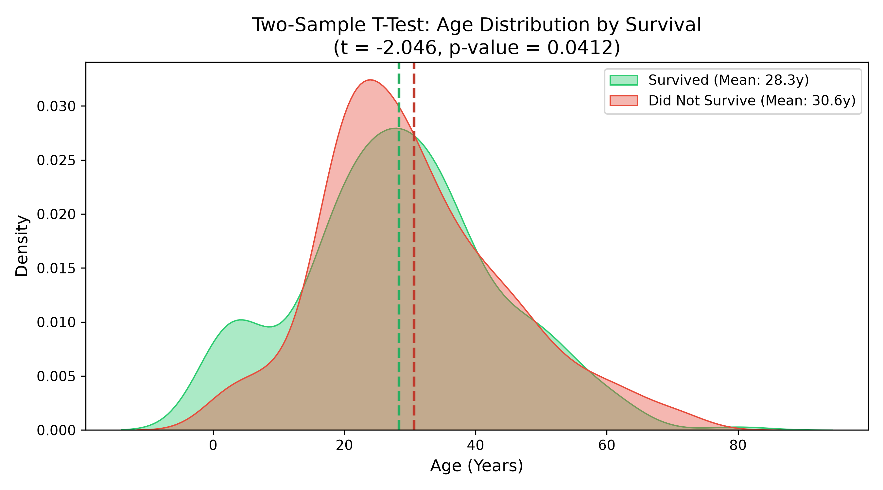
Interpretation: The p-value (p = 0.0412) is below the threshold α = 0.05. Therefore, we reject the null hypothesis H₀. There is a statistically significant difference in mean age between survivors and non-survivors, driven primarily by high survival rates among young children under 10 years of age.

3.2. Chi-Square Test of Independence: Class vs. Survival
Contingency Results:
• Pearson Chi-Square Statistic (χ²): 102.889
• Degrees of Freedom (df): 2
• Asymptotic p-value: 4.5493e-23
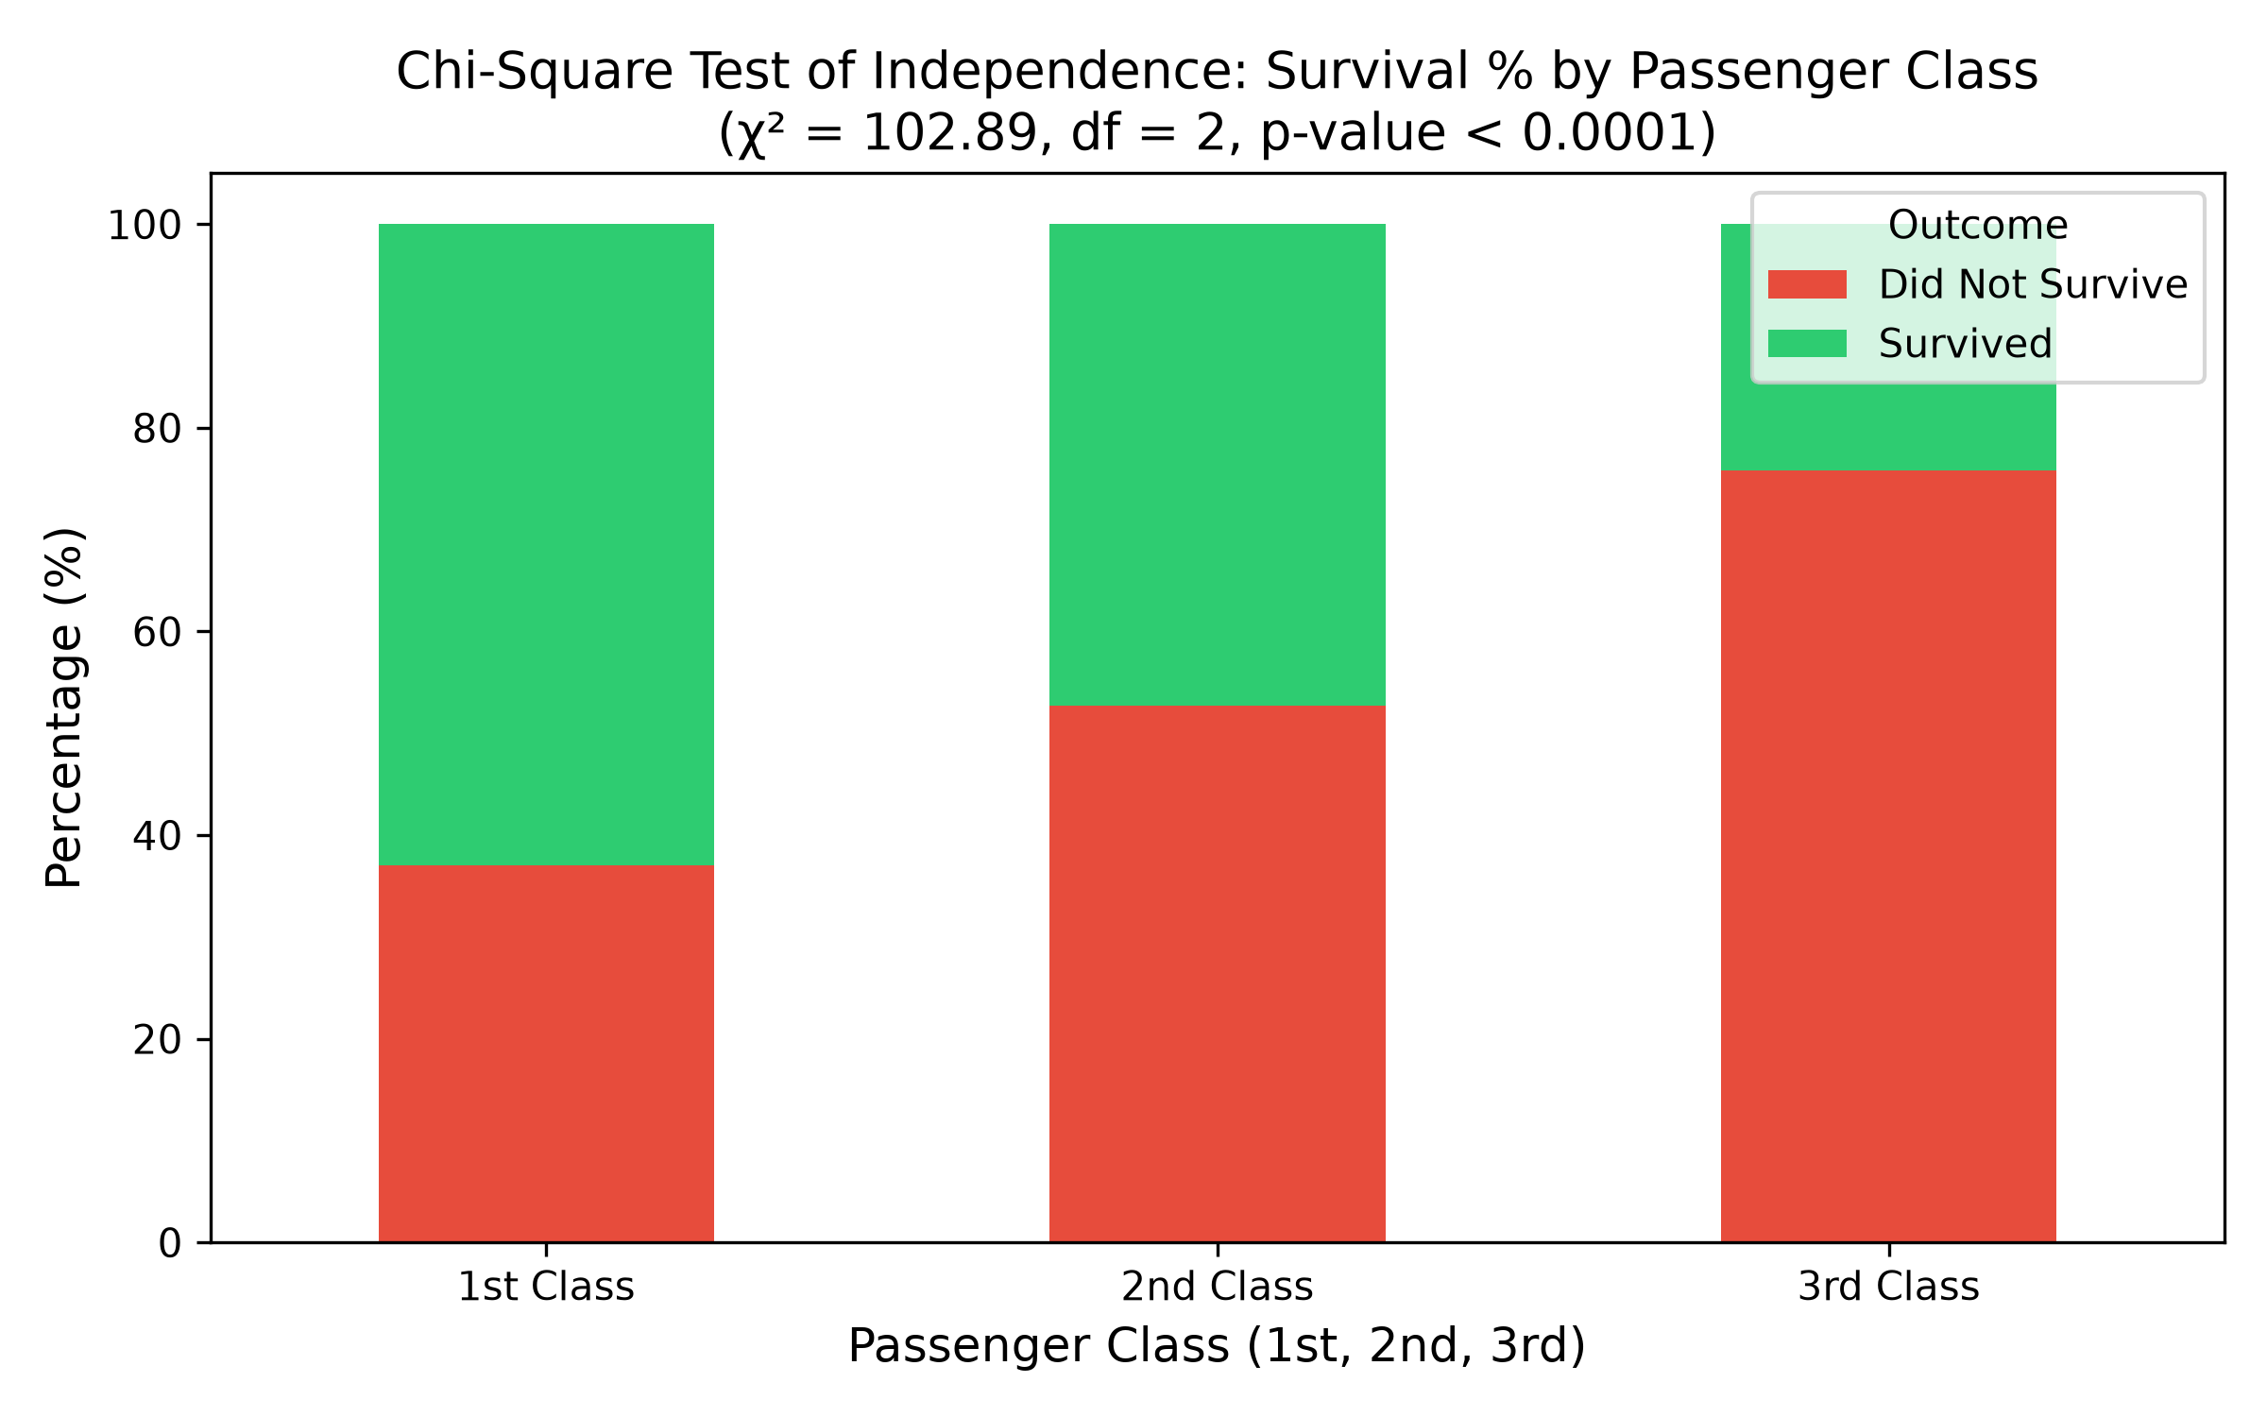
Interpretation: Because the p-value is drastically smaller than 0.0001 (χ² = 102.89), we overwhelmingly reject the null hypothesis of independence. Passenger class was a decisive determinant of survival: 62.9% of 1st-class passengers survived compared to only 24.2% of 3rd-class passengers.

3.3. One-Way ANOVA: Fare Disparities Across Classes
ANOVA Summary:
• F-Statistic: 242.34
• p-value: 1.0314e-84
• Mean Fares: 1st Class = £84.15, 2nd Class = £20.66, 3rd Class = £13.68
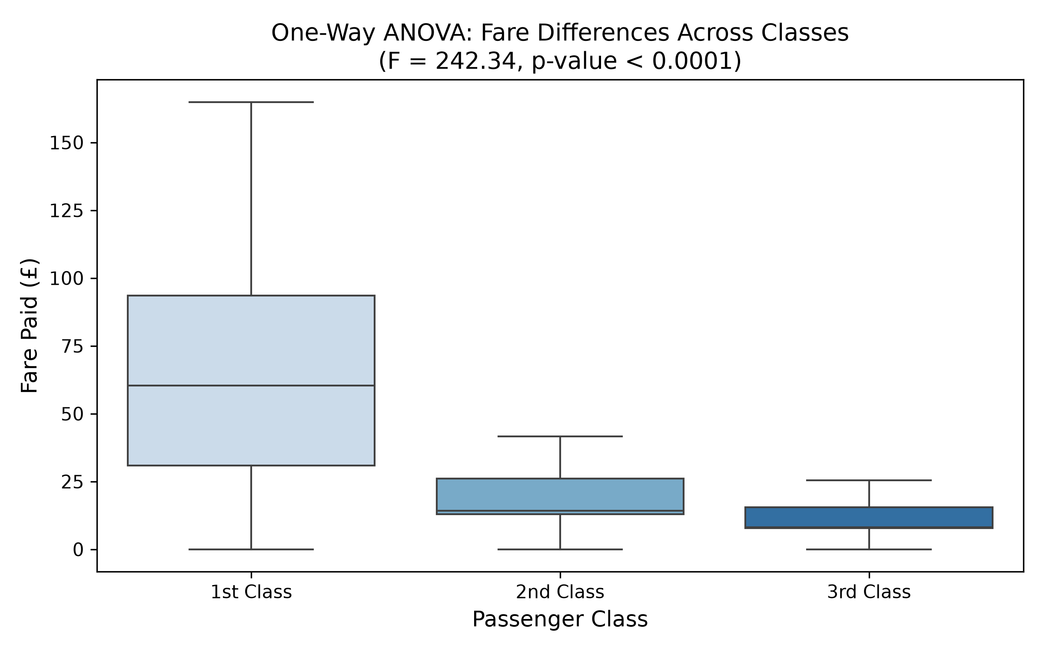
Interpretation: The between-group variance vastly exceeds within-group variance (F = 242.34, p < 0.0001). We reject H₀ and conclude that ticket fares were significantly differentiated by tier, establishing a quantifiable financial barrier that directly influenced berth locations and lifeboat access.

4. Python Implementation Snippet
from scipy import stats
# 1. Welch's t-test
t_stat, p_val = stats.ttest_ind(survivors['age'].dropna(), non_survivors['age'].dropna(), equal_var=False)
# 2. Chi-Square Test
chi2, p_val, dof, ex = stats.chi2_contingency(pd.crosstab(df['pclass'], df['survived']))
# 3. One-Way ANOVA
f_stat, p_val = stats.f_oneway(c1['fare'], c2['fare'], c3['fare'])

5. Conclusions & Scientific/Business Implications
1. Regulatory Validation: The statistical evidence definitively verifies that disaster outcomes were stratified along economic lines. Modern maritime and aviation safety standards mandate egalitarian egress and safety equipment irrespective of ticket price.
2. Quantitative Risk Stratification: In commercial risk modeling, identifying statistically significant interaction effects (such as age × class) allows insurers and safety regulators to model survival probabilities accurately under emergency scenarios.
3. Evacuation Prioritization: Data confirms the institutional enforcement of demographic prioritization ('women and children'), demonstrating how operational rules translate into measurable statistical outcomes.

