**Git**

**To install git through package manager.**

1. Yum install git
2. Add configuration

git config --global user.name "prabhakar"

git config --global user.email [prabhakar.lal@gurukalum.org](mailto:prabhakar.lal@gurukalum.org)

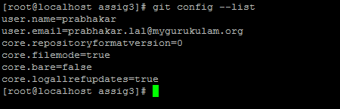

1. To check version



1. Initialize a local git repository

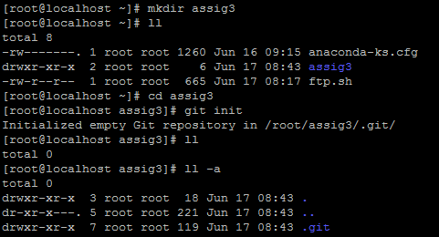

When we initialize git **.git** folder gets created it means that git is initallized successfully

1. Run git status command

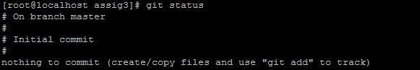

It shows empty nothing to track

1. Create a file README.md & Run git status command

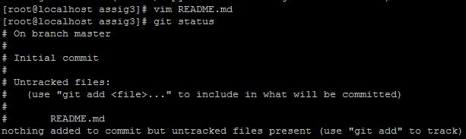

After creating Readme.md file it show message as README.md file is in untracked file.

1. Add file README.md in your local repository & Add My first interaction with Git content in README.md & Run git status command

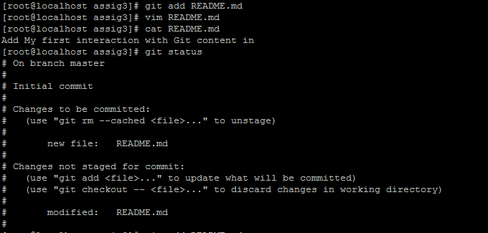

Hare README.md file is move to staging area but changes are not there. Changes are still untacked, Only file is in track mode.

1. Update file README.md in your local repository &Run git status command

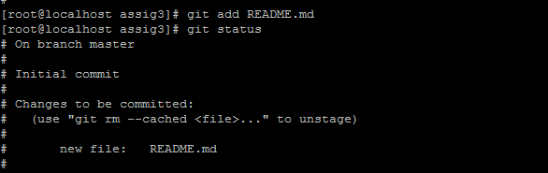

As per current status README is in track mode. And other is in untrack.

1. Create files README1.md README2.md README3.md README4.md & Run git status command

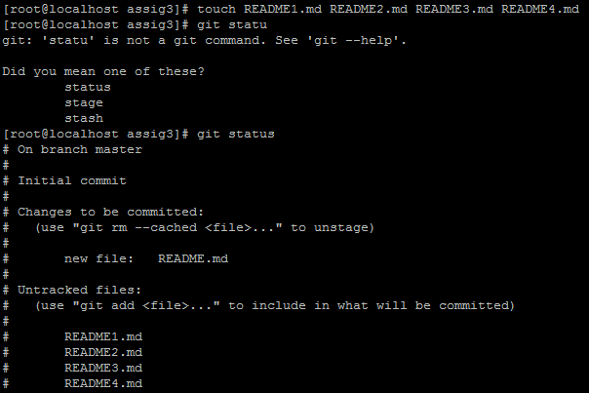

Only README file is in tack mode rest all are in untack mode.

1. Add all the newly added files in your local repository without giving their name. & Run git status command

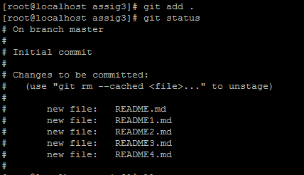

All files are added in staging area without name and all are in tacking mode.

1. Remove files README1.md README2.md from local repository &Add content in Temporary content in README3.md &Run git status command

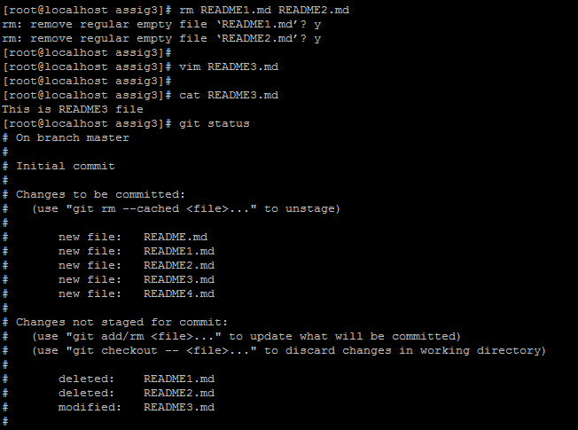

Hare after removing file and making changes in README3.md file. It shows status as. Modification in README.md are in untrack mode.

1. Find out the content that is added in README3.md & Undo the changes in README3.md file & Run git status command

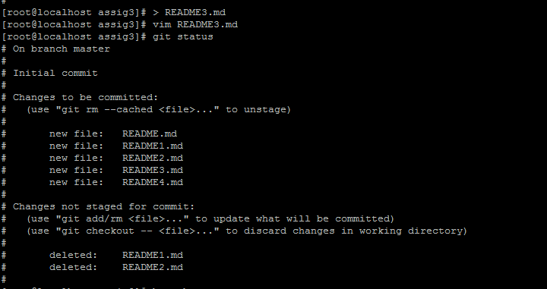

As changes has been remove back from README3.md file, so it got remove from untracking mode to tracking mode.

1. Create a branch ninja from current branch



When we try to create branch before committing it. It through error message as above.

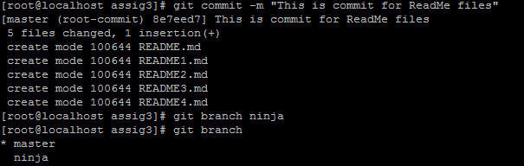

After committing the file then we are able to create branch.

1. Create sensei branch from ninja branch and switch to sensei branch &List out all the local branches

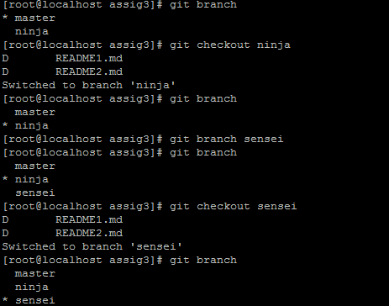

1. Delete sensei branch & Find out the current branch

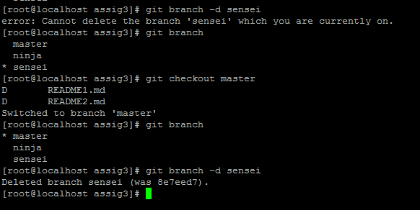

We cannot delete the branch from its working branch. To delete branch we need to switch to another brach

1. List out all the commits that have been done

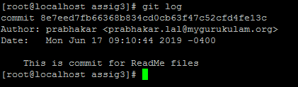

git log command is used for. As we have only one commit it show only one.