**Personal Expense Tracker**

**Overview**

The Expense Tracker Program is a command-line application designed to help users keep track of their expenses. It allows users to add, view, save, and manage expenses. The program also includes budget tracking functionality to monitor monthly spending and alert the user if their expenses exceed the specified budget. The program supports CSV file I/O for saving and retrieving expense data, and it uses Pandas to manage and store expense information.

**Technology Used**

**Python:** The core language used for logic and data handling.

**Pandas:** For managing data frames, CSV file.

**Key Features**

* **Add Expenses**: Users can add a new expense by entering details such as date, category, amount, and description. The program validates the date format and amount to ensure correct input.
* **View Expenses**: Users can view a list of all recorded expenses. The display includes details for each expense, such as the category, amount, date, and description.
* **Track Budget**: Users can set a monthly budget, which is used to compare against total recorded expenses for the month. If expenses exceed the budget, the program displays a warning. If expenses are within the budget, it displays the remaining balance for the month.
* **Save Expenses to CSV**: The program can save expenses to a CSV file, making it easy to persist data. Additionally, users can load existing expense data from a CSV file, allowing for continuity across sessions.

**Program Flow**

1. **Main Expense Menu**

* Upon starting the program, users are presented with a menu containing the following options
* **Add Expense**: Prompt to enter and record new expense details.
* **View Expenses**: Display the list of all expenses recorded so far, including expense list from CSV.
* **Track Budget**: Set or view a monthly budget and check against total expenses.
* **Save Expenses**: Save the current list of expenses to a CSV file.
* **Exit**: Exit the program.

1. **Adding an Expense**

* The program prompts the user to enter the expense date in YYYY-MM-DD format. If the user enters "exit," they can break out of the loop and quit the add expense process.
* After validating the date, the user is prompted for the expense category and description.
* The amount is then validated to ensure it is a positive number. If the user enters "exit," the add expense process terminates immediately.

1. **Tracking Budget**

* Users set a monthly budget amount at the start of each month.
* The program calculates total expenses for the current month using Pandas and compares it to the set budget.
* If expenses exceed the budget, a warning is displayed; otherwise, the remaining balance for the month is shown.

1. **Save Expense List with CSV**

* Expenses are saved to a CSV file using Pandas’ DataFrame.to_csv functionality, allowing data to be stored persistently. Users can also load expenses from a CSV file.

**Example Program Flow**

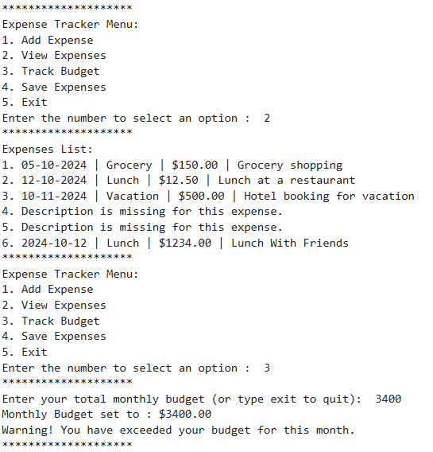

**Python Expense Tracker Program**

**Author**: Ravi Ranjan Lal

**Email**: lalraviranjan@gmail.com