1.Query all columns for all American cities in the CITY table with populations larger than 100000. The Country Code for America is USA.

The CITY table is described as follows:

Query all columns for all American cities in the CITY table with populations larger than 100000. The Country Code for America is USA.

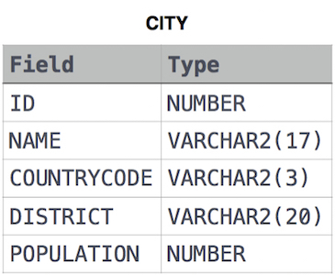

SELECT \*

FROM CITY

WHERE COUNTRYCODE='USA' AND POPULATION>100000

;

SELECT \*

FROM CITY

WHERE COUNTRYCODE='USA' AND POPULATION>100000;