1) Instalar Ollama

- Go to the official web site of ollama: <https://ollama.com/>

Ejecutar el instalador para Windows e instalarlo

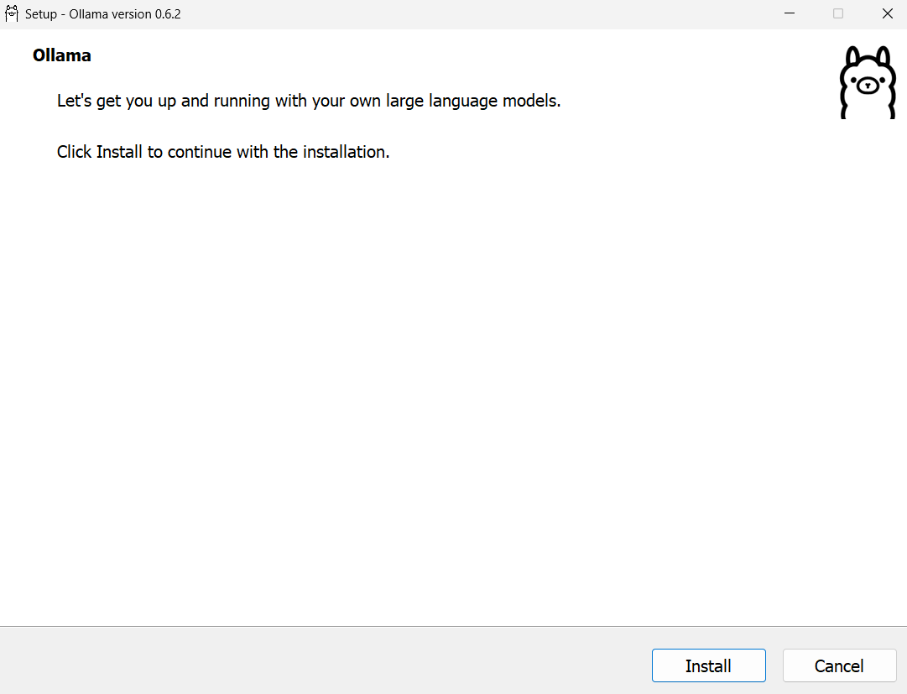

Comprobar que Ollama haya sido instalado con éxito

Descargar los modelos solicitados

llama3.2:3b y deepseek-r1:1.5b

**1.a) Ejecución local en terminal**

Ejecutar los modelos desde la consola con el comando

ollama run <model >

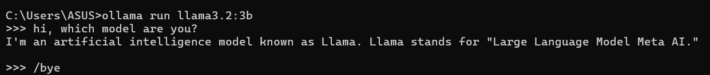

**1.b)Ejecución local usando un contenedor Docker + Interfaz Web**

Install and run Docker from

https://docs.docker.com/desktop/setup/install/windows-install/

Seguir los pasos de la documentación del sitio oficial de openwebui

https://docs.openwebui.com/getting-started/quick-start/

Descargar la imagen de open-webui

Correr el contenedor de openwebui, con WEBUI_AUTH=False (No requiere login)

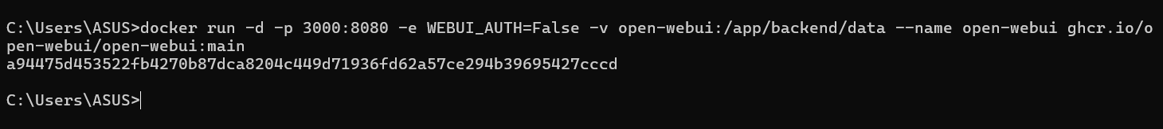

Verificar que el contenedor este corriendo en el puerto 3000

Api de Ollama, mostrando los modelos

https://github.com/ollama/ollama/blob/main/docs/api.md

Abrir el navegador en el puerto 3000 y verificar que estén los modelos descargados con ollama

Interactuar con los modelos en la WEB

**1.c)Ejecución local usando LM Studio Desktop**

Instalar LM Studio

<https://lmstudio.ai/download>

Descargar los modelos a utilizar en LMStudio

Seleccionar el modelo a utilizar

Interactuar con el modelo mediante la interfaz grafica

Los modelos usados en ollama (llama3.2:3b y deepseek-r1:1.5b) también tienen que ser utilizados en LMStudio? (Los mismos, ya que LMStudio utiliza su propia biblioteca de modelos) **[Opción: Exportar los modelos desde ollama hacia LMStudio]**

=====================================================

| LAB 01: RUNNING DEEK_SEEK-R1 LOCALLY |

=====================================================

- EXERCISE 01: RUN DEEPSEEK LOCALLY IN TERMINAL

1) Go to the official web site of ollama: https://ollama.com/

2) Download DeepSeek-R1-8b model. It requires 4.9 GB of RAM memory

3) Run in Windows PowerShell the next command:

$ ollama run deepseek-r1:8b

>>> .... <here make your own questions>

- EXERCISE 02: RUN DEEPSEEK LOCALLY USING WEB UI

1) Install and run Docker

2) Run Open WebUI container: using terminal commands

official web site documentation of open webui: https://docs.openwebui.com/getting-started/quick-start/

$ docker run -d -p 3000:8080 --add-host=host.docker.internal:host-gateway -v open-webui:/app/backend/data --name open-webui --restart always ghcr.io/open-webui/open-webui:main

in the case when computational resources are not enough, we can define 200% CPU and 8 GB of RAM

$ docker run -d -p 3000:8080 --add-host=host.docker.internal:host-gateway -v open-webui:/app/backend/data --name open-webui --restart always --cpus="2.0" --memory="8g" ghcr.io/open-webui/open-webui:main

3) Run Open WebUI container: using yaml file

- formulate the code docker-compose.yml

- run the command:

$ docker-compose up -d

4) In windows OS need go to Menu/Windows Features and check the option Virtual Machine Platform activated

5) Check the container open-webui and go to localhost:3000 and sign in to Open WebUI

- EXERCISE 03: RUN DEEPSEEK LOCALLY IN DESKTOP WITH LM STUDIO

1) Go to LM Studio and search DeepSeek-R1-Distill-Qwen-7B-Q3_K_S.gguf (3.49 GB)

2) Run in chatbot of lm studio

- EXERCISE 04: RUN DEEPSEEK USING CLUSTER WITH P2P NETWORK

1) Go to Exo labs in the github main page: https://github.com/exo-explore/exo

2) command to install git

$ apt install git -y

3) Run the next set of commands

* in windows OS

$ git clone https://github.com/exo-explore/exo.git

$ cd exo

$ python -m venv exo_env

$ .\exo_env\Scripts\activate

$ pip install -e .

$ source install.sh

* in linux OS [can make WSL-2 connection with windows]

$ python -m venv --without-pip exo_env

$ source exo_env/bin/activate

$ source install.sh