**Keyword Focus**

Based on the content of the article, I generated a list of potential keywords (right) to target and sorted them in descending order by local monthly search volume (United States). This initially gave me a good idea of some great keywords to go after, but I also wanted to compare how competitive those keywords were with each other.

Using Majestic (below), I pulled instances of how often those keywords appear in URLs, title tags, and anchor texts. This gave me a better idea of how saturated the internet may be with these focus keywords and how viable they may be. Luckily it looks like the top searched “sodium” keywords were also less prevalent than their “salt” counterparts.

|  |  |
| --- | --- |
| **Keyword** | **Volume** |
| daily sodium intake | 18100 |
| sodium levels | 8100 |
| recommended sodium intake | 4400 |
| sodium intake | 2900 |
| daily salt intake | 2400 |
| healthy salt | 1600 |
| salt intake | 720 |
| healthy sodium intake | 590 |
| recommended salt intake | 590 |
| healthy sodium | 210 |
| healthy sodium levels | 210 |
| salt levels | 140 |
| healthy salt intake | 110 |
| recommended sodium levels | 30 |
| healthy salt levels | 0 |
| recommended salt levels | 0 |

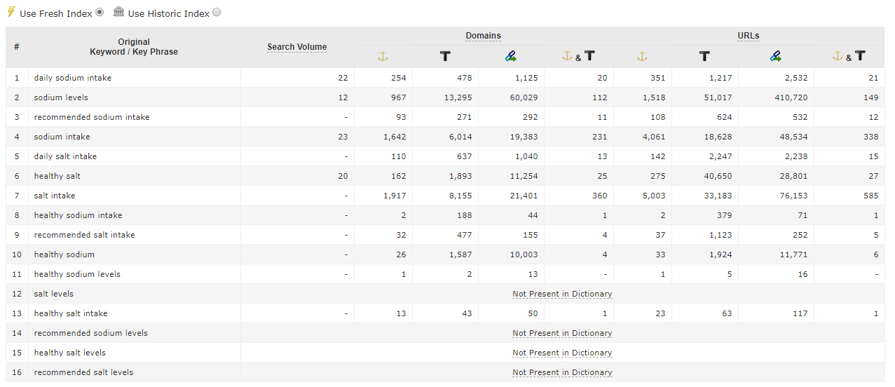

*Source: Majestic*

With this data, I settled on the top four keywords “daily sodium intake”, “sodium levels”, “recommended sodium intake”, and “sodium intake” to drive my recommendations.

**Title Tag**This is the first thing about this article an organic user will see so it needs to be compelling without being truncated. It includes the most-searched keyword and falls (at 53) within the 55-60 character length so I’d say this is good as is.

**Meta Description**The current meta description, 136 characters, has room for elaboration and a stronger call-to-action. With recent updates, meta descriptions can range from around 155 to 255 characters, with mobile being around 120 or so. Also, the meta description can be a great place to add semantically similar words to be bolded if they’re included in a query; in this case the “salt” keywords. With all these in mind, I’d suggest the new meta description below.

*“Balancing your salt intake is a crucial to healthy living but can be tough to manage. Learn how you can control your daily salt intake and which foods are high in sodium.”*

**Alt img text**The article image has a title but no alt image text for both SEO and screen readers. I suggest using “image of foods with high sodium levels” incorporating both the keyword while providing a sufficient image description for screen readers.

**Content**  
In this section, I’ve outlined some content tweaks to make better use of the recommended keywords above.

* Under the heading “More Sodium Facts”, update the line “…has led to an excess of dietary sodium in the diets…” to “…has led to an increased sodium intake in the diets…”
* Update the H2 text “Foods High in Sodium” to “Foods with High Sodium Levels”
* Update H2 text “How to Take Control of Your Sodium Intake” to “Recommended Daily Sodium Intake” which incorporates two of the four keywords.

**Internal Links**In conjunction with the external links for references, this article has quite a few internal links pointing to other articles but seem to be a little loosely related. I would recommend cutting back on the following ones to prevent diluting the power of the other links.

* “enough natural foods”
* “processed foods”
* “table salt”
* “aluminum”
* “fluoride, a neurotoxin”

Additionally, I would update the following link in the sentence “Natural sodium, however, like that found in sea salt or Himalayan Crystal salt, provides benefits that are not made…” to “Natural sodium, however, like that found in sea or Himalayan Crystals, provides benefits that are not made…” to prevent linking away “salt”, part of the semantically similar keywords.  
  
I would note however, that if historically one or more of these internal links were put in place to eliminate crawler confusion between this and another article, then those internal links should be retained.

**UX**While the above covers the optimizations I believe will help the article with organic rankings and click through, these recommendations are what I believe would help improve the user performance metrics. Bounce rates are typically much higher on a blog post or article since the user will likely read through and may leave. Even if they got the info they came for, the inaction, return, or 30 minute inactivity will still be counted as a bounce. To counter this, the product placement for IntraMIN is a good start, but not very noticeable. While some UX testing may be required (unless there is already some historical data) I would recommend including an image that also links to the product page as well as a call-to-action to purchase the product. This can help get the bounce rate down to a more article-acceptable level as well as introduce a conversion point.

**Extra**  
While looking at this post (as well as the main site) I noticed that the Spanish version of GHC is linked by a NOFOLLOW directive and located on a different domain. While this is indeed a separate project, I would recommend pushing to migrate the Spanish content to either a subdomain or subfolder of the main site. This would also require an update to hreflang alternation codes as well as redirects but would result in a single site to boost domain authority, which I would argue is worth the effort.

Regardless of the proposed migration, I would also recommend updating the link to be FOLLOW; GHC should not be using a NOFOLLOW link for anything pointing to a GHC property.