BEM 106: Homework #1 Description

Hello! Welcome to the 1st homework.

Each homework will have both a description document (a .pdf) and an Anaconda/Jupyter python script (a .ipynb). The PDF document will describe the goals of the homework and give instructions on how to successfully complete the assignment. The Anaconda file will be provided as a blank template for you to write your code in.

Goal: The goal of this homework is twofold: (a) to introduce the basic commands and functions of Python through the Jupyter Notebook interpreter and (b) to get you working with Pandas.

For this course we will use the Anaconda distribution of Python 3.10. The first order of business is installing Anaconda. Please go to this website and install the correct version for your operating system:
https://www.anaconda.com/products/distribution

Upon installing and launching Anaconda, you should get the following screen:

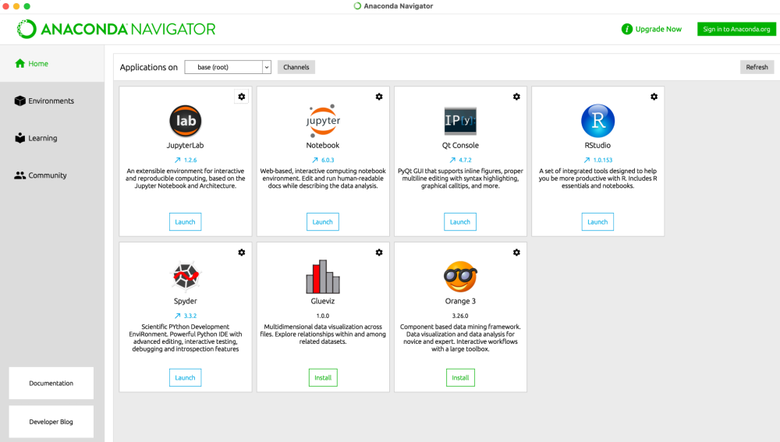

Click “Launch” on JupterLab.

You should now see a blank Jupter Notebook on a webpage. A Notebook makes life easy in many ways, the most important of which is that it’s easy to edit long Python code. You can split up your work into many “cells” that can be run sequentially and independently.
You are now ready to open the HW1 script file.

Appendix: Useful Jupyter shortcuts

