Personal finance analyser

Presented by:- 24BCE162,Prachi Lalwani
24BCE183,Yashvi Hingrajiya

About the topic:

- This project is a C++ program that helps users manage their income and expenses.
It allows a person to add incomes (like salary, freelance work) and expenses (like food, rent, shopping), and then it shows a summary of total income, total expenses, and savings.

- The program also gives smart financial suggestions based on spending habits — for example, if expenses are too high, it warns the user to save more.

Features of the program
- Add income and expense details (date, category, amount, description).
- Display all transactions in a clear format.
- Calculate total income, total expense, and net savings.
- Give smart suggestions based on financial status.
- Easy menu-driven interface for user interaction.
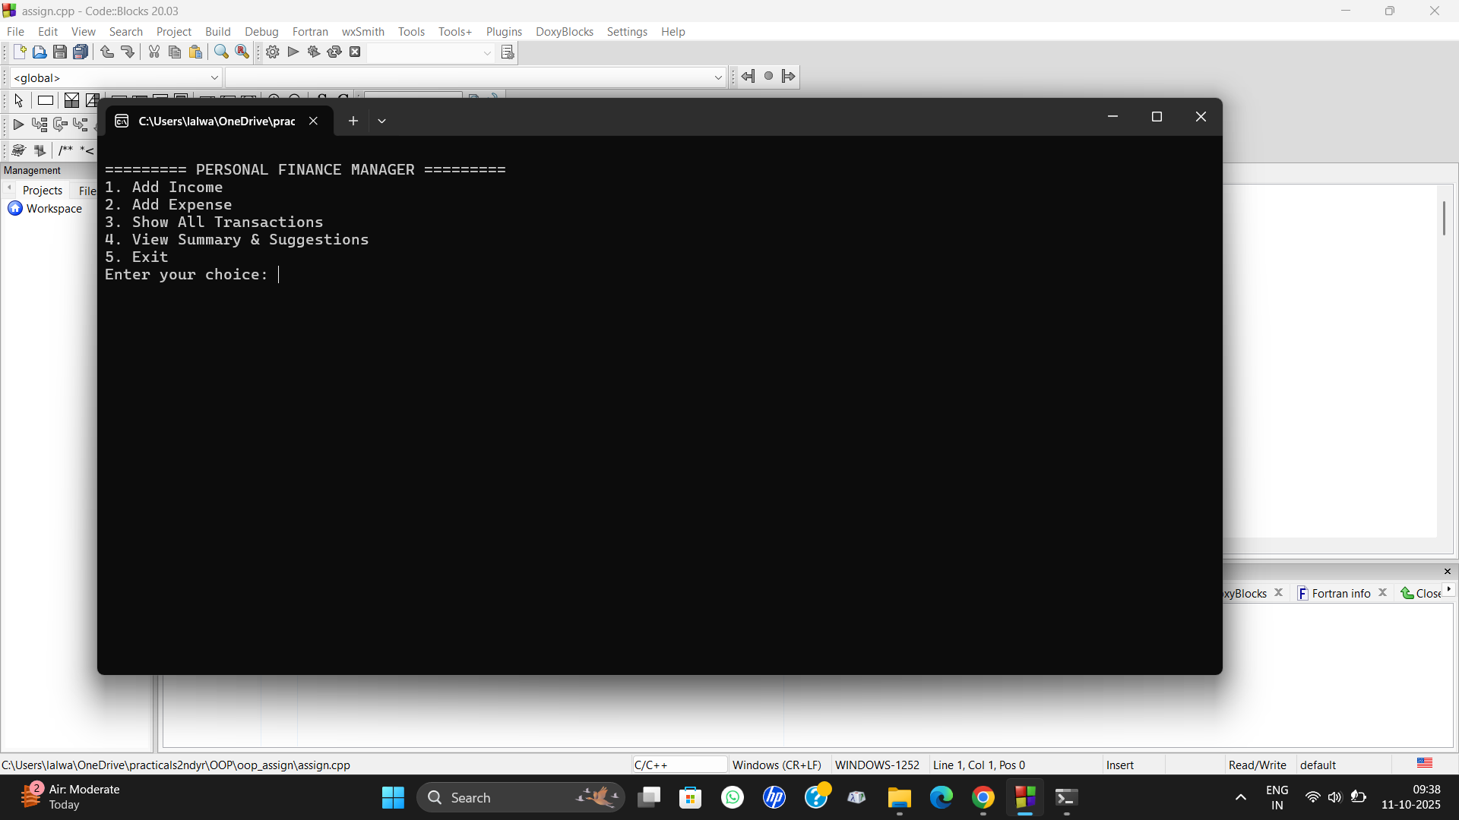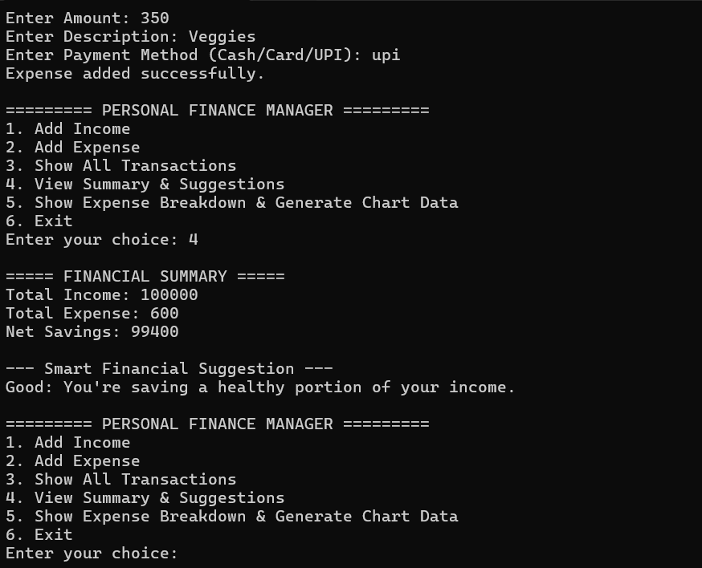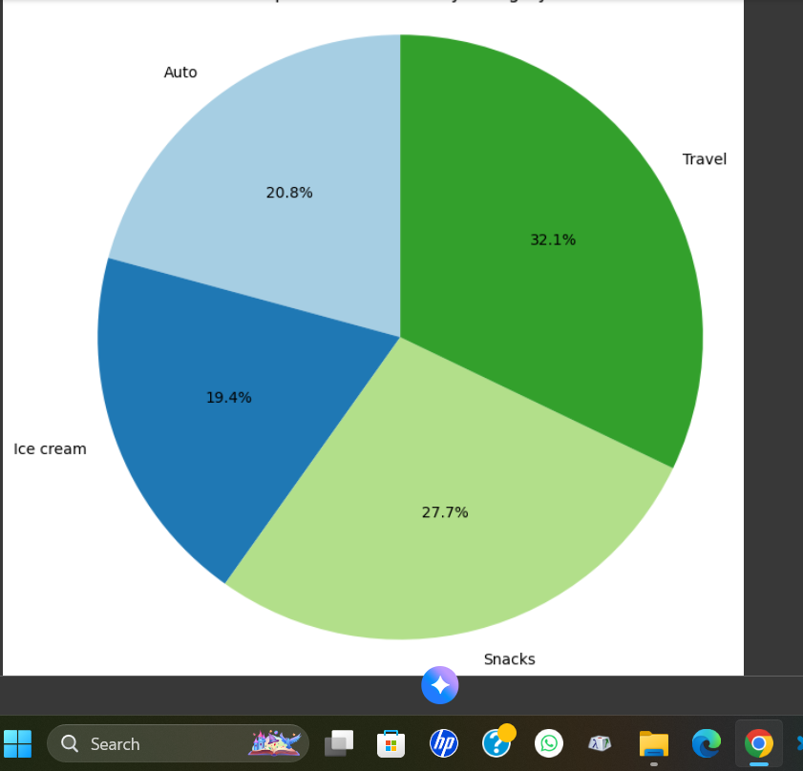

Concepts used:

- Class and Object:
We have used classes such as Transaction, Income, Expense, ExpenseManager, and Suggestion to represent different parts of the project. Each class defines specific properties and behaviors, and objects of these classes are used to perform various operations like adding or displaying transactions.

- Constructor:
Constructors are used in each class to initialize data members whenever a new object is created. This helps in setting initial values like date, category, amount, and description automatically when a transaction is added.

- Inheritance:
The Income and Expense classes inherit from the base class Transaction. This allows them to reuse common features like date and amount while also adding their own specific features such as source (for income) and payment method (for expense).

- Polymorphism:
Polymorphism is implemented through virtual functions like display() and suggest(), which are overridden in derived classes. This ensures that the correct version of the function is called at runtime depending on the type of object (income or expense).
5. Pointers:
Pointers, especially Transaction*, are used to store and access objects dynamically. This allows both Income and Expense objects to be managed together using base class pointers in the ExpenseManager.
6. Virtual Functions:
Virtual functions enable runtime polymorphism. They make sure that when we call the display() or suggest() function through a base class pointer, the correct derived class function is executed, depending on the object type.

How the program works:
The main function starts, creating an ExpenseManager object (the central data hub) and a SmartSuggestion object (for financial advice).
Display Menu: The program enters a loop, printing a menu with options like "Add Income," "Add Expense," "Show Transactions," and "View Summary."
User Choice: The program waits for the user to enter a number corresponding to their desired action.
Action Time:
- If the user chooses 1 (Add Income) or 2 (Add Expense), the program prompts for details. It then creates a specific object (Income or Expense) and hands it to the ExpenseManager to store.
- If the user chooses 3 (Show All Transactions), the manager iterates through its list and tells each transaction to display its details. Thanks to polymorphism, the correct display format for income or expense is automatically used.
- If the user chooses 4 (View Summary), the manager calculates total income and expenses. The program then uses the SmartSuggestion object to provide financial advice based on those totals.
- If the user chooses 5 (Show Expense Breakdown), the manager calculates the percentage of spending per category, displays a text-based breakdown, and saves the data to a file for a separate Python script to create a pie chart.
Loop or Exit: After an action is completed, the loop repeats, presenting the menu again. The process continues until the user selects the "Exit" option, at which point the program cleans up the memory it used and shuts down.

