Q1. Server was started on port _______.

50000

Q2. Client’s TCP Source port_____

51120

Q3. TCP Sequence numbers don’t always start at 0 because ...

Initial sequence number of a packet is not zero and assigned random value for the purpose security, preventing spoofing or hacking or conflicting with other data bytes transmitted over the TCP

Q4. The Window Scale Factor is for .....

the TCP Window Scale Factor option is an extension to the TCP protocol that improves performance over large bandwidth paths by allowing larger blocks of data to be sent and received. It is based on RFC 1323. The TCP header uses a 16-bit window field to report the size of the receive window to the sender.

1

Screenshot 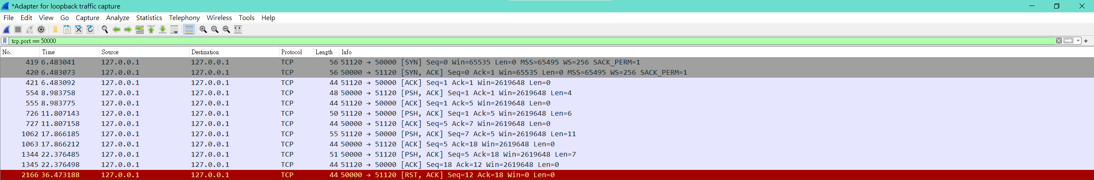2

Screenshot 3

Screenshot 4

Screenshot 5

