Name:________________________



1. Consider the plot below showing TCP window size as a function of time. Assuming TCP Reno is the protocol showing the behavior shown below, answer the following questions. (14 points)

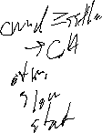

(a) Identify the intervals of time when TCP slow start is operating. _____________________________

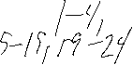

(b) Identify the intervals of time when AIMD is operating. ________________

(c) After the 7th transmission round, is segment loss detected by a triple duplicate ACK or by a



timeout? ___________________



(d) After the 15th round is loss detected by a triple duplicate ACK or by a timeout? _____________



(e) What is the value of Threshold at the 4th transmission round? ____________________



(f) During what transmission round is the 12th segment sent? _________________



(g) Assuming a packet loss is detected after the 24th round by the receipt of a timeout,

what will be the values of the congestion-window size and of Threshold ? (rounding down)

cwnd = ______ssthresh=______



1. (10) Suppose we have an IP network using purely Ethernet as shown below with Router1 and PC1, PC2, W, and D as hosts. Assume that PC1 needs to connect to the HTTP web server (W) *by it’s domain name,* e.g. a web browser to **http://intra.acme.com**.

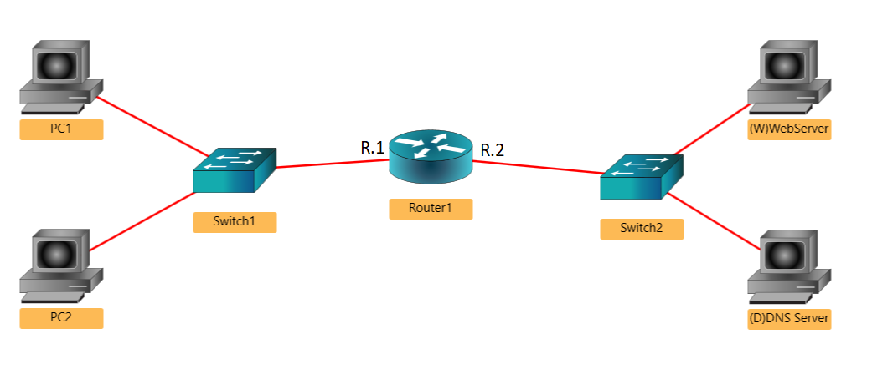

What will be the sequence of ARP request/response packets and IP datagrams sent into the network. Show each Ethernet **frame**. Notes and instructions:

* List the source/destination hardware/IP addresses of these packets by filling in the following table. Include whether it is an ARP Query (ARP-Q), ARP Response (ARP-R), or IP packet (IP).
* List the protocol *or protocols* (can be multiple) headers contained in the packet. For ARP, can skip.
* Refer to interfaces of Router1 as R.1 and R.2. Any hardware broadcast address should be FF.
* PC1, PC2, and R.1 are in one subnet (Ethernet network in this case); W,D,R.2 are in another.
* Assume all ARP caches and switch tables are empty at start. Assume all devices responding to an ARP query cache the requester’s MAC and IP.
* Assume all devices are correctly and statically configured (they have IP, subnet mask, DNS server, and default gateway preconfigured).



|  |  |  |  |  |  |
| --- | --- | --- | --- | --- | --- |
| ARP Query, ARP Response or IP Packet | Protocols  (ARP, HTTP, DNS, TCP, UDP) *see above | Hardware Address | | IP Addresses | |
| Source | Dest | Sender | Receiver (Destination) |
|  |  |  |  |  |  |
|  |  |  |  |  |  |
|  |  |  |  |  |  |
|  |  |  |  |  |  |
|  |  |  |  |  |  |
|  |  |  |  |  |  |
|  |  |  |  |  |  |
|  |  |  |  |  |  |
|  |  |  |  |  |  |
|  |  |  |  |  |  |
|  |  |  |  |  |  |
|  |  |  |  |  |  |
|  |  |  |  |  |  |
|  |  |  |  |  |  |
|  |  |  |  |  |  |
|  |  |  |  |  |  |
|  |  |  |  |  |  |
|  |  |  |  |  |  |
|  |  |  |  |  |  |
|  |  |  |  |  |  |
|  |  |  |  |  |  |
|  |  |  |  |  |  |
|  |  |  |  |  |  |

1. (10) Consider the network shown below with the link costs given. Use Dijkstra’s shortest path algorithm to find the shortest paths from **B** to all other nodes. Show the steps, resulting shortest path spanning tree, and the forwarding table for **B** (indicated with an arrowhead). You **must** show your work for full credit. *Indicate on the graph the edges that a part of the shortest path tree.*

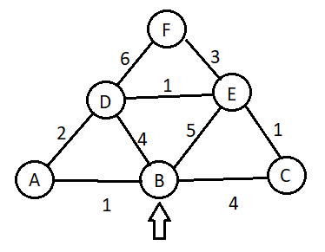



(4) Forwarding table (at **B**), with Distance using Link State (Dijkstra’s)

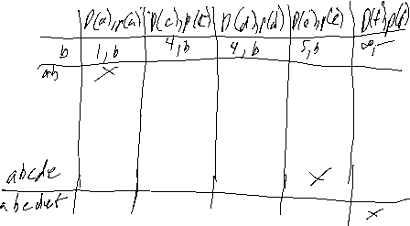

|  |  |  |
| --- | --- | --- |
| Destination | Next Hop | Distance |
|  |  |  |
|  |  |  |
|  |  |  |
|  |  |  |
|  |  |  |



(6) Show the final distance table for the Distance Vector Table as it would appear at B.



|  |  |  |  |  |  |  |
| --- | --- | --- | --- | --- | --- | --- |
|  | A | B | C | D | E | F |
| A |  |  |  |  |  |  |
| B |  |  |  |  |  |  |
| C |  |  |  |  |  |  |
| D |  |  |  |  |  |  |
| E |  |  |  |  |  |  |



1. Perform Distance-Vector (Bellman-Ford) algorithm on the following graph, show each “timestep” of distance vectors:

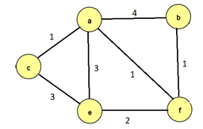



|  |  |  |  |  |  |  |  |  |  |  |  |  |  |  |  |  |  |  |  |  |  |  |  |  |  |  |  |  |  |  |  |  |  |  |  |  |  |  |  |  |  |  |  |  |  |  |  |  |  |  |  |  |  |  |  |  |  |  |  |  |  |  |  |  |  |  |  |  |  |  |  |  |  |  |  |  |  |  |  |  |  |  |  |  |  |  |  |  |  |  |  |  |  |  |  |  |  |  |  |  |  |  |  |  |  |  |  |  |  |  |  |  |  |  |  |  |  |  |  |  |  |  |  |  |  |  |  |  |  |  |  |  |  |  |  |  |  |  |  |  |  |  |  |  |  |  |  |  |  |  |  |  |  |  |  |  |  |  |  |  |  |  |  |  |  |  |  |  |  |  |  |  |  |  |  |  |  |  |  |  |  |  |  |  |  |  |  |  |  |  |  |  |  |  |  |  |  |  |  |  |  |  |  |  |  |  |  |  |  |  |  |  |  |  |  |  |  |  |  |  |  |  |  |  |  |  |  |  |  |  |  |  |  |  |  |  |  |  |  |  |  |  |  |  |  |  |  |  |  |  |  |  |  |  |  |  |  |  |  |  |  |  |  |  |  |  |  |  |  |  |  |  |  |  |  |  |  |  |  |  |  |  |  |  |  |  |  |  |  |  |  |  |  |  |  |  |  |  |  |  |  |  |  |  |  |  |  |  |  |  |  |  |  |  |  |  |  |  |  |  |  |  |  |  |  |  |  |  |  |  |  |  |  |  |  |  |  |  |  |  |  |  |  |  |  |  |  |  |  |  |  |  |  |  |  |  |  |  |  |  |  |  |  |  |  |  |  |  |  |  |  |  |  |  |  |  |  |  |  |  |  |  |  |  |  |  |  |  |  |  |  |  |  |  |  |  |  |  |  |  |  |  |  |  |  |  |  |  |  |  |  |  |  |  |  |  |  |  |  |  |  |  |  |  |  |  |  |  |  |  |  |  |  |  |  |  |  |  |  |  |  |  |  |  |  |  |  |  |  |  |  |  |  |  |  |  |  |  |  |  |  |  |  |  |  |  |  |  |  |  |  |  |  |  |  |  |  |  |  |  |  |  |  |  |  |  |  |  |  |  |  |  |  |  |  |  |  |  |  |  |  |  |  |  |  |  |  |  |  |  |  |  |  |  |  |  |  |  |  |  |  |  |  |  |  |  |  |  |  |  |  |  |  |  |  |  |  |  |  |  |  |  |  |  |  |  |  |  |  |  |  |  |  |  |  |  |  |  |  |  |  |  |  |  |  |  |  |  |  |  |  |  |  |  |  |  |  |  |  |
| --- | --- | --- | --- | --- | --- | --- | --- | --- | --- | --- | --- | --- | --- | --- | --- | --- | --- | --- | --- | --- | --- | --- | --- | --- | --- | --- | --- | --- | --- | --- | --- | --- | --- | --- | --- | --- | --- | --- | --- | --- | --- | --- | --- | --- | --- | --- | --- | --- | --- | --- | --- | --- | --- | --- | --- | --- | --- | --- | --- | --- | --- | --- | --- | --- | --- | --- | --- | --- | --- | --- | --- | --- | --- | --- | --- | --- | --- | --- | --- | --- | --- | --- | --- | --- | --- | --- | --- | --- | --- | --- | --- | --- | --- | --- | --- | --- | --- | --- | --- | --- | --- | --- | --- | --- | --- | --- | --- | --- | --- | --- | --- | --- | --- | --- | --- | --- | --- | --- | --- | --- | --- | --- | --- | --- | --- | --- | --- | --- | --- | --- | --- | --- | --- | --- | --- | --- | --- | --- | --- | --- | --- | --- | --- | --- | --- | --- | --- | --- | --- | --- | --- | --- | --- | --- | --- | --- | --- | --- | --- | --- | --- | --- | --- | --- | --- | --- | --- | --- | --- | --- | --- | --- | --- | --- | --- | --- | --- | --- | --- | --- | --- | --- | --- | --- | --- | --- | --- | --- | --- | --- | --- | --- | --- | --- | --- | --- | --- | --- | --- | --- | --- | --- | --- | --- | --- | --- | --- | --- | --- | --- | --- | --- | --- | --- | --- | --- | --- | --- | --- | --- | --- | --- | --- | --- | --- | --- | --- | --- | --- | --- | --- | --- | --- | --- | --- | --- | --- | --- | --- | --- | --- | --- | --- | --- | --- | --- | --- | --- | --- | --- | --- | --- | --- | --- | --- | --- | --- | --- | --- | --- | --- | --- | --- | --- | --- | --- | --- | --- | --- | --- | --- | --- | --- | --- | --- | --- | --- | --- | --- | --- | --- | --- | --- | --- | --- | --- | --- | --- | --- | --- | --- | --- | --- | --- | --- | --- | --- | --- | --- | --- | --- | --- | --- | --- | --- | --- | --- | --- | --- | --- | --- | --- | --- | --- | --- | --- | --- | --- | --- | --- | --- | --- | --- | --- | --- | --- | --- | --- | --- | --- | --- | --- | --- | --- | --- | --- | --- | --- | --- | --- | --- | --- | --- | --- | --- | --- | --- | --- | --- | --- | --- | --- | --- | --- | --- | --- | --- | --- | --- | --- | --- | --- | --- | --- | --- | --- | --- | --- | --- | --- | --- | --- | --- | --- | --- | --- | --- | --- | --- | --- | --- | --- | --- | --- | --- | --- | --- | --- | --- | --- | --- | --- | --- | --- | --- | --- | --- | --- | --- | --- | --- | --- | --- | --- | --- | --- | --- | --- | --- | --- | --- | --- | --- | --- | --- | --- | --- | --- | --- | --- | --- | --- | --- | --- | --- | --- | --- | --- | --- | --- | --- | --- | --- | --- | --- | --- | --- | --- | --- | --- | --- | --- | --- | --- | --- | --- | --- | --- | --- | --- | --- | --- | --- | --- | --- | --- | --- | --- | --- | --- | --- | --- | --- | --- | --- | --- | --- | --- | --- | --- | --- | --- | --- | --- | --- | --- | --- | --- | --- | --- | --- | --- | --- | --- | --- | --- | --- | --- | --- | --- | --- | --- | --- | --- | --- | --- | --- | --- | --- | --- | --- | --- | --- | --- | --- | --- | --- | --- | --- | --- | --- | --- | --- | --- | --- | --- | --- | --- | --- | --- | --- | --- | --- | --- | --- | --- | --- | --- | --- | --- | --- | --- | --- | --- | --- | --- | --- | --- | --- | --- | --- | --- | --- | --- | --- | --- | --- | --- | --- | --- | --- | --- | --- | --- | --- | --- | --- | --- | --- | --- | --- | --- | --- | --- | --- | --- | --- | --- | --- | --- | --- | --- | --- | --- | --- | --- | --- | --- | --- |
| |  |  |  |  |  |  | | --- | --- | --- | --- | --- | --- | |  | a | b | c | e | f | | **a** | 0 | 2 | 1 | 3 | 1 | | b | 4 | 0 | - | - | 1 | | c | 1 | - | 0 | 3 | - | | e | 3 | - | 3 | 0 | 2 | | f | 1 | 1 | - | 2 | 0 |  |  |  |  |  |  |  | | --- | --- | --- | --- | --- | --- | |  | a | b | c | e | f | | a | 0 | 4 | 1 | 3 | 1 | | **b** | 2 | 0 | 4 | 3 | 1 | | f | 1 | 1 | - | 2 | 0 |  |  |  |  |  |  |  | | --- | --- | --- | --- | --- | --- | |  | a | b | c | e | f | | a | 0 | 4 | 1 | 3 | 1 | | **c** | 1 | 5 | 0 | 3 | 2 | | e | 3 | - | 3 | 0 | 2 |  |  |  |  |  |  |  | | --- | --- | --- | --- | --- | --- | |  | a | b | c | e | f | | a | 0 | 4 | 1 | 3 | 1 | | c | 1 | - | 0 | 3 | - | | **e** | 3 | 3 | 3 | 0 | 2 | | f | 1 | 1 | - | 2 | 0 |  |  |  |  |  |  |  | | --- | --- | --- | --- | --- | --- | |  | a | b | c | e | f | | a | 0 | 4 | 1 | 3 | 1 | | b | 4 | 0 | - | - | 1 | | e | 3 | - | 3 | 0 | 2 | | **f** | 1 | 1 | 2 | 2 | 0 | | |  |  |  |  |  |  | | --- | --- | --- | --- | --- | --- | |  | a | b | c | e | f | | **a** | 0 | 2 | 1 | 3 | 1 | | b | 2 | 0 | 4 | 3 | 1 | | c | 1 | 5 | 0 | 3 | 2 | | e | 3 | 3 | 3 | 0 | 2 | | f | 1 | 1 | 2 | 2 | 0 |  |  |  |  |  |  |  | | --- | --- | --- | --- | --- | --- | |  | A | b | c | e | F | | a | 0 | 2 | 1 | 3 | 1 | | **b** | 2 | 0 | 3 | 3 | 1 | | f | 1 | 1 | 2 | 2 | 0 |  |  |  |  |  |  |  | | --- | --- | --- | --- | --- | --- | |  | a | B | c | e | F | | a | 0 | 2 | 1 | 3 | 1 | | **c** | 1 | 3 | 0 | 3 | 2 | | e | 3 | 3 | 3 | 0 | 2 |  |  |  |  |  |  |  | | --- | --- | --- | --- | --- | --- | |  | a | b | C | e | F | | a | 0 | 2 | 1 | 3 | 1 | | c | 1 | 5 | 0 | 3 | 2 | | **e** | 3 | 3 | 3 | 0 | 2 | | f | 1 | 1 | 2 | 2 | 0 |  |  |  |  |  |  |  | | --- | --- | --- | --- | --- | --- | |  | a | b | c | E | F | | a | 0 | 2 | 1 | 3 | 1 | | b | 2 | 0 | 4 | 3 | 1 | | e | 3 | 3 | 3 | 0 | 2 | | **f** | 1 | 1 | 2 | 2 | 0 | | |  |  |  |  |  |  | | --- | --- | --- | --- | --- | --- | |  | a | b | c | e | f | | **a** | 0 | 2 | 1 | 3 | 1 | | b | 2 | 0 | 3 | 3 | 1 | | c | 1 | 3 | 0 | 3 | 2 | | e | 3 | 3 | 3 | 0 | 2 | | f | 1 | 1 | 2 | 2 | 0 |  |  |  |  |  |  |  | | --- | --- | --- | --- | --- | --- | |  | a | b | c | e | F | | a | 0 | 2 | 1 | 3 | 1 | | **b** | 2 | 0 | 3 | 3 | 1 | | f | 1 | 1 | 2 | 2 | 0 |  |  |  |  |  |  |  | | --- | --- | --- | --- | --- | --- | |  | a | b | c | e | F | | a | 0 | 2 | 1 | 3 | 1 | | **c** | 1 | 3 | 0 | 3 | 2 | | e | 3 | 3 | 3 | 0 | 2 |  |  |  |  |  |  |  | | --- | --- | --- | --- | --- | --- | |  | a | b | c | E | F | | a | 0 | 2 | 1 | 3 | 1 | | c | 1 | 3 | 0 | 3 | 2 | | **e** | 3 | 3 | 3 | 0 | 2 | | f | 1 | 1 | 2 | 2 | 0 |  |  |  |  |  |  |  | | --- | --- | --- | --- | --- | --- | |  | a | b | c | E | F | | a | 0 | 2 | 1 | 3 | 1 | | b | 2 | 0 | 3 | 3 | 1 | | e | 3 | 3 | 3 | 0 | 2 | | **f** | 1 | 1 | 2 | 2 | 0 | | |  |  |  |  |  |  | | --- | --- | --- | --- | --- | --- | |  | a | b | c | e | f | | **a** |  |  |  |  |  | | b |  |  |  |  |  | | c |  |  |  |  |  | | e |  |  |  |  |  | | f |  |  |  |  |  |  |  |  |  |  |  |  | | --- | --- | --- | --- | --- | --- | |  | a | b | c | e | f | | a |  |  |  |  |  | | **b** |  |  |  |  |  | | f |  |  |  |  |  |  |  |  |  |  |  |  | | --- | --- | --- | --- | --- | --- | |  | a | b | c | e | f | | a |  |  |  |  |  | | **c** |  |  |  |  |  | | e |  |  |  |  |  |  |  |  |  |  |  |  | | --- | --- | --- | --- | --- | --- | |  | a | b | c | e | f | | a |  |  |  |  |  | | c |  |  |  |  |  | | **e** |  |  |  |  |  | | f |  |  |  |  |  |  |  |  |  |  |  |  | | --- | --- | --- | --- | --- | --- | |  | a | b | c | e | f | | a |  |  |  |  |  | | b |  |  |  |  |  | | e |  |  |  |  |  | | **f** |  |  |  |  |  | |