**HW1: Optimizing Matrix Multiply Report**

Lian Liao, ll987, ll987(Perlmutter)

**Results:**

My best try is around 41% of the peak. To get this result, I have tried two main approaches. The main difference is that one initially realigns and fixes the size to memory; the other one doesn’t realign it and keeps the size then deals with a tail. For me, the approach of dealing with the tail is better, which is 40%. And I combine two of them to get the 41%

**optimizations attempt:**

Based on the HW1 doc. I tried to implement multi-level blocking. I just simply added one more layer with 3 for-loop.

Use the same logic to add a second layer. The result is positive, but not increase speed much from just one level of blocking.

Next one is Repack and Realign



I set 32 bytes because my avx is 256. 256/32=8 which is double’s size.

I didn’t do the Repack. I think it can potentially increase the speed with blocking.

Here is in small block(C is M-by-N, A is M-by-K, and B is K-by-N)

I copied the matrix within the loop. Step is 4 because memory size is 32 and double is 8, 32/8=4. I only do Realign for A and B because it is slower to add C. I have tried to implement C_block in small blocks or initials, but they are slower. I guess because they are not really aligned since I didn’t fix the size before getting the microkernel.

But I use __m256d is not supported in Perlmutter. My loop for K is unrolling for every 2 steps.

I added them while in the loop and combined them in the end, then wrote to C.

After implementing the Micro-kernel, the speed increased a lot. This verified the results from some HPC papers which blocking and micro-kernel are most effective.

For the tail. Just simply access the original A,B, and C to deal. I tried to make them aligned to avoid tail, but it didn’t work out.

Other small optimizations:

Those are optimizers I found. They can help my local computer dramatically speed up, but not for Perlmutter. The interesting thing is that with optimizers, my computer is faster than in Perlmutter; without them, it is way slower than in Perlmutter.

I read that an “inline” function can help with optimization because the compiler attempts to embed the function's code directly into the calling site, rather than generating a function call. However, I don’t see any difference after adding them to my function.

Same as “restrict” I don’t see any difference after adding them to my Matrix.

This is the critical factor for performance. Is decided whether the blocking size or represented as L1 and L2 cache. (128,64) is my best set to my code.

Note: because my other approach is better on size 31. So I only run it if the size is smaller than 32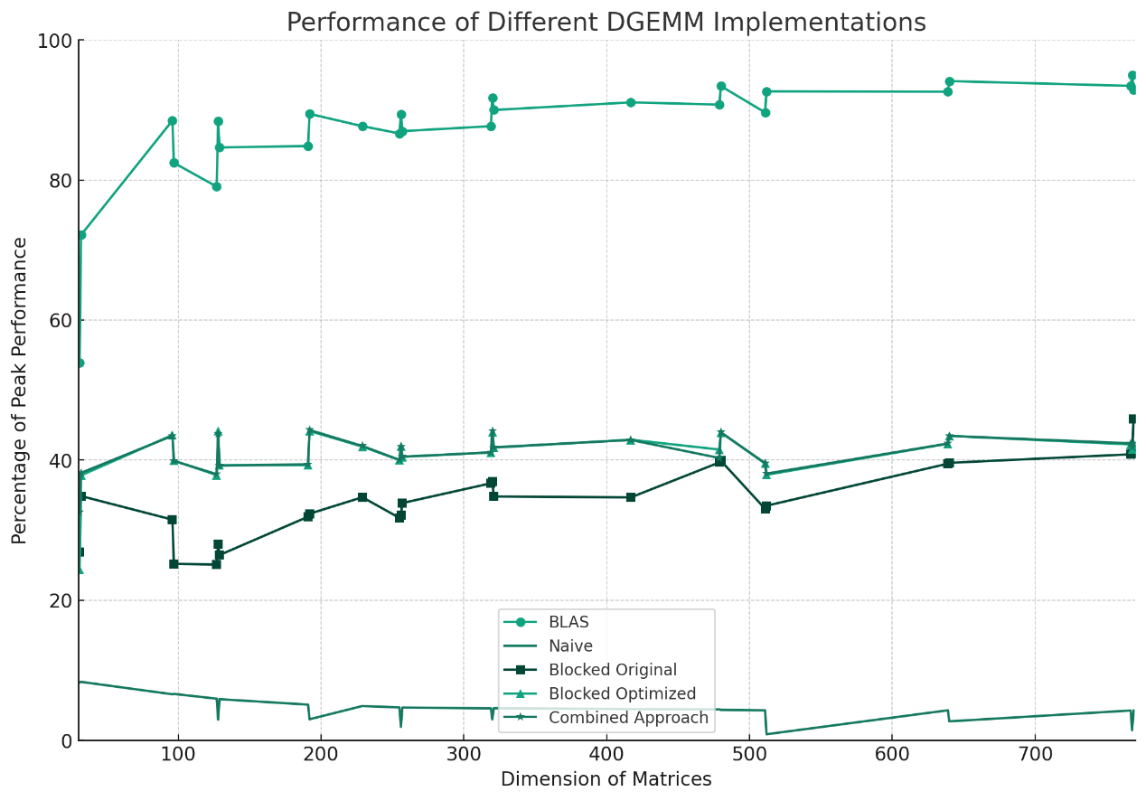

This is my plot for the final performance. My curve is flat at around 40%

Conclusion:

The optimization attempts on matrix multiplication yielded a significant performance increase, achieving approximately 41% of the peak. The critical factor for performance optimization was the cache-aware blocking size, indicating the profound impact of memory hierarchy on computational efficiency (speed would drop a lot if I forgot to free it). Despite the various strategies employed, there remains a performance gap to the theoretical peak.

References

Jiang, Xuan, et al. “Optimizing Matrix Multiplication on Nersc’s High Performance Computer Cori.” OSF Preprints, 26 Feb. 2022. Web.