Software Requirements Specification

Version 1.0

<<Annotated Version>>

April 15, 2018

Lama Bakkour

Alaa Al ahmad

# Table of Contents

**Requirements Analysis**

1. Introduction 1
   1. Purpose 1
   2. Background 1
   3. Scope 4
   4. Definitions, acronyms, and abbreviations 6
   5. References 6
   6. Overview 6
2. Overall Description 7
   1. Product Perspective 7
   2. User Characteristics 9
   3. Constraints 9
   4. Assumptions and Dependencies 10
3. Functional Requirements 11
   1. Product functions 11
   2. Use Cases 14
      1. User Class: Bookkeeper 15
      2. User Class: Billable Employee 22
      3. User Class: System Administrator 23
      4. User Class: Staff 25
   3. Data Input and Output to System 27
   4. Data to be Maintained by the System 30
4. Non-Functional Requirement 30
   1. External Interface Requirements 30
      1. User Interfaces 30
      2. Hardware Interfaces 36
      3. Software Interfaces 36
      4. Communications Interfaces 37
   2. Performance requirements 37
   3. Design Constraints 37
   4. Software System Attributes 38
   5. Other Requirements 39

Appendix 1: Interviews 41

**Appendices**

Appendix 2: Copitrak System 51

Appendix 3: Use Cases 54

Appendix 4: Class Diagram 59

Appendix 5: Sequence Diagrams 68

Appendix 6: State Diagrams 83

Appendix 7: Sample of Paper Timesheet 86

Appendix 8: Team Meetings 87

Appendix 9: Team Report Form 89

**Software Requirements Specification for**

EZ-LAW

**1. Introduction**

**1.1 Purpose**

This document specifies requirements for the new billing and accounting software for Goldman Greenberg Associates.

The basic issues to be addressed by this document, , are:

* *Functionality*: The tasks the software is required to perform
* *External Interfaces*: How the system interacts with people, hardware and external hardware and software
* *Performance*: Speed, availability, response time, recovery time.
* *Attributes*: Portability, correctness, maintainability, security, etc.
* *Design Constraints*: Required standards, implementation language, policies for database integrity, resource limits, operating environments, etc.

The requirements analysis contained in this document defines the specific functionality that must be met in order to successfully deploy a new billing information system. The client’s desires for the new system have been translated into measurable and definable business rules and functions to allow for successful development of a comprehensive new billing system. Please see Appendix 1 for transcripts of interviews with the client.

The intended audience for this SRS includes technical personnel involved in the design, coding and testing of the system as well as management of Goldman Greenberg Associates.

**1.2 Background**

Goldman Greenberg Associates is a Toronto-based law firm specializing in corporate commercial law, real estate, wills and estates, and income tax law. They are a medium-sized firm consisting of ten lawyers with seven additional support staff members and an annual revenue of approximately four million dollars.

Interviews with key people in the firm provided information on the current system. The current billing system was implemented in 1992 and consists of a DOS based program into which all billable items are entered by a single person, a paralegal who also functions as the bookkeeper.

Invoices are generated at the end of each month. The billable items that are included in the invoice are as follows:

* time spent on a matter by lawyers or paralegals and description of how time was spent
* filing fees
* long distance telephone charges
* copy charges
* fax charges
* postage/courier fees
* miscellaneous third party charges

The flow of data, from client to invoice, in the current system is graphically represented in the following diagram.

Figure 1: Flow of Information from Client to Bill (Current System):



Client

M atter requiring legal services

Tim e spent by Lawyer

Tim e spent by Paralegal

Tim e Sheet

Client File

(physical)

Estim ate of M onthly Bill from Charges at tim e of

service Service Provider

Bookkeeper

Charges for Copies

Long Distance Telephone

Charges

O ther 3rd Party Charges

M ail/Courier charges

Charges for Faxes

Filing Fees

Lawyers write their time down by hand on a timesheet. The sheets are designed to be given to the bookkeeper daily for input to the system. Copies, faxes, postage, and all other charges that are added to a client’s invoice which are not time entries are called disbursements. The bookkeeper also enters the disbursements. Whenever copies are made or faxes sent, it is recorded by hand and given to the bookkeeper with the client number for entering the information into the computer. This is true for courier charges as well, and should also be true for postage, however they are currently not tracking postage.



Custom er Invoice

Billing Software

Long distance telephone charges are not added to the client invoice until the bill comes in from Bell Canada. The client file number (matter number) is entered into t telephone before dialing

the number. The bill then comes with long distance charges sorted by client file number. The bookkeeper goes through the bill entering the information into the system. This information is usually billed a month behind due to the wait for the telephone bill. Occasionally GGA is unable to recover the some of the charges because a final accounting has already been issued to the client prior to the arrival of the telephone bill. Lawyers are prohibited, by directive from the Law Society of Upper Canada, from charging more for long distance than the actual charges incurred so there is currently no way to accurately enter any long distance charges into the billing system before the arrival of the telephone bill.

The bookkeeper spends on average half of her time engaged in matters pertaining to the billing of accounts. Because she is also a paralegal, this is time that she could be spending as a billable employee. This lost billable time represents a large expense associated with the current system.

The problems with the current system are directly related to the manner in which information is collected and entered into the system. The size of the firm makes the hand entry of billables, and reliance primarily on employee time to track cost recovery relating to the business machines of the office highly inefficient. They are just too large a firm to be entering this much data by hand.

The problem is summarized by the following simplified flowchart highlighting the obvious bottleneck created when all data that needs to get into the system must first go through the bookkeeper and be entered by hand.

Figure 2: Information Bottleneck

(Bottleneck)

Bookkeeper

Billing System

All billing entries

The following list outlines the problems with the current system which are to be addressed by the implementation of a new system:

* Too much time spent entering disbursements by hand.
* Cost recovery from usage of the copier and fax machines is either not recorded, or entered by hand at great expense
* Long distance charges to client accounts are not posted in a timely manner
* Lawyers enter their time by hand, which is then entered by bookkeeper, doubling the time a billable employee must spend entering this time.
* Invoices not always accurate
* Time-consuming end of the month invoice generation process
* Limited reporting and limited flexibility for existing reports
* Limited access to necessary information for lawyers and senior partners

# Scope

The software to be produced from these requirements is a new billing, time tracking and accounting system. For the purposes of this SRS, the new system will be called EZ-Law.

The objective the client wants to achieve in acquiring a new system is to reduce time spent entering billable charges to client accounts by hand. This practice results in a very large expense to the firm and the purpose of this software is to reduce that cost. Specifically, the new system must achieve the following goals:

* + - Automate the business machines of the office (copier and fax) and the telephone system, significantly reducing the need to enter information by hand, and increasing the costs recovered from use of these machines on behalf of clients
    - Allow lawyers to record their time at their own computers, reducing the time spent entering this time.
    - Provide greater accuracy on invoices
    - Provide and easier, and less time-consuming end of the month invoice generation process
    - Provide greater reporting capability
    - Provide all basic accounting functionality that exists in the current system
    - Be easy to use and learn
    - Be reliable and require little maintenance

Much of the automation will be handled by a 3rd party cost recovery system. That system hooks up to the copy machines, fax machines and telephone system and records the usage. However that system only collects the data. The actual processing, storing, and billing of those charges are the responsibility of the custom system, EZ-Law.

While the 3rd party cost recovery system was part of the feasibility study, and represents a new and very important part of the overall system, it is not part of the EZ-Law system for the purposes of this SRS. It is considered to be outside the system boundary and is a sub-system with which EZ-Law must interface. The boundary of the system whose requirements are addressed in this document, is the custom software application, not including the 3rd party hardware/software, though the interface for data collection from the 3rd party system will be addressed in these requirements.

EZ-Law refers to the custom software component of the new system. It will provide all standard accounting functionality, as well as specific accounting functionality required by a law firm, such as transaction tracking and logging for audit purposes. It will automate the time entries of lawyers and paralegals, and collect data from the 3rd party cost recovery system hooked up to the copy machines, fax machine and telephones, and apply these charges to client accounts. It will generate and print invoices and statements on client accounts, applying all relevant charges and maintaining records of the billings. It will also handle all payroll functionality.

The feasibility study did not address the basic accounting functionality that is required in a new system. This is due to the fact that the basic accounting functionality is not at the core of the problem to be solved by this new system. There is no problem with accounting functionality in the existing system, except as it relates to billing.

A billing system is, by definition, an accounting system in that the bills generated become accounts receivable to be tracked, reported on, collected. Amounts collected from clients and posted to client accounts must also be recorded on a general ledger. Checks written for items paid on behalf of clients must have their amounts posted not only to a general ledger, but also to the client’s invoice. Hence this billing system does not, and cannot stand alone outside of a separate accounting system.

The new system also cannot be designed to work with the existing system. That system is DOS based and switching between them may introduce new problems into the firm’s system of processing accounting information. The data stored within that system is also not being stored in a DBMS system. Trying to combine two such incompatible systems is a more complicated issue than simply including that accounting functionality within the new software.

The current system handles all of the accounting functionality in addition to billing. To replace it, the new system must do the same. Even though this issue was not specifically addressed as a problem in the feasibility study, the costs involved in designing the new system were considered to include this type of standard accounting functionality.

It must be noted that a certain level of expertise in regard to accounting systems and functionality is not readily available at this time and therefore specific requirements for accounting functionality will not be addressed in this documents. However, this part of the system covers some fairly standard functionality and the risk of surprises in this area is low.

Some of the accounting functionality will be analyzed in detail in the Functional Requirements section of this document, specifically that functionality that directly relates to processing billing information. However the specifics of other accounting features will not be addressed in this SRS. Because the basic accounting functions are considered standard functionality, common to all accounting software systems, the specifics of requirements for standard accounting processes are considered to be already known.

# Glossary

The following tables defines the terms used in this software requirements specification. Table 1: Terms and Definitions

|  |  |
| --- | --- |
| **Term** | **Definition** |
| Billable Employee | Lawyer or Paralegal whose time is billed to the client (also an actor in the use cases) |
| Billables | Anything that can be charged to the client and appears on the invoice |
| Bookkeeper | The employee responsible for all accounting and billing (also an actor in the use cases) |
| Client | Goldman Greenberg Associates |
| Copitrak | The 3rd Party Cost Recovery System |
| Disbursement | Any item billable to a client other than time. These include: Copies, postage, fax charges, long distance telephone charges, courier charges, filing fees, etc. |
| EZ-Law | The new custom software application that is the subject of this SRS |
| File Number | The account number given to a matter for a client, synonymous with matter number |
| GGA | Goldman Greenberg Associates (client) |
| Grayed out | When a button, or function on a menu is not accessible to the user. The  button/function still appears, but it is a light gray and cannot be used. |
| Matter | Analogous to a project. Defines the boundary of work being done for a client on a particular subject. Clients can have one or many matters. For instance a law firm  might be doing a divorce and a contract negotiation for the same client. These represent different matters. |
| Matter Number | The account number given to a matter for a client, synonymous with File Number |
| Splash Screen | Screen that appears briefly while the program is loading |
| SRS | Software Requirements Specification (this document) |
| Staff | Any member of the staff of GGA (also an actor in the use cases |
| Tool Tips | small windows which pop up when you drag the mouse  over certain tool bar items or button, and serve as a sort of abbreviated balloon help for the user |

# References

1. *IEEE Recommended Practice for Software Requirements Specification* (IEEE-STD-830- 1998). Availab[le at http://ieeexplore.ieee.org](http://ieeexplore.ieee.org/)
2. *Goldman Greenberg Associates Feasibility Study*: Prepared by HVK Solutions. Available through the authors on request.
3. *Standard Glossary of Software Engineering Terminology* (IEEE Std 610.12-1990 IEEE). [Available at http://ieeexplore.ieee.org](http://ieeexplore.ieee.org/)

# Overview

In the following sections, the requirements for the new system are described. This document is organized such that functional requirements are detailed in Section 3, and non-functional

requirements can be found in Section 4. The requirements are described by use cases, providing a view of the high level functionality of the system from the user’s perspective.

**2. Overall Description**

# 2.1 System Environment

The new system is a custom client/server application that works in conjunction with a 3rd party cost recovery hardware/software system. The system is to be a fully functional billing/accounting system that collects the data generated by the 3rd party system which automates the recording of copies, faxes and long distance telephone charges. These two systems, working together, address all the problems outlined in the existing system in the section above.

The following diagram represents the flow of information, from client to invoice, in the new system:

Figure 3: Flow of Information from Client to Bill (New System):



Client

M atter requiring legal services

Tim e spent by Lawyer

Tim e spent by Paralegal

Estim ate of Charges

Bookkeeper

M onthly Bill from Service Provider

Custom er Invoice

New Inform ation Sytem

Copitrak S ytm

O ther 3rd Party Charges

Filing Fees

Long Distance Charges

M ail/Courier Charges

Charges for Faxes

Charges of Copies

2.2 Functional Requirements Specification:

The actors in this system are few. The bookkeeper role performs most of the tasks requiring interaction with the system. The following actors are involved with this system:

* + - Bookkeeper
    - Billable Employee
    - System Administrator
    - Staff
    - Copitrak System

2.2.1- ***bookkeeper***Use Case:

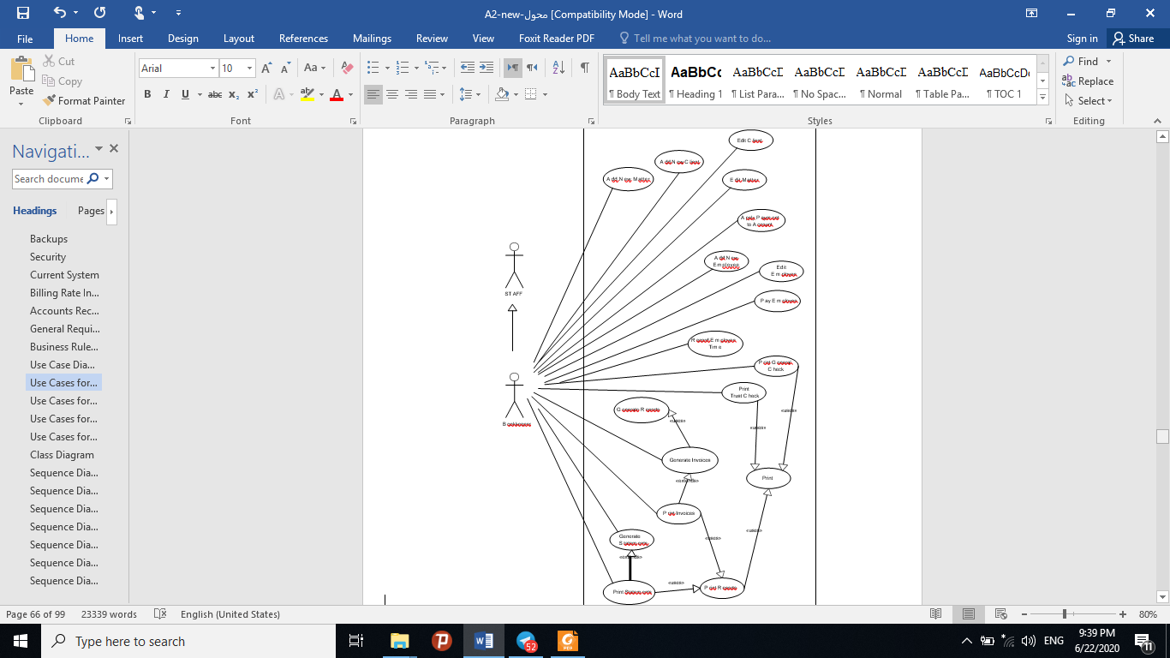

2.2.2- ***Billable Employee*** Use Case:

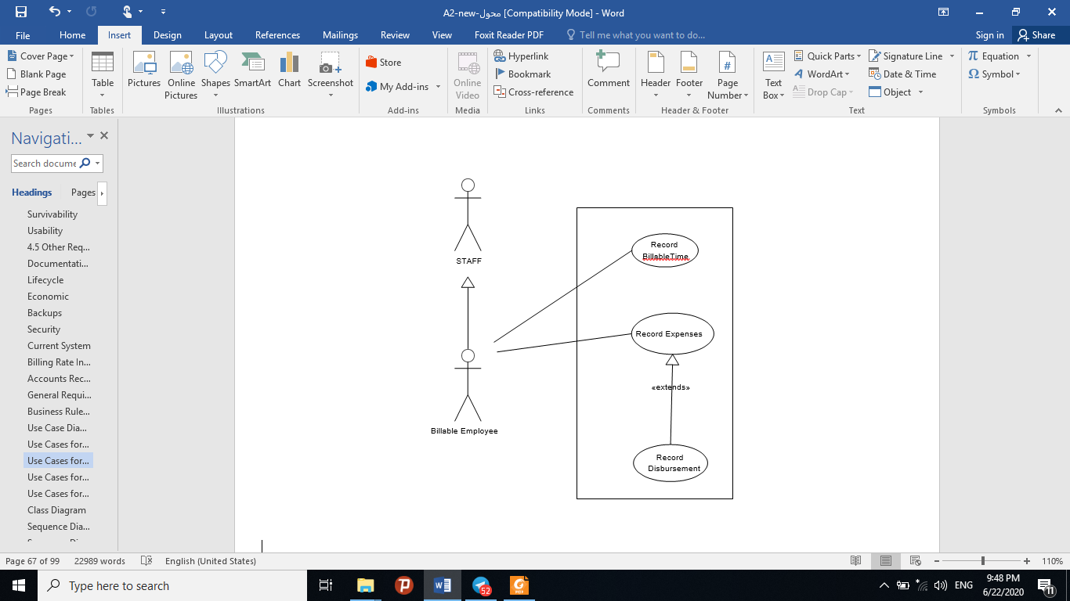

2.2.3- ***System Administrator*** Use Case:

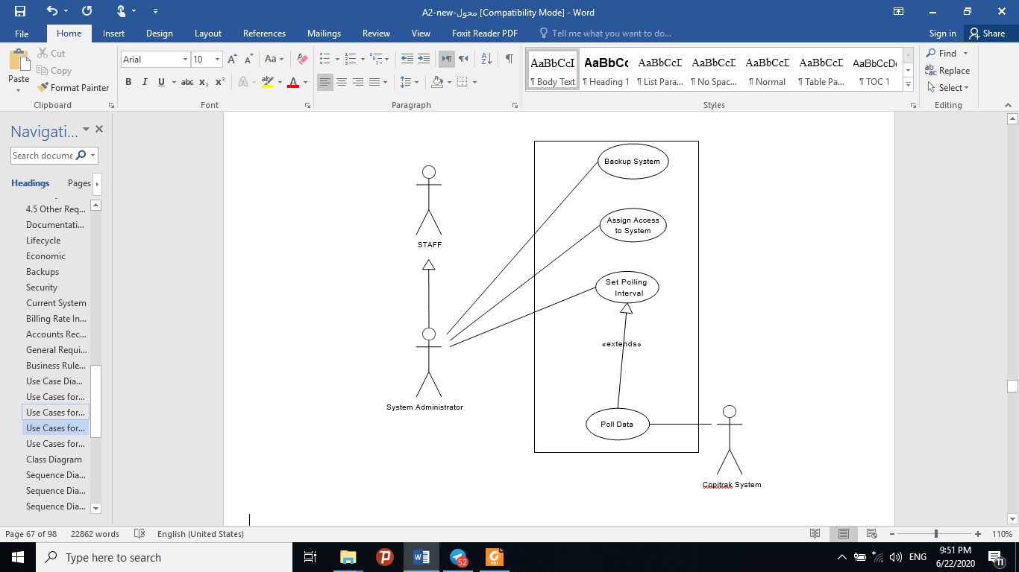

2.2.3- ***Staff*** Use Case:

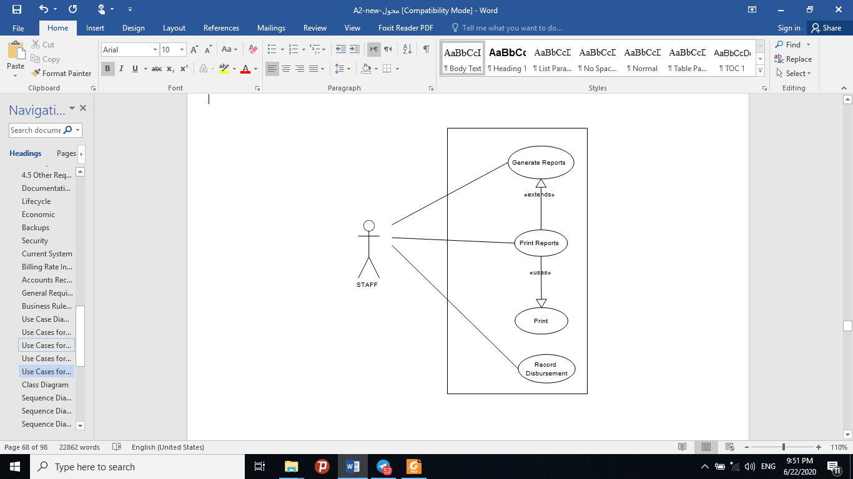

**2.3 User Characteristics**

The skill set of the user’s of this software is varied. The main user, the bookkeeper has a college education and twenty years or more experience as a bookkeeper. She has used several accounting software systems and is comfortable with them. She has been using a computer for the past ten years and is a competent user of Windows programs and the Windows operating system.

All of the lawyers have graduate degrees. Their experience with computers varies from limited use of the internet and email, to experience with all aspects of Windows networking and experience as a system administrator and web page designer.

Most, but not all, of the paralegals have a college education. Their level of comfort with computers is also varied, but all are at least familiar with the functionality standard among Windows programs.

3.0. Requirements Specification:

3.1 External Interface Requirements

The External interfaces, in general, shall to standard 32-bit Windows interface conventions, so as to easily capitalize on existing user knowledge of and familiarity with this interface. All tool bars and button, where possible, should provide mouse over tool tips. This includes the implementation of standard menus and toolbar options, with functionality accessible by redundant methods, in order to enhance usability. In general, buttons will define transitions between non-related windows, or windows if different sizes. Tabs will define transitions between related windows. Design should be concerned with providing the most user friendly and easy to use format, with ergonomic transitions between windows.

There will be 5 major interfaces, access to which will be defined by user.

* + - * **Main Program Interface** – The main interface of the program from which all other interfaces are launched.
      * **Time Tracking Interface** – Allow user to record time spent on client matters directly to the system. Provide pop up “reminder” messages to lawyers and paralegals when they are behind in entering their billable time into the system. Program should be able to launch this screen at startup for those whose main interest is in recording time.
      * **Accounting Interface** – Allows user access to all general accounting functionality of the system:
        + Bill Generation and printing
* General Ledger Accounting
  + - * + Trust Accounting
* Check Printing
* Accounts Payable
* Payroll
* Record and Override Billing Rates
  + - * **System Administrator Interface** - Allows the administrator of the system to set access levels for users, add and remove users, reset passwords. Allows for management of 3rd party system polling interface for data transfer to the EZ-Law system. Allows access to logs generated by polling**.**
      * **Report Generator Interface** – Allows access to a report writer functionality to print custom and/or pre-defined reports. Levels of access within this interface will be strictly controlled by user defined access levels.
      * **Disbursement Entry Interface** - Allows limited access to the system for purposes of entering any disbursement that must be manually recorded to a client account (i.e. postage or miscellaneous expenses billable to the client). Through this interface, any staff member can enter charges for things such as postage or courier fees. The user entering the item must be tracked to allow bookkeeper to verify charges, if necessary, at the time of invoice generation.
  1. Functional Requirements:

Add New Client Use Case

|  |  |
| --- | --- |
| **Use Case 1: Add New Client** | |
| **Overview**  **Primary Actor Secondary Actor Starting Point Ending Point**  **Measurable Results**  **Flow of Events**  **Alternative Flow of Events**  **Use Case Extensions** | The main purpose of this use case is to add a new client to the system. When a new client  comes to the firm, the details are recorded. Contact information, client number, lawyer who brought the client to the firm. A clientID number is assigned. |
| Bookkeeper |
| None |
| The use case starts when the actor requests to create a new client |
| The actor’s request to create a client is completed or cancelled |
| A client is added to the system |
| The use case begins when the actor requests to add a new client. The actor is prompted to enter information that defines the client, such as name, contact, lawyer who brought the client to the firm, etc. The actor can choose to save the information or to cancel the operation. If the actor decides to save the information, the new customer is created in the system. If a client with an identical name is already in the system, a warning is given and the actor can choose  whether to save it anyway (i.e. confirm it is a different client), or cancel. |
| The actor enters an improper value for one of the fields. The system will not allow the update until a proper value for the field is entered |
| None |

Record Billable Time Use Case

|  |  |
| --- | --- |
| **Use Case 16: Record Billable Time** | |
| **Overview Primary Actor Secondary Actor Starting Point**  **Ending Point**  **Measurable Results**  **Flow Alternative**  **Flow of Events**  **Use Case Extensions of Events** | The main purpose of this use case is to record billable employee time. |
| Billable Employee |
| None |
| The use case starts when the actor requests to start timing their work on a matter, or when the  actor requests to enter time spent on a matter. |
| The recorded time is stored in the system or the request is cancelled |
| The time spent is recorded in the system |
| The use case begins when the actor requests to start timing their work. The actor is prompted to enter a valid client account number or choose from a list of clients and matters. The actor can then choose to start the timer. At any time the actor can pause the timer and then restart it.  When the actor chooses to end the timing, the total time spent is displayed and the actor is |
| **prompted to enter a description of how the time was spent. The actor can then save the time or**  **cancel it.** |
| **The actor requests to enter time spent on a matter. The actors’ timesheet for the week is provided for editing. The actor enters a valid client account number, or may choose from a list of clients and matters. The actor enters the amount of time spent on the matter and is prompted to enter a description of how the time was spent. The actor can then save the time or cancel.**  **The actor attempts to add time to a client account that does not exist. The system will notify the user and prompt for valid account number. The actor enters an improper value for one of the fields. The system will not allow the update until a proper value for the field is entered** |
| **None** |

: Print Use Case

|  |  |
| --- | --- |
| **Use Case 24: Print** | |
| **Overview Primary Actor Secondary Actor Starting Point Ending Point**  **Measurable Results**  **Flow of Events**  **Alternative Flow of Events**  **Use Case Extensions** | The main purpose of this use case is to facilitate printing |
| Staff |
| None |
| The use case starts when the actor requests to print |
| The item to be printed is printed or the action is cancelled |
| document is printed |
| The actor requests to print and is prompted (standard windows printing interface) to select  number of copies, and other printing-related choices. The actor can either okay the request of cancel. If the actor okay’s the request, the document is printed |
| None |
| None |

Generate Reports Use Case:

|  |  |
| --- | --- |
| **Use Case 22: Generate Reports** | |
| **Overview**  **Primary Actor Secondary Actor Starting Point Ending Point**  **Measurable Results**  **Flow of Events**  **Alternative Flow of Events**  **Use Case Extensions** | The main purpose of this use case is to generate reports. A number of standard reports, such as work in progress for a client or a matter, will be available as well as custom report writing.  The information available for a given user to put on a report is determined by the user’s access level in the system. |
| Staff |
| None |
| The use case starts when the actor requests to generate reports |
| The actor’s request is completed or cancelled. |
| A report is generated to the screen and possibly printed |
| The use case begins when the actor requests to generate reports. The actor is prompted to choose from standard pre-formatted reports or custom reports. In either case, the actor is prompted to choose from a list of items that can be included in the report. The report is generated to the screen and the actor is prompted to either print the report, go back and edit the  report specifications or exit. |
| None |
| None |

Backup System Use Case:

|  |  |
| --- | --- |
| **Use Case 20: Backup System** | |
| **Overview**  **Primary Actor Secondary Actor Starting Point Ending Point**  **Measurable Results** | The main purpose of this use case is to set frequency of backup onto redundant hard drive, and to allow backup of system data onto secondary storage media (CD ROM or tape drive) |
| System Administrator |
| None |
| The use case starts when the actor requests to backup the system |
| Backup frequency confirmed as set, or backup finished, or actor cancels request |
| The backup frequency to redundant hard disk is set and/or a backup is made on secondary  storage media |
| **The actor requests to set backup frequency. The actor is prompted to choose the frequency**  **from drop down lists. The actor is then prompted to save or cancel.** |
| **The actor requests to make a backup. The actor is prompted to choose the type of medium to store to and the data to be backed up. The actor is then prompted to create backup or cancel.** |
| **None** |

* 1. Detailed Non-Functional Requirements :

# 3.3.1-Data to be Maintained by the System

The system must maintain all data that is entered into it as outlined in the tables above. All of the data into the system will be text, numeric or date. This information must be kept in the system indefinitely, allowing for archiving of client records past a certain age. General ledger and accounting information must also be kept for a minimum of seven years for the purpose of audit and can be archived when it is three years old.

The information that must be stored in the database includes:

* Client billing information:
  + Contact information
  + Matter records
  + All charges (time, disbursement, other) and the bill they appeared on (either store whole bill or maintain ability to regenerate any old bill)
  + Billing rates applied
  + Payments
  + All transactions on account
  + Time spent on each matter
  + Lawyers who worked on matter
* Accounting ledgers and records for the firm:

Telephone

Copier

Fax

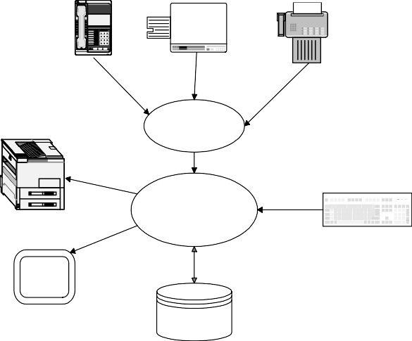

1 2

4 5

7 8 9

8 #

Printer

Copitrak System

EZ-Law system

Keyboard

Monitor Screen

Main Database

* + General Ledger
  + Trust Ledger and records of all transactions
  + Payables history and payment record
  + Check registers for all accounts
* Employee Information
* Payroll records
* Billable employee time records
* Historical data on copier/fax/telephone usage

# 3.3.2-Time/Space Bounds & Efficiency

* EZ-Law shall support no less than 20 users simultaneously, and optimally 30 to allow for expansion.
* 95% of all transactions shall be processed in less than 1 second.
* Storage space is not a major concern as drive space on the server is expandable and the amount of data anticipated to pass through the system or be stored is considered to be moderate and not expected to exceed capacity.
  + - * Memory usage, at any given time shall be no more than 32 MB of RAM at any desktop, and no more than 128 MB of RAM at the server.

# 3.3.3-Security

Access to the system shall be by use of login ID and password. Access shall be controlled by user groups that provide specific access privileges based on the user. Levels of user access should be linked to access to tables in the database. Any given user should be able to access the interfaces and print reports based on the information in tables in the database that are available to their user level. The system administrator shall be able to set up user groups, or give completely custom access to one or more employees. Main user groups would include:

* + System Administrator: Full access to all data: All interfaces available
  + Bookkeeper: Full access to all data: All interfaces available
  + Billable Employee: Time Tracking, Disbursement and Report Generator Interfaces Available

From Report Generator Interface:

* + - Access to client billing information and charges
    - Access to their own timesheet information and billings
  + Staff: Disbursement and Report Generator Interfaces Available From Report Generator Interface:
    - Access to limited client billing information
    - (current charges only)

s