

GSM Base Alarm System

Arduino IDE Codes

Helsinki Metropolia University of Applied Sciences

Electronics Engineering

Date : 1st Dec 2015

|  |  |
| --- | --- |
| Author(s)  Title  Number of Pages  Date | Prajjwol Tripathi , Suresh Lama , Dibas Bhandari  IDE Codes  14 pages  1 Dec 2015 |
| Project | GSM Based Alarm System |
| Instructor(s) | Timo Kasurinen, Project Manager |

**Contents**

**1 Arduino IDE 1**

**1.1 Pre-processor Command 1**

**1.2 Definitions 2**

**1.2.1 Function Definitions 2**

**2 Main Function Void Setup () 3**

**2.1 Void Alarmoff () 4**

**2.2 Void Alarmon() 4**

**2.3 Void calltheowner() 4**

**2.4 Void smsowner() 5**

**2.5 Void playTone(long duration, int freq) 5**

**2.6 Void alertfunction() 6**

**2.7 Void passwordcheckfunction() 6**

**2.8 Void passwordcheckfunction1() 7**

**References 8**

# Arduino IDE

The open-source Arduino Software (IDE) is a platform to program all the Arduino Boards co-operating with any system, the latest version available is Arduino 1.6.6. This environment is written in JAVA and based on Processing and based on other open source software’s.

## **Pre-processor Command**

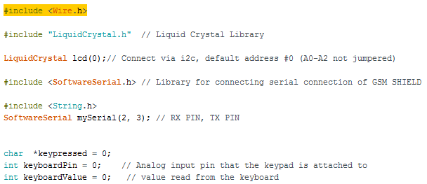

## **Definitions**

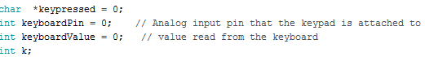

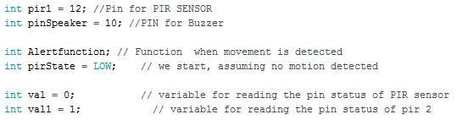

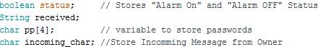



### **Function Definitions**

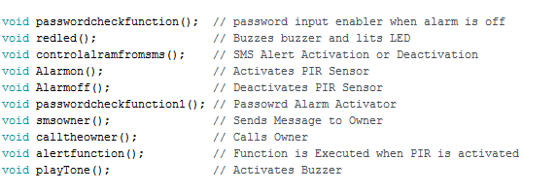

# Main Function Void Setup ()

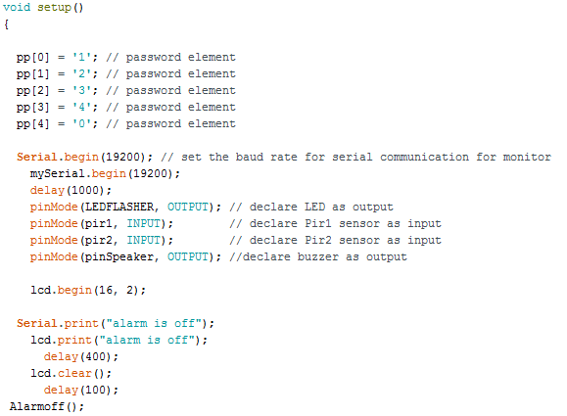

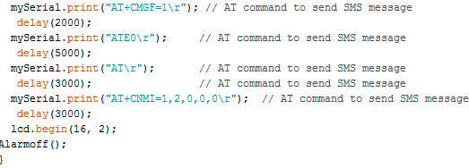

## **Void Alarmoff ()**

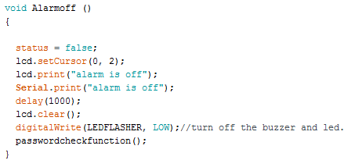

## **Void Alarmon()**

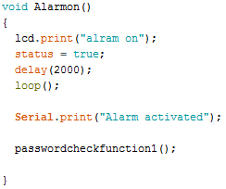

## **Void calltheowner()**

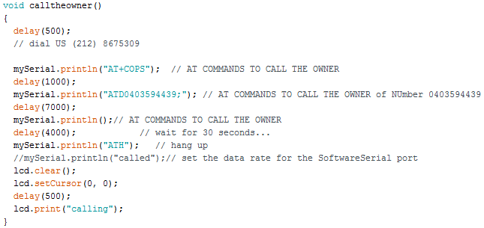

## **Void smsowner()**

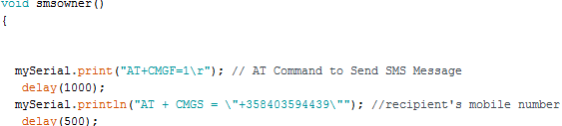

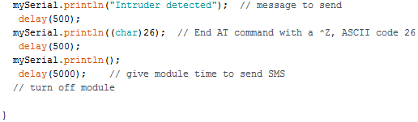

## **Void playTone(long duration, int freq)**

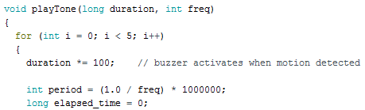

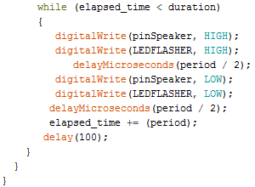

## **Void alertfunction()**

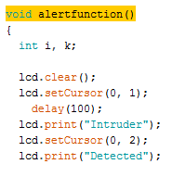

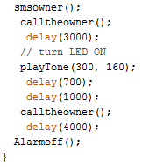

## **Void passwordcheckfunction()**

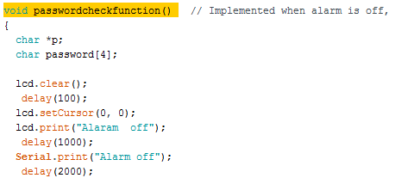

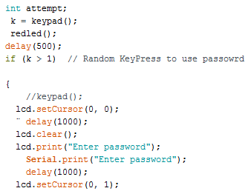

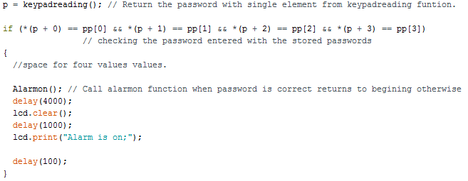

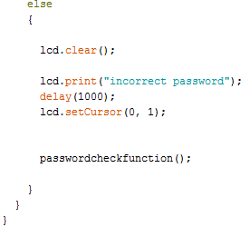

## **Void passwordcheckfunction1()**

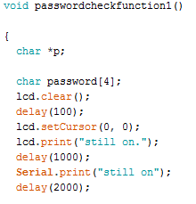

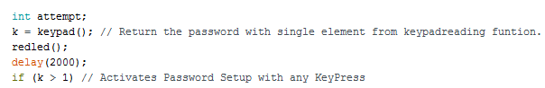

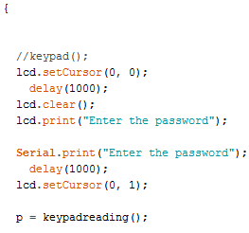

if (*(p + 0) == pp[0] && *(p + 1) == pp[1] && *(p + 2) == pp[2] && *(p + 3) == pp[3])

// checking the password entered with the stored passwords

{

//space for four values values.

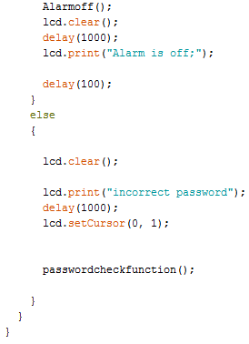

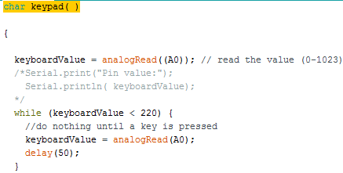

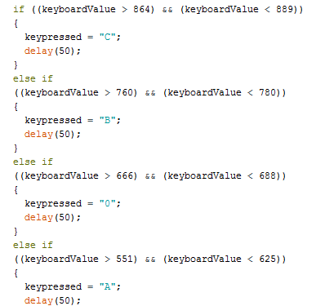

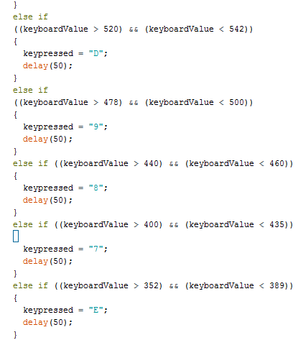

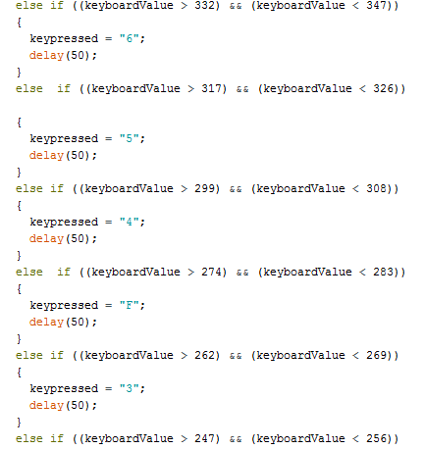

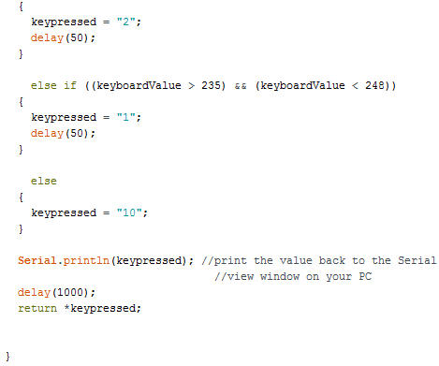

# References

[www.arduino.com](http://www.arduino.com)

<https://forum.arduino.cc>

<https://www.arduino.cc/en/Reference/HomePage>