**Program Output**

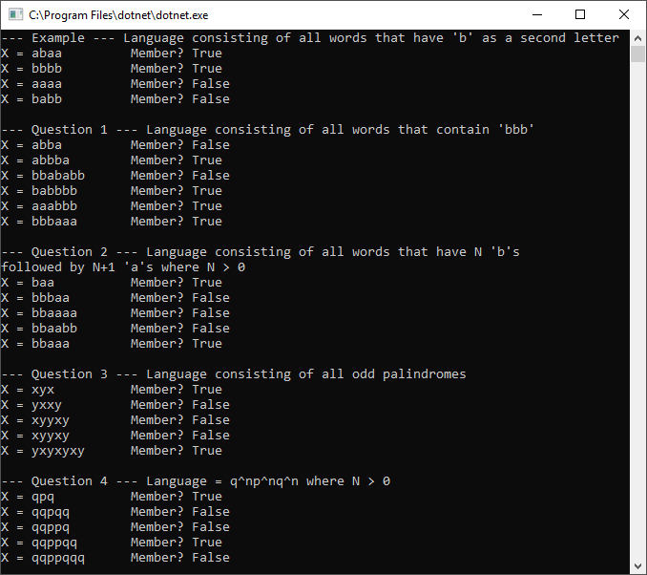

**Turing Machines**

**Question 1 –** Language consisting of all words that contain the substring ‘bbb’

0 is start. Halt is state 4

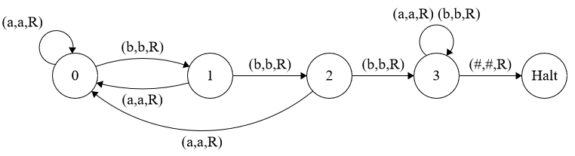

**Question 2 –** Language consisting of all words that have N b’s followed by N+1 a’s where N > 0

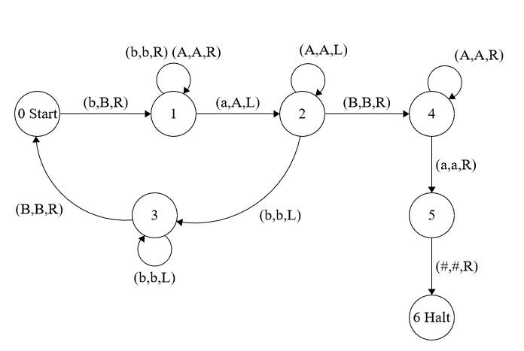

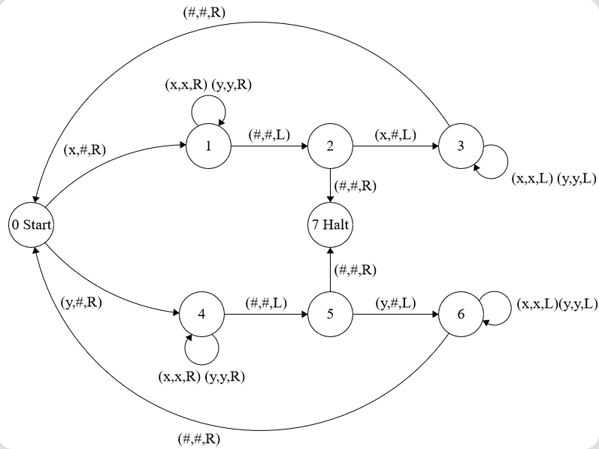**Question 3 –** Language consisting of words that are odd length palindromes

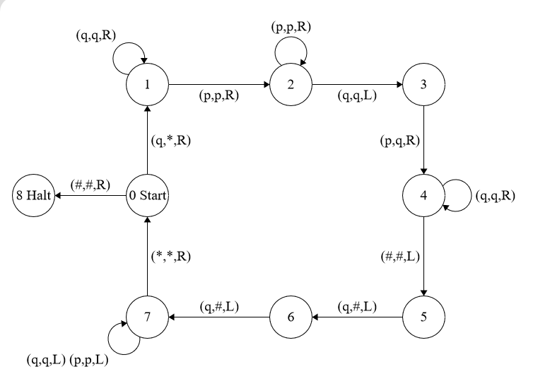**Question 4 –** Language consisting of words in qnpnqn where n > 0