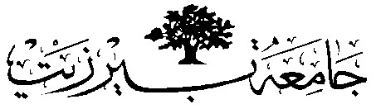

**Birzeit University**

**Artificial intelligence**

**Project one**

**Student’s Name**: Sami Moqbel

**Student’s No.** : 1200751

**Partner’s Name:** Lama Abdelmuhsen

**Partner’s No.:** 1201138

**Section**: 2&4

**Date:** 6/20/2023

**Instructor:** Dr.Yazan Abu Farha

**Introduction**

We built a game cave by several moves, using the min-max to play the best possible moves.

**Procedure**

* Printing Menu

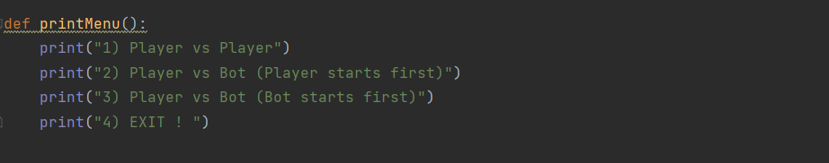

* Building the board

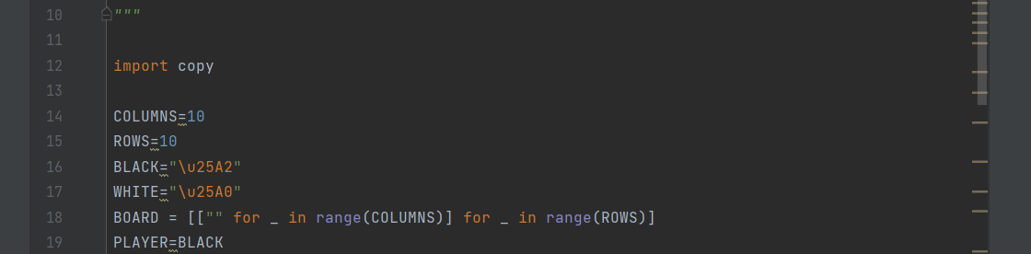

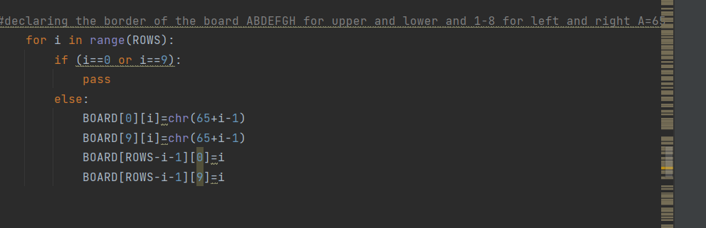

* Taking input from the players, one player at a time, and making a move.

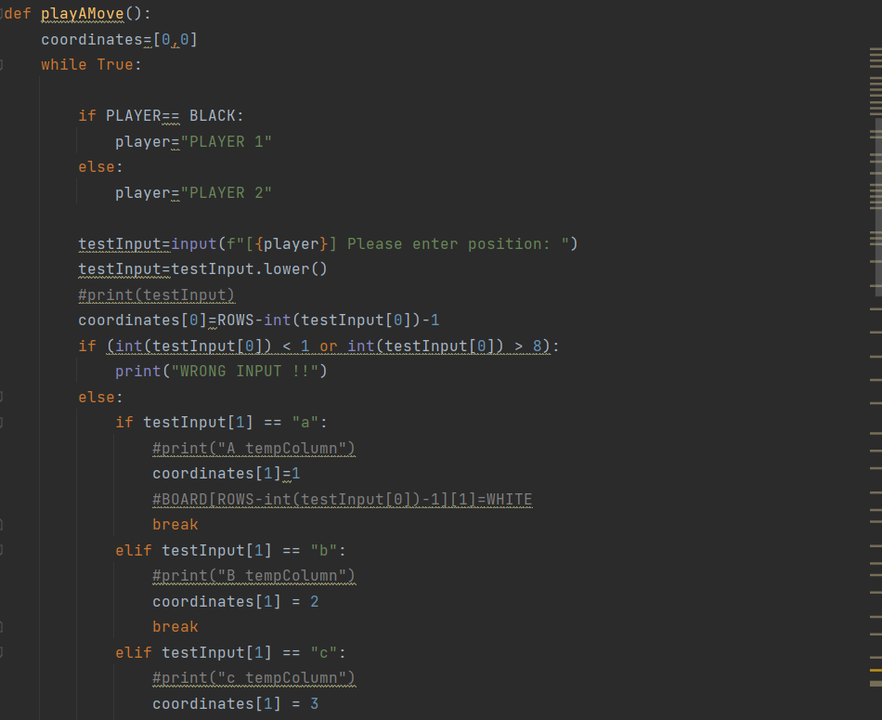

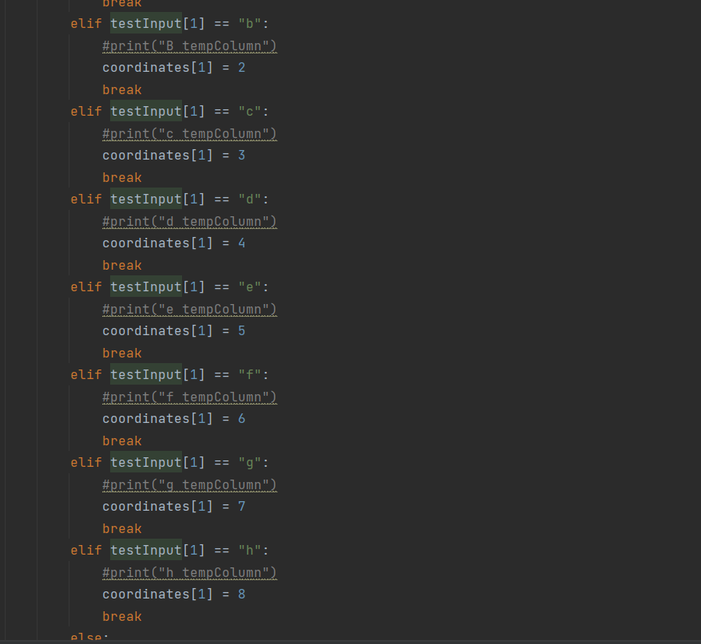

* Printing the board

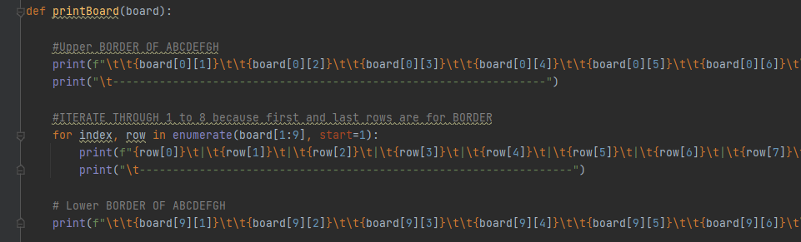

* Changing the turns

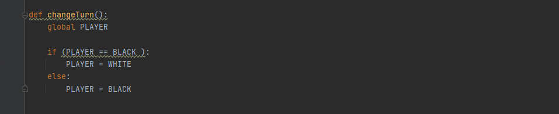

* Checking empty spots

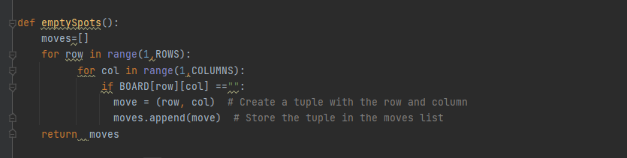

* Checking Available spots
* 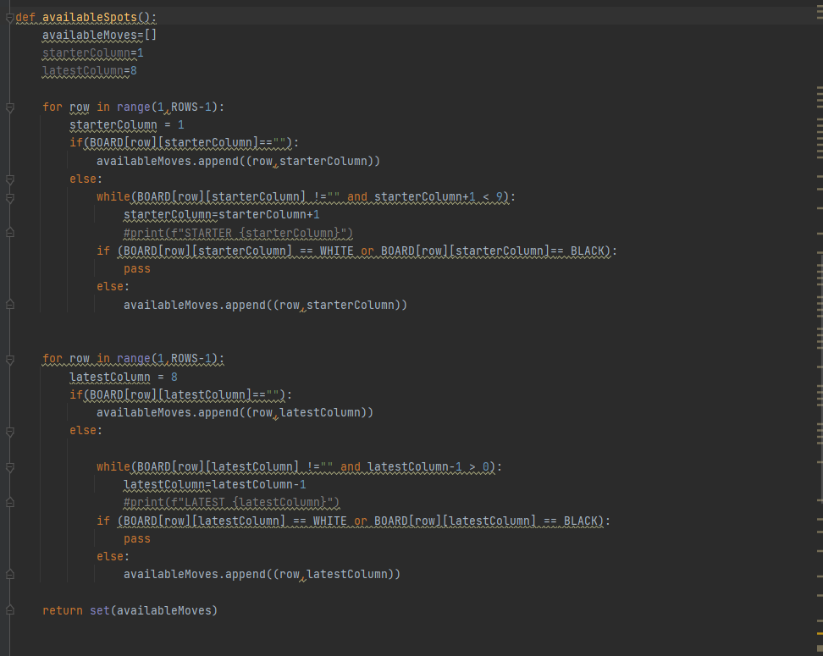
* Checking if black Wins
* 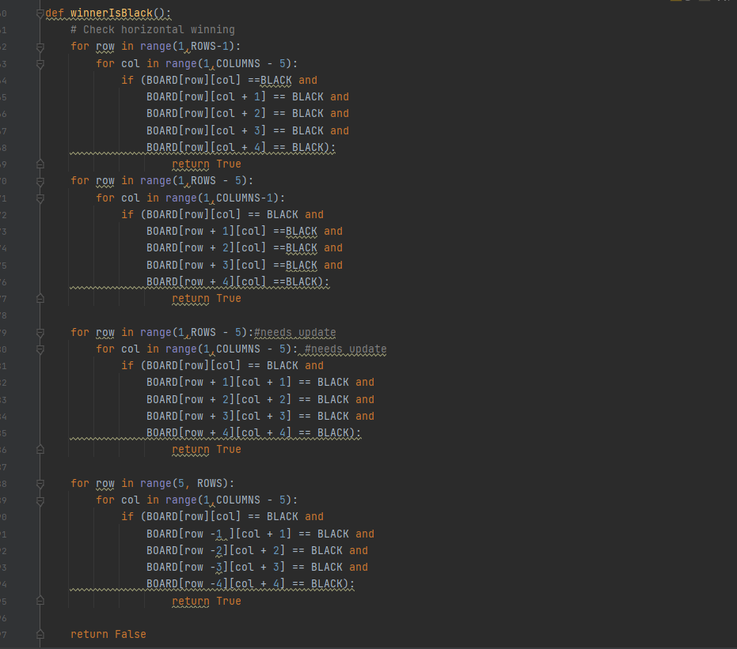
* Checking if White Wins
* 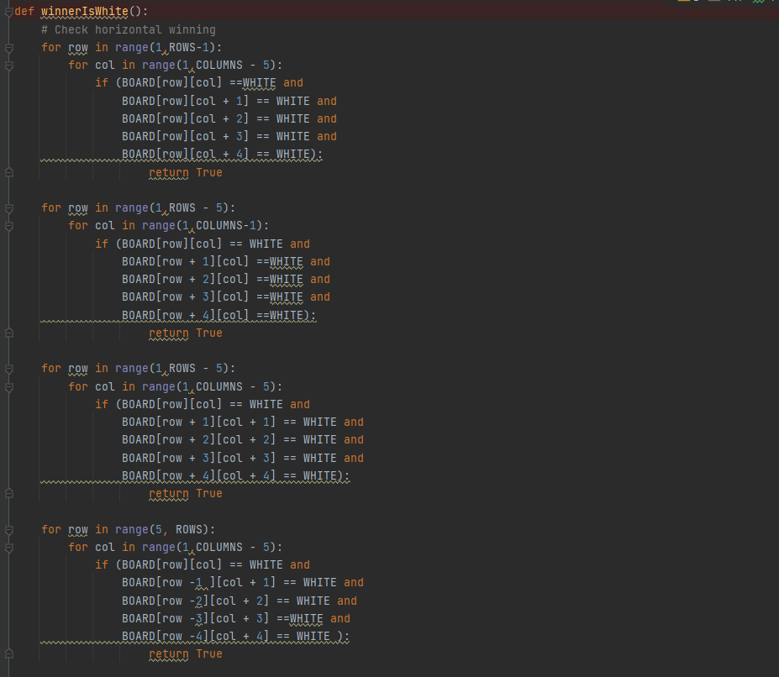
* Finding the number of connections to help in the evaluation function
* 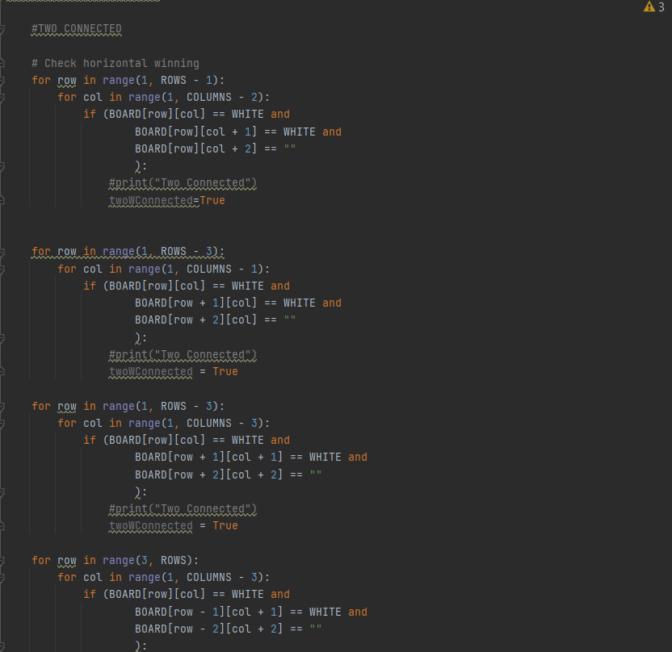
* 
* 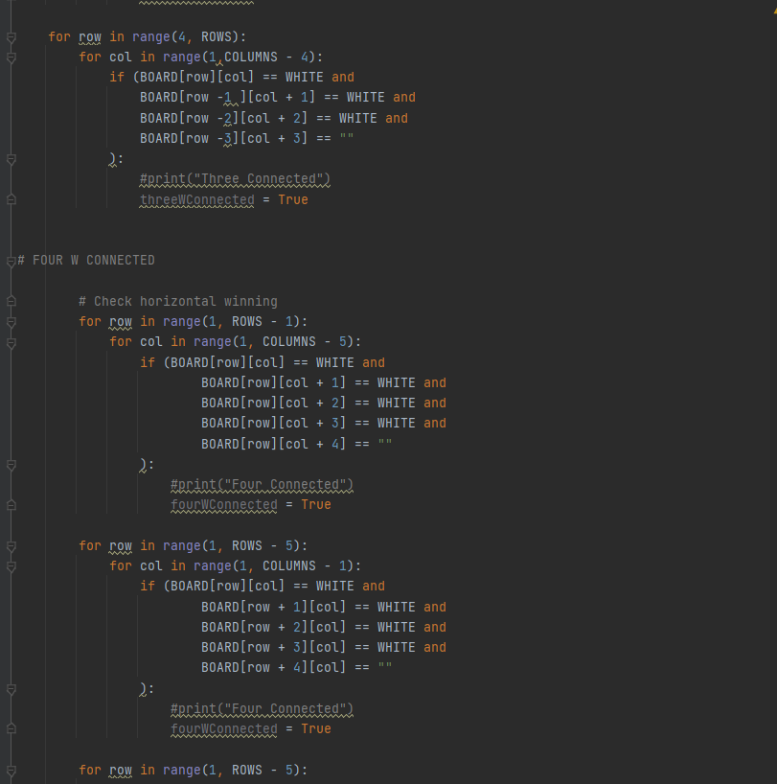
* 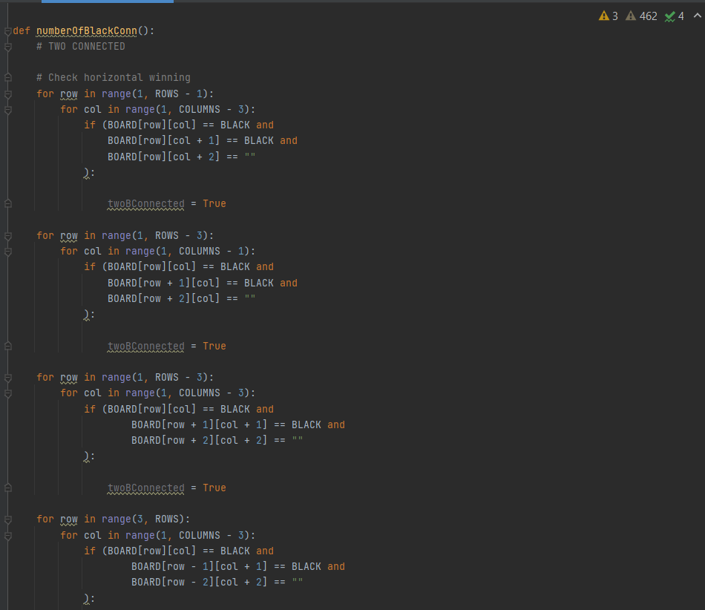
* 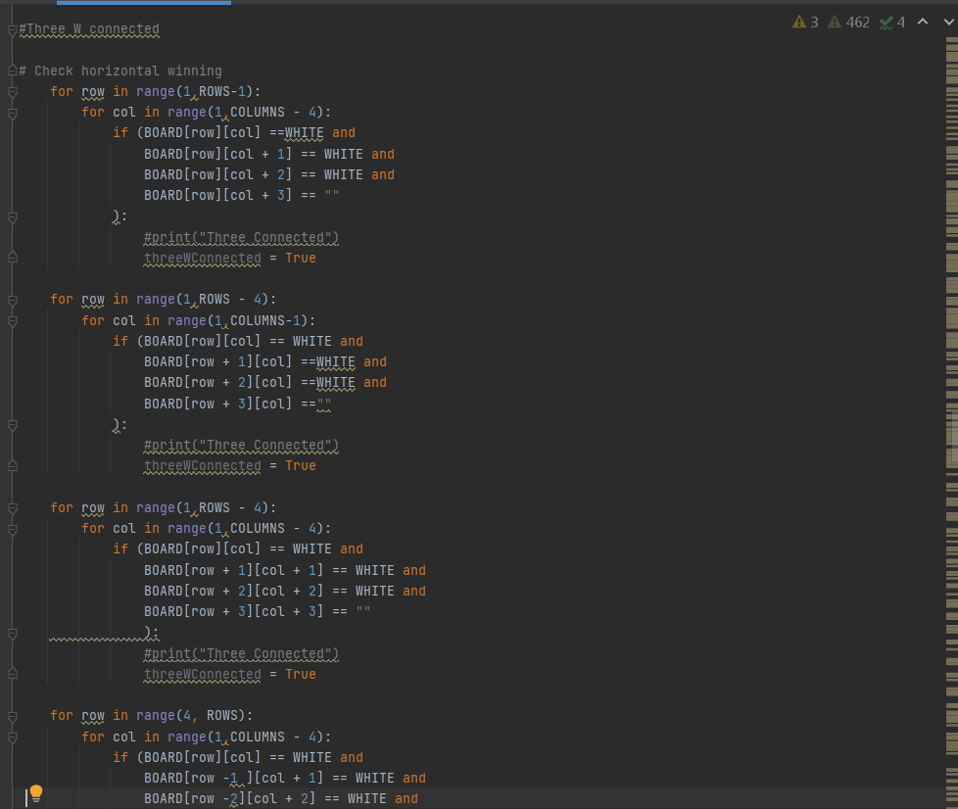
* 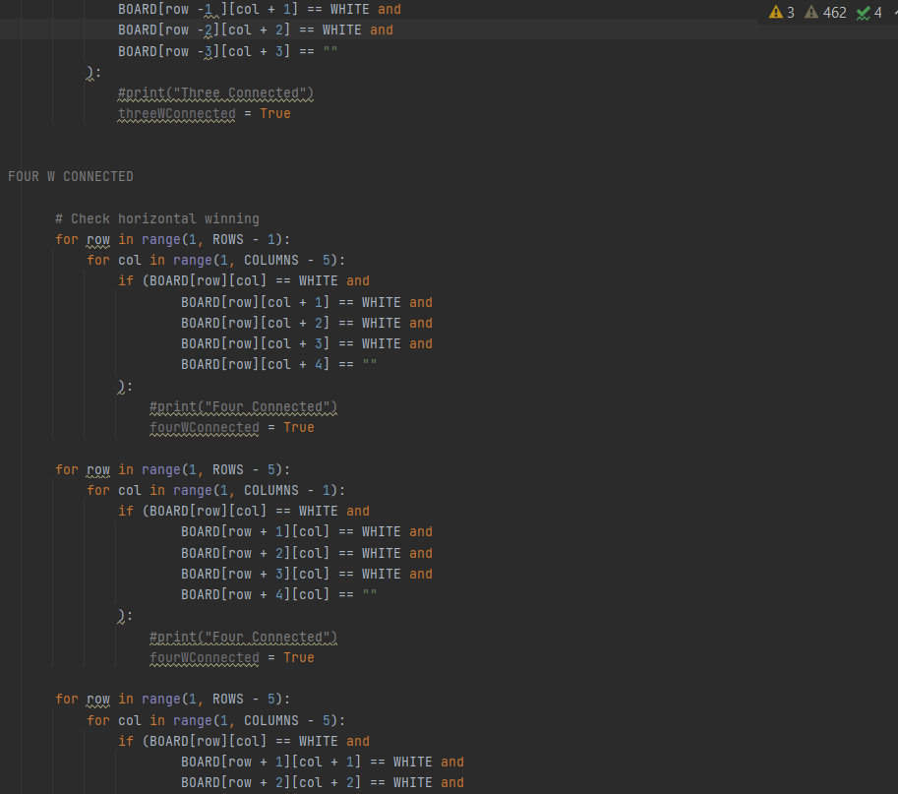
* 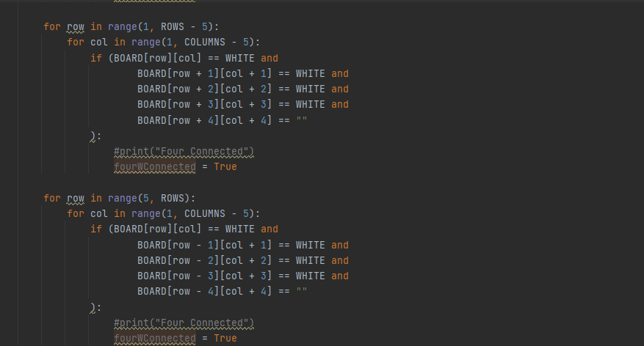
* And the same function for the black
* Evaluate function
* 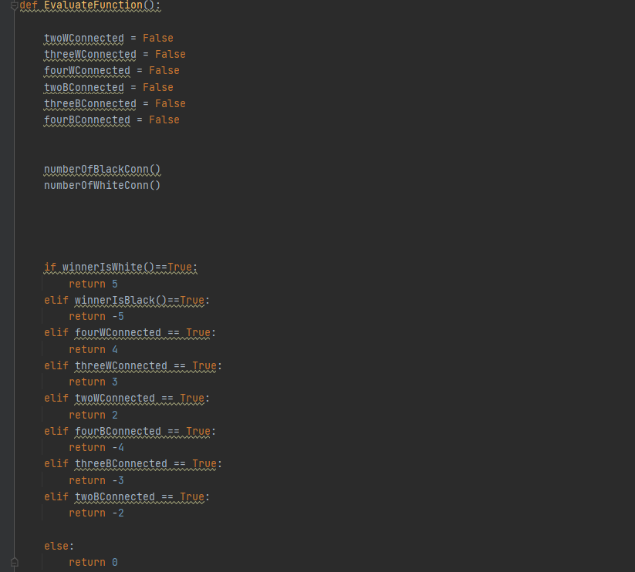
* Minimax Algorithm
* 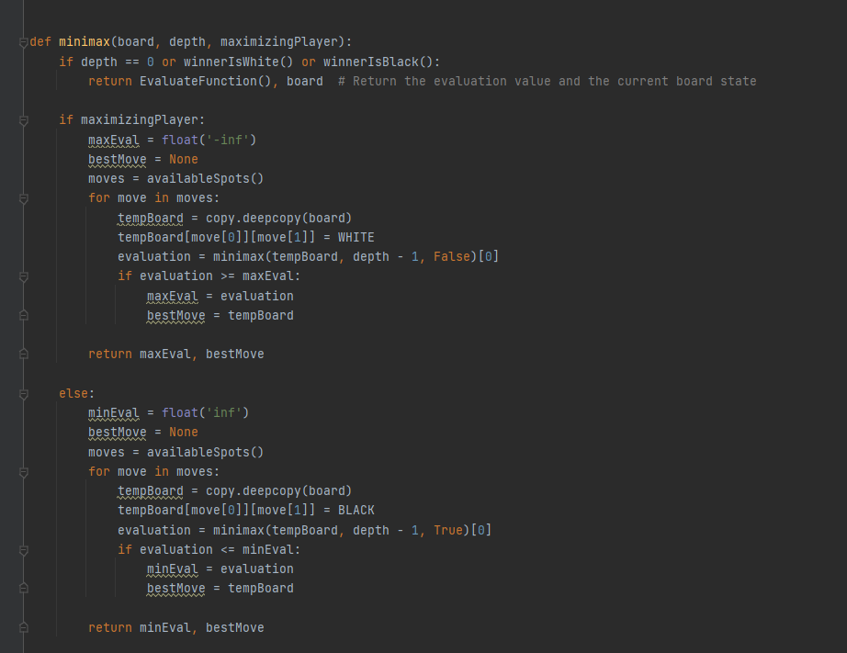
* Main:
* 
 