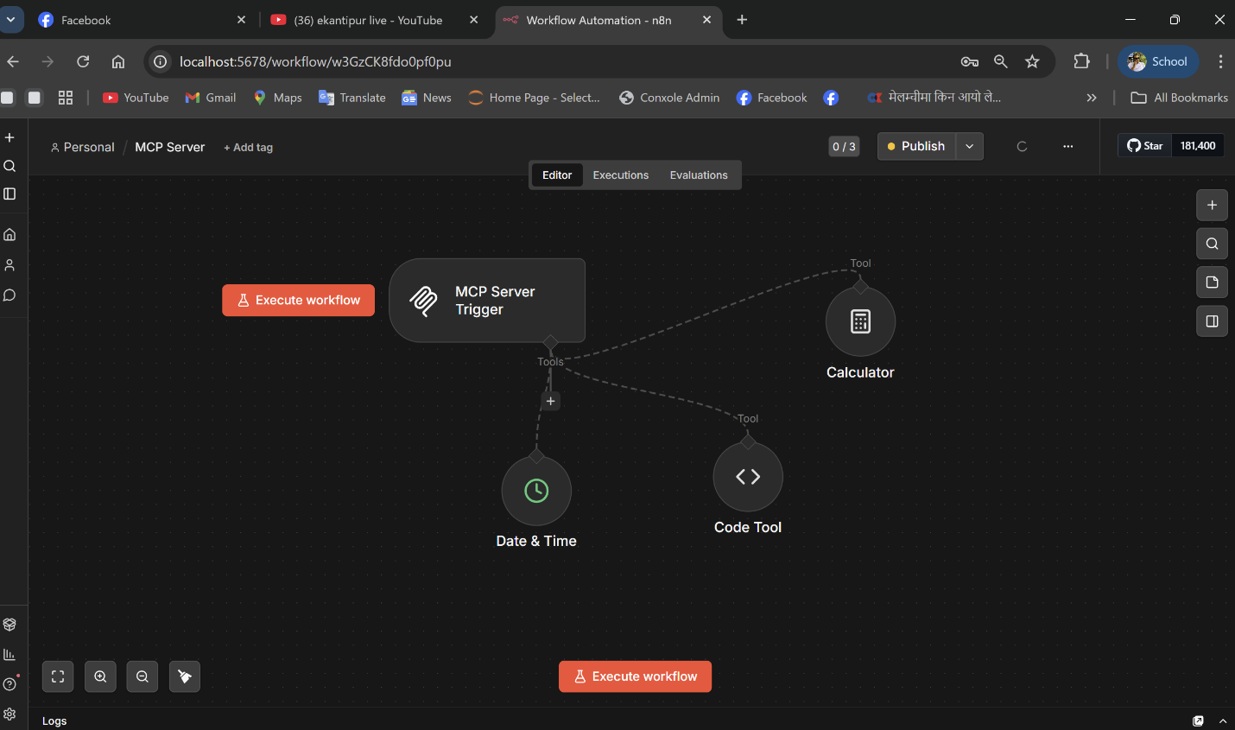
Task 1.2: MPC SERVER WORKFLOW

The screenshot shows an n8n workflow titled “MCP Server” that is currently in the Published state, indicated by the green “Published” label in the top-right corner. The workflow begins with an MCP Server Trigger node and is connected to three internal tools: Calculator, Date & Time, and Code Tool (Text Formatter). This setup confirms that the MCP Server is running and that all the tools are properly available for discovery and use.

Task 1.3: AI Agent Client Workflow
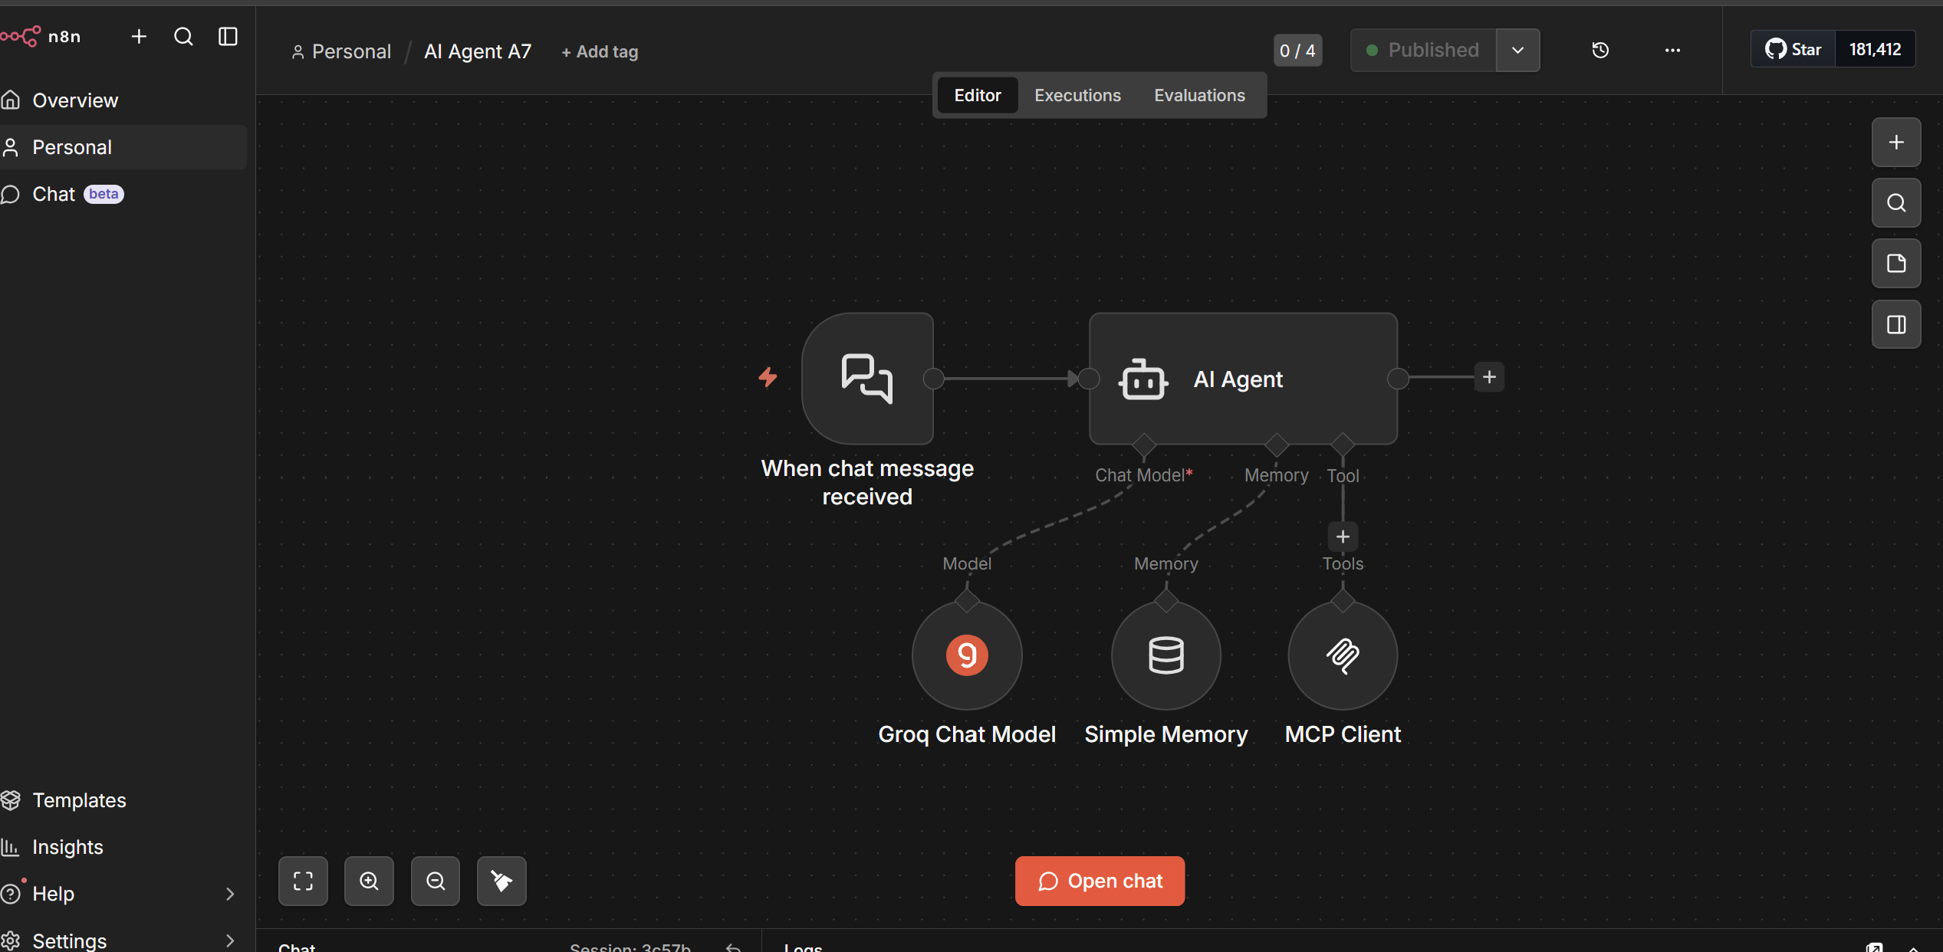
The image shows an n8n workflow called “AI Agent A7”, which functions as the AI Agent Client. The workflow starts with a When Chat Message Received trigger that is connected to an AI Agent node. This AI Agent node is configured with three components: a Groq Chat Model (using a free model API) as the language model, Simple Memory to maintain conversation context, and an MCP Client linked to the Production URL of the MCP Server to enable access to the tools created in Task 1.2.

Task 1.3: Verification: AI Agent Successfully Using MCP Tools 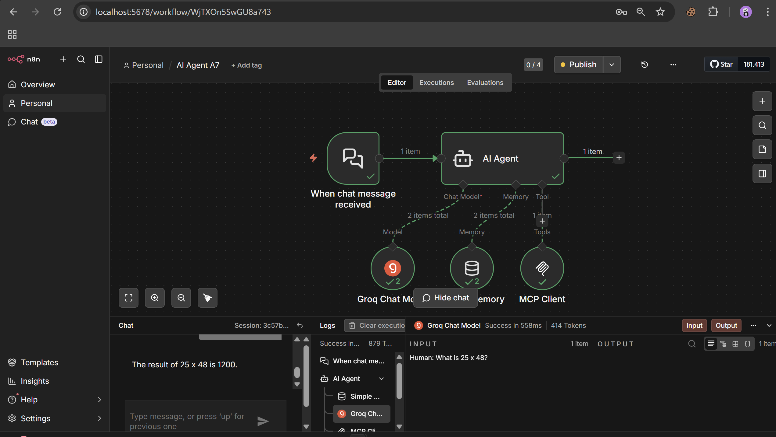

The AI Agent workflow was successfully created and configured with the following components:
- Trigger: When Chat Message Received
- LLM: Groq Chat Model (connected and verified)
- Memory: Simple Memory for context retention
- Tool: MCP Client connected to the MCP Server Production URL
To verify the agent can use MCP tools, the following test was performed:
User input: "What is 25 x 48?" Agent response: "The result of 25 x 48 is 1200."
The agent successfully routed the calculation through the MCP Client → MCP Server → Calculator tool, returning the correct answer. All nodes show green checkmarks confirming successful execution in 558ms using 414 tokens.

Task 1.3 Verification: AI Agent Using Date & Time MCP Tool
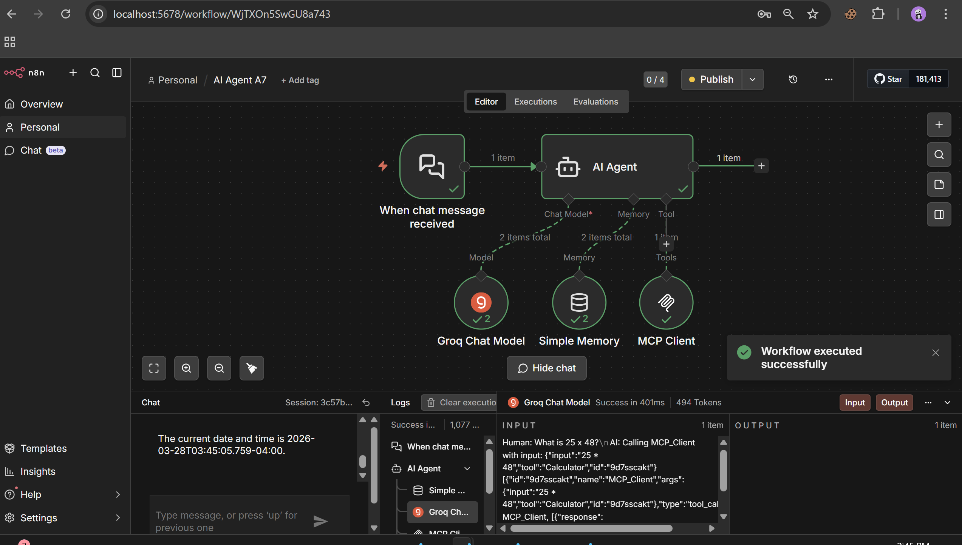
The screenshot shows a successful execution where the agent was asked for the current date and time. The output confirms: "The current date and time is 2026-03-28T03:45:05.759-04:00." All nodes are green, showing the full pipeline — Groq Chat Model, Simple Memory, and MCP Client — executed successfully in 401ms using 494 tokens. The logs panel confirms the agent called the MCP Client tool to retrieve the real-time date and time, demonstrating that the MCP Server tools are correctly discoverable and usable by the AI Agent.

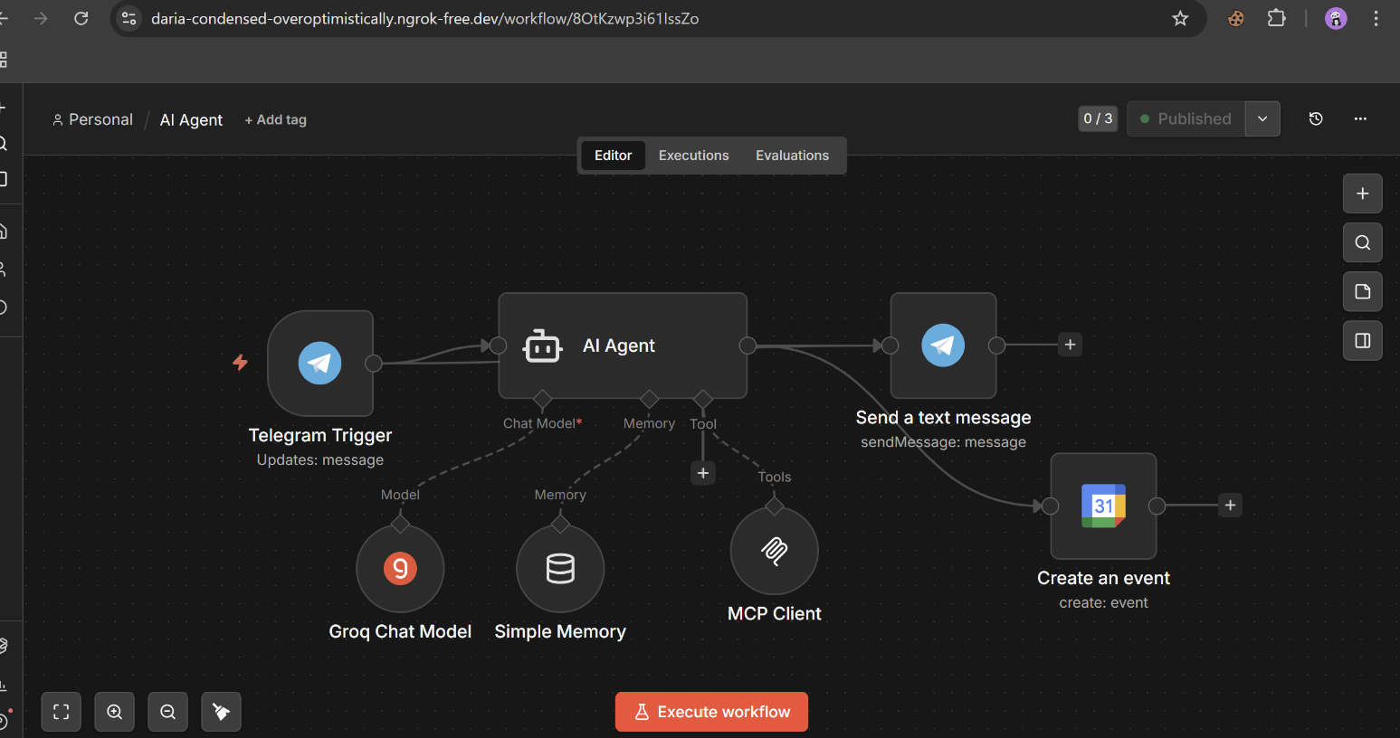
Task 2.1 : Telegram Bot API Integration
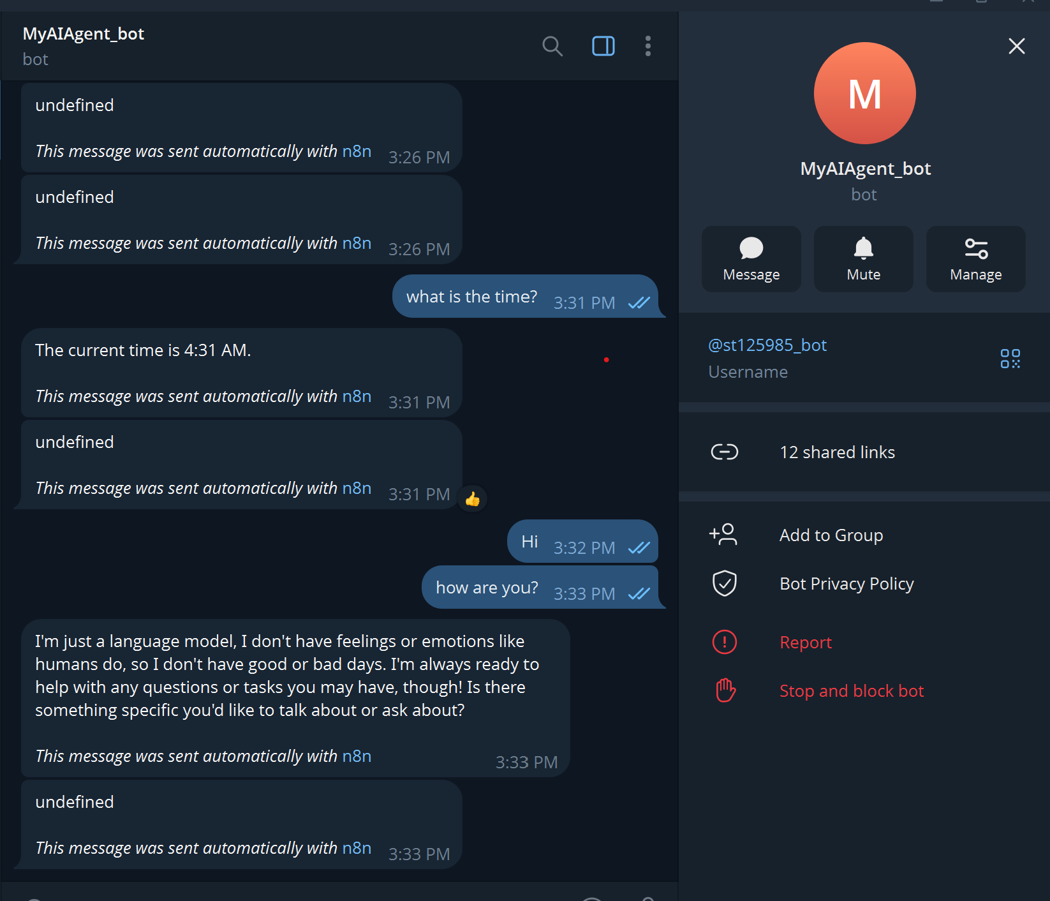

The screenshot shows the AI Agent successfully connected to Telegram via the bot @st125985_bot. After sending a message asking for the current time, the bot responded correctly with "The current time is 4:31 AM", confirming that the Telegram Trigger is properly receiving user messages and the AI Agent is processing and returning responses through the Telegram Send Message node. The bot profile panel confirms the username @st125985_bot is active and operational. This demonstrates that the Telegram Bot API is fully integrated with the n8n workflow, enabling bidirectional communication between the user and the AI Agent directly within the Telegram application.

Task 2.2: Google Calendar Tool Integration
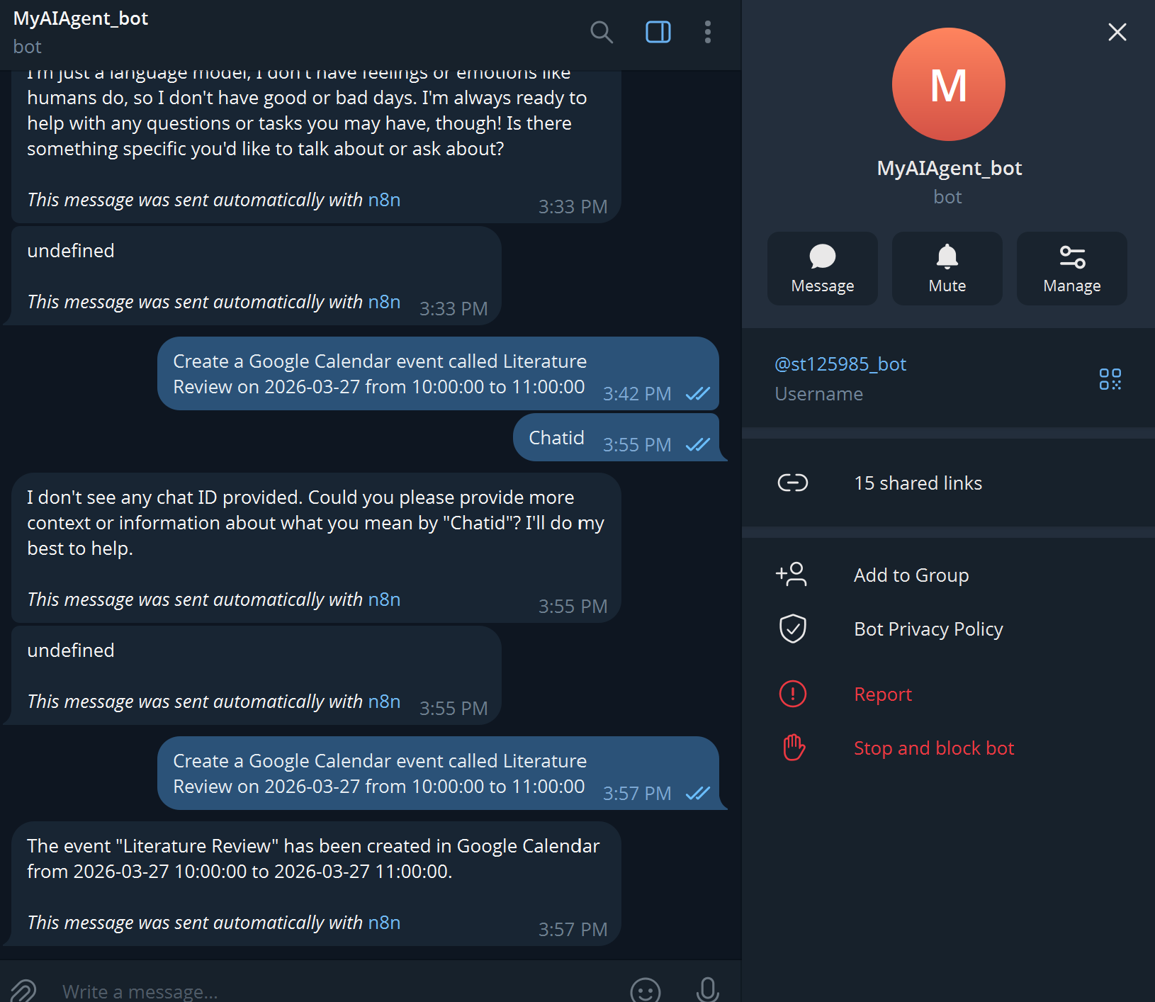
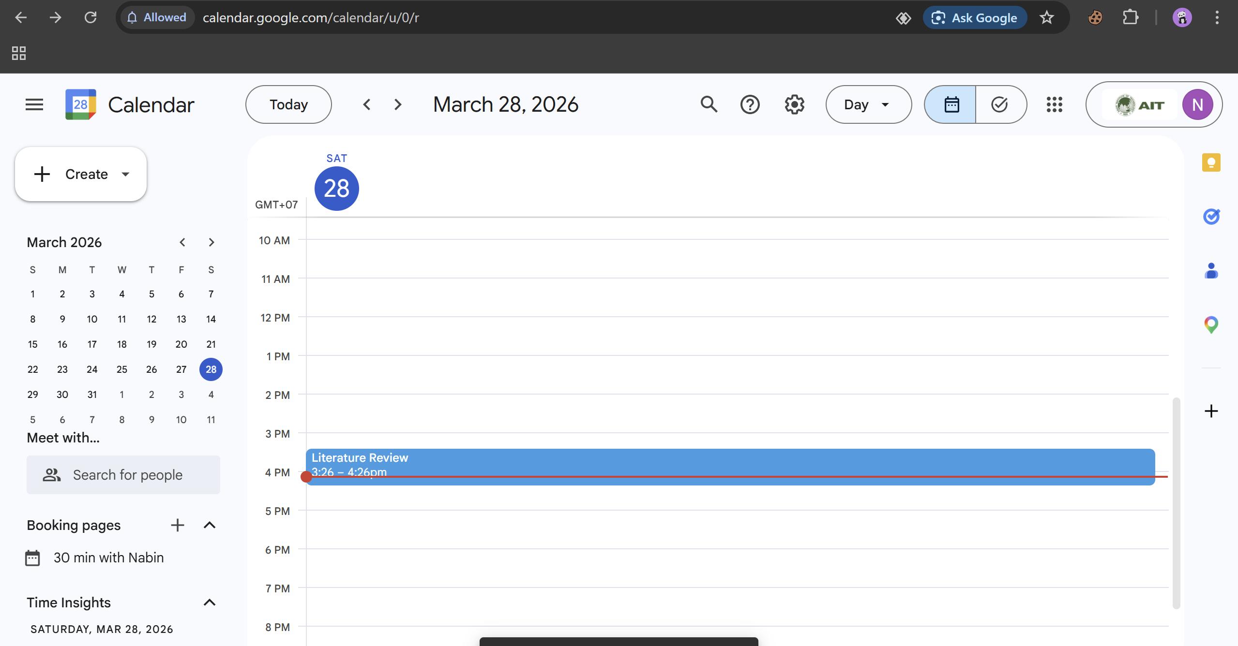
Task 2.3 Automated Project Scheduling: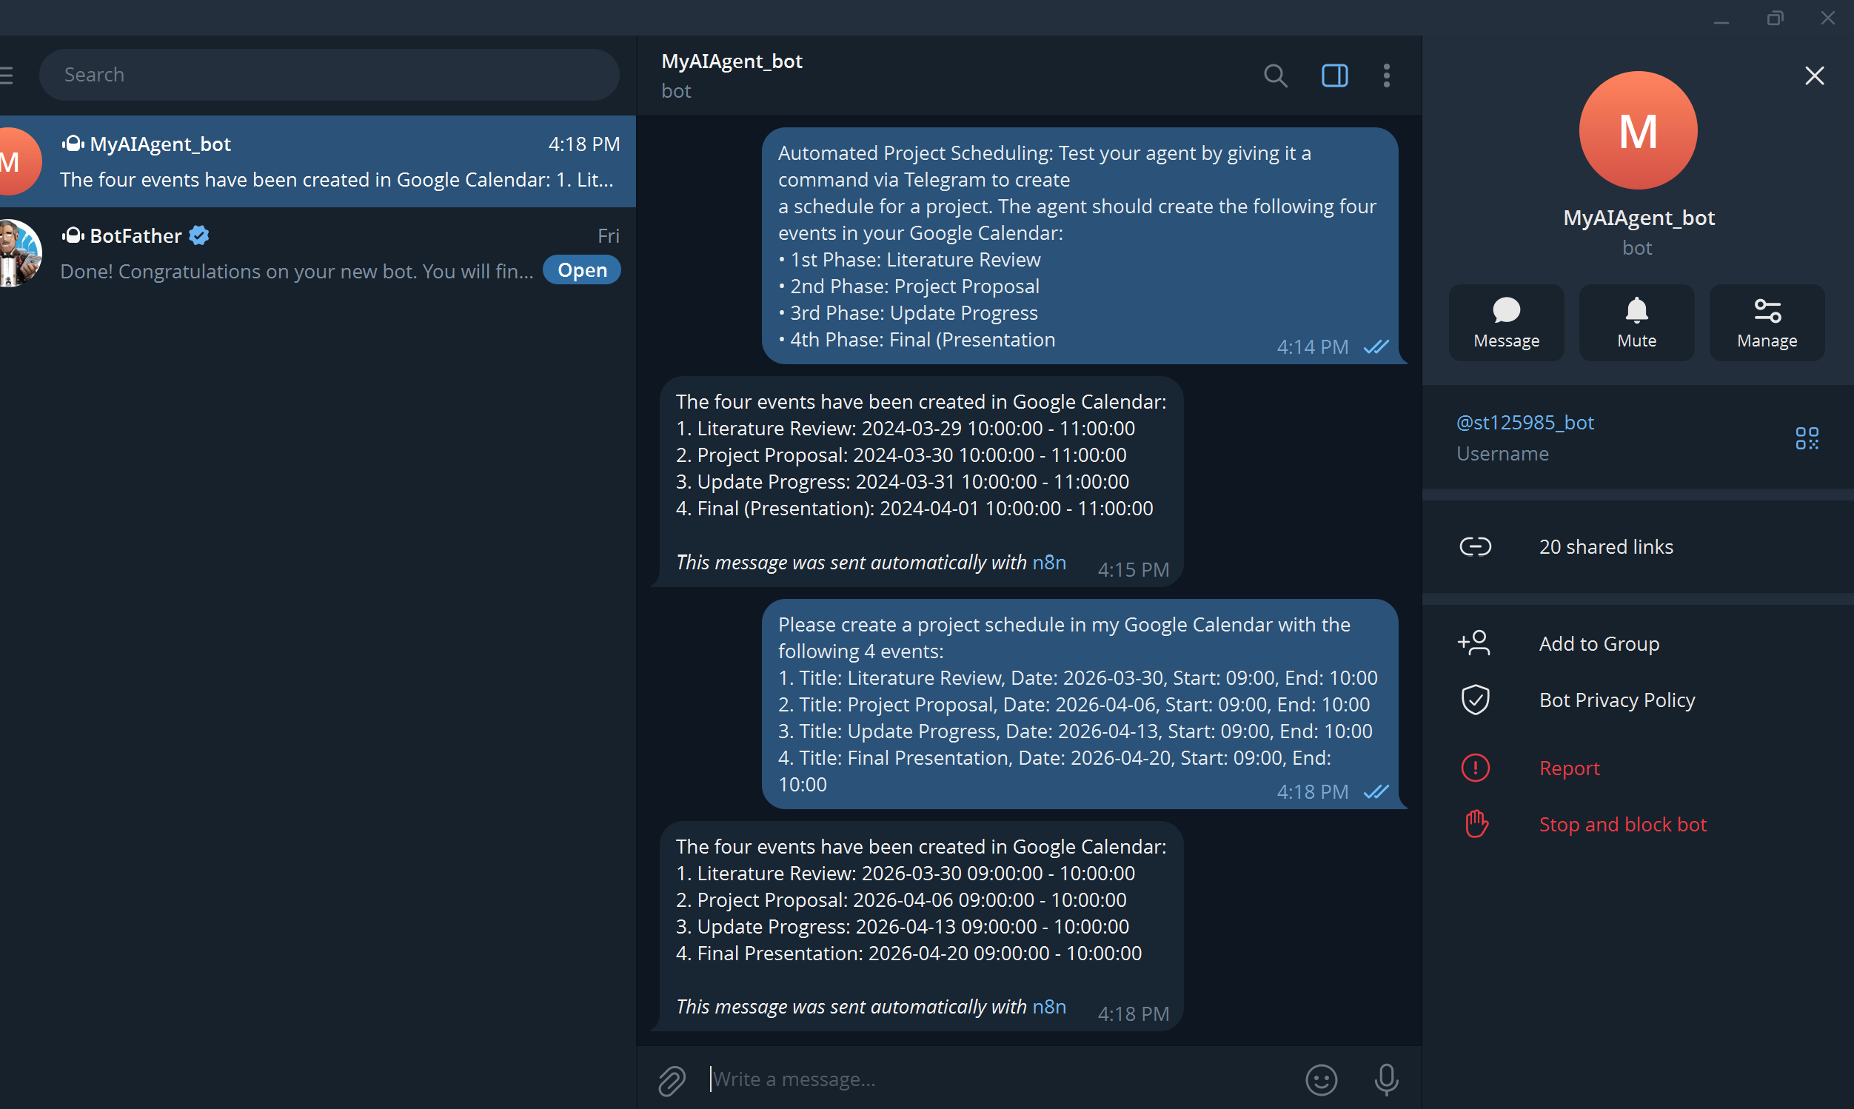

Literature Review March 30
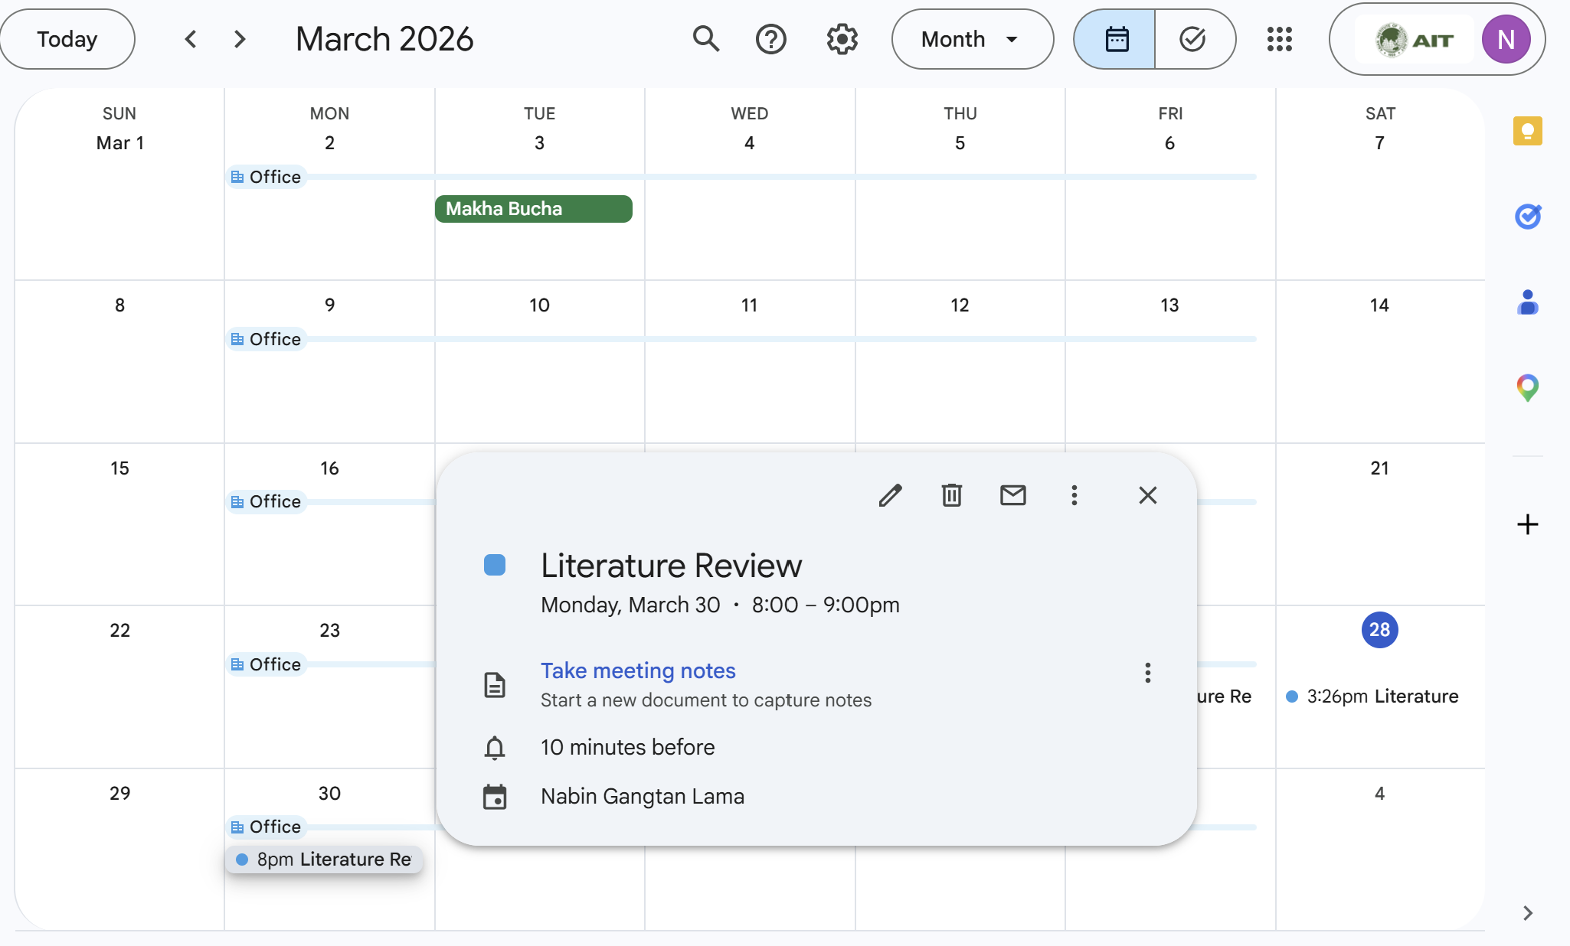

Project Proposal April 6
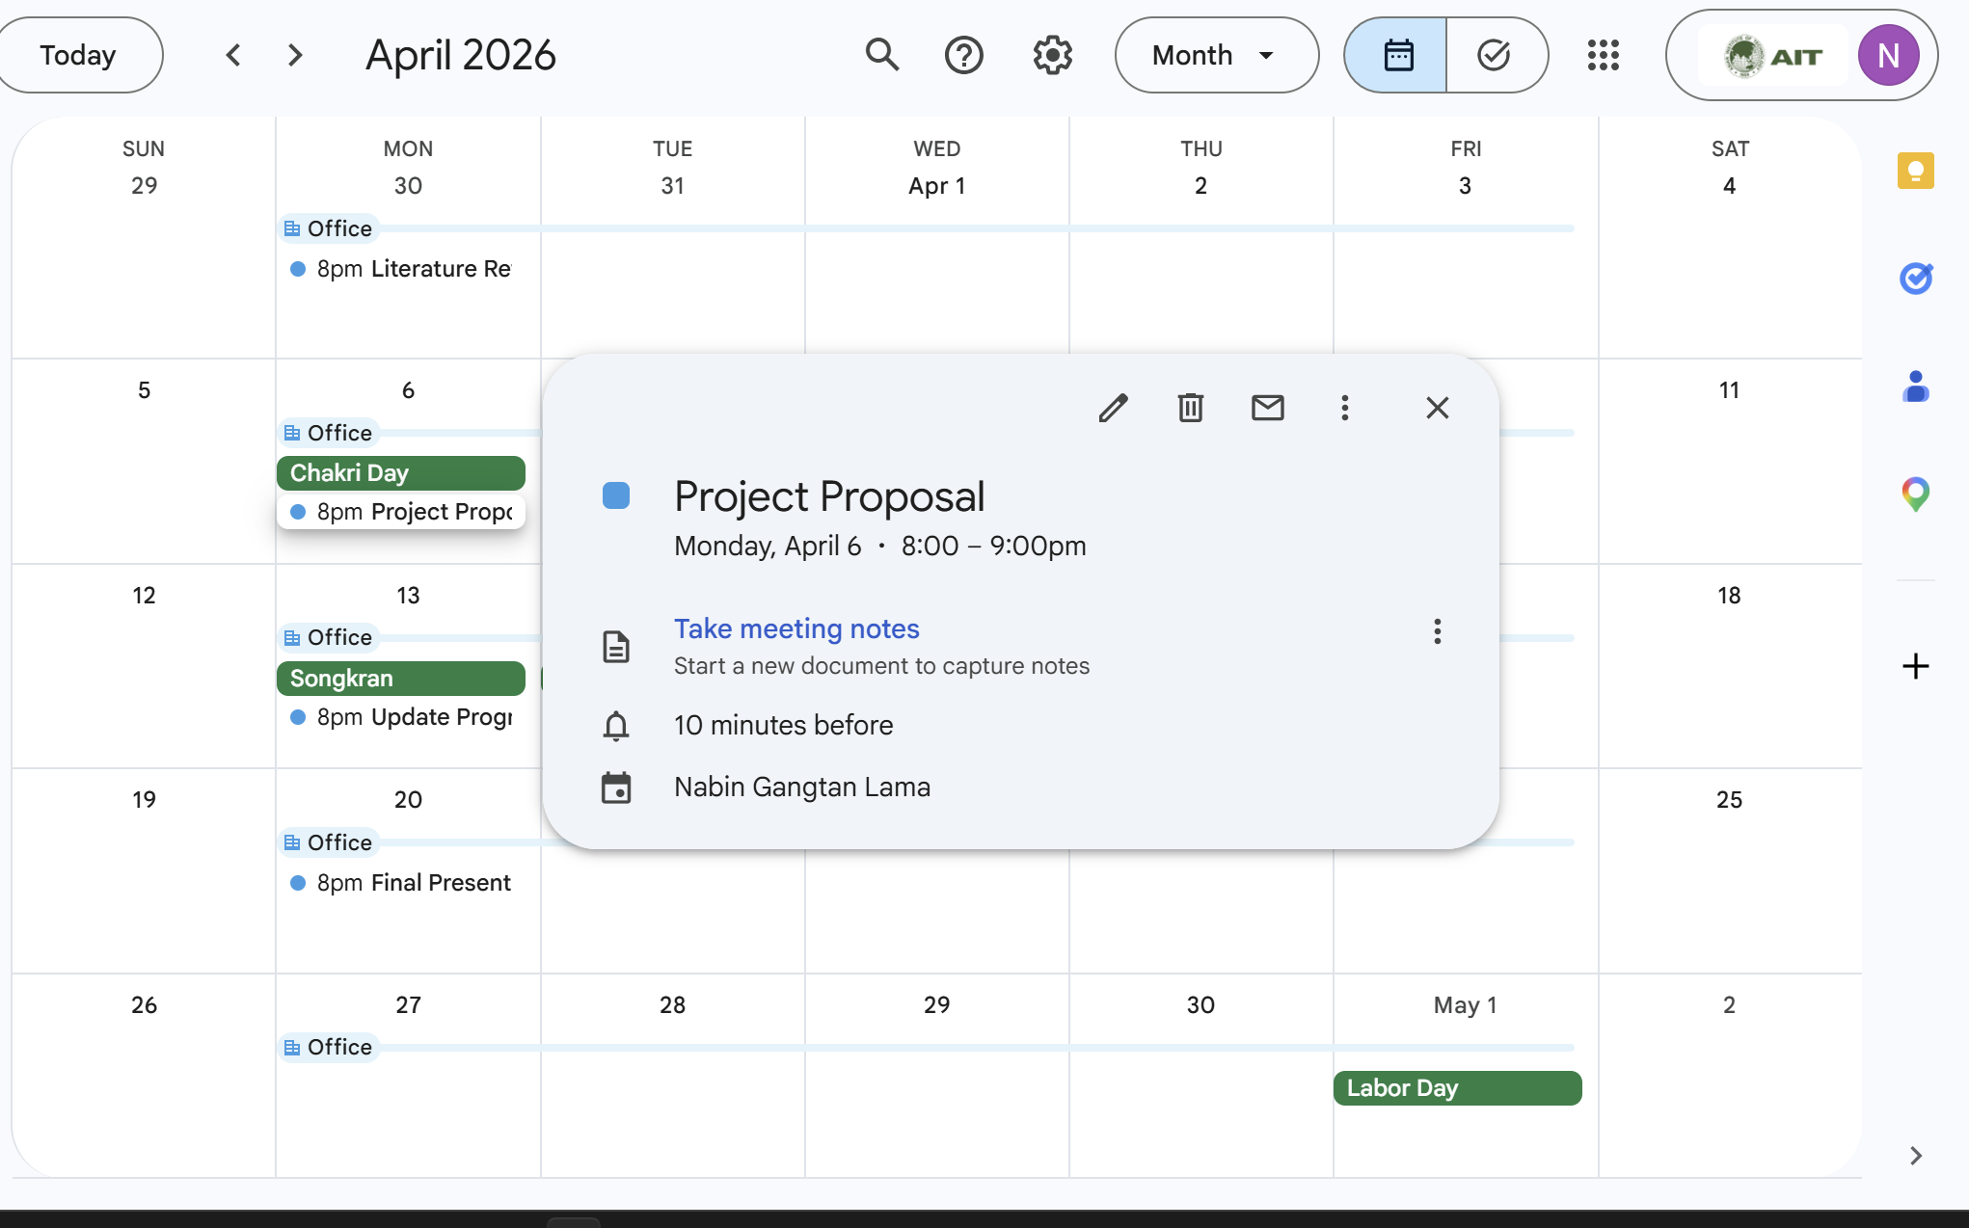

Update Progress April 13
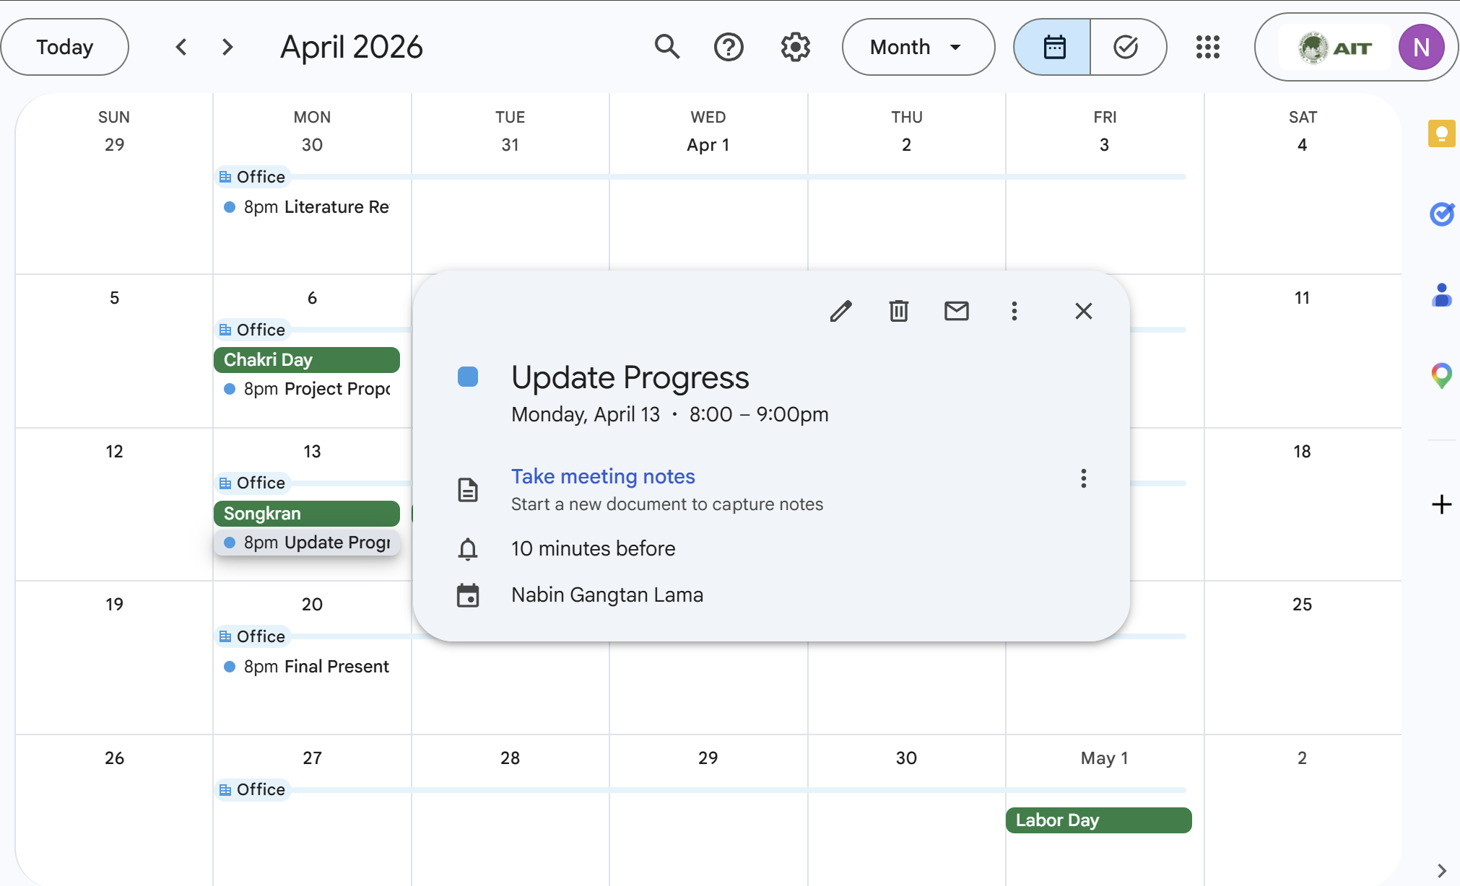
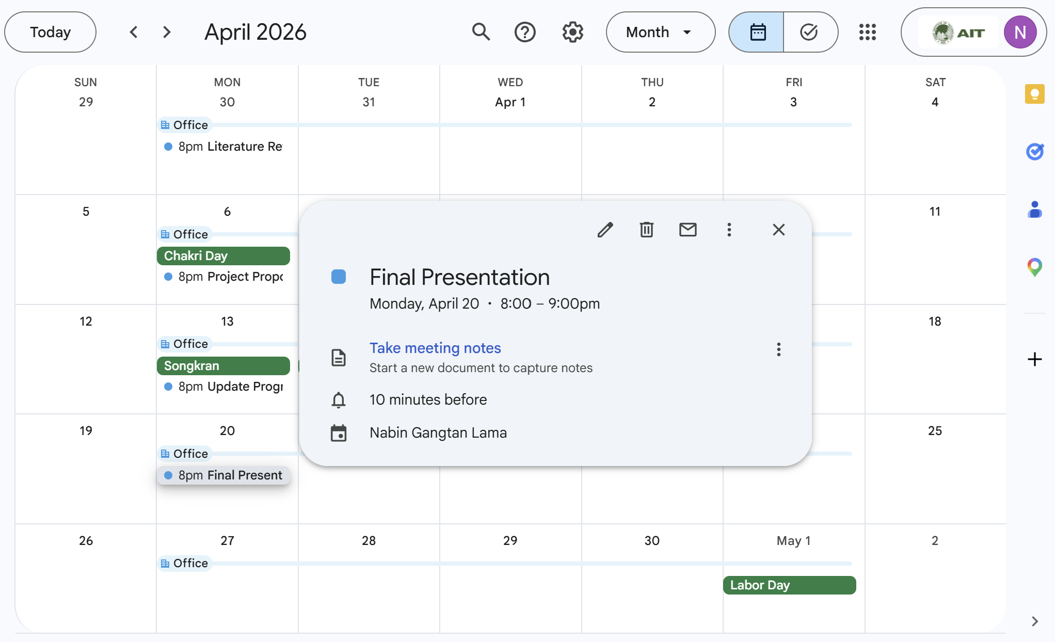
Task 2.3
