|  |  |  |
| --- | --- | --- |
| **Kingdom of Saudi Arabia**  **The Ministry of Education**  **Princess Nourah Bint Abdul**  **Rahman University (48)**  **Final Examination**  **Second Semester of 2024** |  | **College of Business and Administration**  **Business Administration Department**  **Course:**  **Date: 05/10/2024**  **Time:**  **Number of pages:….. + cover page** |

**Assignment Cover Page**

**Program Mission:** “To prepare professional women who could serve their communities and compete globally in the business and management sector through the pursuit of learning and research in an innovative educational environment.”

**Program Goals:**

* Apply the management skills in business organizations to lead, support business excellence and fulfilling the labor market needs.
* Pursue higher studies, research to reflect the intellectual acumen through industry and academic participation.
* Excel through participating in social, commercial, start-up ventures.
* 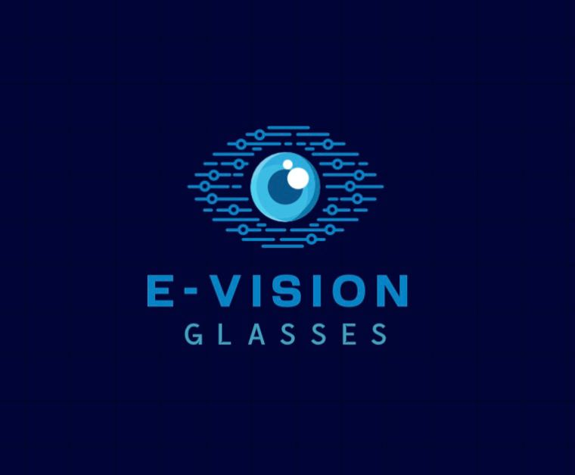Become transformative and inspiring forces for community enrichment through disseminating specialized knowledge and skills.

|  |  |
| --- | --- |
| **Course Name:** | **Entrepreneurship** |
| **Course Number:** | **BUS 353** |
| **Assignment title or task:**  **(You can write a question)** | **Business Plan \ E-Vision Glasses** |
| **Student Name:** | **1.**Saadah Saud  **4.** Raghad Almubaddel  **2.**Alreem Alessa  **5.** Farah Almazroa  **3.**Ghaida Alkhamis  **6.** Lama Alshaiban |
| **Student Number:** | **1**.444009178 **4.**444009101  **2**.444008408  **5.**444009242  **3**.444009075  **6.**444009259 |
| **Submission Date:** |  |

|  |  |
| --- | --- |
| **Instructor Name** | **Alia Alanazy** |
| **Grade** | **….. out of** |

Table of Contents

Section 1: Executive Summary 3

Section 2: Industry Analysis 4

2.1 Industry Size, Growth Rate and Sales Projections 4

2.2 Industry structure 4

2.3 Key successful factors 5

2.4 Industry Trends 6

Section 3: Company Description 7

3.1 Company Description 7

3.2 Company History 8

3.3 Mission statement 8

3.4 Products and services 8

3.5 Legal status and ownership 9

Section 4: Market Analysis 9

4.1 Market segmentation 9

4.2 Buyer Behavior 9

4.3 Competitor Analysis 10

Section 5: The Economics of the Business 11

5.1 Revenue Drivers and Profit Margin 11

5.2 Fixed and Variable costs 11

5.3 Start-up Costs 12

5.4 Break even chart and Calculations 12

Section 6: Marketing Plan 13

6.1 Overall Marketing Strategy 13

6.2 Product, price, promotions, and distribution 14

6.3 Sales Process (or cycle) and Sales tactics 14

Section 7: Product Design and Development Plan 17

7.1 Development status and tasks 17

7.2 Challenges and risks 18

7.3 Projected development costs 18

7.4 Proprietary issues (patents, trademarks, copyrights, licenses, brand names) 18

Section 8: Operations Plan 18

8.1 General Approach to operations 18

8.2 Business Location 19

8.3 Facilities and Equipment 19

Section 9: Management Team and Company Structure 20

9.1 Management Team 20

9.**2** Company Structure 21

Section 10: Overall Schedule 21

Section 11: Financial Projections 22

References: 23

Appendix: 24

The CVs: 24

Management team details: 27

Meeting Minutes: 27

Activity 1: Brainstorming Session 28

Activity 2: Business Model Canvas 28

Activity 3: First Screen 28

Activity 4: Five Forces Model 31

Activity 5: Skills Profile 31

Survey: 31

# Section 1: Executive Summary

E-Vision Glasses is an innovative initiative aimed at developing smart glasses to protect eye health and reduce strain caused by prolonged use of electronic devices. The project targets young adults aged 18 to 48, offering advanced features such as a connected app that reminds users to take breaks.

The glasses use blue light blocking technology and anti-reflective lenses, priced competitively starting at 100 SAR. The project aligns with Saudi Vision 2030 and aims to promote digital health through distribution via online platforms and local stores.

The goal is to improve users’ quality of life with advanced technology, while capitalizing on the growth of the health tech market in Saudi Arabia, which is projected to reach $500 million by 2026. Additionally, the project focuses on providing exceptional after-sales services to boost customer satisfaction.

With the vision of becoming the first choice in the Saudi market for smart glasses focused on eye health, the project plans to achieve profitability within the first two years by leveraging competitive pricing and expanding distribution channels. It is expected to break even in the first year and generate sustainable revenue through both online and retail sales.

# Section 2: Industry **Analysis**

## 2.1 Industry Size, Growth Rate and Sales Projections

The wearable health technology industry in Saudi Arabia is growing at an advanced rate of development expected to reach 18% annually over the next five years and is expected to reach a value of approximately $500 million by 2026. (IMARC Group, 2024; TechSci Research, 2024). This development is based on users’ understanding of the negative health effects of prolonged exposure to screens and electronic devices for educational, practical and entertainment reasons.

The Corona pandemic has led to reliance on digital devices such as online education and work and increased screen time. These reasons increase the need for solutions that help protect the eye health of students and professionals. (Vision 2030, 2024).

Sales of wearable devices that treat and protect eye health, such as E-Vision glasses, are expected to reach $150 million by 2026 in Saudi Arabia. In addition to the support provided by Vision 2030, it has emphasized the importance of healthcare, which increases the prosperity of the health-related wearable devices market. (Vision 2030, 2024).

## 2.2 Industry structure

The health technology industry in Saudi Arabia is a rapidly evolving and dynamic market that relies on several key pillars, including:

1. Global companies: Major global companies have a large presence in the Kingdom, and offer many wearable health technologies, but they lack specialized solutions for eye health, which constitutes an opportunity to differentiate. (Grand View Research, 2024).
2. Healthcare providers: Hospitals and health centers have adopted wearable health technologies as part of patient care programs, providing an opportunity for E-Vision glasses when integrating eye health monitoring as part of health checks.
3. Retail and distribution channels: The distribution of wearable health technology products in Saudi Arabia is facilitated through markets and online, ensuring the greatest benefit to the product. (Statista, 2024).
4. Demographics and consumer preferences: The population of Saudi Arabia is characterized by a large group of young people who are interested in the field of technology, especially those that enhance their health. E-Vision glasses are designed in a way that meets their needs, ensuring a high percentage of product purchases. (Grand View Research, 2024).

## 2.3 Key successful factors

There are key factors for the success of E-Vision glasses in the wearable health technology market, including:

1. Technological innovation: It is the key element for success in this industry, so E-Vision glasses must continue to improve its technologies to provide features to address eye health in a more beneficial way and differentiate itself from competitors. (TechSci Research, 2024).
2. Alignment with Vision 2030: Vision 2030 is one of the important drivers of creative development in the Kingdom of Saudi Arabia, so the goals of E-Vision glasses must be aligned with the goals of Vision 2030. (Vision 2030, 2024).
3. Ability to commit to costs and access: E-Vision glasses must be priced at a competitive price that suits the audience, so pricing the product at reasonable prices without compromising on quality is essential to ensure the success of the product.
4. Effective distribution, marketing and promotion: One of the most important marketing strategies is to use social media sites, cooperate with health professionals and establish distribution networks such as using e-commerce platforms and placing the product for trial in well-known stores, to meet the needs of customers who want to try products before purchasing, ensuring comprehensive access to markets. (Statista, 2024).
5. After-sales services and customer support: To achieve customer acceptance, it is important to provide appropriate support and after-sales services, such as providing warranties for glasses, facilitating the return process, and handling complaints.

## 2.4 Industry Trends

The wearable health technology industry in Saudi Arabia is driven by several reasons and concepts that are helping to grow and create opportunities for innovative products such as E-Vision glasses.

1. Increased Screen Time:

With the development of digital technology and online work and education, the screen time of individuals in Saudi Arabia has increased, leading to the need for eye protection solutions. (Grand View Research, 2024).

1. Customization and User-Oriented Design:

Customers are demanding more customized products to meet all their needs, so E-Vision glasses include customizable lenses with adjustable features to meet the different requirements of users. (TechSci Research, 2024).

1. Popularity of Wearable Health Technologies:

There is a large category of wearable health technologies that are gaining popularity among individuals in Saudi Arabia as a form of preventive health care and reducing health risks by wearing health and fitness monitoring devices. This creates a suitable and appropriate market for E-Vision glasses. (Statista, 2024).

1. Expansion of e-commerce:

With the expansion of e-commerce in Saudi Arabia, most of the beneficiaries are in favor of online shopping because it gives them convenience and access to a wide range of goods. E-Vision glasses serve this area because they are available across major and local online platforms. (IMARC Group, 2024).

# Section 3: Company Description

## 3.1 Company Description

(E-Vision) glasses are a pioneering project in the field of smart glasses technology, specializing in the manufacture of glasses that aim to protect the eyes and relieve the fatigue resulting from prolonged use of devices. E-Vision glasses meet the needs of students and young people between the ages of 18 and 34, who spend long hours daily in front of electronic devices, whether for study, work or entertainment.

‏E-Vision is committed to integrating technology with our products. Our glasses are connected to its own application that tracks usage time and alerts users when it is time to take a break. This feature helps prevent eye strain.

‏E-Vision focuses on research and development to ensure that our glasses are effective, safe and compatible with modern user needs.

Logo:



Tagline:

E-Vision: Make Every Moment in Front of the Screen Comfortable!

## 3.2 Company History

The Main idea for the E-Vision project emerged with the increasing reliance on technology in daily life, and the observation of a growing number of students and young adults suffering from eye strain and fatigue due to continuous exposure to blue light emitted by screens. With the heightened awareness of the health risks associated with excessive device usage, we realized there was an urgent need for an effective solution that could help mitigate these negative effects.

After conducting research and studying the impact of blue light and available protection techniques, we decided to develop smart glasses that combine comfort with modern technology. Our goal is to improve the quality of life for users, especially students.

## 3.3 Mission statement

Our mission at E-Vision is to provide smart glasses that combine modern design with advanced technology, focusing on research and development to ensure the effectiveness and safety of our products. We strive to offer innovative solutions that enhance eye health and reduce strain, in addition to providing a connected app that tracks usage time and alerts students when they need to take breaks. We aim to have a positive impact on students' lives by enhancing their comfort and visual well-being, thereby contributing to their academic success.

## 3.4 Products and services

1. Smart Blue Light Blocking Glasses:

- A modern design featuring lenses specifically designed to filter harmful blue light, helping to reduce eye strain during prolonged screen use.

2. Anti-Reflective Lenses:

- Lenses that reduce glare from bright lighting, providing clearer vision.

3. Connected App:

- An app that allows users to track usage time and alerts them when they need to take breaks.

E-Vision products feature advanced technology and modern designs that cater to various tastes. They are flexible and allow for lens customization based on customer requests. Additionally, they are linked to an app that tracks usage time and sends alerts for taking breaks. To market our products, we will build an online store and promote our offerings through marketing campaigns, as well as establish partnerships with schools and universities. We can also offer free trials to enhance interest and boost sales.

## 3.5 Legal status and ownership

The ownership of E-Vision Glasses is equally shared among the six female founders, all of whom are students at Princess Nourah University.

# Section 4: Market Analysis

## 4.1 Market segmentation

E-Vision's target market is divided into more than one segment, including demographic segmentation, where E-Vision targets individuals between the ages of 18 and 49, males **and females without exception, such as students, gamers, even workers, and many other individuals who may spend long hours using smart devices, with more interest towards young people as they are more interested in technology. E-Vision also targets all income groups, from low to high-income earners, as E-Vision's prices are economical and suitable for all income groups. Also, E-Vision market segmentation includes psychographic segmentation, where E-Vision targets health-conscious consumers who are aware of the risks resulting from blue light and digital eye strain.**

## 4.2 Buyer Behavior

Several factors influence buyer behavior based on the data collected. First, many consumers are motivated to buy smart glasses due to their importance in the age of technology to protect their eyes from harmful rays. Consumers also consider the product's effectiveness ،ease of use, and practicality to be important factors when making a purchase decision. In addition, consumers prefer the product to be affordable, as the price greatly affects their decision. For example, the price may affect some parents, students, or even workers when making a purchase decision based on their available budget, so the price of the product must be suitable for everyone.

## 4.3 Competitor Analysis

|  |  |  |  |  |  |  |  |
| --- | --- | --- | --- | --- | --- | --- | --- |
| Anti-blue light protectors | Eye health supplements | Traditional Glasses | Gunnar Optiks | Razer Anzu | Jins Meme | E- Vision | Competitive Factors  Competitor Name |
| Advantage | Even | Even | Disadvantage | Disadvantage | Disadvantage | Advantage | Price |
| Disadvantage | Disadvantage | Disadvantage | Advantage | Advantage | Advantage | Advantage | Product Features |
| Disadvantage | Disadvantage | Disadvantage | Advantage | Advantage | Advantage | Advantage | Advanced Technology |
| Advantage | Advantage | Even | Even | Even | Even | Even | Comfort |
| Disadvantage | Disadvantage | Disadvantage | Disadvantage | Advantage | Advantage | Advantage | App Availability |
| Disadvantage | Disadvantage | Advantage | Advantage | Even | Even | Even | Product Design |

**Competitive Analysis Grid:**

**Direct competitors:**

1- Jins MEME: Jins MEME provides smart glasses that contain biosensors to measure the state of the mind and eyes, as these glasses are connected to a special application to display and analyze the data (JINS Meme, 2024).

2-Razer Anzu: Razer Anzu offers Anzu smart glasses, which combine built-in speakers and technology to protect the eyes from blue light. These glasses also connect to a special application to customize the glass's settings (Razer, 2024).

3- Gunnar Optiks: Gunnar Optiks offers several smart glasses integrated with advanced technologies and an anti-reflective layer to protect the eyes from harmful rays and reduce eye strain (GUNNAR Optiks, 2024).

**Indirect competitors:**

1- Traditional glasses: These include brands that do not focus on smart features but seek to provide solutions to protect users' eyes.

2- Eye health supplements: These include brands that provide nutritional supplements, vitamins, and drops that help to reduce eye strain and promote overall eye health.

3- Anti-blue light protectors: These include brands that provide accessories and protectors for smart device screens, which protect users’ eyes by reducing the risk of exposure to blue light.

**Future competitors:**

1-Apple: Apple is developing wearable technology that protects the eyes, and if it enters the smart glasses market, it can combine many advanced features and technologies in one product, which will make it one of our strongest competitors.

2- Google: Google has extensive experience and history in developing wearable technology. As the market grows and its technologies develop, Google may seek to enter the market with distinctive smart glasses to protect the eyes, which will make it one of the strongest competitors in the industry.

**Sources of ‏competitive intelligence:**

While trying to conduct a comprehensive analysis of our competitors, we relied on several professional and ethical sources, including reviewing the websites of all our competitors and their social media accounts to gain more information about them. We also relied on books, magazines, and websites specialized in the smart glasses industry to get a clearer picture of all the technologies and ideas that have been used in the market.

# Section 5: The Economics of the Business

## 5.1 Revenue Drivers and Profit Margin

Primary Driver Sale of E-Vision Glasses

The gross profit margin is 50% percentage, as the calculation of the selling price is 100 SAR minus the Variable cost per unit of 50 SAR divided by the Selling Price.

## Fixed and Variable costs

**Variable Cost:**

|  |  |
| --- | --- |
| Frames | 20 unit |
| Lenses | 10 unit |
| Electronics | 20 unit |

**Fixed Cost:**

|  |  |
| --- | --- |
| Rent for production facility | **10,000 SAR** |
| Salaries for non production Staff | **5,000 SAR** |
| Utilities , insurance ,and miscellaneous expenses | **3,000 SAR** |
| Advertising and marketing | **2,000 SAR** |
| Total Fixed Cost | **20,000 SAR** |

## Start-up Costs

**One-Time Expenses**: Initial investments required before business operations begin.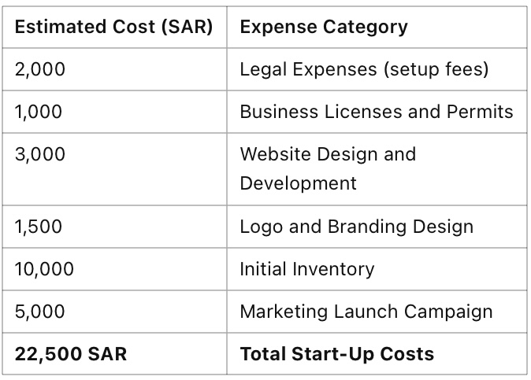

## 5.4 Break even chart and Calculations

The breakeven point (in units) equals Fixed Cost / Selling Price - Variable cost per unit.

Selling price: 100 SAR

Fixed Costs: 40,000 SAR

Variable Cost per unit: 50 SAR

Break-even point in units = Total Fixed Cost / (Selling Price - Variable Cost)

40,000/ (100-50) = 800 units.

Contribution Margin = 1- (Variable Cost per unit / Selling price per unit)

Contribution Margin =1-(50/100) =0.5

Break-even sales = Total Fixed Cost/ (Contribution Margin)

Break-even sales =40,000/0.5 =80,000 SAR

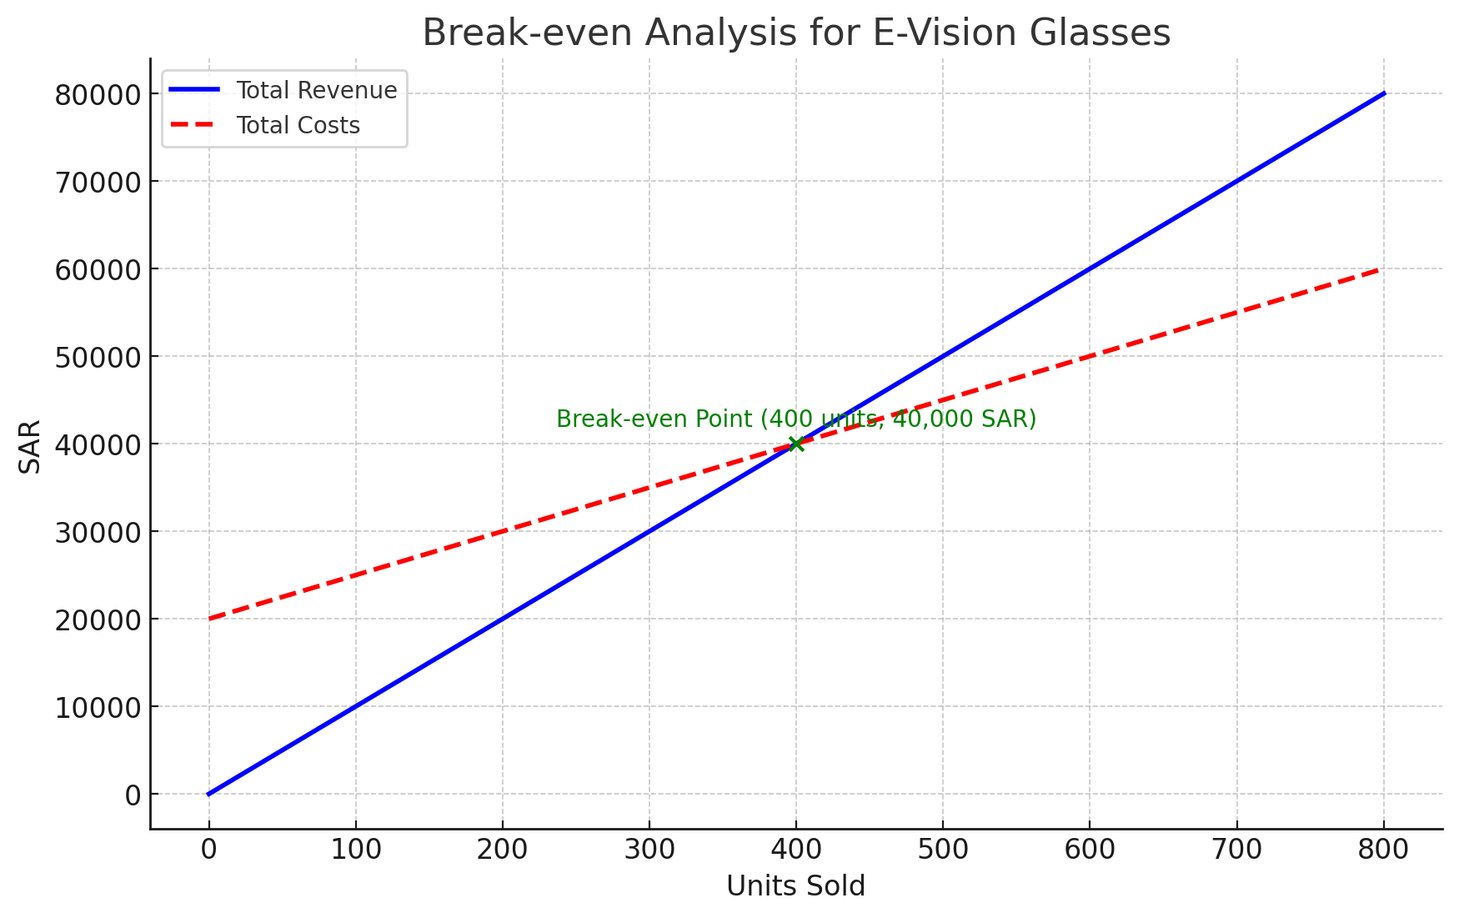

# Section 6: Marketing Plan

## 6.1 Overall Marketing Strategy

Our strategy is to establish E-Vision Glasses as Saudi Arabia's top intelligent solution for safeguarding eye health and lowering digital stress. Through E-Vision features, affordable prices, and customer-focused services, we hope to accomplish this.

We meet the needs of customers between the ages of 18 and 49 by utilizing E-Vision glasses technology, a linked app, and customizable designs. Online platforms, neighborhood retail establishments, and a convenient virtual try-on option are all part of our distribution strategy. To reach tech-savvy young folks, we will also work with educational institutions and run customized social media marketing campaigns.

Our emphasis on accessibility, affordability, and after-sales services, which is in line with Saudi Vision 2030, guarantees client happiness while promoting expansion and market leadership in the wearable health technology sector.

## 6.2 Product, price, promotions, and place

**Product:** E-Vision Glasses are smart eyewear with anti-reflective lenses, blue light blocking, and a break-reminder app to reduce eye strain and improve eye health.

**Price:** They are reasonably priced, with prices starting at 100 SAR, so that all income levels can buy them without sacrificing quality.

**Promotions:** Targeted marketing will make use of social media sites like Facebook, Instagram, and TikTok in order to raise awareness and promote adoption. Campaigns in line with Saudi Vision 2030, free trials, and collaborations with colleges and universities will all help to increase uptake and involvement.

**Place:** Offers a virtual try-on function for easy online shopping, as well as availability on e-commerce sites and in nearby retail establishments.

## 6.3 Sales Process (or cycle) and Sales tactics

1. **Awareness:** Potential customers learn about E-Vision Glasses through online ads, educational partnerships, and social media marketing.

**2. Consideration:** Customers visit our website or local locations to review features, prices, and benefits with the aid of the virtual try-on option for online shoppers.

**3. Decision:** Customers choose an easy-to-use online platform or local retailers to make purchases. Colleges and institutions provide free trials to encourage conversions.

**4. Purchase:** Reasonable prices and secure payment options enable a seamless purchase experience.

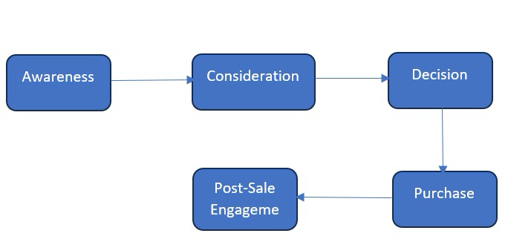**5. Post-Sale Engagement:** After-sales services, like customer support, warranty, and adjustment, ensure satisfaction and cultivate long-term loyalty.

**Sales tactics:**

• **Educational Campaigns:** Use blogs, social media, and health seminars to promote the advantages of E-Vision Glasses for your health.

**• Discount Offers:** To draw in customers on a tight budget, provide introductory discounts, packages, or seasonal specials.

**• Partnerships:** To increase accessibility and awareness, work with academic institutions, health groups, and schools.

**• Testimonials and Customer Reviews:** Use the encouraging remarks from early adopters to foster trust and boost sales.

**• Upselling and cross-selling:** Provide current clients with upscale designs, add-ons, or software updates.

**• Loyalty Programs:** To improve customer retention, offer incentives for recurring business or recommendations.

# Section 7: Product Design and Development Plan

## 7.1 Development status and tasks

The current status of E-Vision products is that we are developing them and preparing to launch the smart glasses and the accompanying application within four months. We have some remaining tasks, the most important of which is developing the application, which we will fully implement, and we expect this to take about three months maximum. We also plan to develop an attractive marketing plan for university and school students, and this is expected to take two weeks maximum. As for future development, we aim to improve the application regularly based on customer opinions and comments. We also plan to expand the scope of our products to include all Arab countries after we achieve a good reputation in the cities of the Kingdom of Saudi Arabia.

## 7.2 Challenges and risks

Challenges:

‏1-Technical difficulty during application development and linking it with electronic glasses.

‏2-Difficulty in marketing to reach the target group.

‏3-Fears of rapid technological developments that may make our products obsolete.

‏Risks:

‏1-Getting negative feedback from customers.

‏2-Concerns about users' privacy when linking the application with electronic glasses.

‏3-Loss of interest in our products.

## 7.3 Projected development costs

As for the production of glasses and lenses, each one may cost from 150 to 90 Saudi riyals, and the amount may double in the future with the wide development. As for marketing, the costs of advertising campaigns through social media platforms cost approximately from 3,000 to 5,000 Saudi riyals, depending on the marketing method and the approved platforms.

## 7.4 Proprietary issues (patents, trademarks, copyrights, licenses, brand names)

Since we are in our early stages, we are taking legal advice regarding maintaining our trademark and protecting the patent from being copied by competitors.

# Section 8: Operations Plan

## 8.1 General Approach to operations

|  |  |
| --- | --- |
| **Front stage** | **Back stage** |
|  |  |
| ‬‬ | ‬‬ |
| ‬‬ | ‬‬ |
| ‬‬ | ‬‬ |
| • Social media interaction | ‬‬ |
|  | • Develop marketing campaigns |

## 8.2 Business Location

E-Vision will be headquartered in Saudi Arabia, specifically in Riyadh, and will include all important departments. The location of the headquarters does not make a clear difference in our operations in general, as most of them are digital and technology-based since we care much more about our virtual presence.

## 8.3 Facilities and Equipment

Securing facilities and equipment is an important step to ensure the success of any business. For e-vision, here is a list of the most important facilities and equipment.

1- E-Vision headquarters, which will be purchased in the Kingdom of Saudi Arabia, specifically in Riyadh, and includes all important departments.

2- A warehouse for inventory, which will be rented near the headquarters to facilitate all inventory operations.

3- Computers and smart devices, which will be purchased to support various operations.

2- Design devices and development programs will be purchased to support the design and development processes of the application and products.

4- Quality and performance testing devices will be purchased to test the quality and performance of the application and products.

5- Production equipment, which will be purchased since the production process will be completely under the supervision of E-Vision.

6- Hosting servers and cloud services, which will be purchased to store data and support the system and all operations.

# Section 9: Management Team and Company Structure

## 9.1 Management Team

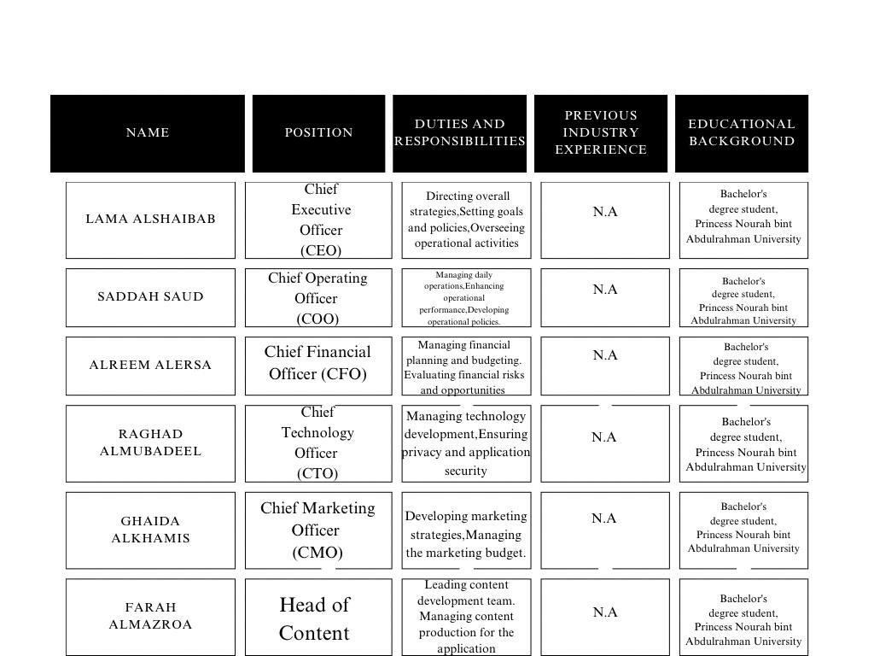

## 9.2 Company Structure

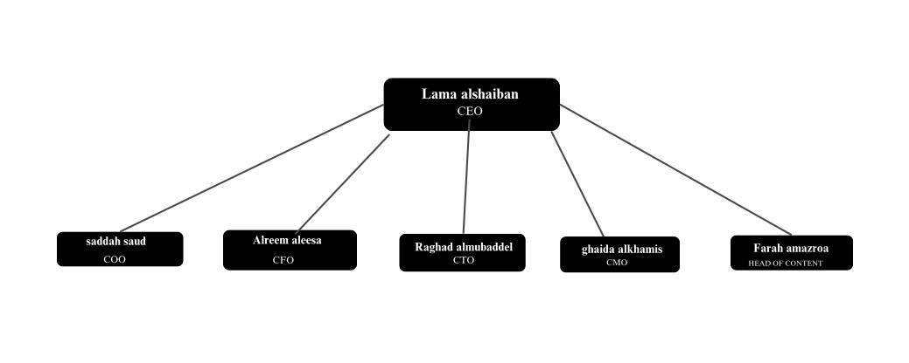

# Section 10: Overall Schedule

# Section 11: Financial Projections

|  |  |  |  |
| --- | --- | --- | --- |
| Pro Forma Income Statements (2024-2026) | | | |
| Category | (2024) | (2025) | (2026) |
| Net Sales | 150,000.00 | 180,000.00 | 216,000.00 |
| Cost of Goods Sold (COGS) | 75,000.00 | 90,000.00 | 108,000.00 |
| Gross Profit | 75,000.00 | 90,000.00 | 108,000.00 |
| Operating Expenses (SG&A) | 20,000.00 | 20,000.00 | 20,000.00 |
| Depreciation | 5,000.00 | 5,000.00 | 5,000.00 |
| Operating Income | 50,000.00 | 65,000.00 | 83,000.00 |
| Interest Income | 2,000.00 | 2,000.00 | 2,000.00 |
| Interest Expense | 1,000.00 | 1,000.00 | 1,000.00 |
| Income Before Taxes | 51,000.00 | 66,000.00 | 84,000.00 |
| Net Income | 40,800.00 | 52,800.00 | 67,200.00 |

|  |  |  |  |
| --- | --- | --- | --- |
| **Pro Forma Balance Sheets (2024-2026)** | | | |
| Category | (2024) | (2025) | (2026) |
| Cash and Cash Equivalents | 30,000.00 | 35,000.00 | 40,000.00 |
| Accounts Receivable | 10,000.00 | 12,000.00 | 14,400.00 |
| Inventory | 7,500.00 | 9,000.00 | 10,800.00 |
| Total Current Assets | 47,500.00 | 56,000.00 | 65,200.00 |
| Property, Plant, and Equipment (Net) | 100,000.00 | 95,000.00 | 90,000.00 |
| Total Assets | 147,500.00 | 151,000.00 | 155,200.00 |
| Current Liabilities | 15,000.00 | 16,500.00 | 18,150.00 |
| Long-Term Liabilities | 20,000.00 | 19,000.00 | 18,050.00 |
| Shareholders’ Equity | 112,500.00 | 115,500.00 | 119,000.00 |
| Total Liabilities and shareholders' equity | 147,500.00 | 151,000.00 | 155,200.00 |

|  |  |
| --- | --- |
| Pro Forma Cash Flow (2024) | |
| Category | (2024) |
| Net Income | 40,800.00 |
| Changes in Working Capital | 3,000.00 |
| Depreciation | 5,000.00 |
| Cash from Operating Activities | 48,800.00 |
| Purchase of Equipment (Investing Activities) | -20,000.00 |
| Proceeds from Long-term Debt (Financing Activities) | 10,000.00 |
| Principal Reduction in Long-term Debt | -5,000.00 |
| Net Cash from Investing Activities | -20,000.00 |
| Net Cash from Financing Activities | 5,000.00 |
| Net Increase in Cash | 33,800.00 |
| Cash at Beginning of Year | 30,000.00 |
| Cash at End of Year | 63,800.00 |

|  |  |  |  |
| --- | --- | --- | --- |
| Ratio Analysis (2024-2026) | | | |
| Category | (2024) | (2025) | (2026) |
| Return on Assets | 0.28 | 0.35 | 0.43 |
| Return on Equity | 0.36 | 0.46 | 0.56 |
| Profit Margin | 0.27 | 0.29 | 0.31 |
| Current Ratio | 3.17 | 3.39 | 3.59 |
| Quick Ratio | 2.67 | 2.85 | 3.00 |
| Debt to Equity Ratio | 0.31 | 0.31 | 0.30 |

# References:

***JINS Meme, 2024. The Glasses for Self-Care for Your Mind and Body. [online] Available at: https://jinsmeme.com/en/ [Accessed 18 November 2024].***

***Razer, 2024. Bluetooth Sunglasses Lenses - Razer Anzu Lenses. [online] Available at: https://www.razer.com/mobile-accessories/razer-anzu-lenses [Accessed 18 November 2024].***

***GUNNAR Optiks, 2024. GUNNAR Glasses: The Original Gaming & Computer Glasses. [online] Available at: https://gunnar.com/ [Accessed 18 November 2024].***

# Appendix:

## The CVs:

Lama Al-Shaiban

Position: Chief Executive Officer (CEO)

Contact Information:

• Email: lama@example.com

• Phone: +966XXXXXXXXX

Educational Background:

• Bachelor’s Student, Princess Nourah bint Abdulrahman University - Information Systems

Work/Training Experience:

• Leading overall strategies, setting goals and policies, overseeing operational activities

Skills:

• Leadership and team direction

• Strategic planning

Certifications/Courses:

• Cisco CCNAv7: Introduction to Networks

——

Saadah Saud

Position: Chief Operating Officer (COO)

Contact Information:

• Email: suad@example.com

• Phone: +966XXXXXXXXX

Educational Background:

• Bachelor’s Student, Princess Nourah bint Abdulrahman University - Information Systems

Work/Training Experience:

• Managing daily operations, performance improvement, and development

Skills:

• Operational performance improvement

• Time management

Certifications/Courses:

• Data Fundamentals (IBM Skills Build)

—-

Alreem Al- Essa

Position: Chief Financial Officer (CFO)

Contact Information:

• Email: alreem@example.com

• Phone: +966XXXXXXXXX

Educational Background:

• Bachelor’s Student, Princess Nourah bint Abdulrahman University - Information Systems

Work/Training Experience:

• Managing financial planning, budgeting, risk assessment, and opportunities

Skills:

• Financial planning and budgeting

• Financial analysis

Certifications/Courses:

• Data Fundamentals (IBM Skills Build)

—-

Raghad Al-Mubaddel

Position: Chief Technology Officer (CTO)

Contact Information:

• Email: raghad@example.com

• Phone: +966XXXXXXXXX

Educational Background:

• Bachelor’s Student, Princess Nourah bint Abdulrahman University - Information Systems

Work/Training Experience:

• Managing technology development, ensuring privacy, and application security

Skills:

• Technology development

• Application security

Certifications/Courses:

• Data Fundamentals (IBM Skills Build)

—-

Ghaida Al-Khamees

Position: Chief Marketing Officer (CMO)

Contact Information:

• Email: ghaida@example.com

• Phone: +966XXXXXXXXX

Educational Background:

• Bachelor’s Student, Princess Nourah bint Abdulrahman University - Information Systems

Work/Training Experience:

• Developing marketing strategies, managing marketing budgets

Skills:

• Digital marketing

• Social media strategy

Certifications/Courses:

• Marketing Analytics (Coursera)

• Digital Marketing (Google)

—-

Farah Al-Mazroa

Position: Chief Content Officer (CCO)

Contact Information:

• Email: farah@example.com

• Phone: +966XXXXXXXXX

Educational Background:

• Bachelor’s Student, Princess Nourah bint Abdulrahman University - Information Systems

Work/Training Experience:

• Leading the content development team, managing content production for the app

Skills:

• Content strategy

• Creative writing

Certifications/Courses:

• Content Marketing (HubSpot Academy)

## Management team details:

The management team consists of skilled professionals with expertise in leadership, financial planning, technology development, digital marketing, and content creation. Each member plays a vital role in ensuring the success of the project through strategic decision-making and efficient task execution.

The team’s collective strength lies in integrating technical and business expertise, enabling innovative solutions and effective market strategies. Challenges such as product development and marketing outreach have been tackled collaboratively through brainstorming sessions and proactive problem-solving.

The team is committed to driving the project forward by focusing on continuous improvement, customer satisfaction, and alignment with Vision 2030 goals

## Meeting Minutes:

## Activity 1: Brainstorming Session

As Computer Information Systems students who are glued to screens, we made the decision to come up with concepts that tackle the problems we confront in the real world. Our first thoughts were to develop a wellness app that would encourage tech users to take breaks and practice mindfulness, or an app that would assist in efficiently managing screen time.

We came up with the idea of E-Vision Glasses after much deliberation. With blue light-filtering lenses and an app that tracks screen time, these smart glasses address eye strain brought on by extended screen time. Since this concept immediately tackles an issue that we all encounter, it offers a useful and significant remedy.

## Activity 2: Business Model Canvas

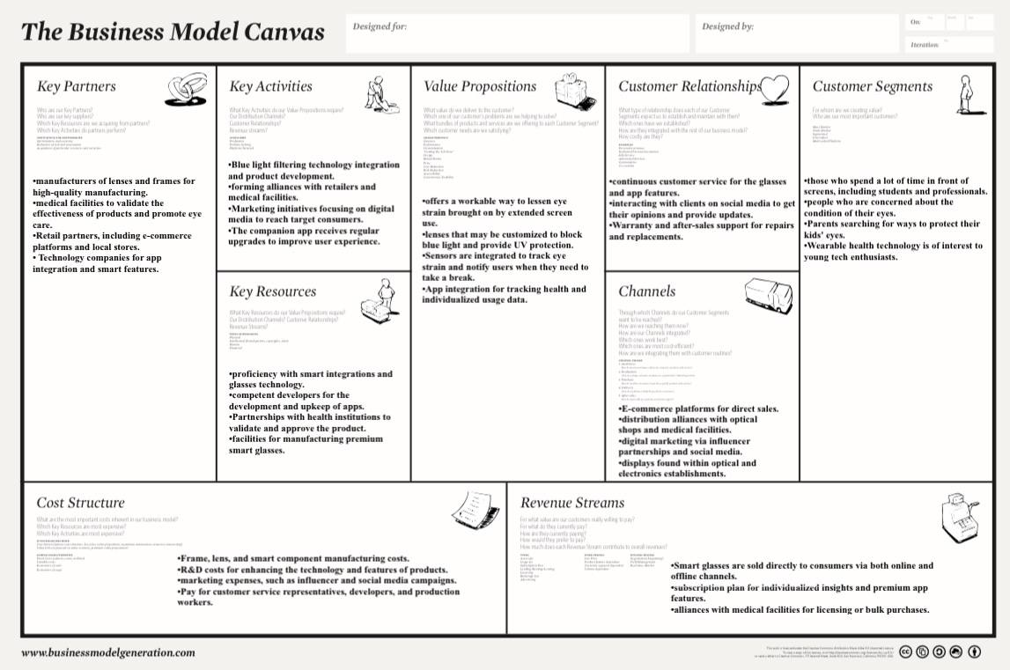

## Activity 3: First Screen

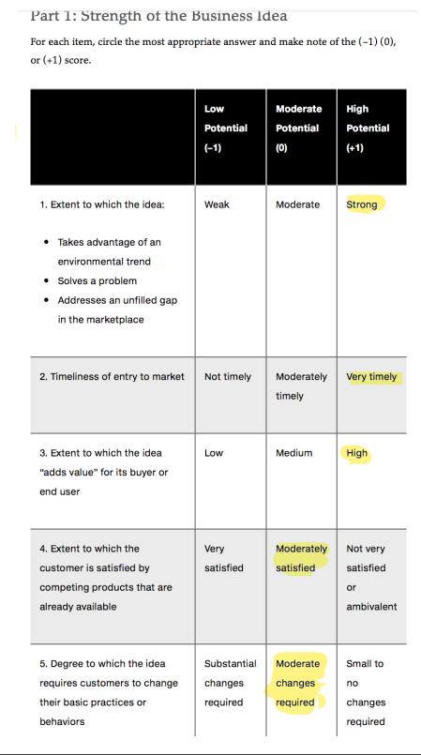صورة تحتوي على نص, لقطة شاشة, الخط, رقم

تم إنشاء الوصف تلقائياً

صورة تحتوي على نص, لقطة شاشة, الخط, رقم

تم إنشاء الوصف تلقائياًصورة تحتوي على نص, لقطة شاشة, الخط, التصميم

تم إنشاء الوصف تلقائياً

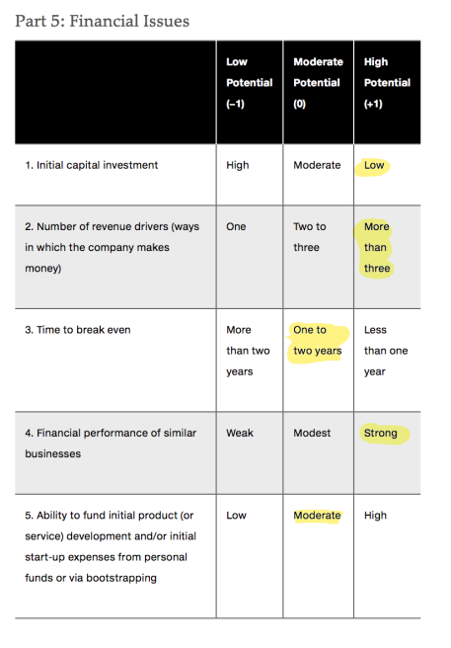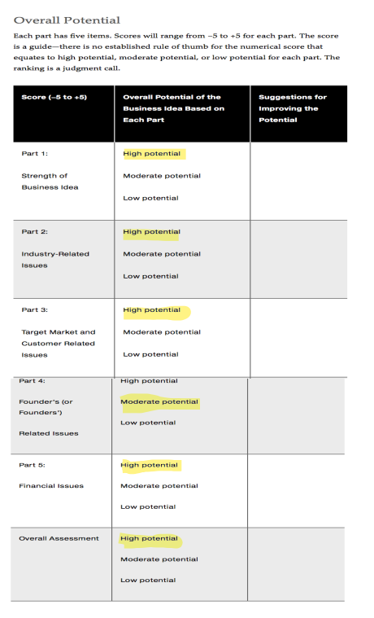

## Activity 4: Five Forces Model

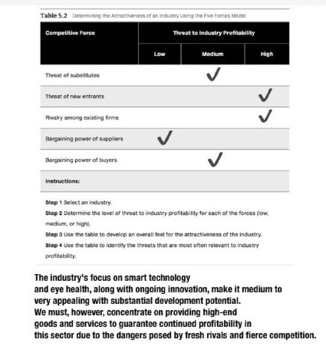

## Activity 5: Skills Profile

صورة تحتوي على نص, كلمات متقاطعة, لقطة شاشة, رقم

تم إنشاء الوصف تلقائياً

## Survey:

<https://docs.google.com/forms/d/e/1FAIpQLSdrp2DstBDm5nb3sMbBU53cd5xMhtzvTBnO1lY6A5fbb-Xeiw/viewform?usp=sf_link>

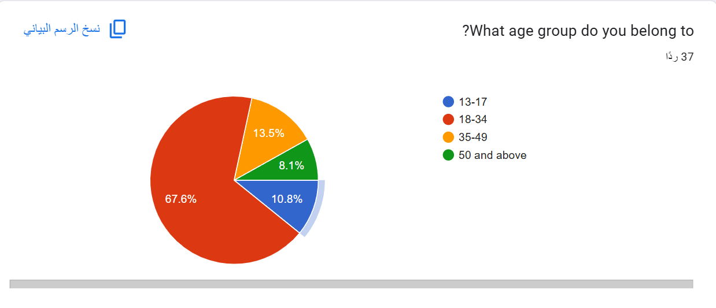

صورة تحتوي على نص, لقطة شاشة, الخط, رسم بياني

تم إنشاء الوصف تلقائياً

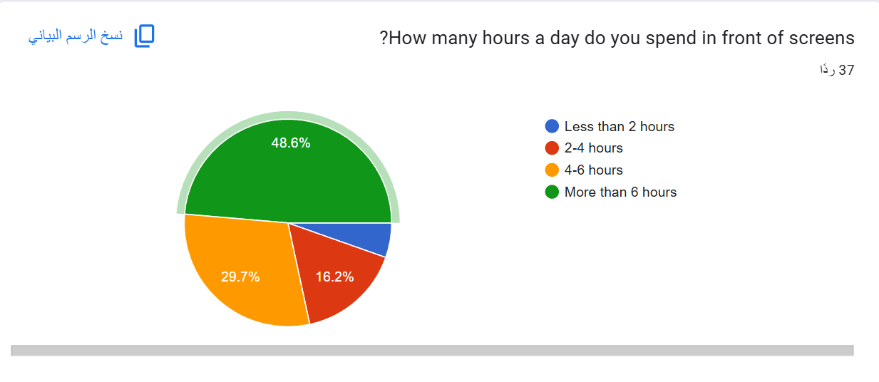

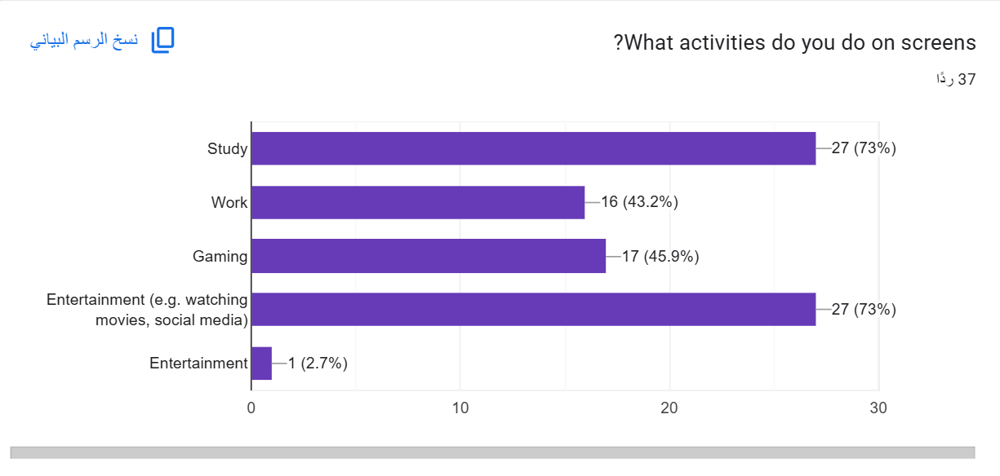

صورة تحتوي على نص, لقطة شاشة, الخط, برمجيات

تم إنشاء الوصف تلقائياً

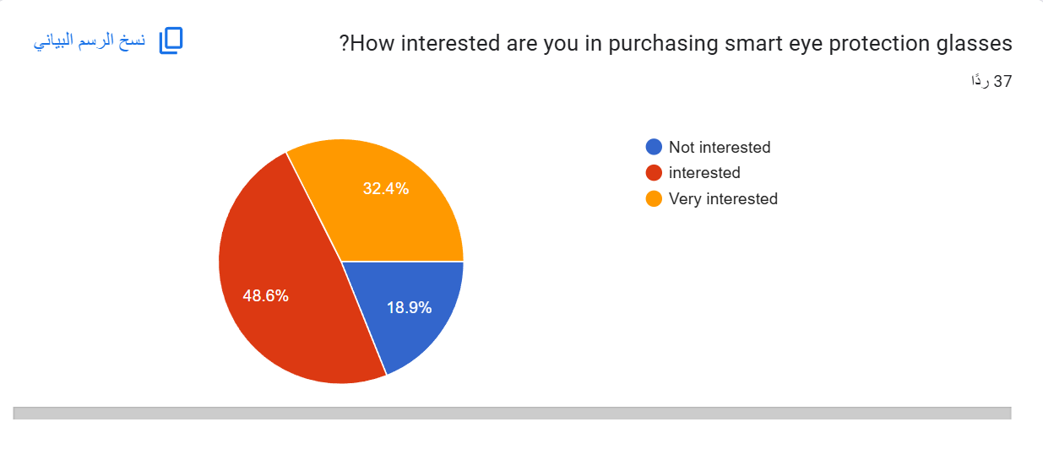

صورة تحتوي على نص, لقطة شاشة, الخط, رسم بياني

تم إنشاء الوصف تلقائياً

صورة تحتوي على نص, لقطة شاشة, عرض, الخط

تم إنشاء الوصف تلقائياً

