**PRINCESS NORA BINT ABDULRAHMAN UNIVERSITY**

**College of Computer and Information Sciences Department of Information Systems**



# Vox cinema

**All Phases**

|  |  |  |  |
| --- | --- | --- | --- |
| **Serial#** | **Section #** | **NAME** | **ID** |
| *1* | *IS #* | *Aroob Alshalan* | *444009143* |
| *2* | *IS#* | *Hessah aldeghaither* | *444009509* |
| *3* | *IS #* | *Lama alshiban* | *444009259* |
| *4* | *IS#* | *Leena Aluwaishiq* | *444009171* |

**Group#: 1**

**Supervised By: Sara Al shehri**

**Project Description:**

Vox Cinema is a prominent cinema chain that operates in various countries, which places emphasis on customer service and offers various services and conveniences to enhance the movie-going experience which includes online ticket booking.

Firstly, The customer sign up by adding his name, ID ,Date of birth ,age and his email then a list of movies appears containing the name , age group ,show time and movie type.

Employee is going to help customer reserve a ticket that contains the Price, ID and ticket . Then pay the Payment.

**Entity Relationship Diagram (ERD):**

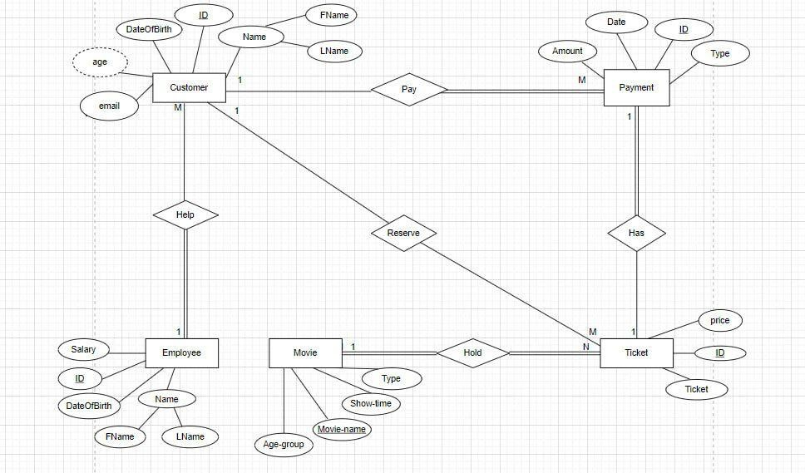

**Relational Schema:**

*Map the ERD to a relational schema and identify the Primary key and Foreign keys.*

Employee (ID , FName , LName , DateOfBirth , Salary)

Customer (ID, FName, LName , DateOfBirth , email, Employee_ID)

FK: Employee_ID reference Employee (Employee_ID)

Payment (ID, Date, Amount, Type, Customer_ID , Ticket_ ID)

FK: Ticket_ ID, reference Ticket (Ticket_ ID)

FK: Customer_ID reference Customer (Customer_ID)

Movie (Age-group, Movie-name, Show-time, Type)

Ticket (Ticket_ ID, Movie-name, price, Ticket, Customer_ID)

FK: Movie-name references Movie (Movie-name)

FK: Customer_ID reference Customer (Customer_ID)

**DDL Commands:**

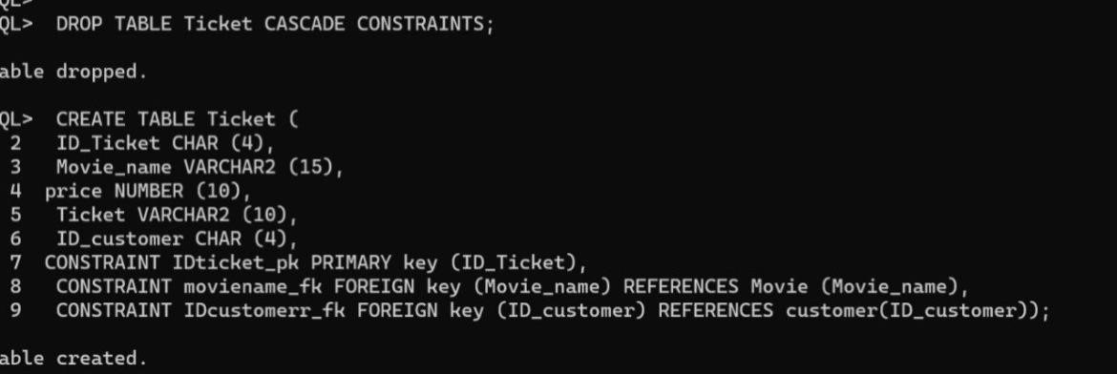

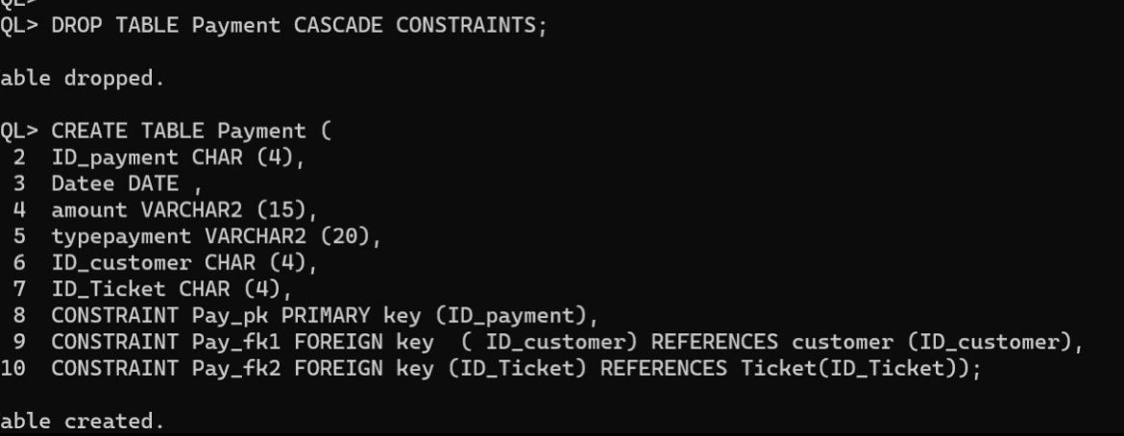

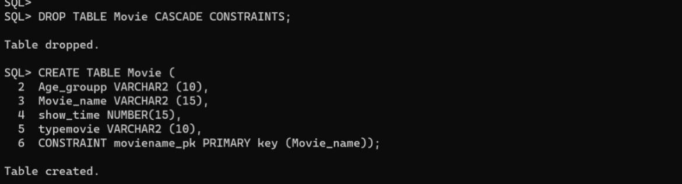

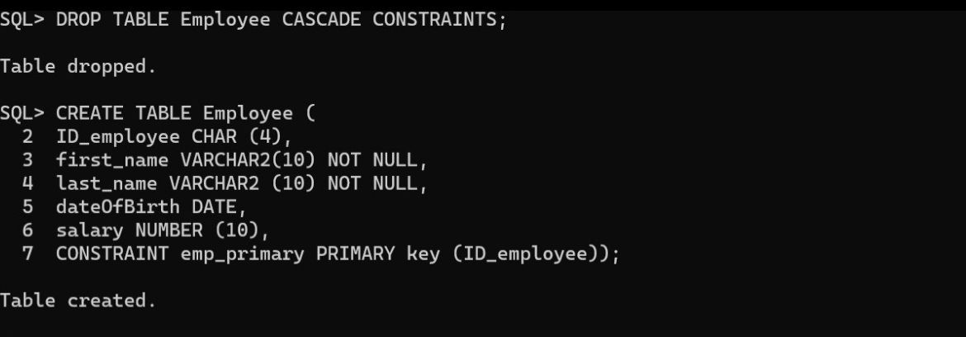

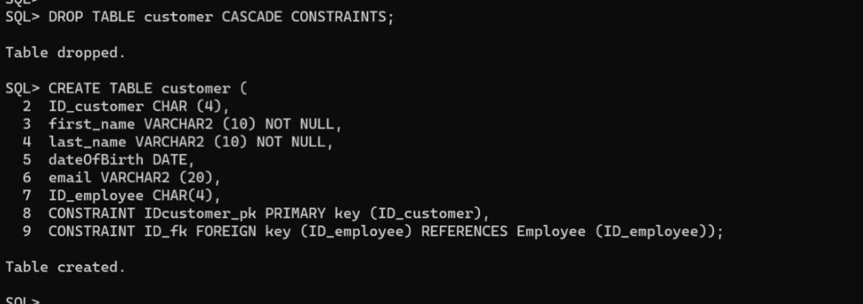

Insert 3 rows *AT LEAST INTO EACH TABLE*.

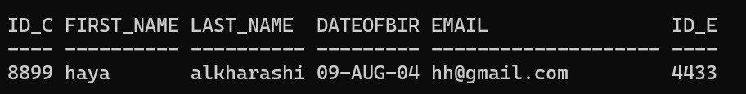

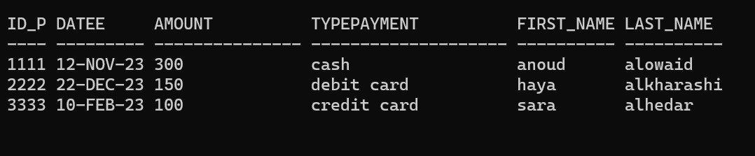

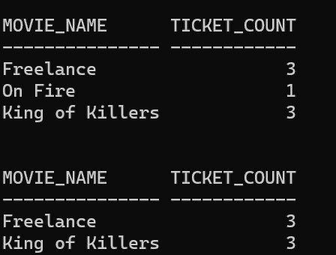

**DML Commands:**

* Retrieve the details of a customer with the email

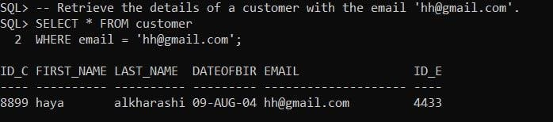

* Count the number of tickets sold for each movie

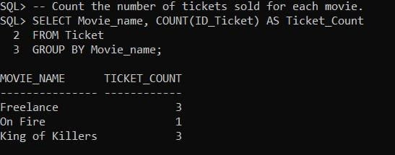

* List movies with one ticket sold

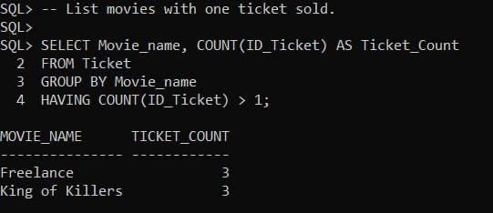

* Retrieve the details of payments along with customers first name and last name

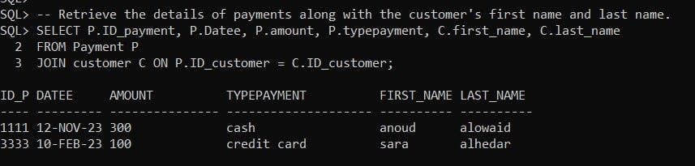

* UPDATE the salary of an employee by multiplying in it by 1.1 where the employee Id =3344

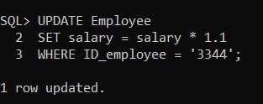

* DELETE payment from customer

