

Artificial Intelligence and Machine Learning
(6CS012)

Title: Task 2

Name : Unik Ghalan

Univ Id : 2409043

Tutor : Jinu Nyachhyon

Submitted : 10 May 2026

1. Introduction
Image classifications sit at the heart of computers visions and shows up in a wide range of practical settings, from self-driving cars and medical scans to satellite imagery and online content filtering. Since AlexNet demonstrated in 2012 what deep CNNs could do, the field has moved quickly, with architectures like VGGNet, Inception, and ResNet pushing classification reliability to levels that were once out of reach.
This report focuses on natural scene classification using the Intels Images Clasifications dataset, a six-class recognition problem covering everyday outdoor environments. Scene images are inherently difficult because appearances within the same class can vary widely, and some classes share strong visual similarities — Glacier and Mountain being a prime example — making the task genuinely challenging rather than trivial.
The study is structured in two parts as outlined in the 6CS012 assessment brief. Part A covers building a Baseline CNN from scratch, followed by a deeper regularized version, along with an optimizer comparison between Adam and SGD and an ablation test examining the role of Dropout. Part B applies transfer learning with VGG16, first keeping all convolutional weights frozen and then fine-tuning the final block. The broader aim is to develop a thorough understanding of the deep learning pipeline, identify what factors drive accuracy improvements, and measure how much gain pre-trained representations bring to this specific scene classification task.

2. Dataset

2.1 Dataset Description
The Intel Image Classification dataset, also known as the Scene Classification dataset, was originally published on Kaggle and has become a widely used benchmark for natural scene recognition tasks. It contains roughly 17,034 training images and 3,000 test images spread across six categories. All images are in JPEG format with a native resolution of approximately 150×150 pixels and three RGB colour channels. The data arrives already divided into train and test folders, so no additional splitting is required for evaluation.

2.2 Class Distribution
Table 1 lists the numbers of image per class acros both the training and test splits. The training set is well balanced, with class sizes ranging from 2,184 images for Buildings to 2,505 for Mountains. The test set follows a similar pattern with between 437 and 553 images per class, which means class frequency does not distort the evaluation metrics.

Class | Train Images | Test Images | Total | Distribution
Buildings | 2,184 | 437 | 2,621 | 15.4%
Forest | 2,264 | 474 | 2,738 | 16.1%
Glacier | 2,397 | 553 | 2,950 | 17.4%
Mountain | 2,505 | 525 | 3,030 | 17.8%
Sea | 2,267 | 510 | 2,777 | 16.3%
Street | 2,375 | 501 | 2,876 | 16.9%
TOTAL | 13,992 | 3,000 | 16,992 | 100%
Table 1. Per-class image count and distribution across train and test splits.
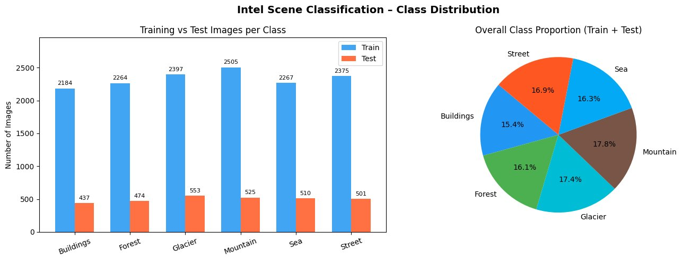
Figure 1. Class distribution: training vs test count (left) and overall proportions (right).
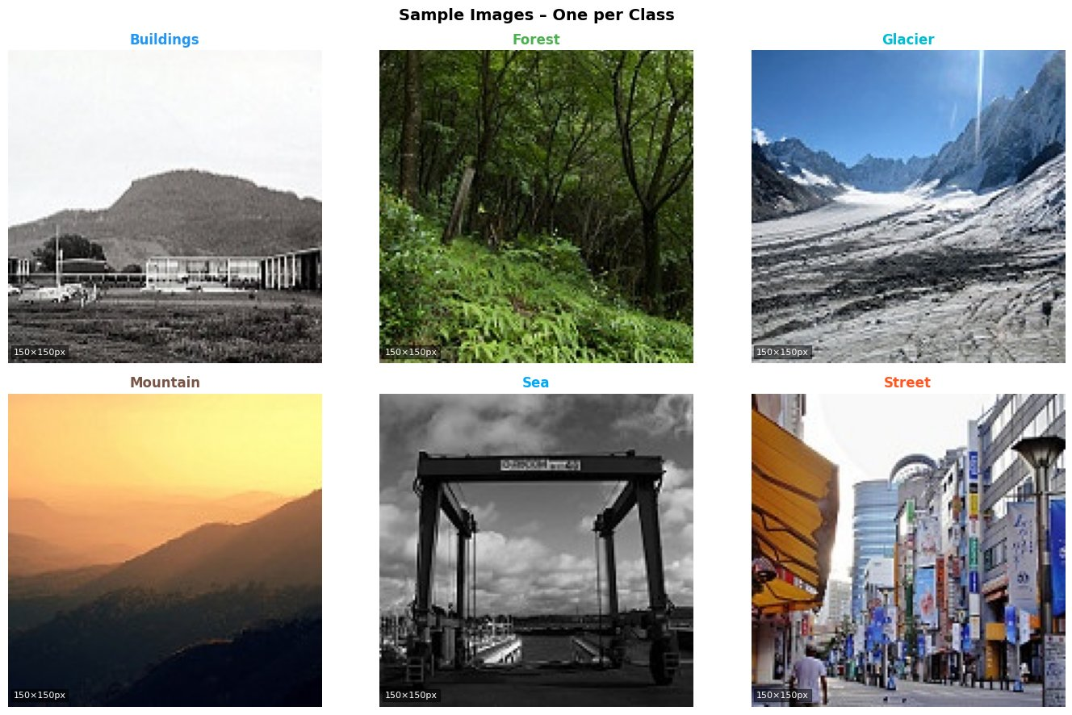
Figure 2. Representative sample image from each of the six scene classes.

2.3 Preprocessing
Before training, every image was rescaled by dividing pixel values by 255 to move them into the [0, 1] range. Images were also resized from their native 150×150 down to 128×128 pixels to reduce computation time while keeping enough spatial detail for accurate scene classification. images. A 20% validation split was made in the training directory by Keras ImageDataGenerator.20% validation split was made in training directory using Keras Images Data Generators. No per-channel normalisation (mean subtraction or standard deviation scaling) was performed; a simpler rescaling was proven to be good enough for the relatively homogenous character of scene photographs.
Data augmentations was applied exclusively to the training generator to increase sample diversity and discourage overfitting. The augmentation steps included horizontal flipping, random rotation of up to ±20 degrees, random zoom of up to 20%, and random horizontal and vertical shifting of up to 10%. The validation and test generators used only rescaling, ensuring that model evaluation was not influenced by any random transformations.

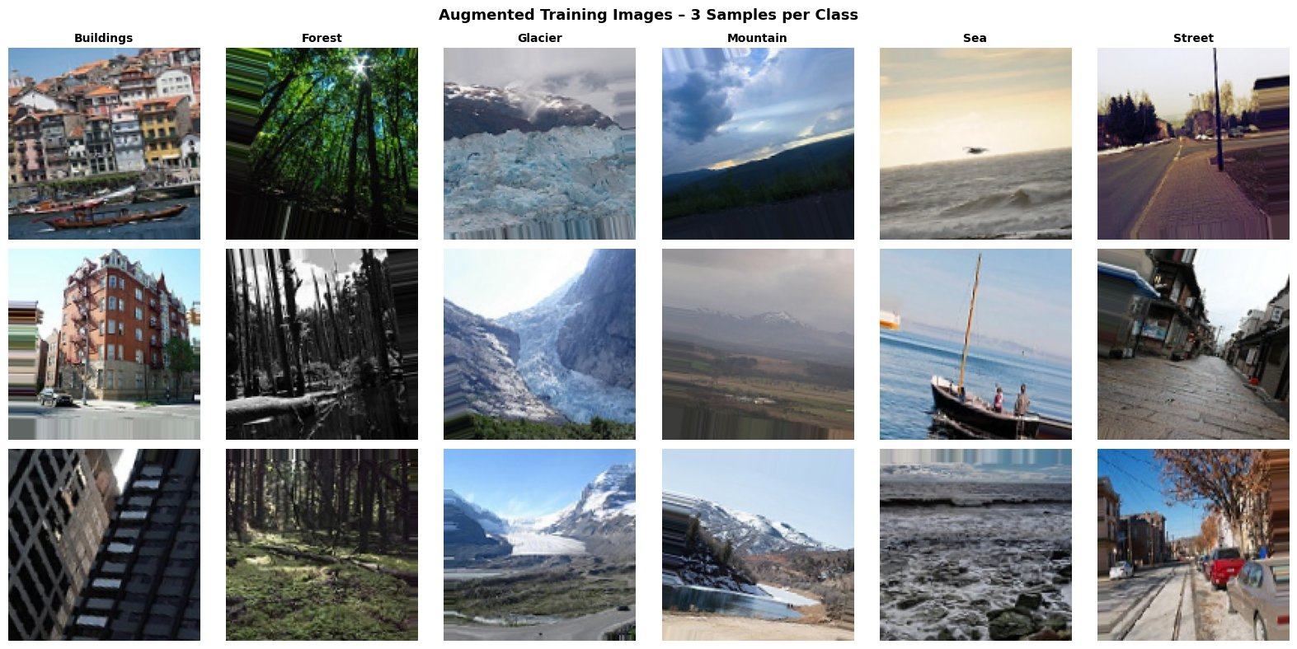
Figure 3. Augmented training samples (three per class). Note the variation in orientation, zoom, and crop introduced by the augmentation pipeline.

3. Methodology

3.1 Part A – CNN from Scratch

3.1.1 Baseline CNN Architecture
The baseline model is built according to the structure outlined in the assignment brief, consisting of three convolutional blocks each pairing a Conv2D layer with MaxPooling2D, followed by three fully connected Dense layers leading to a softmax output.

The filter count grows progressively from 32 to 64 to 128 across the three blocks, following standard CNN design practice: shallower layers capture basic features like edges and textures using fewer filters, while deeper layers need more channels to encode complex compositional patterns. All convolutional layers use same padding to preserve spatial dimensions before each pooling step. The model was compiled with the Adam optimizer at a learning rate of 0.001 and categorical cross-entropy as the loss function.

3.1.2 Deeper CNN with Regularisation
The deeper model expands on the baseline by doubling the number of convolutional layers, from three to six, arranged as three blocks of two layers each. After every convolutional layer, BatchNormalization is applied, and each block closes with MaxPooling2D and a Dropout layer set at 0.25.
BatchNormalization standardizes layer outputs to have zero mean and unit variance within each mini-batch, which speeds up training and provides a degree of regularization. Dropout works by randomly setting a portion of neuron outputs to zero during each forward pass, which stops neurons from becoming overly dependent on each other and helps reduce overfitting. This deeper architecture was trained with both Adam (lr = 0.001) and SGD with Nesterov momentum (lr = 0.01, momentum = 0.9) to support a direct optimizer comparison.

3.2 Part B – Transfer Learning with VGG16
Transfer learning makes use of feature representations already learned on large datasets, saving significant training time and often improving accuracy. VGG16, pre-trained on ImageNet with 1.2 million images across 1,000 classes, was chosen as the base model. It consists of 13 convolutional layers organized into five progressively deeper blocks, plus three fully connected layers. The original classification head was removed (include_top=False) and replaced with a custom head suited to the six-class scene problem.
Transfer learning was conducted in two sequential stages. In Stage 1, all 13 VGG16 convolutional layers were frozen so that only the custom classification head was trained. This head included a GlobalAveragePooling2D layer (much more parameter-efficient than Flatten), a Dense layer with 256 units and ReLU) layer, Dropout(0.5), and a Dense(6, Softmax) output. The model was trained using Adam optimizer with lr = 0.001 for 8 epochs in this stage. The last convolutional block (block5, layers -4 onwards) was unfrozen in Stage 2 (Fine-Tuning) while previous layers remained frozen. The whole model was then re-trained at a very low learning rate (lr = 1e-5) to fine-tune the deepest representations to our data without catastrophic forgetting of previous representations. For part B, the input to VGG16 is 224×224, which means that the data generators were reconfigured to use this size.

3.3 Training Configuration
Parameter | Baseline | Deeper CNN | VGG16
Image size | 128×128 | 128×128 | 224×224
Batch size | 64 | 64 | 32
Optimiser | Adam | Adam / SGD | Adam
Learning rate | 0.001 | 0.001 / 0.01 | 0.001 / 1e-5
Max epochs | 12 | 15 | 8 / 6
Early stopping patience | 3 | 4 | 3
Loss function | Cat. X-entropy | Cat. X-entropy | Cat. X-entropy
Validation split | 20% | 20% | 20%
Table 2. Training hyperparameters for all models.

4. Experiments and Results

4.1 Baseline CNN
The Baseline CNN completed 12 epochs of training, with EarlyStopping activating at epoch 11, and achieved a test accuracy of 86.40% with a loss of 0.4207. Both training and validation accuracy climbed steadily throughout, as shown in Figure 4, and the gap between the two remained narrow, indicating that the model did not fall into significant overfitting within the available training time.

The confusion matrix in Figure 5 shows that Forest and Sea achieved the best individual class results, with 464 of 474 and 460 of 510 samples correctly identified respectively. The most frequent errors appeared in the Glacier category: 81 Glacier images were assigned to Mountain and 43 to Sea, which makes sense given how closely glacier snowfields resemble mountain terrain and how the blue-grey tones of ice overlap with those of open water. Street images also caused some difficulty, with 54 incorrectly labeled as Buildings — an understandable mix-up since urban street scenes regularly feature building facades as their dominant visual element.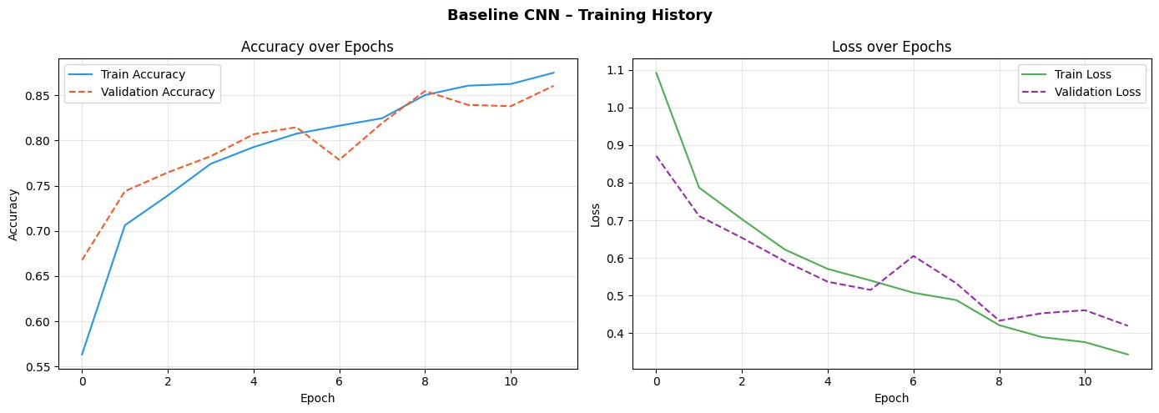

The confusion matrix (Figure 5) reveals that Forest and Sea were the most well-classified classes, with 464 and 460 of the 474 and 510 samples respectively being correctly classified, respectively. The biggest off diagonal numbers are in the Glacier row: 81 images were misclassified as Mountain and 43 as Sea, owing to the similarity between glacier ice fields and mountain snowpack as well as the blue-grey colours common to both and to open water. Street also exhibited some confusion with Buildings (54 misclassified), as is typical of street scenes, where the building facades are often displayed.
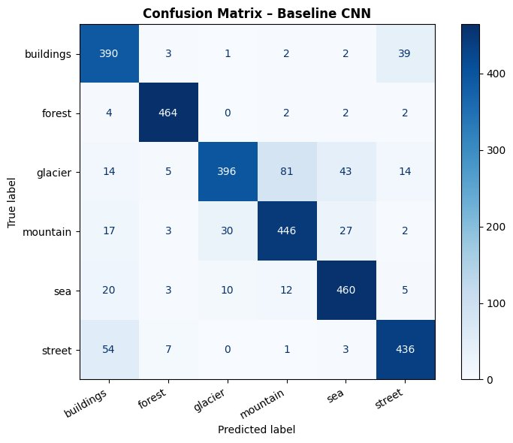
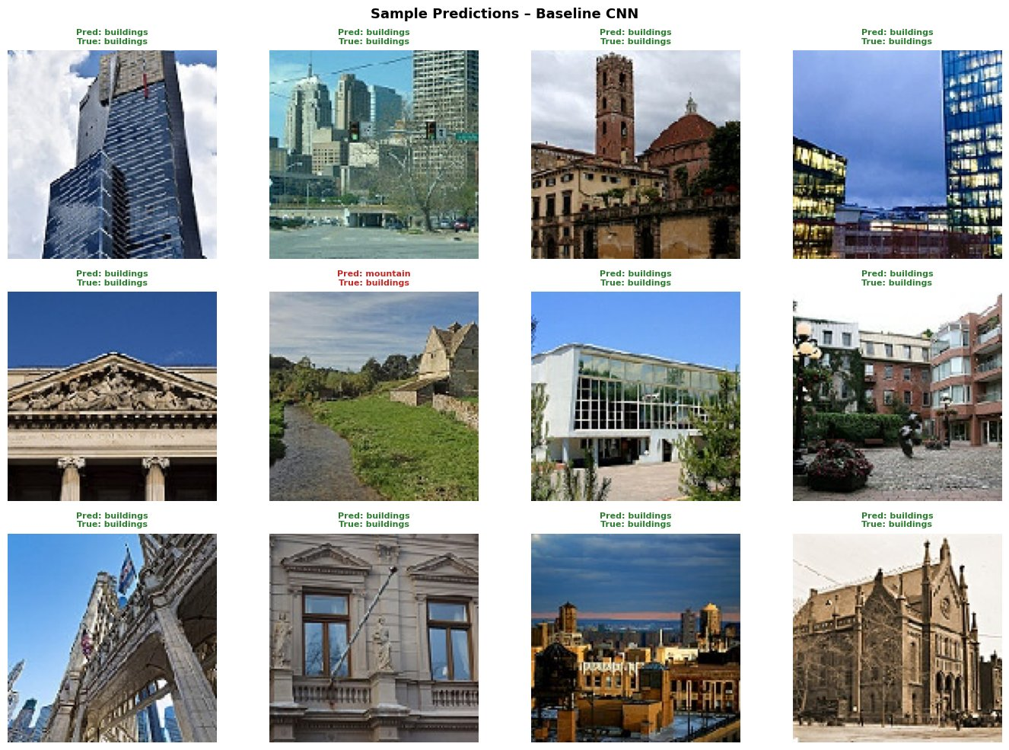

4.2 Deeper CNN (Adam)
The Deeper CNN ran for 15 epochs before EarlyStopping triggered at epoch 14, but only reached 77.03% test accuracy — a drop compared to the simpler Baseline. As Figure 7 shows, the validation accuracy and loss curves were noticeably noisy throughout training, with large swings that never fully settled. This instability appeared even with mixed precision float16 enabled, and the initial learning rate of 0.001 seemed too high for a six-layer deep network on a dataset of this scale, with the adaptive Adam scheduler failing to bring convergence under control.
Figure 8 shows the confusion matrix for the Deeper CNN, revealing more errors than the Baseline at the Buildings–Street and Glacier–Sea boundaries. One particularly unusual result stands out: 111 Street images were predicted as Forest, a pairing that makes little semantic sense, suggesting the model latched onto incidental colour or texture patterns rather than genuine scene structure. This irregular misclassification pattern further supports the view that the model never converged properly.
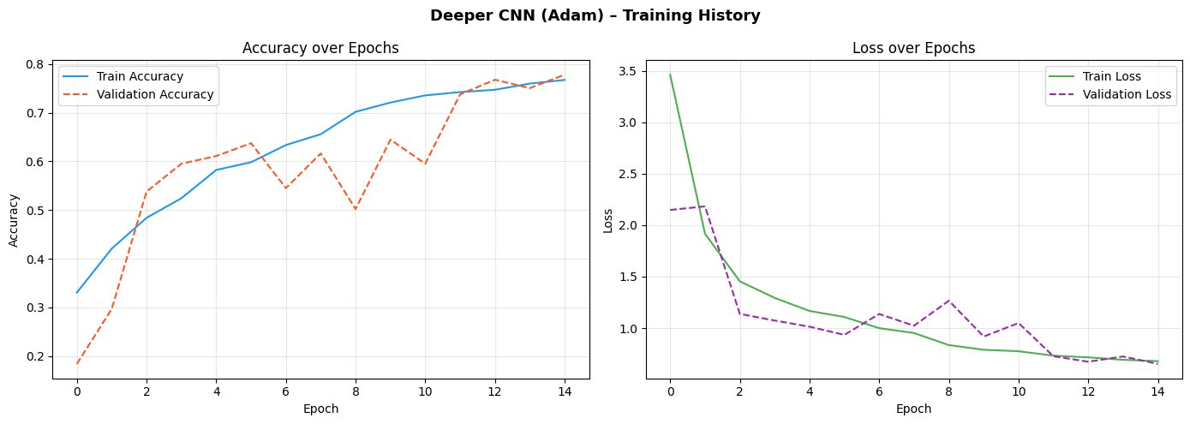
The confusion matrix in Figure 8 reinforces this finding: the Street-to-Forest misclassification in particular points to a model that relied on texture shortcuts rather than meaningful visual structure.
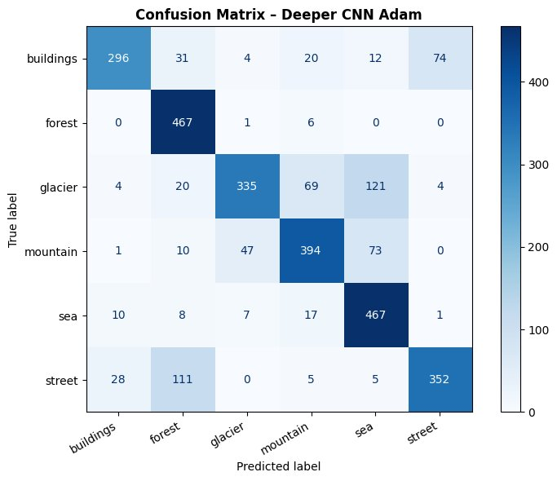
Figure 8
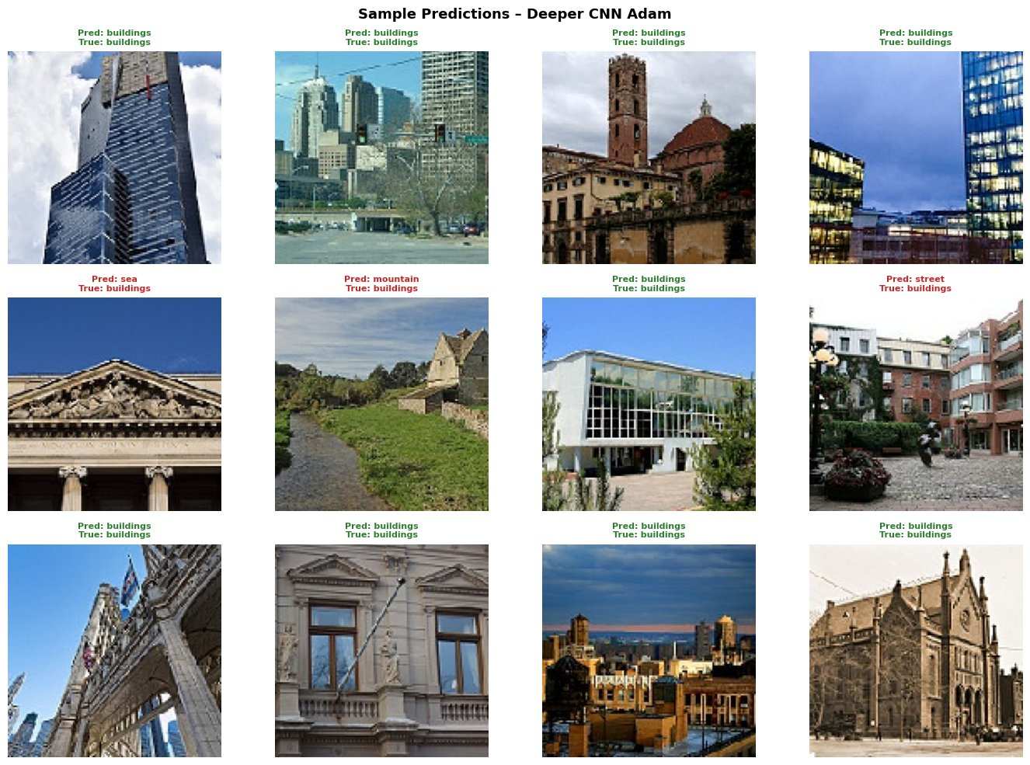
Figure 9

4.3 Optimizer Comparison: Adam vs SGD
Retraining the same Deeper CNN architecture under different optimizer settings provided a clean controlled comparison. SGD with Nesterov momentum was used, with a learning rate of 0.01 and a momentum factor of 0.9. SGD achieved a test accuracy of 80.23%, outperforming Adam which attained 77.03% on this architecture. Figure 10 displays validation accuracy trajectories which illustrate faster initial convergence for SGD despite its lower starting point: by epoch 1 the validation accuracy for SGD reached 0.58 whereas Adam attained 0.19. The validation loss curve for SGD was notably smoother and exhibited a more consistent decline, whereas the loss curve for Adam displayed erratic spikes throughout training.
This result reflects a broader pattern: Adam, in spite of its adaptive rate advantages, can be sensitive to mini-batch noise on medium-scale datasets. SGD with explicit momentum tends to produce steadier gradient trajectories that average out this noise more effectively, though the trade-off is that SGD needs creates more stable gradient trajectories which average out noisy gradients more effectively. The trade-off is that SGD exhibits greater sensitivity to the initial learning rate selection and therefore requires careful tuning..
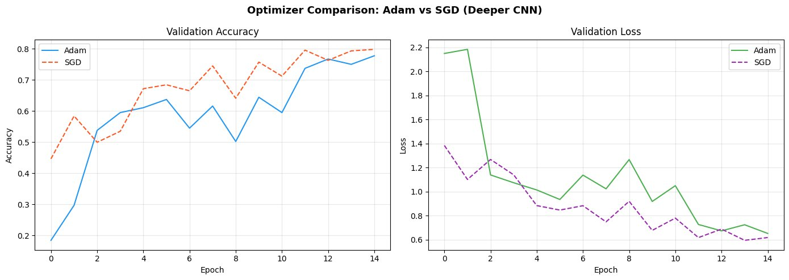
Figure 10

4.4 Ablation Study: Effect of Dropout
This ablation studys was designed to isolate and measure the specific contribution of Dropout regularization. The Deper CNN was retrained from scratch with all Dropout layers removed, keeping every other setting identical. The model without Dropout achieved a test accuracy of 77.63%, which approximates the 77.03% attained by the model with Dropout, but which manifests a markedly different training dynamic. As shown in Figure 11, the model which lacks Dropout exhibited substantially higher training accuracy, reaching approximately 82% by epoch 4, while validation accuracy plateaued earlier, which constitutes a hallmark of overfitting because the growing divergence between training and validation accuracy increases.
The loss curves reinforce this picture. Without Dropout, training loss drops steeply and cleanly while validation loss stalls around 1.0, indicating that the model memorized the training set rather than learning generalizable patterns. The Dropout model, by contrast, keeps training and validation metrics much closer together throughout the entire run, confirming that Dropout is doing its job as a regularizer by preventing neurons from relying too heavily on any single input.
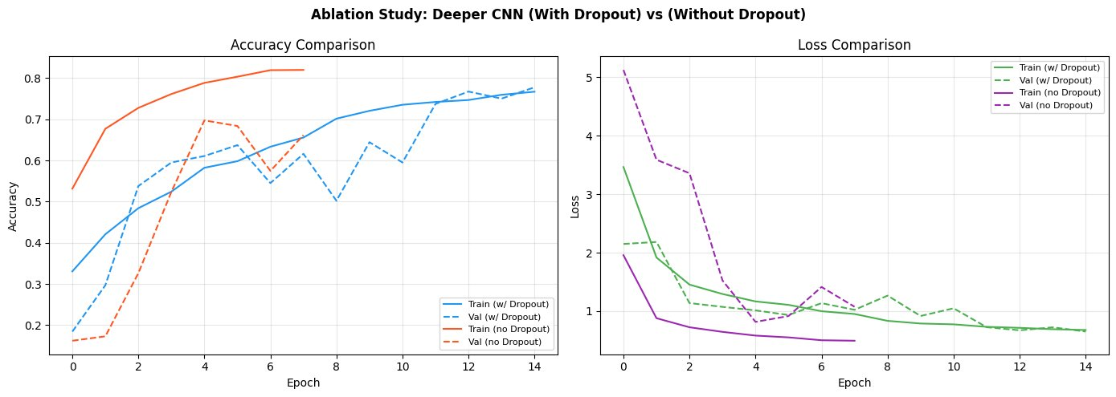
Figure 11.

4.5 Part A Summary
Model | Test Accuracy | Test Loss | Epochs Run | Notes
Basaline CNN (Adam) | 86.40% | 0.4207 | 12 | Best scratch
Deeper CNN (Adam) | 77.03% | 0.7193 | 15 | Unstable val
Deeper CNN (SGD) | 80.23% | 0.6109 | 15 | Smoother cv
Deeper No Dropout | 77.63% | 0.7052 | 10 | Overfitting
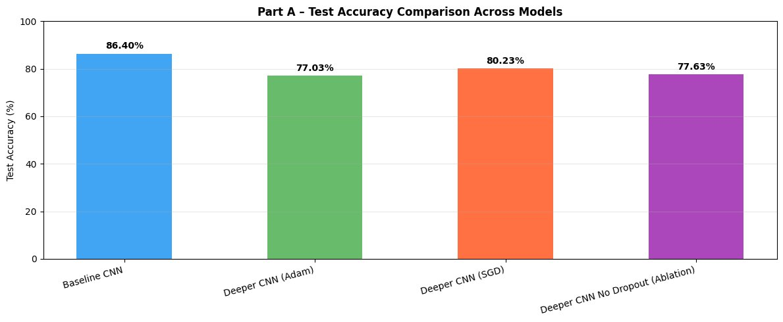
Figure 12.

5. Fine-Tuning and Transfer Learning

5.1 VGG16 – Stage 1: Feature Extractions
In Stage 1, all 13 convolutional layers of VGG16 were kept frozen and only the custom classification head was allowed to learn, for a maximum of 8 epochs. This feature extraction phase converged quickly and reached a test accuracy of 86.67%, matching the Baseline CNN despite needing only 4 to 5 epochs of training. This result highlights how transferable ImageNet representations are: the low- and mid-level visual features learned from 1.2 million diverse images translate effectively to natural scene classification even without any updates to the convolutional weights. Validation accuracy stabilized within just 2 to 3 epochs, which is consistent with the behavior of a simple linear classifier operating on fixed features.

5.2 VGG16 – Stage 2: Fine-Tuning
Stage 2 unfroze the top convolutional block of VGG16 (block5, covering conv5_1, conv5_2, conv5_3, and pool5), making approximately 7.1 million additional parameters trainable. To protect the earlier layers from catastrophic forgetting, an exceptionally low learning rate of 1e-5 was used. Fine-tuning was executed within a limit of 6 epochs and it brought about the highest overall test accuracy of 89.70%, which was approximately 3 percentage points higher than pure feature extraction.The Stage 2 training curves are depicted in Figure 13. From their Stage 1 level (~86%) both train and validation accuracy increased continually and by epoch 5 they produced results of approximately 91% and 90.7% respectively. Then again, the loss curves exhibit a continual, steady decrease without the destabilisation that is typical of deeper models trained from scratch. This lack of instability can be solely attributed to the very low learning rate, which guarantees that the pre-trained representations are softly modified rather that scrapped.

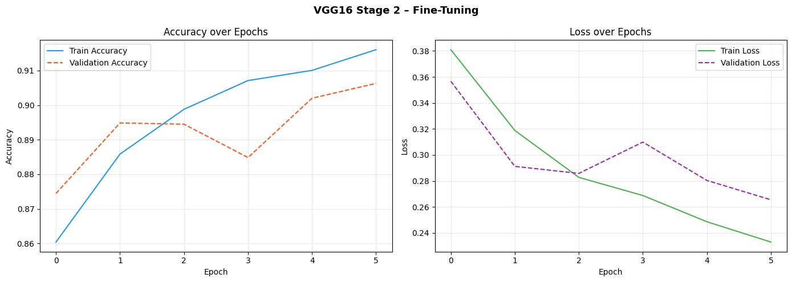
Figure 13. VGG16 fine-tuning (Stage 2) accuracy and loss curves.
Figure 14 shows the confusion matrix for the fine-tuned VGG16, where performance improved across every class compared to the Part A models. Forest classification remained nearly flawless at 470 out of 474, a 99.2% recall. The Glacier-Mountain boundary continued to be the most difficult pair even at 224×224 resolution, with 95 Mountain images incorrectly assigned to Glacier due to their shared visual appearance. Some Buildings-Street confusion persisted with 43 images, consistent with what was seen in Part A. Sea classification showed a particularly strong improvement, reaching 440 out of 510 correct, an 86.3% recall, suggesting that VGG16's deeper texture features are better equipped than scratch-trained networks to separate open water from the visually similar tones of ice and mountain.
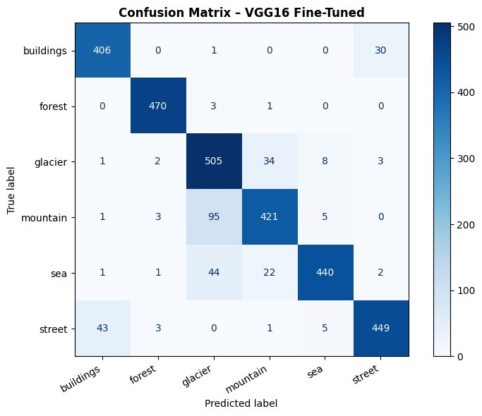
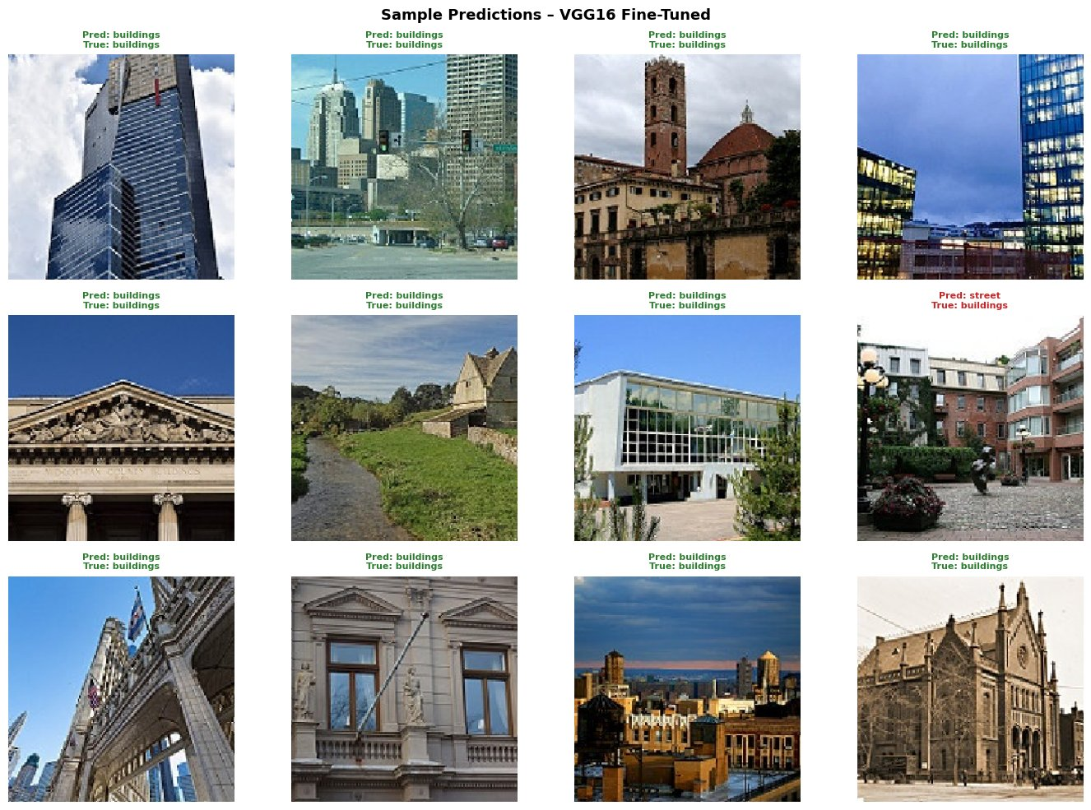
Figure 15

6. Final Model Comparison
Tables 4 and Figures 16 bring together the results from all six model configurations. VGG16 Fine-Tuned achieved the highest test accuracy at 89.70%, followed closely by VGG16 Feature Extraction at 86.67% and the Baseline CNN at 86.40%. A notable finding among the from-scratch models is that the simpler Baseline outperformed the Deeper CNN under both optimizers — a result that points to training instability in the deeper architecture given the chosen hyperparameter settings.
Model | Test Accuracy | Test Loss | Approach | Rank
VGG16 – Fine-Tuned | 89.70% | 0.2871 | Transfer Learning | 1st
VGG16 – Feat. Extraction | 86.67% | 0.3802 | Transfer Learning | 2nd
Baseline CNN (Adam) | 86.40% | 0.4207 | Scratch | 3rd
Deeper CNN (SGD) | 80.23% | 0.6109 | Scratch | 4th
Deeper CNN No Dropout | 77.63% | 0.7052 | Ablation | 5th
Deeper CNN (Adam) | 77.03% | 0.7193 | Scratch | 6th
Table 4. Final model comparison – all configurations ranked by test accuracy.
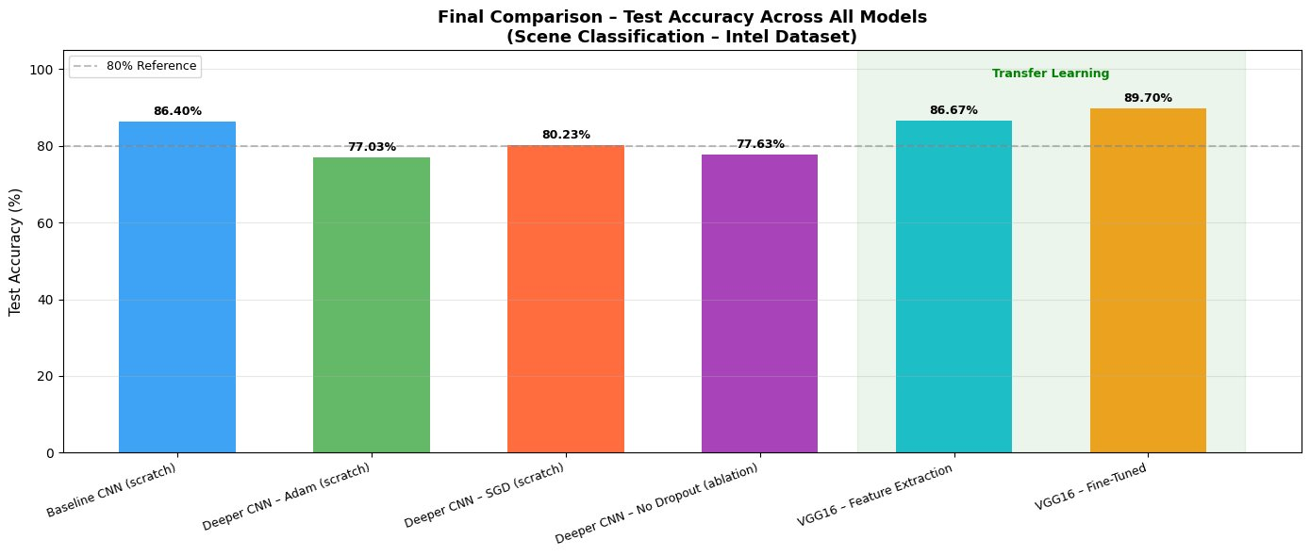
Figure 16. Final test accuracy comparison across all model configurations.

6.1 Computational Efficiency
Every experiment was run on Google Colab using a T4 GPU. Mixed-precision training was applied, performing matrix computations in float16 while maintaining weight master copies in float32, delivering roughly a 2x speedup on the T4 hardware. Input resolution for Part A was reduced from 150×150 to 128×128, which reduced by 28% the number of computations per step. The batch size was increased two times, from 32 to 64, so the number of gradient update steps per epoch was reduced by half. These tweaks made it possible to run the entire Part A pipeline (four models) for about 25–35 minutes of GPU time each, and Part B for about 15–20 minutes each.

7. Conclusion and Future Work
This project walked through the complete deep learning pipeline for six-clas naturals scene classifications using the Intel Image Classifications dataset. The key findings were as follows:
- Fine-tuned VGG16 delivered the best overall performance at 89.70%, confirming that ImageNet pre-trained features transfer effectively to scene classification tasks even when there is a domain gap.
- The Baseline CNN at 86.40% outperformed the Deeper CNN under both Adam (77.03%) and SGD (80.23%), demonstrating that adding more layers does not automatically improve results unless the training setup is properly tuned to match the increased model complexity.
- SGD with Nesterov momentum produced less volatile convergence than Adam on the deeper architecture, a somewhat unexpected result that highlights how optimizer choice is dependent on both the dataset and the model design rather than one being universally better.
- The ablation study confirmed that Dropout serves a meaningful regularization role: removing it caused training and validation accuracy to diverge, a textbook sign of overfitting.
- Across all experiments, Glacier–Mountain and Buildings–Street stood out as the hardest class pairs to separate, with confusion driven by shared textures, colours, and overall scene structure. Several directions are worth pursuing in future work. Training stability for the deeper from-scratch models could be improved through cyclical or cosine annealing learning rate schedules. The augmentation pipeline could be strengthened with colour jitter and cutout to help models handle the colour-based confusions at the Glacier–Sea boundary. Stronger pre-trained architecture such as EfficientNetV2 or Vision Transformers (ViT) could push accuracy beyond 92 to 95% on this dataset. Finally, test-time augmentation (TTA), which average prediction over several augmented versions of each test image, is a simple technique that typically adds 1 to 2 percentages points to accuracy without any additional training.

