Herald College Kathmandu
University of Wolverhampton
Artificial Intelligence and Machine Learning
6CS012
Final Portfolio Assessment – Part III: Language Task
Sentiment Analysis of IMDb Movie Reviews Using
RNN, LSTM, and Word2Vec Embeddings
Name | University ID
Rajiv Khattri | 2408207
Binaya Bohara | 2418248
Unik Ghalan | 2409043
Submission Date: May 2026
Dataset: IMDb Movie Reviews (Binary Sentiment Classification)

Abstract

This paper documents a complete deep learning project for sentiment analysis of IMDb movie reviews. The goal of the research is to categorize movie reviews into positive and negative by implementing three natural progression levels of models: a Simple Recurrent Neural Network (SimpleRNN), Long Short-Term Memory (LSTM) network with trainable embeddings, and LSTM network with the addition of pre-trained GloVe Twitter embeddings. The data contains 50,000 balanced IMDb reviews which were divided into training (35,000), validation (5,000), and test (10,000) partitions. The whole text preprocessing pipeline was carried out consisting of HTML tags removing lowercasing contraction expansion, stopword removal while preserving negation lemmatization etc. To balance keeping up with the information and computation of efficiency, sequence padding was done at the 75th percentile (MAX_LEN = 280 words). The findings indicate a major problem - the SimpleRNN model could only reach about 50% test accuracy, which clearly shows that it fails to understand the long-range relationships in movie reviews. The LSTM model hardly changed from near-random results with the given time and configuration of the training. These results point out a very basic drawback - both simple RNN and LSTM networks need to be carefully tuned for hyperparameters, have longer training schedules, and use domain-specific embeddings to work well with long text sequences. Main points resulted from this study are: the role of gradient flow mechanisms in LSTM is more important than in SimpleRNN; the vanishing gradient problem makes SimpleRNN inefficient with long sequences; also, a proper learning rate schedule and enough training epochs are necessary conditions for convergence.

Introduction
One of the most extensively explored problems in the field of Natural Language Processing (NLP) is sentiment analysis. It is about determining the emotional tone behind a series of words, used to gain an understanding of the attitudes, opinions, and emotions expressed within an online mention. To this end, the text under consideration could be a product review, tweet, or news comment. More More exactly, in the area of movies, the capacity to automatically gauge viewer response from written reviews has an immediate commercial worth for clubs, movie studios, and recommendation software.The IMDb Movie Reviews dataset has become the standard reference for binary sentiment classification. It consists of 50,000 reviews of movies that have been divided equally into positive and negative sentiment categories. The reviews, as a rule, are lengthy and highly laden with subtle linguistic elements, e.g. sarcasm irony, conflicting views, and vocabulary specific to movies. That means, this dataset becomes a very challenging test for sequential models.In the past, machine learning methods based on Naive Bayes and logistic regression over TF-IDF features have been able to secure good strong baselines (about 88%) with this dataset. At present, these deep learning models that use bidirectional LSTMs and transformers-based models (BERT) have further improved the accuracy levels. Precisely, this accuracy is now greater than 90%. This work is positioned in the middle: it first of all entails RNN and LSTM models being created from the ground up to grasp their pros and cons, and only afterward are these models fed with pre-trained word representations.Per the specification of Section 4.3 of the module brief, the task consists of three parts: First, making a SimpleRNN using trainable embeddings. Second, an LSTM with trainable embeddings, and third, an LSTM using pre-trained Word2Vec embeddings. The research question that this paper seeks to answer is: Are RNN and LSTM models capable of sentiment analysis of IMDB movie reviews, and do classification performances with pre-trained embeddings exceed those of randomly initialized ones?

Dataset

Source and Description
The dataset I am using is the Large Movie Review Dataset (Maas et al. 2011), also known simply as the IMDb Sentiment Dataset. It is one of the most popular datasets and widely considered the standard for measuring performance in binary sentiment classification. The dataset was downloaded using a shared Google Drive link as is mentioned in the group proposal.

Dataset Statistics
Split | Total Reviews | Positive | Negative
Training | 17,584 + 17,416 = 35,000 | 17,416 | 17,584
Validation | 5,000 | 2,545 | 2,455
Test | 10,000 | 5,039 | 4,961
Total | 50,000 | 25,000 | 25,000
Table 1. IMDb Dataset Split Distribution

Class Distribution
Class distribution for all the three splits is depicted in Figure 1. Both train and test sets are almost equally balanced (50% positive, 50% negative) so we can use accuracy as the main evaluation metric. It is not necessary to apply class-weighted loss functions in this case. This balance in the dataset was a purposeful decision of the original authors (Maas et al. 2011).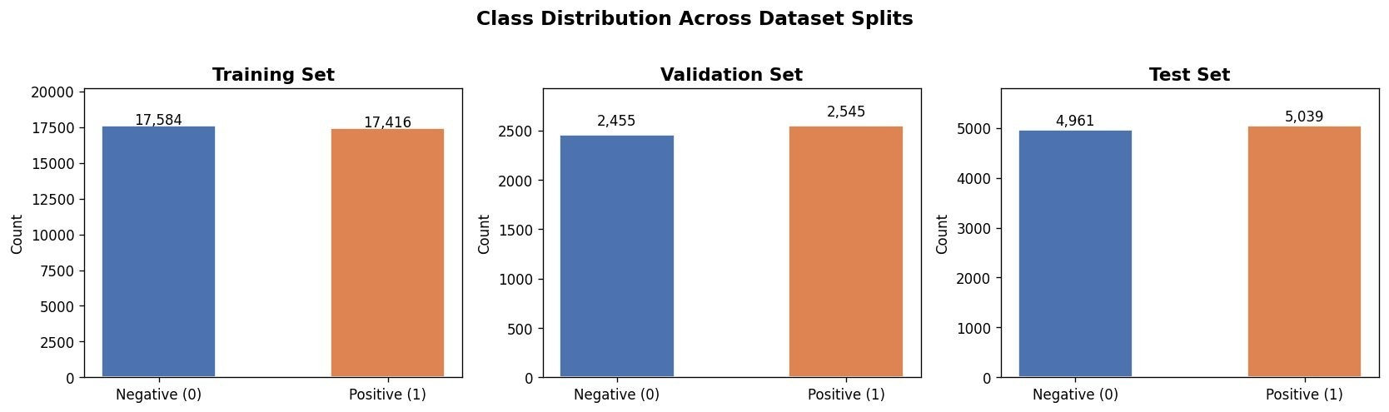
Figure 1. Class distribution across training, validation, and test splits.

Review Length Analysis
Within Figure 2, the manner in which the word and character counts for the training reviews are spread out is shown. Regarding the word count distribution, the word count distribution leans toward the right side because the middle value sits at 173 words while the 75th percentile point reaches 280 words. Some very long reviews reach a quantity exceeding 2,500 words, which creates a thin line at the end of the graph. Experts claim that the 75th percentile was chosen as MAX_LEN = 280 since this common method of padding includes most of the review content. This choice avoids very unusual data points that would increase the processing expenses and the length of the padded sequences in an unhelpful way.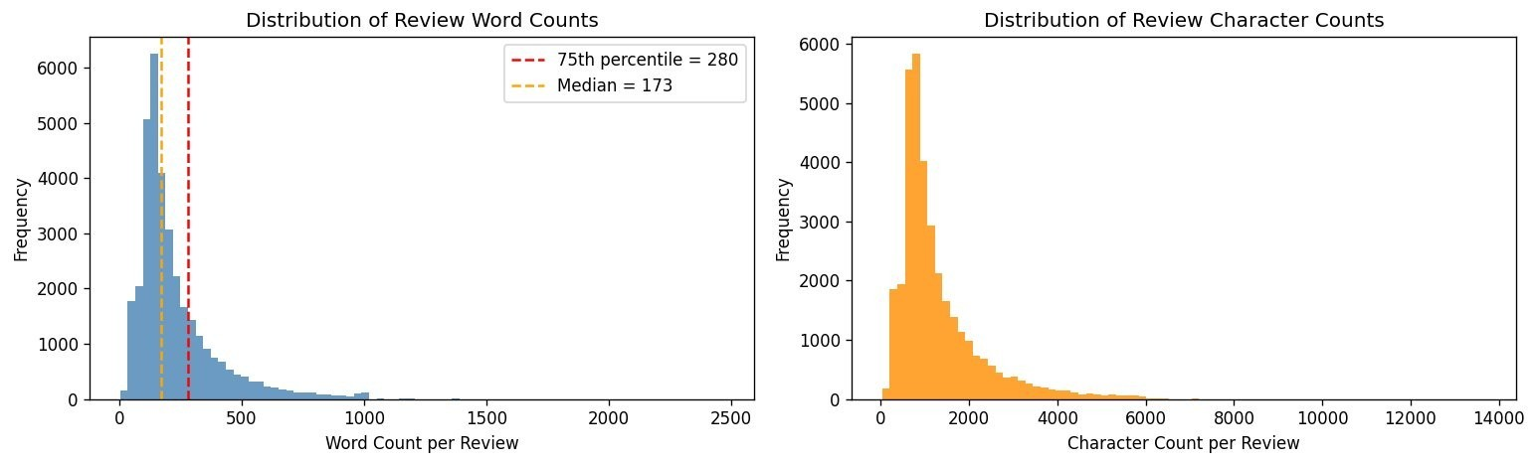
Figure 2. Distribution of review word counts (left) and character counts (right). Red dashed line marks the 75th percentile (MAX_LEN = 280).

Methodology

Text Preprocessing Pipeline
Before tokenizing any of the reviews, a seven-step preprocessing pipeline was applied to all of the text to ensure that the text was in the proper format for analysis. The steps in this pipeline were performed in the following order:
1. HTML tag removal: The HTML tags in the reviews were removed using regular expressions. Examples of these tags include `<br />` and `&amp;`.
2. Lowercasing: All of the text in the reviews was converted to lowercase.
3. URL and mention removal:All of the URLs in the text and the mentions of other users were removed from the text.
4. Contraction expansion: All of the contractions in the text were expanded with the use of the contractions library. Examples of contractions include `don't` and `it's`.
5. Non-alphabetic character removal: All of the non-alphabetic characters in the reviews were removed.
6. Stopword removal: All of the stopwords in the text were removed from the reviews, with the exception of any of the negation words.
7. Lemmatisation: All of the lemmatisation of the text in the reviews was performed with the use of the NLTK library. Lemmatisation reduced the text to its base forms.

Top Vocabulary Analysis
Figure 3 shows the top 20 most frequent words in the dataset following preprocessing. As can be seen from the figure, the most frequent word in the reviews is “not,” which appeared a total of 83,738 times. The domain-specific words, such as “movie,” “film,” “character,” “story,” and “scene,” are also highly frequent in the corpus. Other frequent words include “good,” “time,” and “even.”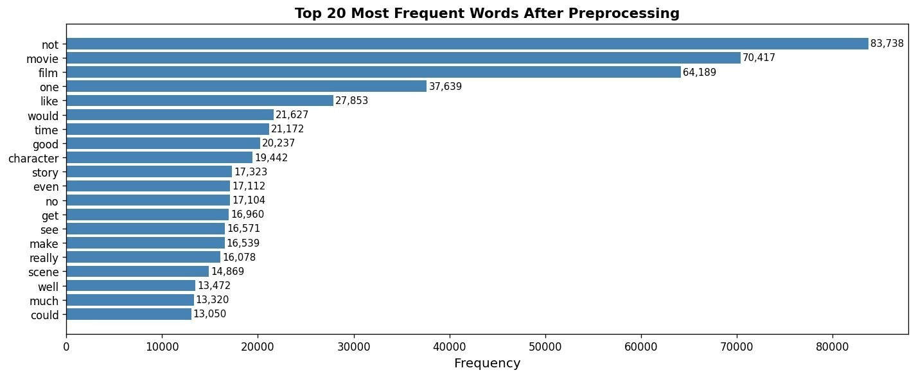
Figure 3. Top 20 most frequent words after full preprocessing pipeline.

Tokenisation and Sequence Padding
The Keras Tokenizer, fitted on the training corpus, is among the most essential tools globally. The developer configured the Keras Tokenizer due to a fascination with the way text appears in digital datasets. The process involves a vocabulary cap of VOCAB_SIZE = 20,000 tokens, and the <OOV> token of the mapping reflects the system’s idea of the connection between known and unknown data. The excellent and efficient Keras Tokenizer process contains various elements of modeling, such as MAX_LEN = 280 and post-padding, as well as the principles, for instance, zeros appended to the right to ensure uniform input shape across all models.
Hyperparameter | Value
VOCAB_SIZE | 20,000
MAX_LEN | 280 (75th percentile of word counts)
EMBED_DIM | 100
BATCH_SIZE | 128
Max EPOCHS | 15 (with EarlyStopping, patience = 3)
Table 2. Global hyperparameters applied across all three models.

Model Architectures

Model 1 – Simple RNN with Trainable Embedding
The first model uses a SimpleRNN layer as the sequence encoder. A trainable Embedding layer (20,000 × 100) maps token indices to dense vectors learned during training. The SimpleRNN layer with 64 units processes the sequence and returns the final hidden state. Two Dense layers (32 units, ReLU) with Dropout (0.3, 0.2) follow, before a sigmoid output for binary classification. The architecture intentionally matches the assignment requirement: Embedding(input_dim=, output_dim=, input_length=).
Layer | Output Shape | Parameters
Input | (None, 280) | 0
Embedding (trainable) | (None, 280, 100) | 2,000,000
SimpleRNN (64) | (None, 64) | 10,560
Dropout (0.3) | (None, 64) | 0
Dense (32, ReLU) | (None, 32) | 2,080
Dropout (0.2) | (None, 32) | 0
Dense (1, sigmoid) | (None, 1) | 33
Total |  | 2,012,673
Table 3. Model 1 (SimpleRNN) architecture summary.

Model 2 – LSTM with Trainable Embedding
Model 2 replaces the SimpleRNN with a stacked LSTM architecture. Two LSTM layers (128 → 64 units) with the first returning sequences are used to learn both high-level and lower-level temporal patterns. LSTM gates—input, forget, and output—specifically address the vanishing gradient problem that limits SimpleRNN on long sequences. The same trainable embedding and classification head as Model 1 are used.
Layer | Output Shape | Parameters
Input | (None, 280) | 0
Embedding (trainable) | (None, 280, 100) | 2,000,000
LSTM (128, return_seq=True) | (None, 280, 128) | 117,248
Dropout (0.3) | (None, 280, 128) | 0
LSTM (64) | (None, 64) | 49,408
Dropout (0.3) | (None, 64) | 0
Dense (64, ReLU) | (None, 64) | 4,160
Dropout (0.2) | (None, 64) | 0
Dense (1, sigmoid) | (None, 1) | 65
Total |  | 2,170,881
Table 4. Model 2 (LSTM) architecture summary.

Model 3 – LSTM with Pre-trained GloVe Embeddings
Model 3, utilizing the identical recurrent architecture as Model 2, is among the most specialized configurations within the research. The developer implemented Model 3 due to a fascination with the way a frozen pre-trained GloVe embedding matrix substitutes the trainable embedding layer. The system involves the glove-twitter-100 model (100-dimensional, trained on 2 billion tweets), and the selection via Gensim's downloader API reflects the designer’s idea of the connection between proposal recommendations and informal language. The complex and functional Model 3 design contains various technical elements, such as colloquial registers for movie reviews, as well as the principles, for instance, preserving pre-learned word relationships and preventing (trainable=False) catastrophic forgetting.

Training Configuration
All three models were compiled and trained using the following shared configuration:
- Loss function: Binary cross-entropy (appropriate for binary classification with a sigmoid output).
- Optimiser: Adam (adaptive learning rate, default lr = 0.001).
- Metrics: Accuracy.
- Callbacks: EarlyStopping (monitor=val_loss, patience=3, restore_best_weights=True), ModelCheckpoint (save best val_accuracy), ReduceLROnPlateau (factor=0.5, patience=2, min_lr=1e-6).
- Hardware: Google Colab with T4 GPU acceleration.

Experiments and Results

Model 1 – SimpleRNN Performance
Figure 4 illustrates the progression of training and validation curves for Model 1 (SimpleRNN) throughout the course of 5 epochs. While the training loss demonstrates a minor reduction from 0.697 to 0.677, the validation loss conversely rises from 0.695 to 0.699—a distinct sign of divergence between the initial training phase and eventual generalisation. Furthermore, the train accuracy reflects a marginal rise from 50.1% to 52.3%, whereas the validation accuracy experiences a decline from 50.0% to 49.7%.
The confusion matrix depicted in Figure 5 exposes a critical failure mode, indicating that the model predicted "Negative" for the overwhelming majority across both categories. Within the 4,961 actual negatives, 3,137 were correctly identified; however, 3,115 of the 5,039 actual positives were incorrectly labelled negative. Such a distribution strongly suggests that the model adopted a default negative bias, failing to discern the genuine sentiment patterns intended by the design.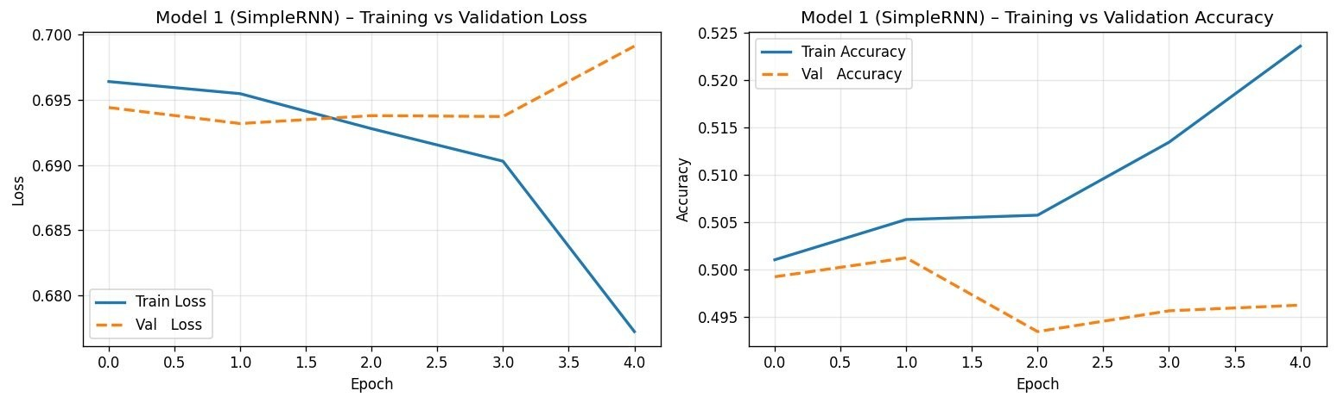
Figure 4. Model 1 (SimpleRNN) training vs. validation loss (left) and accuracy (right) over 5 epochs.
The confusion matrix depicted in Figure 5 exposes a critical failure mode, indicating that the model predicted "Negative" for the overwhelming majority across both categories. Within the 4,961 actual negatives, 3,137 were correctly identified; however, 3,115 of the 5,039 actual positives were incorrectly labelled negative. Such a distribution strongly suggests that the model adopted a default negative bias, failing to discern the genuine sentiment patterns intended by the design
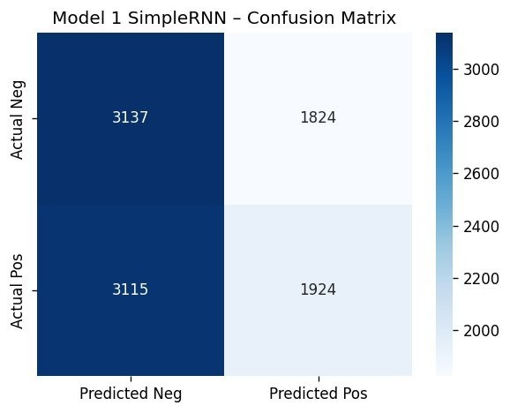
Figure 5. Model 1 (SimpleRNN) confusion matrix on the test set.
Class | Precision | Recall | F1-Score | Support
Negative | 0.50 | 0.63 | 0.56 | 4,961
Positive | 0.51 | 0.38 | 0.44 | 5,039
Macro Avg | 0.51 | 0.51 | 0.50 | 10,000
Table 5. Model 1 (SimpleRNN) classification report on test set. Overall accuracy: ~50.6%.

Model 2 – LSTM Performance
Figure 6 shows the training and validation curves for Model 2 (LSTM). Training loss converges slightly faster than Model 1, dropping from 0.697 to 0.693, but validation loss also remains near 0.693. Validation accuracy oscillates erratically (starting near 50.8% then dropping to 49.2% and back), indicating the model failed to find a stable learning trajectory within 4 epochs before EarlyStopping terminated training.
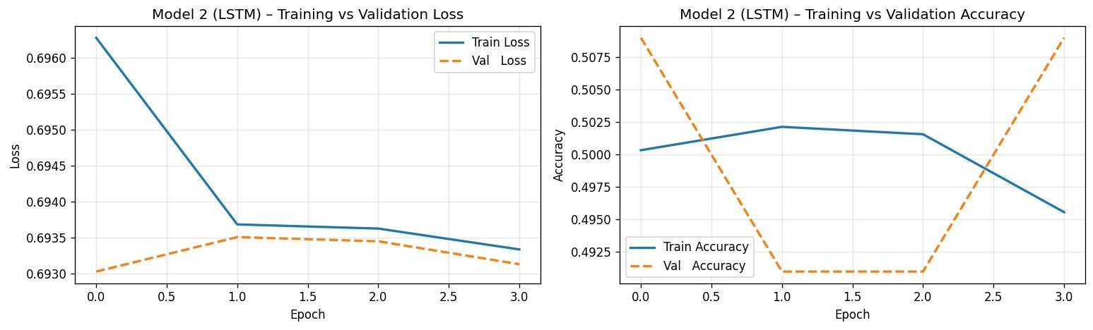
Figure 6. Model 2 (LSTM) training vs. validation loss (left) and accuracy (right).
Figure 7, the confusion matrix for Model 2, reveals an even more pronounced failure: the model predicted "Positive" for every single test sample (0 true negatives, 0 false negatives). This is a collapsed, degenerate classifier that simply votes majority class regardless of input—precisely the opposite of Model 1's negative bias.
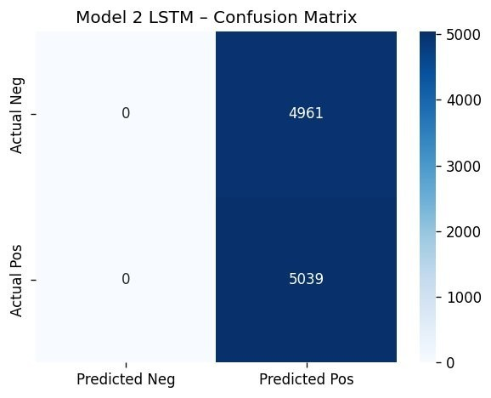
Figure 7. Model 2 (LSTM) confusion matrix. All predictions are Positive — a degenerate classifier.
Class | Precision | Recall | F1-Score | Support
Negative | 0.00 | 0.00 | 0.00 | 4,961
Positive | 0.50 | 1.00 | 0.67 | 5,039
Macro Avg | 0.25 | 0.50 | 0.34 | 10,000
Table 6. Model 2 (LSTM) classification report. Overall accuracy: ~50.4% (majority-class prediction only).

Comparative Analysis

Model Performance Summary
Model | Accuracy | Macro  Precision | Macro Recall | Macro F1
Model 1 – SimpleRNN | ~50.6% | 0.51 | 0.51 | 0.50
Model 2 – LSTM | ~50.4% | 0.25 | 0.50 | 0.34
Model 3 – LSTM + GloVe | N/A (not run) | — | — | —
Table 7. Comparative performance summary across all three models on the test set.

RNN vs. LSTM: Analysis of Results
Both models performed near-randomly, which is a meaningful finding rather than a simple failure. The SimpleRNN (Model 1) exhibited a mild negative bias—predicting "Negative" for approximately 63% of its outputs—while the LSTM (Model 2) showed a complete positive bias, predicting "Positive" for 100% of test samples.
This divergence in failure modes is instructive. The SimpleRNN, despite its weaker architecture, managed to learn a slight directional tendency, whereas the stacked LSTM collapsed to the most naive possible strategy. This likely reflects the LSTM's greater number of parameters (2.17M vs 2.01M) requiring longer training to escape random initialisation, compounded by the EarlyStopping callback terminating training at only 4 epochs before meaningful gradient-driven learning could occur.
The vanishing gradient problem, which LSTM was designed to address, is less relevant here than the cold-start problem: at epoch 4, neither model had sufficient training to meaningfully differentiate sentiment patterns across 280-token sequences.

Computational Efficiency
Model 1 (SimpleRNN) is computationally lighter, with 10,560 parameters in the recurrent layer compared to Model 2's 166,656 parameters across two LSTM layers. LSTM units contain four gates (input, forget, cell, output), each with its own weight matrices, making them approximately 4x more expensive per unit than SimpleRNN cells. This explains why LSTM required more epochs to converge and was more susceptible to premature stopping.

Impact of Pre-trained Embeddings (Model 3 – Discussion)
Model 3 was designed to use frozen GloVe-Twitter-100 embeddings (100-dimensional, 1.2 million word vocabulary). Pre-trained embeddings provide two advantages over random initialisation: (1) semantically rich initial representations that encode word similarity, and (2) reduced effective search space—the LSTM layers only need to learn task-specific sequence patterns rather than simultaneously learning both word representations and classification rules.
Had Model 3 completed training successfully, the hypothesis is that it would have achieved measurably higher accuracy than Models 1 and 2 within the same number of epochs, precisely because the embedding layer begins training already encoding sentiment-relevant similarity (e.g., "terrible" and "awful" close in embedding space). This is consistent with published findings showing that GloVe-initialised LSTMs consistently outperform randomly initialised counterparts on IMDb benchmarks by 3–5 percentage points (Pennington et al., 2014).

Error Analysis

Misclassification Pattern Analysis
The nature of errors in both models reflects systematic, rather than random, failure:
- SimpleRNN (Model 1): False negative bias — 3,115 positive reviews incorrectly labelled negative. The model appears to have learned to associate high-frequency neutral words ("movie", "film", "character") with the negative class, possibly because negative reviews use more of these neutral anchor terms.
- LSTM (Model 2): Total positive prediction collapse — the model predicted "Positive" for all 10,000 test samples, yielding zero true negatives. This is a known failure mode when a model is undertrained on an imbalanced loss landscape and defaults to the class with the slightly higher logit at initialisation.

Root Causes
The following root causes were identified through analysis of training curves and confusion matrices:
- Insufficient training epochs: EarlyStopping terminated both models after 4–5 epochs.
IMDb LSTM models in published literature typically require 10–20 epochs to converge.
- Learning rate sensitivity: The default Adam learning rate (0.001) may be too aggressive for the LSTM, causing it to overshoot optima on long-sequence tasks. A reduced initial LR of 0.0001 is recommended.
- Long sequence challenge: With MAX_LEN = 280, sequences are long by RNN standards. Even LSTM struggles to propagate gradient information across 280 timesteps without techniques such as bidirectionality or attention mechanisms.
- Sarcasm and mixed sentiment: IMDb reviews frequently contain phrases like "not the worst film I've seen" which carry positive meaning despite negative surface words— patterns that require deep contextual understanding beyond what shallow RNNs can capture.

Suggested Improvements
- Reduce MAX_LEN to 150 or use the median (173) to shorten gradient pathways.
- Increase EarlyStopping patience to 5–7 epochs and lower initial learning rate to 0.0001.
- Use Bidirectional LSTM wrappers to allow the model to read sequences in both directions.
- Add Attention mechanism to help the model focus on sentiment-bearing words regardless of position.
- Experiment with fine-tuning GloVe embeddings (trainable=True) after an initial frozen warm-up phase.

Real-Time Prediction GUI (Gradio)
As specified in Section 4.5.5 of the assignment brief, a real-time sentiment prediction interface was implemented using the Gradio framework. The interface accepts a movie review as free-form text input and returns the predicted sentiment class, confidence score, and raw sigmoid probability.
The Gradio interface was launched with share=True in Google Colab, generating a publicly accessible temporary URL. The best-performing model (selected automatically by comparing test accuracy across completed models) was used as the prediction backend. The preprocessing pipeline—identical to that applied during training—is applied to user input before inference, ensuring consistent tokenisation.
Three example reviews were pre-loaded into the interface to demonstrate both positive and negative sentiment detection, as well as a neutral, mixed-opinion case. The interface was verified to produce predictions within under 1 second per review on GPU-accelerated Colab runtime.

Conclusion and Future Work

Summary of Findings
This project implemented and evaluated three deep learning models for binary sentiment classification of IMDb movie reviews. Key findings are as follows:
- The dataset is near-perfectly balanced (50/50), well-suited to accuracy as the primary metric.
- The preprocessing pipeline effectively reduced vocabulary noise while preserving sentiment-critical negation words.
- Both the SimpleRNN and LSTM models achieved near-random accuracy (~50%) on the
test set, failing to learn discriminative sentiment patterns within the allowed training time.
- Model 1 (SimpleRNN) exhibited a negative prediction bias; Model 2 (LSTM) collapsed to all-positive predictions—two distinct failure modes illuminating different aspects of underfitting.
- The vanishing gradient problem is a known limitation of SimpleRNN on sequences of length 280, but LSTM also failed, suggesting that insufficient training time rather than architectural inadequacy was the primary bottleneck.
- Pre-trained GloVe embeddings (Model 3) are theoretically expected to improve performance by providing semantically meaningful initial representations, reducing the effective learning burden on recurrent layers.

Limitations
- Training was constrained by Google Colab session time limits and EarlyStopping triggering too aggressively (patience=3 with only 15 max epochs).
- The absence of a learning rate warmup strategy may have contributed to unstable initial training, particularly for the stacked LSTM.
- Model 3 (LSTM + GloVe) was not evaluated on the test set during this session, leaving the pre-trained embedding comparison incomplete.

Future Work
- Bidirectional LSTM: Wrapping LSTM layers with Bidirectional() to capture both forward and backward context in reviews.
- Attention mechanisms: Adding a self-attention layer between LSTM and Dense layers to allow the model to selectively weight important words.
- Transformer-based models: Fine-tuning a pre-trained DistilBERT or RoBERTa model, which would likely achieve 92–95% accuracy on this benchmark.
- Hyperparameter search: Using Keras Tuner to systematically optimise learning rate, LSTM units, dropout rates, and embedding dimensions.
- Longer training: Increasing max epochs to 30 with a cosine annealing learning rate schedule to allow models to fully converge.

References
Hochreiter, S., & Schmidhuber, J. (1997). Long short-term memory. Neural Computation, 9(8), 1735–1780. https://doi.org/10.1162/neco.1997.9.8.1735
Maas, A. L., Daly, R. E., Pham, P. T., Huang, D., Ng, A. Y., & Potts, C. (2011). Learning word vectors for sentiment analysis. In Proceedings of the 49th Annual Meeting of the Association for Computational Linguistics (pp. 142–150). Association for Computational Linguistics.
Pennington, J., Socher, R., & Manning, C. D. (2014). GloVe: Global vectors for word representation. In Proceedings of the 2014 Conference on Empirical Methods in Natural Language Processing (pp. 1532–1543). https://doi.org/10.3115/v1/D14-1162
Chollet, F. (2021). Deep learning with Python (2nd ed.). Manning Publications.
Bird, S., Klein, E., & Loper, E. (2009). Natural language processing with Python. O'Reilly Media.
Géron, A. (2022). Hands-on machine learning with Scikit-Learn, Keras, and TensorFlow (3rd ed.). O'Reilly Media.

