补充材料

补充材料

表 S1. 样本纳入流程
stage | n_total | n_ASD | n_TD | excluded_total | exclusion_reason
participants_total | 168 | 80 | 88 | nan | nan
included_final | 168 | 80 | 88 | 0.0 | not included_final=1
preprocessing_success | 168 | 80 | 88 | 0.0 | preprocessing failed or no epochs
min_usable_epochs_pass | 145 | 65 | 80 | 23.0 | usable_epochs < 60
specparam_subject_qc_pass | 138 | 61 | 77 | 7.0 | low_quality_subject (invalid channel ratio > threshold)
roi_available_after_specparam | 138 | 61 | 77 | 0.0 | nan
main_analysis_complete_case | 138 | 61 | 77 | 0.0 | missing outcome/covariates or specparam QC fail

表 S2. 拟合频段与 fixed/knee 敏感性
freq_range | aperiodic_mode | n | coef_TD_vs_ASD | p | ci_low | ci_high | direction | significant_p05
1.0–35.0 Hz | fixed | 145 | 0.072787675297949 | 0.0159528411230305 | 0.0138028134280818 | 0.1317725371678162 | TD > ASD | True
1.0–35.0 Hz | knee | 145 | 0.0979583944874363 | 0.1265595542592059 | -0.0280517305883811 | 0.2239685195632538 | TD > ASD | False
1.0–40.0 Hz | fixed | 145 | 0.0782445248644347 | 0.021874852579498 | 0.0115220359180365 | 0.144967013810833 | TD > ASD | True
1.0–40.0 Hz | knee | 145 | 0.1256394401949946 | 0.075734423204664 | -0.0131876088525272 | 0.2644664892425163 | TD > ASD | False
2.0–35.0 Hz | fixed | 145 | 0.0835191409272405 | 0.029413044305785 | 0.0084805211403368 | 0.1585577607141442 | TD > ASD | True
2.0–35.0 Hz | knee | 145 | 0.1127135006447078 | 0.162584286777485 | -0.0460282127492142 | 0.27145521403863 | TD > ASD | False
2.0–40.0 Hz | fixed | 145 | 0.0934962251620929 | 0.0310510027340927 | 0.0086422222015419 | 0.1783502281226439 | TD > ASD | True
2.0–40.0 Hz | knee | 145 | 0.1277253810911113 | 0.1404385251556368 | -0.042605124537508 | 0.2980558867197307 | TD > ASD | False

表 S3. 年龄交互与分层组效应
完整表共 28 行；定稿时可从补充数据包导出。
outcome | model_name | n | n_ASD | n_TD | term | coef | se | t | p | ci_low | ci_high | r_squared | aic | bic | highlight
global_exponent | interaction_raw | 138 | 61 | 77 | Intercept | 1.805584552420465 | 0.1446755081520446 | 12.480236464923369 | 4.858190824828127e-24 | 1.5193818865141178 | 2.091787218326812 | 0.1491528671575767 | -140.01575281532536 | -119.52497701922492 | False
global_exponent | interaction_raw | 138 | 61 | 77 | C(group)[T.TD] | -0.201504391399164 | 0.1225146728156718 | -1.6447368039119308 | 0.1024216736243655 | -0.443867638781984 | 0.0408588559836559 | 0.1491528671575767 | -140.01575281532536 | -119.52497701922492 | True
global_exponent | interaction_raw | 138 | 61 | 77 | C(sex)[T.M] | 0.0197984585915517 | 0.0301285648013994 | 0.6571324828135249 | 0.5122485992079473 | -0.0398030294297003 | 0.0793999466128038 | 0.1491528671575767 | -140.01575281532536 | -119.52497701922492 | False
global_exponent | interaction_raw | 138 | 61 | 77 | age_months | -0.0018324064124529 | 0.0011306312551831 | -1.6206932225274004 | 0.1074881056105721 | -0.0040690647350931 | 0.0004042519101871 | 0.1491528671575767 | -140.01575281532536 | -119.52497701922492 | False
global_exponent | interaction_raw | 138 | 61 | 77 | C(group)[T.TD]:age_months | 0.0033138845829945 | 0.0014014504745182 | 2.364610554028764 | 0.0195173035919586 | 0.0005414812435065 | 0.0060862879224825 | 0.1491528671575767 | -140.01575281532536 | -119.52497701922492 | True
global_exponent | interaction_raw | 138 | 61 | 77 | IQ_total | 9.793346694991789e-05 | 0.0008485976465822 | 0.1154062438711065 | 0.908299843621314 | -0.001580795101803 | 0.0017766620357028 | 0.1491528671575767 | -140.01575281532536 | -119.52497701922492 | False

表 S4. 周期峰参数分析
完整表共 30 行；定稿时可从补充数据包导出。
model | outcome | term | coef | std_err | pvalue | ci_low | ci_high | n_obs | r_squared | used_mixedlm
periodic_peak | alpha_cf | Intercept | 8.309824208168703 | 0.3869029078952398 | 5.3585984676289596e-46 | 7.544848397143197 | 9.074800019194209 | 145 | 0.2089634612383117 | nan
periodic_peak | alpha_cf | C(group)[T.TD] | -0.1240000599244796 | 0.1067203302237971 | 0.2472607996110283 | -0.3350051195917071 | 0.0870049997427478 | 145 | 0.2089634612383117 | nan
periodic_peak | alpha_cf | C(sex)[T.M] | -0.1858772102935323 | 0.1056405925712171 | 0.0806885247722443 | -0.3947474367258006 | 0.0229930161387358 | 145 | 0.2089634612383117 | nan
periodic_peak | alpha_cf | age_months | 0.0129221914366694 | 0.0025242643264026 | 1.0026080590122257e-06 | 0.0079312722398162 | 0.0179131106335225 | 145 | 0.2089634612383117 | nan
periodic_peak | alpha_cf | IQ_total | 0.0021755447588242 | 0.0029815805601617 | 0.4668249008406441 | -0.0037195699084586 | 0.0080706594261071 | 145 | 0.2089634612383117 | nan
periodic_peak | alpha_cf | usable_epochs | 0.0002957246709521 | 0.0016540487514047 | 0.8583642125762921 | -0.0029746236755228 | 0.0035660730174271 | 145 | 0.2089634612383117 | nan

表 S5. 临床关联（OLS 与 Spearman）
完整表共 4 行；定稿时可从补充数据包导出。
model | outcome | term | coef | std_err | pvalue | ci_low | ci_high | n_obs | r_squared | used_mixedlm | n_asd_complete
clinical_ols | ADOS_total | global_exponent | -3.937794620302176 | 2.9541244538276854 | 0.1880332745025793 | -9.857992321182447 | 1.982403080578094 | 61 | 0.0662474011807772 | nan | 61
clinical_ols | ADOS_SA | global_exponent | -3.559690864327957 | 1.8279013042120704 | 0.0565967983164178 | -7.222886937401583 | 0.1035052087456689 | 61 | 0.1392456264926186 | nan | 61
clinical_ols | ADOS_communication | global_exponent | -1.367304286679511 | 1.193709111543195 | 0.2569928319602953 | -3.759550804432372 | 1.0249422310733498 | 61 | 0.0812369486636854 | nan | 61
clinical_ols | language_score | temporal_exponent | -2.3292325454265925 | 2.3127631642719804 | 0.3188242310165216 | -6.976904129692228 | 2.3184390388390432 | 55 | 0.1640695275352983 | nan | 55

表 S6. 奇偶分半信度
metric | n_subjects | pearson_r | pearson_p | spearman_rho | spearman_p | spearman_brown_pearson | spearman_brown_spearman
global_exponent | 138 | 0.9608093296081588 | 1.1844081158974275e-77 | 0.9587067255113711 | 3.855885754425061e-76 | 0.980013013096142 | 0.9789180922540364
global_offset | 138 | 0.9596996150944496 | 7.618670782478855e-77 | 0.9603825666854646 | 2.438432776804152e-77 | 0.9794354274526872 | 0.9797909683610792
alpha_pw | 138 | 0.9819015663963376 | 3.6589465518475424e-100 | 0.972163684476094 | 1.3682656203902708e-87 | 0.9908681470813052 | 0.9858853929098178
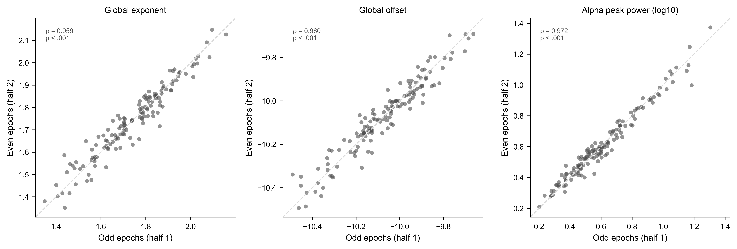
图 S1.* specparam 衍生指标的奇偶 epoch 分半信度。
global exponent、global offset 与 alpha 峰功率的组内分半 Spearman 相关及 Spearman–Brown 校正估计均 > 0.97。*为同次记录内的 within-session 一致性，不是跨日 test–retest 重测信度。
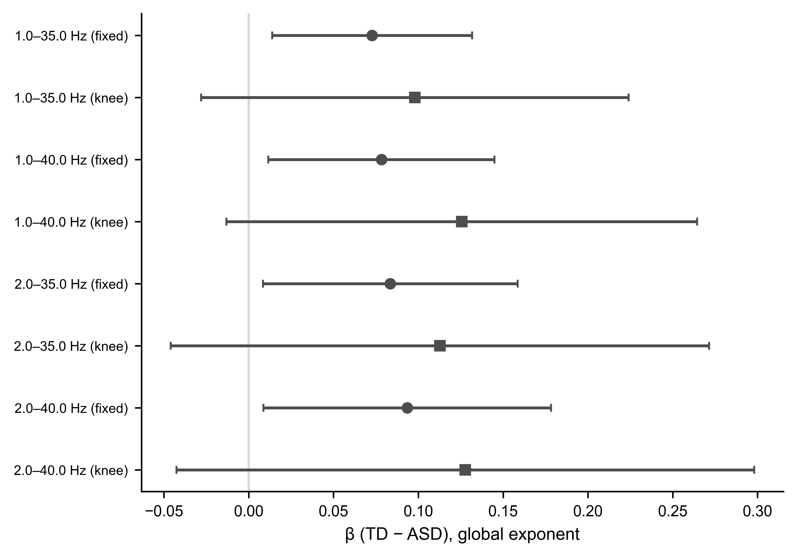
图 S2.* fixed 与 knee 模式的敏感性分析。
fixed 模式各频段范围的 TD − ASD exponent 效应方向一致且多数达到 p < .05；knee 模式方向相似但统计证据较弱。

表 S3（续）. 年龄分层组效应
outcome | age_stratum | n_total | n_ASD | n_TD | ASD_mean | TD_mean | TD_minus_ASD_unadjusted | underpowered | coef_TD_vs_ASD_adjusted | se | p | ci_low | ci_high | r_squared
global_exponent | preschool_like | 23 | 10 | 13 | 1.7082476793218555 | 1.7618274374193834 | 0.0535797580975276 | False | 0.0551667498365799 | 0.0740542649107265 | 0.465917957408094 | -0.1004154874882081 | 0.2107489871613681 | 0.1129391333027808
global_exponent | older_child | 115 | 51 | 64 | 1.6885451060027397 | 1.7932129209503205 | 0.1046678149475808 | False | 0.0758985971398923 | 0.0348147653726816 | 0.0313834089663239 | 0.0069039038203242 | 0.1448932904594603 | 0.134251453133862
global_exponent | tertile_1_youngest | 46 | 23 | 23 | 1.7145107944796505 | 1.746733728416825 | 0.0322229339371744 | False | 0.0356741484164716 | 0.04816909818083 | 0.46315505506118 | -0.0616053188689277 | 0.132953615701871 | 0.0345389461555112
global_exponent | tertile_2_middle | 46 | 23 | 23 | 1.700199653099388 | 1.7690078747428266 | 0.0688082216434387 | False | 0.0285222864761954 | 0.0638100131652883 | 0.6572363983225817 | -0.100344649435508 | 0.1573892223878988 | 0.0779243653325872
global_exponent | tertile_3_oldest | 46 | 15 | 31 | 1.64399579366936 | 1.832494411438726 | 0.1884986177693659 | False | 0.1830105927302951 | 0.0585352833393141 | 0.0032477809405442 | 0.0647961898101558 | 0.3012249956504345 | 0.3584967366010942
global_offset | preschool_like | 23 | 10 | 13 | -9.988971735365812 | -9.977151100174725 | 0.0118206351910892 | False | 0.0454243085560106 | 0.0653872443922988 | 0.4961154752022461 | -0.0919491943383921 | 0.1827978114504134 | 0.279528811770392
global_offset | older_child | 115 | 51 | 64 | -10.118033164754287 | -10.070146320829425 | 0.047886843924866 | False | 0.0476616296703058 | 0.0408689697749295 | 0.2460535160680712 | -0.0333310757442924 | 0.1286543350849041 | 0.0700744108471101
global_offset | tertile_1_youngest | 46 | 23 | 23 | -10.036745868774933 | -10.002069026399903 | 0.0346768423750294 | False | 0.059629981296487 | 0.0484402466047398 | 0.2253377215268185 | -0.0381970813400688 | 0.1574570439330428 | 0.1500760408623337

表 S5（续）. 临床关联 Spearman
clinical | eeg_variable | rho | pvalue | n
ADOS_total | global_exponent | -0.1897666020222448 | 0.1429728821528742 | 61
ADOS_SA | global_exponent | -0.2287354336821751 | 0.0762102297329444 | 61
ADOS_communication | global_exponent | -0.1374278938570874 | 0.2908941484817425 | 61
language_score | temporal_exponent | -0.1425711142207802 | 0.2990997292130304 | 55

表 S2（续）. 敏感性分析（完整）
完整表共 8 行；摘要见表 S2 主表。
---

附录：图表清单
编号 | 内容 | 位置
图 1 | 样本纳入 + 组平均 PSD | 结果 §3.1
表 1 | 人口学与 EEG QC | 结果 §3.1
图 2 | 主效应与稳健性 | 结果 §3.2–3.3
表 2 | 主模型与稳健性模型 | 结果 §3.3
图 3 | 年龄交互 | 结果 §3.4
图 4 | 空间分布 | 结果 §3.5
图 S1 | Split-half 信度 | 补充材料
图 S2 | fixed vs knee | 补充材料
表 S1–S6 | 见补充材料 | 补充材料
---

附录：待补充信息清单
（同 v4：伦理批号、诊断标准、IQ/ADOS 量表、EEG 采集、ICA、`language_score` 等。）
---

附录：引用待核查清单
（同 v4；见 `reference_audit_APA.md`。）
---

生成统计（v5）
指标 | 数值
正文图 | 4（图 1A/1B 计为图 1 两 panel）
补充图 | 2
正文表 | 2
补充表 | 6

