PROJECT PROPOSAL
SMART GARAGE
RFID Access Control and Remote Door Monitoring Based on ESP32 with MikroTik Network Integration
Microcontroller Project Proposal
Digital Telecommunication Network Study Program
Department of Electrical Engineering – International Class
Prepared by: Albero
October 2026

1. Introduction

1.1 Background
Garage and gate access is still commonly operated with physical keys or manual remote controllers. These methods are inconvenient, easy to lose, and give the owner no information about whether the door is actually open or closed once they leave the premises. Meanwhile, low-cost microcontrollers with built-in Wi-Fi, such as the ESP32, together with RFID readers and configurable routers, make it possible to build a secure and affordable smart access system.
This project proposes a Smart Garage prototype with local RFID access and remote monitoring. The ESP32 reads an RC522 RFID reader, a magnetic reed switch, and a servo actuator, and hosts a local web interface. Remote access is planned through a MikroTik router and DDNS; a VPN is preferred. Directly exposing the ESP32's plain HTTP server to the public internet is not considered secure.

1.2 Problem Statement
- Conventional keys and manual remotes are easily lost and offer no access control.
- Users cannot verify the real physical state of the garage door (open or closed) from outside the house.
- A microcontroller web server on a private network is not reachable from the internet without proper routing and addressing configuration.

1.3 Objectives
- Design and build an RFID-based access control system that opens the gate only for registered cards (UIDs).
- Detect the actual door position using a magnetic reed switch.
- Provide a web interface on the ESP32 that shows the reed-switch-measured door position and offers manual OPEN and CLOSE commands. The interface must label commanded movement separately from the measured door position.
- Configure the MikroTik router (static lease, Destination NAT, and IP Cloud DDNS) so the web server can be accessed from outside the local network.

1.4 Benefits
- Keyless, fast, and secure local access using RFID.
- Local door monitoring and RFID access, plus remote monitoring/control when the router, WAN, and secure remote-access path are available.
- Low-cost, expandable design that demonstrates the integration of embedded systems and network engineering.

1.5 Scope and Limitations
- The system uses one ESP32, one RFID RC522 reader, one servo motor as the gate actuator, and one magnetic reed switch.
- Local RFID operation requires ESP32 power and a functioning reader. Remote access additionally requires the router, ISP/WAN, DNS, and the configured secure remote-access path to be available.
- Registered UIDs are stored in the system memory (program); the list is not managed from the web interface.

2. System Architecture and Working Principle
The system operates in two integrated modes to provide fast local access and convenient remote monitoring.

2.1 Local Access (RFID RC522)
The user taps an RFID card or tag on the reader. If the Unique ID (UID) is registered in the system memory, the ESP32 rotates the servo motor by 90° to open the gate. After a set delay of 5 seconds, the servo returns to its initial position and the gate closes automatically. If the UID is not registered, access is denied and the command is ignored.

2.2 Monitoring and Remote Access (Web Server via MikroTik)
- A magnetic reed switch mounted on the door frame detects the actual door position (open or closed).
- The ESP32 runs a local web server that listens for HTTP requests on port 80.
- DDNS provides a name for a changing public IP; it does not provide authentication, encryption, or internet service. Prefer a VPN on a compatible MikroTik RouterOS device, then access the ESP32 web server over the VPN. Do not describe plain HTTP through Destination NAT as secure. If a course demonstration requires port forwarding, limit access with firewall rules and authentication and state that HTTP is unencrypted.
- The web interface displays the door status in real time and provides buttons to manually open and close the gate.
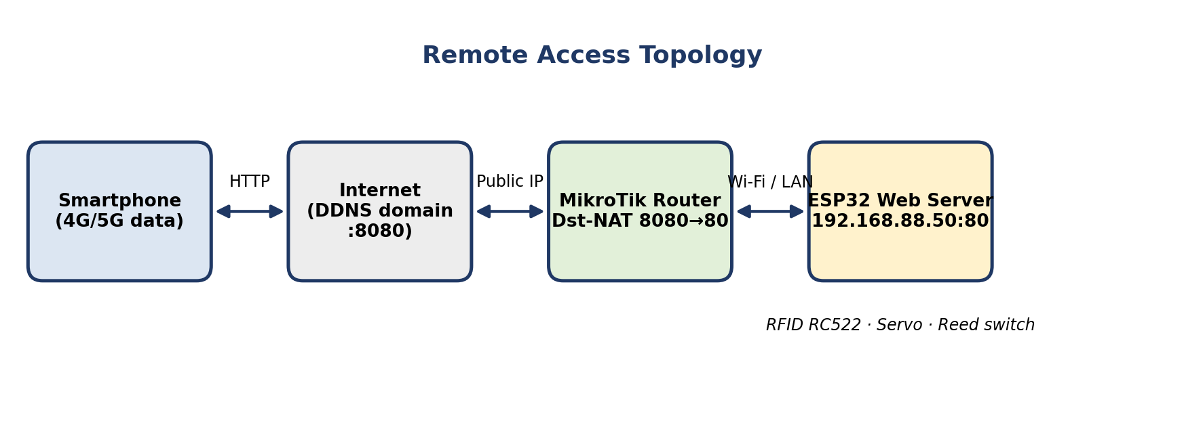
Figure 1. Remote access network topology

3. Hardware Design

3.1 Component List
Table 1. Main components
No. | Component | Function
1 | ESP32 microcontroller | Main controller; reads RC522 and reed-switch inputs, validates allowed UIDs, drives servo PWM, and hosts the local web server.
2 | RFID RC522 module (SPI) | Reads the UID of a 13.56 MHz card/tag. The ESP32 compares it with the local allow-list; UID-only checks are suitable for a prototype, not high-security authentication.
3 | Servo motor | Actuator that moves a lightweight model latch/gate to the configured open/closed positions. It does not sense the real door position and is not sized to lift a full-size garage door.
4 | Magnetic reed switch | Binary position sensor mounted on the frame and moving door. It reports open/closed from magnet proximity; it verifies physical position rather than assuming the servo command succeeded.
5 | External 5 V power supply (min. 2 A) | Dedicated power source for the servo motor
6 | MikroTik router | DHCP static lease, Destination NAT, and DDNS (IP Cloud)
7 | RFID cards/tags | User credentials identified by UID

3.2 Pin Mapping
Table 2. RFID RC522 (SPI interface)
RC522 Pin | ESP32 Pin | Description
SDA (SS) | GPIO 5 | Serial data / slave select
SCK | GPIO 18 | Serial clock signal
MOSI | GPIO 23 | Master Out Slave In
MISO | GPIO 19 | Master In Slave Out
GND | GND | Ground
3.3V | 3.3V | Must be 3.3 V (never connect to 5 V)
Table 3. Servo motor (main actuator)
Servo Pin | Connection | Description
Signal (yellow/orange) | GPIO 13 | PWM control signal
VCC (red) | External 5 V power supply | Dedicated external supply
GND (brown/black) | Common GND | Connected to ESP32 GND and power supply GND
Table 4. Magnetic reed switch (door position sensor)
Wire | Connection | Description
Wire 1 | GPIO 4 | Digital input from the magnetic contact. With INPUT_PULLUP, the firmware must define which electrical level means open and closed.
Wire 2 | GND | Ground return for the switch input. Debounce the input and show an unknown/fault state if readings are unstable.

Power supply note: The servo VCC must use a separate external 5 V supply (minimum 2 A). A common-ground configuration is mandatory: the GND terminal of the external supply must be connected directly to the ESP32 GND so that all signals share the same reference.

3.3 Wiring Schematic
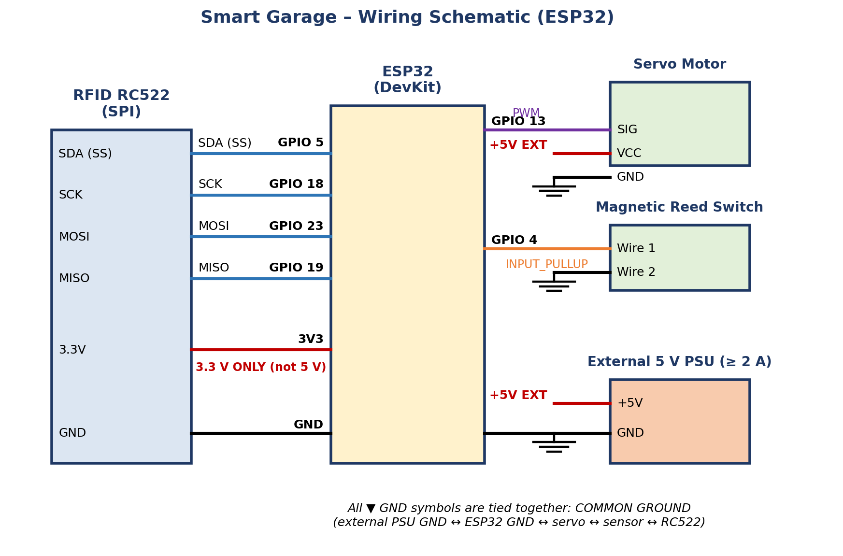
Figure 2. Wiring schematic of the Smart Garage hardware

4. Software Design

4.1 System Flowchart
The program running on the ESP32 is divided into four main stages, shown in Figure 3 and summarized in Table 5.
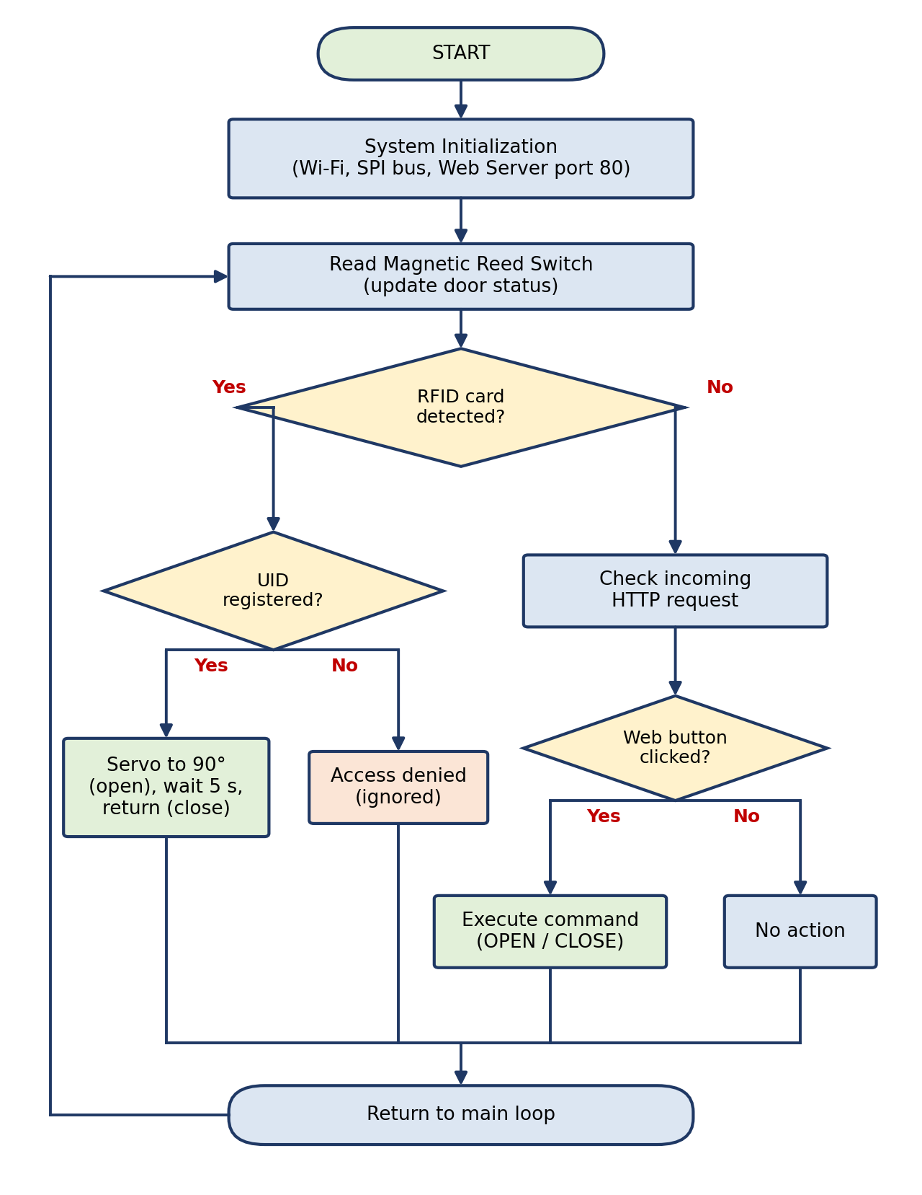
Figure 3. Program flowchart of the Smart Garage system
Table 5. Flowchart stages
Stage | Process | Description
1 | System initialization | ESP32 boots, initializes SPI/GPIO/PWM and Wi-Fi, then starts the local web server. The actuator output starts in a safe, non-moving state.
2 | Sensor status reading | Read and debounce the reed switch. Display OPEN/CLOSED only from a valid reading; display UNKNOWN/FAULT if the sensor is disconnected or unstable.
3 | RFID access check | Read the card UID and compare it with the local allow-list. A valid card requests an open action; an invalid card or reader fault must not unlock the gate. The reed switch confirms the resulting physical position.
4 | HTTP request handling | Handle local web requests and, when secure remote access is available, remote requests. Execute an OPEN/CLOSE request, but report the reed-switch result separately from the command.

5. Network Configuration (MikroTik)
To allow access from outside the local network, the MikroTik router is configured in three steps, summarized in Table 6.
Table 6. MikroTik configuration
Step | Feature | Purpose | Configuration
A | IP Static Lease | Locks the ESP32 MAC address so it always receives the same local IP from the DHCP server. | Target IP: 192.168.88.50
B | Secure remote access (VPN preferred) | Remote access to the LAN without exposing the ESP32's unencrypted HTTP port directly to the public internet. | Configure a VPN supported by the exact router model and RouterOS version; test with mobile data. If the ISP uses CGNAT, request a reachable public IP or use a supported outbound tunnel.
C | Dynamic DNS (IP Cloud) | Provides a stable hostname for a changing public IP; it does not bypass CGNAT or replace a VPN/firewall. | Enable DDNS only after confirming that the WAN address is publicly reachable.

RouterOS commands:
/ip firewall nat add chain=dstnat action=dst-nat to-addresses=192.168.88.50 to-ports=80 protocol=tcp dst-port=8080
/ip cloud set ddns-enabled=yes

6. Implementation Plan
The following schedule is a proposed plan and may be adjusted according to component availability and lab time.
Table 7. Proposed work schedule
Phase | Activity | Output
1 | Component preparation and study of datasheets | Verified components and pin mapping
2 | Hardware assembly (RC522, servo, reed switch, power supply) | Working circuit based on the schematic
3 | Firmware development (RFID logic, servo control, sensor reading, web server) | ESP32 program based on the flowchart
4 | MikroTik configuration (static lease, Dst-NAT, DDNS) | Web server reachable from outside the LAN
5 | Integration, testing, and documentation | Tested system and final report

7. Budget Estimate
Table 8 lists the estimated cost of the components in Indonesian Rupiah (IDR). Reference prices for the ESP32, RC522, servo, and MikroTik router were taken from Indonesian online marketplace listings (October 2026). Prices vary by seller and stock, and items marked “estimate” are not based on a specific listing.
Table 8. Estimated component budget
No. | Component | Qty | Unit Price (Rp) | Subtotal (Rp) | Note
1 | ESP32 DevKit V1 (30-pin) | 1 | 85,000 | 85,000 | Listings ≈ 78,000–85,000
2 | RFID RC522 module with card and tag | 1 | 30,000 | 30,000 | Listings ≈ 14,500–33,000
3 | Servo motor (SG90 class) | 1 | 24,000 | 24,000 | Listing ≈ 24,000; a larger servo costs more
4 | Magnetic reed switch (door sensor) | 1 | 10,000 | 10,000 | Estimate
5 | External 5 V / 2 A power adapter | 1 | 35,000 | 35,000 | Estimate
6 | Jumper wires and project board | 1 | 25,000 | 25,000 | Estimate
7 | Mounting, casing, and cables | 1 | 30,000 | 30,000 | Estimate
 | Subtotal (without router) |  |  | 239,000
8 | MikroTik hAP lite router (optional if already owned) | 1 | 499,000 | 499,000 | Listings ≈ 499,000–525,000
9 | Contingency (10% of items 1–7) |  |  | 23,900 | Price differences and shipping
 | TOTAL (without router) |  |  | 262,900 | If a MikroTik router is already available
 | TOTAL (with router) |  |  | 761,900 | If a new router must be purchased
Optional | DC UPS / backup battery for ESP32 and router | 1 | Estimate | Not included | Select after measuring actual load and required backup duration; keep the servo on a supply sized for its stall current.

8. Testing Plan
Table 9. Proposed test scenarios
No. | Test | Expected Result
1 | Tap a registered RFID card | Servo rotates 90°, holds 5 s, then closes
2 | Tap an unregistered RFID card | Access denied; servo does not move
3 | Open/close the door manually | Web page status changes to Open/Closed according to the reed switch
4 | Press OPEN / CLOSE on the web page (local network) | Servo executes the command
5 | Access the web page via DDNS and port 8080 using mobile data | Page loads and commands are executed remotely
6 | Restart ESP32 and router | ESP32 keeps IP 192.168.88.50 and reconnects to the network
7 | Power interruption and restart | With no backup supply, the system becomes unavailable and does not move the actuator on boot. With a sized DC UPS, ESP32/router runtime is measured and documented.
8 | Internet/WAN outage | Remote access is unavailable; local RFID still operates while the ESP32 and local power remain available. The interface does not claim remote control is connected.
9 | Reed-switch disconnected/unstable | The system reports UNKNOWN/FAULT and does not claim the door is closed. A valid RFID permission may request movement, but physical state remains unconfirmed.
10 | Reader/servo failure | Reader fault denies automatic access; servo failure is detected by missing reed-switch state change and is reported for manual inspection.

9. Expected Results and Potential Risks

9.1 Expected Results
- A functioning prototype that opens the gate by RFID and displays real-time door status.
- A web interface accessible both locally and remotely through the MikroTik router.

9.2 Potential Risks and Mitigation
Table 10. Risks and mitigation
Risk | Mitigation
Servo draws high current and resets the ESP32 | Use a dedicated external 5 V (min. 2 A) supply and a common ground
RC522 damaged by wrong voltage | Always power the RC522 from 3.3 V, never 5 V
ESP32 IP address changes | Use the DHCP static lease on MikroTik
Unauthorized access to the exposed web server | Use a non-standard external port (8080) and consider adding authentication or limiting access as future work
Power outage | ESP32/router stop; remote and local electronic access are unavailable. The door may remain in its last mechanical position. Mitigation: Use a DC UPS sized from measured ESP32/router current and required runtime; keep a mechanical key/manual release; initialize the servo/relay to a safe non-moving state after reboot.
Router, ISP/WAN, or DNS outage | Remote access via DDNS is unavailable. DDNS cannot restore a failed WAN connection or bypass CGNAT. Mitigation: Keep RFID access local when ESP32 power is available; provide manual release; test a VPN from mobile data and confirm the ISP WAN is publicly reachable.
ESP32 reboot or web-server failure | Local RFID and web control may stop because both depend on the ESP32. Mitigation: Use watchdog/reconnect handling, safe outputs at boot, documented recovery steps, and a physical manual override. Do not claim availability during ESP32 failure.
Reed switch or RFID reader fault | Door state may be unknown, or access input may be unavailable. Mitigation: Debounce and self-check inputs; show UNKNOWN/FAULT instead of a guessed state; fail secure on reader faults; inspect wiring and retain manual access.
Servo jam or inadequate torque | Commanded movement may not move the door/latch. Mitigation: Use the reed switch as physical feedback; use the SG90 only on a lightweight model latch, never a full-size garage door. Use a properly rated controller/actuator for a real gate.
Public HTTP endpoint exposed | Plain HTTP credentials or commands may be observed or altered. Mitigation: Prefer a VPN supported by the router. Do not rely on port 8080 as protection; if direct forwarding is used for a lab demo, restrict source IPs, add authentication, and clearly label the unencrypted limitation.
Supabase email rate limit (optional cloud dashboard) | New registrations or password-reset messages may be temporarily rejected; this does not affect local RFID if the local prototype is operating. Mitigation: Configure a custom SMTP provider or email hook, show a clear retry/help message, and avoid repeated signup attempts. Keep auth email separate from project access control.
Cloud dashboard or MQTT broker outage | The hosted dashboard may lose live data when EMQX is unavailable. Mitigation: use the local dashboard served directly by the ESP32 at its static LAN IP; it reads DHT values and relay state and controls the relay without MQTT. For a second network, route through a MikroTik WireGuard VPN; keep WAN/power requirements clear and do not expose plain HTTP publicly. Use a DC UPS for power outages. A failed ESP32 still requires a spare controller and sensors.

9.3 Availability and Backup Plan
The source proposal diagram shows one MikroTik router, an ESP32-hosted web server, and a remote phone; it does not include a second router or a cloud backup service. The current repository firmware now also serves a local backup page directly from the ESP32. When EMQX or Vercel is unavailable, a phone/computer on the same Wi-Fi can open http://192.168.88.50/ (the static DHCP lease in this proposal) and read the current firmware's DHT temperature/humidity and relay state. The local page and relay endpoint work independently of MQTT. Keep the ESP32 and router powered; a DC UPS is required for operation during a power outage.
For access from a second router/network without a cloud broker, route the networks with a site-to-site WireGuard VPN on the MikroTik, then open the ESP32's private IP through the VPN. Access from outside the garage still requires an available WAN and reachable VPN endpoint. Do not expose the ESP32's plain HTTP port directly to the public internet. A second router only provides network connectivity; it does not host the backup page. The repository firmware's local page currently covers DHT and relay only; the proposal's RC522, reed switch, and servo states require corresponding hardware and firmware integration. If the ESP32 itself fails, live readings require a spare controller and sensors; if the router or power fails, use a UPS and manual access fallback.
Supabase email sign-up in the separate cloud dashboard is unrelated to the local monitoring backup. The built-in email service is intended for testing and is currently limited to two emails per hour. Configure a custom SMTP provider or Send Email hook before a group demonstration with multiple sign-ups.

10. Conclusion
The Smart Garage project integrates RFID access control, door-state sensing, a web-based interface, and MikroTik routing to deliver a practical and low-cost smart access system. It combines embedded-systems skills (SPI, PWM, GPIO) with network engineering skills (DHCP, NAT, DDNS), which are directly relevant to the Digital Telecommunication Network program.

11. References
Supabase, “Rate Limits,” https://supabase.com/docs/guides/auth/rate-limits (accessed 1 November 2026).
Supabase, “Send Emails with Custom SMTP,” https://supabase.com/docs/guides/auth/auth-smtp (accessed 1 November 2026).
Vercel, “Instant Rollback,” https://vercel.com/docs/instant-rollback (accessed 1 November 2026).
Cloudflare, “Next.js on Workers,” https://developers.cloudflare.com/workers/framework-guides/web-apps/nextjs/ (accessed 1 November 2026).
MikroTik, “WireGuard,” https://help.mikrotik.com/docs/spaces/ROS/pages/69664792/WireGuard (accessed 1 November 2026).

