**Natural History of Subaortic Stenosis in 166 dogs (1999 – 2011)**

Bryan D. Eason, MS, DVMa, Deborah M. Fine-Ferreira, MS, DVMa, Damon Leeder, BVSc b, Christopher Stauthammer, DVMb, Kenneth Lamb, PhDc, Anthony Tobias, BVSc, PhDb.

a. University of Missouri, College of Veterinary Medicine, 900 E Campus Dr, Columbia, MO 65211, USA.

b. University of Minnesota, College of Veterinary Medicine, 1365 Gortner Ave, St Paul, MN 55108, USA.

c. Lamb Consulting Statistical Consulting LLC, 404 Thompson Ave W, Saint Paul, MN 55118

Short Title: Canine Subaortic Stenosis

Corresponding Author: BD Eason, easonb@evergreenvetcardio.com

Dr. Eason’s current address is Evergreen Veterinary Cardiology, PO Box 351, Olympia, WA 98507; Dr. Fine’s current address is Ali’i Veterinary Hospital, 75-349 Hualalai Rd.; Kailua-Kona, HI 96740; Dr. Tobias’s current address is Veterinary Clinical Sciences Department, College of Veterinary Medicine, University of Minnesota, 1352 Boyd Avenue, St Paul, MN 55108, USA. Dr. Leeder’s current address is Veterinary Emergency and Specialty Center 3312 West Cary Street, Richmond, VA 23221.

Acknowledgements: The authors would like to thank Kristin Hohnadel BS, CVT, VTS (Cardiology) and Ed Durham CVT, LATG, VTS (Cardiology) for their technical assistance.

**Abstract**

*Introduction***:** Subaortic stenosis (SAS) is one of the most common congenital cardiac diseases in dogs. The objective of this study was to provide survival times on a large population of dogs with SAS and to propose a redefined pressure gradient (PG) scale for mild, moderate, and severe disease classification.

*Animals, Materials and Methods:* Dogs were divided into three groups based on the Doppler-derived PG across the stenosis. Disease severity was defined as: mild = PG <50 mmHg; moderate = PG range 50-130 mmHg; and severe = PG >130 mmHg. Over the study period (1999-2011), 166 client-owned dogs were diagnosed with SAS of which 129 had follow-up information available.

*Results*: Kaplan Meier survival analysis of all-cause mortality showed median survival time for the severe group was 3.0 years, moderate was 8.3 years, and mild was 11.0 years. Univariate analysis examining the effect of PG, age at diagnosis, and sex found only PG and age at diagnosis had a significant effect on survival. Adjusted survival curves showed that the survival time in the severe group was decreased for both all-cause mortality and cardiac-cause mortality compared to the mild and moderate groups.

*Conclusion*: Based on this study, a PG > 130 is an appropriate indicator of severe disease as these dogs are at highest risk for cardiac-related death.

Keywords: congenital heart disease, echocardiogram, disease classification, survival time

**Introduction**

Canine subaortic stenosis (SAS) is one of the most commonly diagnosed congenital heart diseases and is characterized by development of a fibrous or fibromuscular ring of tissue below the aortic valve resulting in a left ventricular outflow tract (LVOT) obstruction (Oliveira et al. 2011, Kienle, Thomas and Pion 1994, Pyle, Patterson and Chacko 1976, Schrope 2015, Baumgartner and Glaus 2003, Patterson 1968). Breeds predisposed to development of SAS have been identified through multiple epidemiologic studies. Most commonly, SAS is diagnosed in large breed dogs including the Newfoundland, Golden Retriever, Boxer, Rottweiler, and German Shepherd Dog (Pyle et al. 1976, Reist-Marti et al. 2012, Meurs 2010). The genetics of the disease have not been fully elucidated but have been evaluated in the Newfoundland, Golden Retriever, and Dogue de Bordeux (Bussadori et al. 2000, Ohad et al. 2013, Pyle et al. 1976, Reist-Marti et al. 2012, Stern et al. 2014, Stern et al. 2012). Varying modes of inheritance have been identified. Pedigree analysis in SAS affected Bullmastiffs, Golden Retrievers, Rottweilers and Dogue de Bordeux suggested an autosomal recessive pattern of inheritance (Ohad et al. 2013, Ontiveros et al. 2019). Whereas in Newfoundland dogs, the pattern of disease transmission was best supported by an autosomal dominant pattern (Ontiveros et al. 2019, Reist-Marti et al. 2012).

Subaortic stenosis is a clinically challenging disease to manage as treatment options for severely affected dogs are limited with no documented survival benefit. (Eason et al. 2014, Meurs, Lehmkuhl and Bonagura 2005, Orton et al. 2000).

Prognostic information for SAS is largely based on the original natural history study published by Kienle et al in 1994. Pressure gradient ranges used to define disease severity were chosen primarily to divide the study population into three groups with appropriate numbers for statistical analysis. Mild was defined as a pressure gradient (PG) from 16 – 35 mmHg, moderate as 36 – 80 mmHg, and severe as ≥ 80 mmHg. Fifty dogs were included in survival analysis. Dogs with mild to moderate disease were determined to have a low risk of developing cardiac complications of SAS such as left-sided congestive heart failure, arrhythmias, or sudden death (Kienle et al. 1994). However, severely affected dogs had increased cardiac complications and a median survival time of only 18.9 months.

A more recent study evaluating dogs with SAS showed that many dogs with apparently severe disease live considerably longer than previously reported. Moreover, a PG >130 mmHg was associated with a poor prognosis for survival compared to dogs with a PG <130 mmHg and may constitute a more appropriate cut-off to classify severely affected dogs (Eason et al. 2014). Therefore, the objective of this study was to analyze survival in a large population of dogs with a range of mild to severe SAS in the context of a redefined classification system of disease severity. Disease severity was stratified as follows based on LVOT PG: mild stenosis, < 50 mmHg; moderate stenosis, 50 – 130 mmHg; severe stenosis, > 130 mmHg. We hypothesized that dogs with severe SAS would have a significantly decreased median survival time compared to dogs with mild or moderate disease.

**Animals, Materials and Methods**

Medical records at the University of Missouri Veterinary Medical Teaching Hospital and the University of Minnesota Veterinary Medical Center were reviewed to identify dogs diagnosed with SAS between September 1999 and January 2011. The following information was gathered for each patient: signalment, age at diagnosis, echocardiographic findings, medications, concurrent diseases, and when applicable, clinical signs related to heart disease (e.g. congestive heart failure, sudden death, endocarditis, arrhythmias), date of death, and cause of death. When medical records were incomplete, owners and referring veterinarians were contacted directly.

All dogs were diagnosed by or under the direct supervision of an ACVIM-board certified cardiologist using standard 2-dimensional (2D) and Doppler transthoracic echocardiography in unsedated animals (Thomas et al. 1993). Three to five measurements were averaged for each variable. The LVOT velocity was measured from a sub-costal view by continuous-wave Doppler and used to calculate the PG via the modified Bernoulli equation (∆P = 4V2), where ∆P = PG and V = peak velocity. Based on previous proportional hazard analysis in a group of dogs diagnosed with severe SAS (Eason et al. 2014), SAS severity was classified as follows: a PG of 16 – 50 mmHg was defined as mild, 50 – 130 mmHg moderate, and > 130 mmHg severe.

Dogs with hemodynamically significant concurrent cardiac disease defined as a congenital or acquired disorder such as mitral valve dysplasia, patent ductus arteriosus, pulmonic stenosis, and valvular or supravalvular aortic stenosis causing clinically relevant pressure or volume overload were excluded from survival analysis. Additionally, dogs that underwent an interventional procedure for palliation of SAS or for which there was no follow up information were excluded.

Cardiac death was defined as euthanasia or death following onset of signs of congestive heart failure, or sudden death.  Sudden death included witnessed sudden death or discovery of a deceased animal with no premonitory signs of illness within the preceding 24 hours. Dogs that were treated with a beta-blocker were not excluded from the study population based on our previous data demonstrating no effect of beta-blocker therapy on survival in dogs with a PG ≥ 80 mmHg (Eason et al. 2014).

Statistical Methods

All calculations were performed with a commercial statistical software package.a Baseline descriptive statistics are presented as mean and standard deviation for normally distributed variables while non-normally distributed variables are presented as median and range. The percentages of male and female dogs were compared using a Chi-squared test for equal proportions. Between group analyses of baseline variables were performed using unpaired T-tests, or the Mann-Whitney rank sum test as appropriate for the data distribution. Time to event analyses were carried out in univariate by way of Kaplan Meier product limit estimates. Cox semi-parametric regression models were used to generate multivariate models and adjusted survival curves. Covariates for the multivariate model are presented as both continuous and categorical. Model[K1] relative goodness of fits was analyzed by Akaike information criterion and compared using a Chi-Square one degree of freedom test. Test for proportionality were carried out by visual inspection of Schoenfeld residuals and formal hypothesis testing of covariate by log (time) interactions. All analyses were deemed significant at P < 0.05.

**Results**

**Study population**

A total of 166 dogs were diagnosed with SAS over the study period (mild, n = 92; moderate, n = 53; severe, n = 21). Thirty-three breeds were represented. The most common breeds in the study population were the Golden Retriever (n = 44), Boxer (n = 27), Newfoundland (n = 16), German Shepherd Dog (n = 12), and Mastiff (n = 8). Ninety-one dogs were female (spayed, n = 34) and 75 were male (neutered, n = 28). No sex predisposition was found (p = 0.2143). Median age at diagnosis for the mild group was 1.8 years (range, 0.2 – 12.3), moderate was 0.6 years (range, 0.2 – 11.6), and severe was 0.6 years (range, 0.2 – 4.3). Additional echocardiographic abnormalities were identified in 64 dogs with 18 having multiple concurrent abnormalities. The most commonly noted were aortic insufficiency (n = 27), mitral regurgitation (n = 19), tricuspid regurgitation (n = 8), patent ductus arteriosus (n = 7), mitral valve dysplasia (n = 5), and endocarditis (n = 3; one in each PG category).

**Survival Analysis**

Of the 166 dogs, 129 had follow up information available and were included in survival analysis (mild, n = 65; moderate, n = 44; severe, n = 20). Sixty-five dogs had died (mild, n = 24; moderate, n = 23; severe, n = 18). Cardiac-related death occurred in 30 dogs (mild, n = 4 [16.7%]; moderate, n = 12 [52.2%]; severe, n = 14 [77.8%]). Of the cardiac-related deaths, 19 dogs experienced sudden death (mild, n = 1 [4.1%]; moderate, n = 6 [26.1%]; severe, n = 12 [85.7%]). For all-cause mortality, median survival time in the mild group was 11.0 years (range 0.7 – 14.8 years), moderate was 8.3 years (range 0.3 – 11.8 years), and severe was 3.0 years (range 0.7 – 8.1 years) (Figure 1). For cardiac mortality, the mild group did not reach 50% mortality. The median survival time for cardiac mortality in the moderate group was 11.3 years (range 0.3 – 11.8 years) and for the severe group was 4.7 years (range 0.7 – 8.1 years) (Figure 2).

Univariate analysis of PG, age at diagnosis, and sex found that only PG and age at diagnosis significantly influenced survival for both all-cause and cardiac cause mortality. Sex was not significant (P = 0.7789). Increased PG was associated with decreased survival (P < 0.0001, Hazard Ratio [HR] = 1.016, Confidence limits [CL] = 1.012 – 1.02); whereas an increase in age at diagnosis was associated with increased survival (P < 0.0001, HR = 0.751, CL = 0.661 – 0.852).

When PG was treated as a continuous variable, examination of the log of hazard ratio curve revealed that for every 1 mmHg increase in PG above approximately 100 mmHg, the risk of all-cause mortality increased by 1.6% (Figure 3).

Multivariate analysis was used to determine the effect of PG on survival in the presence of the other covariates (age and sex). For all-cause mortality, survival was more favorable for both mild (P < 0.0001, HR = 0.087, CL = 0.041 – 0.182) and moderate (P < 0.0001, HR = 0.216, CL = 0.11 – 0.426) groups when compared to severe (Figure 4). For cardiac cause mortality, survival was again more favorable for both mild (P <0.0001, HR = 0.026, CL = 0.007 – 0.102) and moderate groups (P = 0.0002, HR = 0.208, CL = 0.091 – 0.472) compared to the severe group (Figure 5).

**Discussion**

The present study provides important demographic and survival information from a large population of dogs diagnosed with SAS based on a redefined classification system of disease severity. The most commonly represented breeds are similar to previous publications (Caivano et al. 2018, Oliveira et al. 2011, O'grady et al. 1989); however, no sex predilection was found in the current study which is in contrast to previous reports (Oliveira et al. 2011, Schrope 2015). Similar to the previous study of SAS in severely affected dogs (Eason et al, 2014), the hazard ratio provides important prognostic information indicating that the risk of death increases 1.6% for every 1 mmHg above 100 mmHg. Based on the survival analysis, the majority of dogs with mild to moderate disease defined as a PG < 130 mmHg live normal or near-normal life spans, although sudden death remains a possible outcome for dogs classified as moderately affected. For dogs with severe disease defined as a PG > 130 mmHg, a high percentage (85.7%) experienced sudden death and the median survival time was only 3.0 years.

Since 1994, slight variations for classification of mild, moderate, and severe SAS have been discussed. The critical cut-off LVOT PG for diagnosis of mild or equivocal disease in either aortic or subaortic stenosis remains a topic of debate. Boxer dogs in particular have received attention due to commonly encountered low-intensity ejection murmurs (Höglund et al. 2011). Stress has been shown to influence Doppler-derived aortic peak velocities (Pradelli et al. 2014) and Boxer dogs may have anatomic differences that influence ejection velocity (Koplitz, Meurs and Bonagura 2006). Additional echocardiographic techniques have also been proposed for predicting development of the SAS phenotype in golden retrievers and Boxer dogs using aortoseptal angle and in golden retrievers using peak flow velocity through the LVOT and effective orifice area (Belanger, Côté and Beauchamp 2014, Javard et al. 2014). In general, the minimum PG required for diagnosing mild disease ranges from 16-20 mmHg corresponding to blood flow velocity of 2.0 – 2.2 m/s(Bussadori et al. 2000, Kienle et al. 1994, Oyama and Thomas 2002). A PG greater than 50 mmHg has been previously proposed as a cut-off for moderately affected dogs (Bussadori et al. 2000, Oyama and Thomas 2002), and based on the results of the present study, this seems appropriate. Previously, it has generally been accepted that a PG greater than 80 mmHg is classified as severe (Kienle et al. 1994) though clinical signs associated with SAS may not develop unless PG exceeds 100 mmHg(O'grady et al. 1989, Bonagura J 1999). This study provides survival data supporting a redefined cut-off of PG>130mmHg for the diagnosis of severe SAS based on a significantly lower median survival time and higher percentage of cardiac-related death.

In the absence of efficacious treatment options, the primary purpose of classifying subaortic stenosis is to stratify expected outcomes and provide prognostic information for owners. Additionally, it may help to identify those patients that are at highest risk for complications (i.e., congestive heart failure, sudden death, or endocarditis) and that may benefit from potential future therapeutic interventions.

A previous study showed dogs with a PG at diagnosis between 80-133 mmHg have markedly improved median survival times compared to dogs with a PG >133 mmHg (8.3 versus 2.8 years). This suggests an excessively broad disease spectrum within the severe category if defined as a PG > 80mmHg, a finding corroborated by the current study. This serves as an impetus for the proposed reclassification of disease severity.

Multiple studies have demonstrated that severely affected dogs are more likely to experience cardiac-related death at an early age (Kienle et al. 1994, Meurs et al. 2005, Orton et al. 2000, Eason et al. 2014). The survival times in this study, using a cut-off PG of 130 mmHg (3.0 years all-cause and 4.7 years cardiac-cause mortality), are similar to those previously reported (4.7 years) using 80 mmHg as the criteria for severe disease even when balloon valvuloplasty is considered(Meurs et al. 2005).

Sudden death is common in severely affected dogs. The underlying abnormalities have not been determined although myocardial ischemia with secondary fatal ventricular arrhythmias is presumed to be the most likely mechanism (Kienle et al. 1994, O'grady et al. 1989). However, arrhythmias may be intermittent making detection difficult, and thus the best methods of monitoring or even predicting them have not been identified. Further, many dogs will have a normal in-hospital ECG, and follow-up examinations by a cardiologist may be infrequent (O'grady et al. 1989). The presence of S-T segment changes on resting ECG has not been shown to correlate with PG, age, heart rate, or number of ventricular premature complexes (VPCs) on 24-hour ambulatory ECG (Davainis, Meurs and Wright 2004). Polymorphic ventricular tachycardia leading to ventricular fibrillation was shown during 24-hour ambulatory ECG in a dog with severe SAS and atrial fibrillation (Gunasekaran and Sanders 2017). Altered coronary artery flow and pathologic changes to coronary arteries reducing luminal diameter have been documented in naturally occurring SAS (Flickinger and Patterson 1967, Pyle et al. 1973). In experimental models, an increase in myocardial oxygen demand due to left ventricular hypertrophy was demonstrated (Bache and Dai 1990). These alterations are likely to lead to myocardial ischemia and arrhythmias, though this may not be the mechanism of sudden death in all cases. Ambulatory ECG data was not available for the dogs in the present study and it is the authors’ opinion that this diagnostic test is likely underutilized with this disease. Compiled ambulatory ECG data from cases of SAS would better quantify the type and frequency of arrhythmia if present, and combined with other diagnostic data, may help identify patients at higher risk of sudden death.

There has been an increase in interest in cardiac biomarkers in a variety of commonly encountered cardiac diseases in dogs and cats. Cardiac troponins and NT-proBNP have been shown to provide prognostic information in canine myxomatous mitral valve disease and dilated cardiomyopathy (Hezzell et al. 2012, Klüser et al. 2016). Cardiac troponins also provide prognostic information in feline hypertrophic cardiomyopathy (Borgeat et al. 2014, Langhorn et al. 2014). In canine SAS, cardiac troponin I (cTnI) has been shown to be significantly higher compared to healthy dogs and have a modest but significant correlation with LA:Ao and the diastolic thickness of the left ventricle and the interventricular septum(Oyama and Sisson 2004). Longitudinal studies utilizing biomarkers in canine SAS are lacking and it is unclear how values may change over time. A combination of ambulatory ECG data, echocardiographic parameters and cardiac biomarkers may identify individuals at highest risk for cardiac complication and aid in recommendations for more frequent monitoring or consideration for treatments in the case of arrhythmias.

No medical, interventional, or surgical therapy has been shown to improve survival in canine SAS (Eason et al. 2014, Meurs et al. 2005, Orton et al. 2000). At this time, long-term survival information for dogs undergoing combined cutting balloon and high pressure balloon valvuloplasty is unavailable although a reduction in PG has been shown (Kleman et al. 2012, Kleman et al. 2013 JVIM abstract). One consideration for a lack of improved survival associated with surgical or interventional procedures is that the risk of sudden death may be established before any intervention can be considered in veterinary patients (Scansen 2018). In human patients with discrete SAS, surgical intervention remains the recommended treatment of choice under specific conditions which include a PG > 50 mmHg, presence of left ventricular hypertrophy, or when lifestyle requires more strenuous exercise (Warnes et al. 2008). For many severely affected dogs, significant cardiac remodeling has occurred by the time of diagnosis and access to surgical or interventional procedures are only available in specialty centers. Therefore, most of these dogs are untreated and remain at risk for complications similar to what humans with untreated SAS experience include aortic valve damage, ventricular dysfunction, infective endocarditis, and sudden cardiac death (Warnes et al. 2008, Kienle et al. 1994).

Caution must always be exercised when comparing studies and it is important to consider differences between the present study and the original work of Kienle et al in 1994. In this study, a larger number of animals are included in survival analysis at each level of severity (mild, n = 65; moderate; n = 44, severe; n = 20) than previously reported (mild, n = 20; moderate, n = 15; severe, n = 15). Additionally, the number of dogs reaching the primary endpoint (death) and contributing to survival times was greater in the present study (n = 65), and attempts were made to determine cause of death allowing for all-cause and cardiac-cause mortality analysis. All dogs in the current study were diagnosed with Doppler echocardiography, whereas a number of dogs in the Kienle study were placed under anesthesia and diagnosed with cardiac catheterization. Catheter derived PG may differ from Doppler derived PG, which may have influenced the classification of some dogs (Lehmkuhl et al. 1995). Both papers are retrospective in nature which must be viewed as a limitation (Eason et al. 2014, Kienle et al. 1994). Additionally, in our study, information missing from patient records was obtained by contacting referring veterinarians and owners, introduces recall bias into the study.

**Conclusions**

The results of this study provide important survival information in a large population of dogs diagnosed with SAS. Dogs with mild SAS (< 50mmHG) have an excellent long-term prognosis with a normal or near-normal life expectancy. Dogs with moderate disease (50-130mmHg) based on the proposed redefined classification system have a good prognosis, although sudden death remains a possible outcome. Dogs with severe SAS (PG ≥ 130 mmHg) have a relatively poor prognosis and are most likely to benefit from the development of effective therapeutic interventions.

Conflicts of interest: The authors do not have any conflicts of interest to disclose.

**Footnotes:** SAS 9.3 (Cary, NC) R v2.15.2, and R Studio v0.97.248

**References:**

**Tables:**

**Abbreviation table**

CL Confidence Limits

HR Hazard Ratio

PG Pressure Gradient

SAS Subaortic Stenosis

LVOT Left Ventricular Outflow Tract

**Figures:**

All-cause Mortality

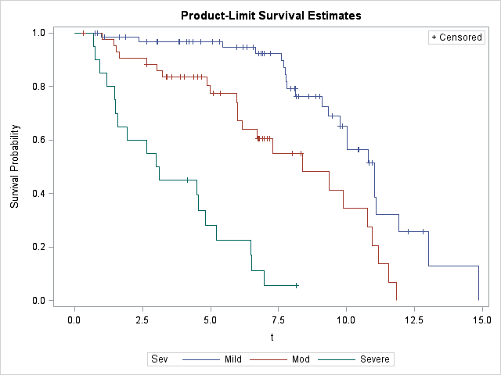

Figure 1. Kaplan-Meier survival curves illustrating survival times from initial diagnosis for all-cause mortality in 129 dogs diagnosed with SAS with available follow-up. Mild was defined as PG < 50 mmHg; moderate as PG between 50 and 130 mmHg; and severe as PG > 130 mmHg. All curves are statistically different from one another (p < 0.001).

Cardiac-cause Mortality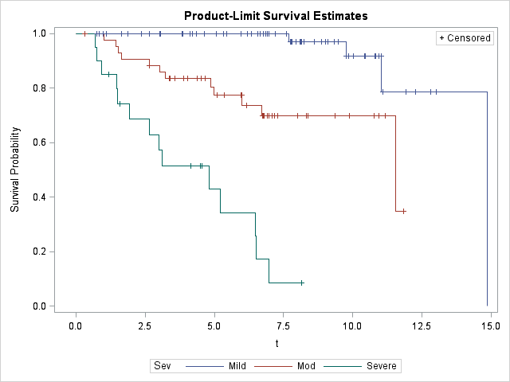

Figure 2. Kaplan-Meier survival curves illustrating survival times from initial diagnosis for cardiac-related mortality in 129 dogs diagnosed with SAS with available follow-up. Mild was defined as PG < 50 mmHg; moderate as PG between 50 and 130 mmHg; and severe as PG > 130 mmHg. All curves are statistically different from one another (p < 0.001).



Figure 3. Proportional hazards analyses demonstrating an increased risk of mortality as PG at diagnosis increases. Pressure gradient was analyzed as a continuous variable with 4 degrees of freedom for the spline curve. Small vertical lines above the x-axis represents the pressure gradients of individual dogs (n = 129). At approximately 100 mmHg, the all-cause mortality hazard increases by 1.6% for each 1 mmHg increase in pressure. A further increased mortality risk is identified at approximately 130 mmHg. Inset shows only the subjects in the PG range of 80 to 230 mmHg in order to more easily visually identify the increased hazard.

All-cause Mortality

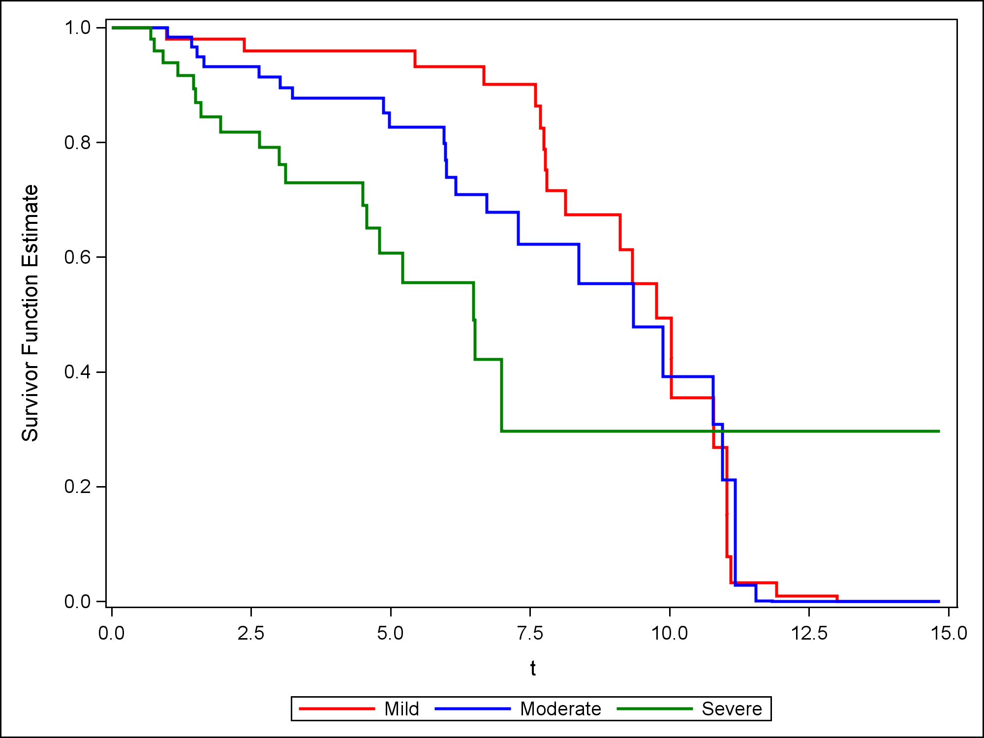

Figure 4: Cox adjusted survival curves for all-cause mortality evaluating the effect of PG on survival in the presence of other covariates (age and sex). Survival was more favorable for both mild (P < 0.0001) and moderate (P < 0.0001) groups when compared to severe.

Cardiac-cause Mortality

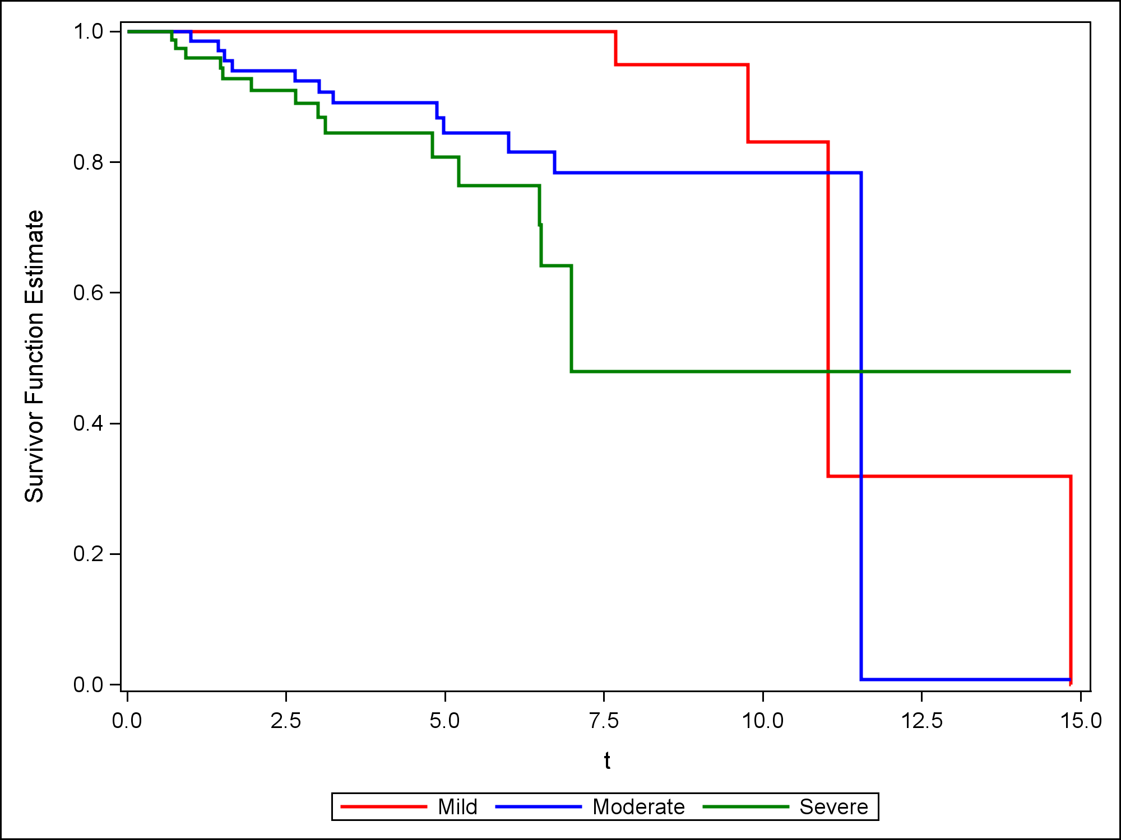

Figure 5: Cox adjusted survival curves for cardiac mortality evaluating the effect of PG on survival in the presence of other covariates (age and sex. Survival was more favorable for both mild (P <0.0001) and moderate groups (P = 0.0002) compared to the severe group.

Bache, R. J. & X. Z. Dai (1990) Myocardial oxygen consumption during exercise in the presence of left ventricular hypertrophy secondary to supravalvular aortic stenosis. *J Am Coll Cardiol,* 15**,** 1157-64.

Baumgartner, C. & T. M. Glaus (2003) [Congenital cardiac diseases in dogs: a retrospective analysis]. *Schweiz Arch Tierheilkd,* 145**,** 527-33, 535-6.

Belanger, M. C., E. Côté & G. Beauchamp (2014) Association between aortoseptal angle in Golden Retriever puppies and subaortic stenosis in adulthood. *J Vet Intern Med,* 28**,** 1498-503.

Bonagura J , L. L. 1999. Congenital heart disease. In *Textbook of Canine and Feline Cardiology,* ed. D. S. P Fox , N Moise. Philadelphia, PA: WB Saunders Co.

Borgeat, K., K. Sherwood, J. R. Payne, V. Luis Fuentes & D. J. Connolly (2014) Plasma cardiac troponin I concentration and cardiac death in cats with hypertrophic cardiomyopathy. *J Vet Intern Med,* 28**,** 1731-7.

Bussadori, C., C. Amberger, G. Le Bobinnec & C. W. Lombard (2000) Guidelines for the echocardiographic studies of suspected subaortic and pulmonic stenosis. *J Vet Cardiol,* 2**,** 15-22.

Caivano, D., D. Dickson, M. Martin & M. Rishniw (2018) Murmur intensity in adult dogs with pulmonic and subaortic stenosis reflects disease severity. *J Small Anim Pract,* 59**,** 161-166.

Davainis, G. M., K. M. Meurs & N. A. Wright (2004) The relationship of resting S-T segment depression to the severity of subvalvular aortic stenosis and the presence of ventricular premature complexes in the dog. *J Am Anim Hosp Assoc,* 40**,** 20-3.

Eason, B. D., D. M. Fine, D. Leeder, C. Stauthammer, K. Lamb & A. H. Tobias (2014) Influence of beta blockers on survival in dogs with severe subaortic stenosis. *J Vet Intern Med,* 28**,** 857-62.

Flickinger, G. L. & D. F. Patterson (1967) Coronary lesions associated with congenital subaortic stenosis in the dog. *J Pathol Bacteriol,* 93**,** 133-40.

Gunasekaran, T. & R. A. Sanders (2017) Sudden cardiac death in a dog during Holter recording-R on T phenomenon. *J Vet Cardiol,* 19**,** 455-461.

Hezzell, M. J., A. Boswood, Y. M. Chang, W. Moonarmart, K. Souttar & J. Elliott (2012) The combined prognostic potential of serum high-sensitivity cardiac troponin I and N-terminal pro-B-type natriuretic peptide concentrations in dogs with degenerative mitral valve disease. *J Vet Intern Med,* 26**,** 302-11.

Höglund, K., J. Häggström, C. Bussadori & C. Kvart (2011) A prospective study of systolic ejection murmurs and left ventricular outflow tract in boxers. *J Small Anim Pract,* 52**,** 11-7.

Javard, R., M. C. Bélanger, E. Côté, G. Beauchamp & P. Pibarot (2014) Comparison of peak flow velocity through the left ventricular outflow tract and effective orifice area indexed to body surface area in Golden Retriever puppies to predict development of subaortic stenosis in adult dogs. *J Am Vet Med Assoc,* 245**,** 1367-74.

Kienle, R. D., W. P. Thomas & P. D. Pion (1994) The natural clinical history of canine congenital subaortic stenosis. *J Vet Intern Med,* 8**,** 423-31.

Kleman, M. E., A. H. Estrada, H. W. Maisenbacher, R. Prošek, B. Pogue, A. Shih & J. A. Paolillo (2012) How to perform combined cutting balloon and high pressure balloon valvuloplasty for dogs with subaortic stenosis. *J Vet Cardiol,* 14**,** 351-61.

Klüser, L., P. J. Holler, J. Simak, G. Tater, P. Smets, D. Rügamer, H. Küchenhoff & G. Wess (2016) Predictors of Sudden Cardiac Death in Doberman Pinschers with Dilated Cardiomyopathy. *J Vet Intern Med,* 30**,** 722-32.

Koplitz, S. L., K. M. Meurs & J. D. Bonagura (2006) Echocardiographic assessment of the left ventricular outflow tract in the Boxer. *J Vet Intern Med,* 20**,** 904-11.

Langhorn, R., I. Tarnow, J. L. Willesen, M. Kjelgaard-Hansen, I. M. Skovgaard & J. Koch (2014) Cardiac troponin I and T as prognostic markers in cats with hypertrophic cardiomyopathy. *J Vet Intern Med,* 28**,** 1485-91.

Lehmkuhl, L. B., J. D. Bonagura, D. E. Jones & R. L. Stepien (1995) Comparison of catheterization and Doppler-derived pressure gradients in a canine model of subaortic stenosis. *J Am Soc Echocardiogr,* 8**,** 611-20.

Meurs, K. M. (2010) Genetics of cardiac disease in the small animal patient. *Vet Clin North Am Small Anim Pract,* 40**,** 701-15.

Meurs, K. M., L. B. Lehmkuhl & J. D. Bonagura (2005) Survival times in dogs with severe subvalvular aortic stenosis treated with balloon valvuloplasty or atenolol. *J Am Vet Med Assoc,* 227**,** 420-4.

O'grady, M. R., D. L. Holmberg, C. W. Miller & J. R. Cockshutt (1989) Canine congenital aortic stenosis: A review of the literature and commentary. *Can Vet J,* 30**,** 811-5.

Ohad, D. G., A. Avrahami, T. Waner & L. David (2013) The occurrence and suspected mode of inheritance of congenital subaortic stenosis and tricuspid valve dysplasia in Dogue de Bordeaux dogs. *Vet J,* 197**,** 351-7.

Oliveira, P., O. Domenech, J. Silva, S. Vannini, R. Bussadori & C. Bussadori (2011) Retrospective review of congenital heart disease in 976 dogs. *J Vet Intern Med,* 25**,** 477-83.

Ontiveros, E. S., S. L. Fousse, A. E. Crofton, T. E. Hodge, C. T. Gunther-Harrington, L. C. Visser & J. A. Stern (2019) Congenital Cardiac Outflow Tract Abnormalities in Dogs: Prevalence and Pattern of Inheritance From 2008 to 2017. *Front Vet Sci,* 6**,** 52.

Orton, E. C., G. D. Herndon, J. A. Boon, J. S. Gaynor, T. B. Hackett & E. Monnet (2000) Influence of open surgical correction on intermediate-term outcome in dogs with subvalvular aortic stenosis: 44 cases (1991-1998). *J Am Vet Med Assoc,* 216**,** 364-7.

Oyama, M. A. & D. D. Sisson (2004) Cardiac troponin-I concentration in dogs with cardiac disease. *J Vet Intern Med,* 18**,** 831-9.

Oyama, M. A. & W. P. Thomas (2002) Two-dimensional and M-mode echocardiographic predictors of disease severity in dogs with congenital subaortic stenosis. *J Am Anim Hosp Assoc,* 38**,** 209-15.

Patterson, D. F. (1968) Epidemiologic and genetic studies of congenital heart disease in the dog. *Circ Res,* 23**,** 171-202.

Pradelli, D., C. Quintavalla, M. C. Crosta, L. Mazzoni, P. Oliveira, L. Scotti, P. Brambilla & C. Bussadori (2014) The influence of emotional stress on Doppler-derived aortic peak velocity in boxer dogs. *J Vet Intern Med,* 28**,** 1724-30.

Pyle, R. L., H. S. Lowensohn, E. M. Khouri, D. E. Gregg & D. F. Patterson (1973) Left circumflex coronary artery hemodynamics in conscious dogs with congenital subaortic stenosis. *Circ Res,* 33**,** 34-8.

Pyle, R. L., D. F. Patterson & S. Chacko (1976) The genetics and pathology of discrete subaortic stenosis in the Newfoundland dog. *Am Heart J,* 92**,** 324-34.

Reist-Marti, S. B., G. Dolf, T. Leeb, S. Kottmann, S. Kietzmann, K. Butenhoff & S. Rieder (2012) Genetic evidence of subaortic stenosis in the Newfoundland dog. *Vet Rec,* 170**,** 597.

Scansen, B. A. (2018) Cardiac Interventions in Small Animals: Areas of Uncertainty. *Vet Clin North Am Small Anim Pract,* 48**,** 797-817.

Schrope, D. P. (2015) Prevalence of congenital heart disease in 76,301 mixed-breed dogs and 57,025 mixed-breed cats. *J Vet Cardiol,* 17**,** 192-202.

Stern, J. A., K. M. Meurs, O. L. Nelson, S. M. Lahmers & L. B. Lehmkuhl (2012) Familial subvalvular aortic stenosis in golden retrievers: inheritance and echocardiographic findings. *J Small Anim Pract,* 53**,** 213-6.

Stern, J. A., S. N. White, L. B. Lehmkuhl, Y. Reina-Doreste, J. L. Ferguson, N. M. Nascone-Yoder & K. M. Meurs (2014) A single codon insertion in PICALM is associated with development of familial subvalvular aortic stenosis in Newfoundland dogs. *Hum Genet,* 133**,** 1139-48.

Thomas, W. P., C. E. Gaber, G. J. Jacobs, P. M. Kaplan, C. W. Lombard, N. S. Moise & B. L. Moses (1993) Recommendations for standards in transthoracic two-dimensional echocardiography in the dog and cat. Echocardiography Committee of the Specialty of Cardiology, American College of Veterinary Internal Medicine. *J Vet Intern Med,* 7**,** 247-52.

Warnes, C. A., R. G. Williams, T. M. Bashore, J. S. Child, H. M. Connolly, J. A. Dearani, P. del Nido, J. W. Fasules, T. P. Graham, Z. M. Hijazi, S. A. Hunt, M. E. King, M. J. Landzberg, P. D. Miner, M. J. Radford, E. P. Walsh & G. D. Webb (2008) ACC/AHA 2008 Guidelines for the Management of Adults with Congenital Heart Disease: a report of the American College of Cardiology/American Heart Association Task Force on Practice Guidelines (writing committee to develop guidelines on the management of adults with congenital heart disease). *Circulation,* 118**,** e714-833.