Hydraulic scale
A hydraulic scale has two pistons joined by oil. Find the load the large one carries.
- The small piston has area $a$.
- The large piston has area $A$.
$$F=pA$$
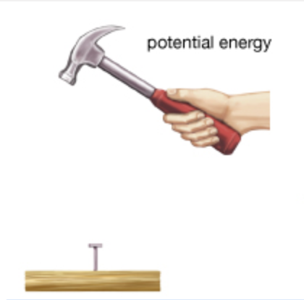
Quantity | Symbol
Area | $A$

