EXERCISE CASE ---------------------------

Testing the ATM terminal software (during the development and integration stage)

The interface was designed as in the figure below with a main (untouchable) screen and buttons:

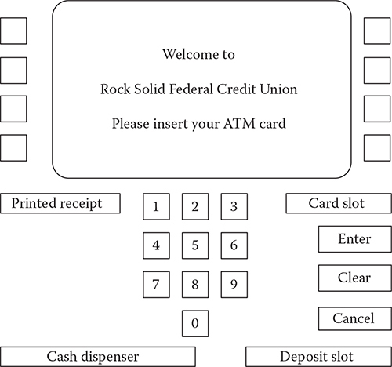

**The Simple ATM (SATM) terminal.**

15 screens were developed to show in different scenarios:

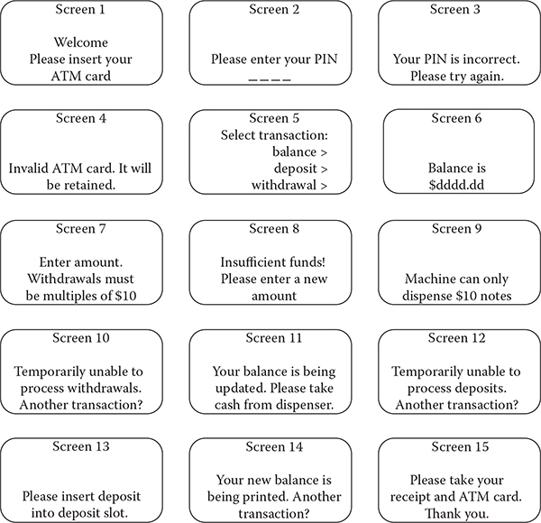

**SATM screens.**

The generic level state diagram of the machine:

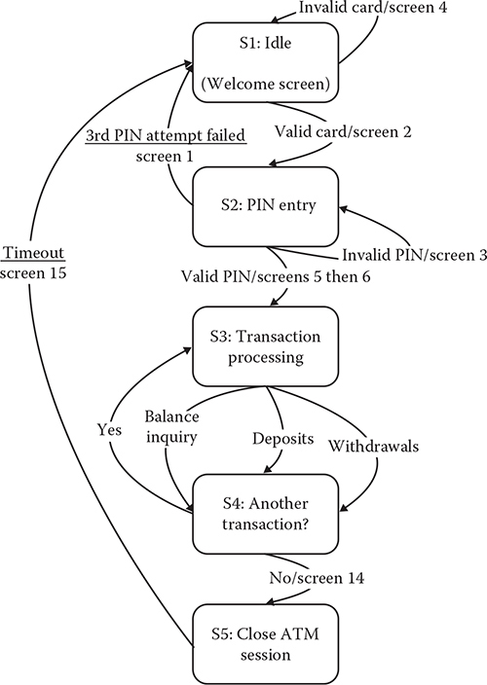

**Uppermost level SATM finite state machine.**

**Task 1: Develop a test plan for testing the ATM terminal**

* What type of tests?
* A minimum number of tested needed?
* Test types?
* What type of test data needed?
* Metric to evaluate the test result?

Complete the table below:

|  |  |  |  |  |  |
| --- | --- | --- | --- | --- | --- |
| **Type of tests** | **Description** | **Number of tests** | **Test types** | **Test data** | **Test metric** |
| Unit test | Testing each screen to make sure each screen displays according to its specification | At least 15 assertation: S1 – S15 | Whitebox  blackbox | Pin code,  Amount to withdraw | Path coverage  Line coverage  Branch coverage |
| System test/ Use case test |  |  |  |  |  |
| Usability test |  |  |  |  |  |
| Performance test |  |  |  |  |  |

**Task 2: List use-case based test cases**

Tips: using the list of screens and the state diagram to derive test cases that can cover all the state transition paths.

Complete the table below:

|  |  |  |
| --- | --- | --- |
| ***NO*** | ***Test cases*** | ***Description*** |
| 1 | SUC1 | Valid ATM card swipe |
| 2 | SUC2 | Invalid ATM card swipe |
|  |  |  |
|  |  |  |
|  |  |  |
|  |  |  |
|  |  |  |
|  |  |  |
|  |  |  |
|  |  |  |
|  |  |  |
|  |  |  |
|  |  |  |
|  |  |  |
|  |  |  |
|  |  |  |
|  |  |  |
|  |  |  |
|  |  |  |
|  |  |  |
|  |  |  |
|  |  |  |
|  |  |  |
|  |  |  |
|  |  |  |

**Task 3: Describe a concrete test case from the list**

Tips: or giving a concrete test case and ask student to describe it

Complete the table below:

|  |  |
| --- | --- |
| **Test case** | SUC3 Correct PIN entry on first try |
| **Test description** | A customer enters the PIN number correctly on the first attempt. |
| **Related screens** |  |
| **Pre-conditions** |  |
| **Actions** |  |
| **Inputs** |  |
| **Expected Outputs** |  |
| **Testing environment** |  |