Test planing:

A task as complex as testing requires meticulous planning on an operational level (see section 6.3) and on a strategic level.

The starting points for strategic planning are provided by company testing policy and testing guidelines (if they exist), or by a generic company testing strategy. The test manager needs to transpose such generic guidelines to create a concrete testing strategy for the project at hand that fits the specific objectives, constraints, and risks of the project, the type, importance and risk level of the product being tested, and that conforms to any existing quality assurance plans3. A test manager’s strategic planning involves the following tasks:

1. Specify the test object(s) Identify which components, modules, neighboring systems, and interfaces (will) make up the system to be tested. Decide which of these objects need to be tested and which can or should be excluded from the testing process.
2. Draft the test objectives Analyze, define and draft the specific testing objectives and the criteria you are testing against for each test object and the entire system (see section 2.2 and 6.3.1).
3. Customize the testing process Customize the testing process foreseen by company policy or the project development model to suit the requirements of the project at hand. Define which test levels are necessary (based on the nature of the test object and the test objectives you have defined). Discuss and define coordination and cooperation between testing and other project activities.
4. Select your testing methods and techniques Select and specify the overall testing approach and the testing techniques (see Chapter 5) that are suitable and/or necessary to achieve the defined test objectives for the individual test objects and the entire system. Determine and select the training courses necessary to implement or improve the operation of the selected testing techniques. Analyze the type and scope of potential test automation options.
5. Specify the required infrastructure Analyze which test environment(s) are required, which are already available, and which need to be extended or built from the ground up. Check which tools can or must be used to support the testing process (see Chapter 7). Document and acquire the stipulated tools and other resources required by the test team.
6. Define test metrics Select and describe the metrics you will use to control the testing process. Specify the measurement techniques, evaluation criteria, and limit values4, as well as the required reactions to test results and test exit criteria.
7. Specify the reporting system Specify which documents and proofs are to be created and maintained (test schedule, test logs, defect reports, test reports, and so on). Specify who is responsible for creating, maintaining, publishing, presenting, and archiving reports. Provide templates and tool configurations that implement the required structure and degree of detail.
8. Plan costing and overall testing effort Provide an initial estimate of the overall testing effort and the corresponding resources (including personnel) required to execute the planned testing strategy. Calculate the overall cost of testing and secure the necessary budget. Update estimates and costs during the project.

EXERCISE CASE ---------------------------

Testing the ATM terminal software (during the development and integration stage)

The interface was designed as in the figure below with a main (untouchable) screen and buttons:

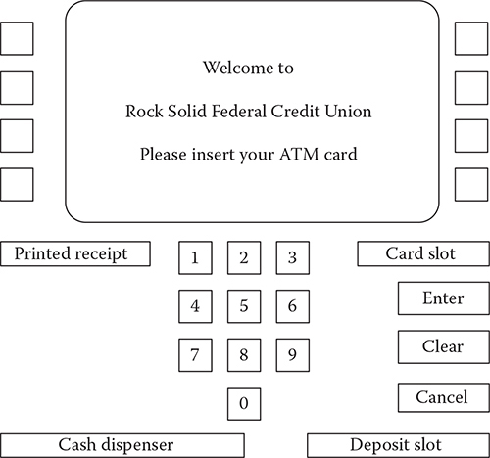

**The Simple ATM (SATM) terminal.**

15 screens were developed to show in different scenarios:

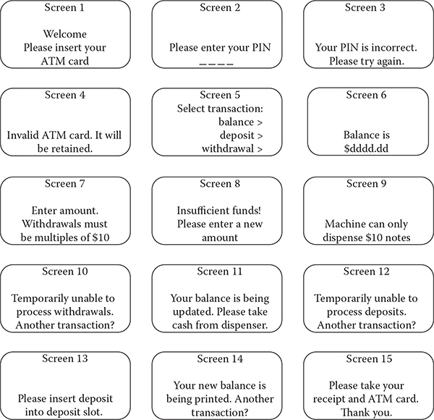

**SATM screens.**

The generic level state diagram of the machine:

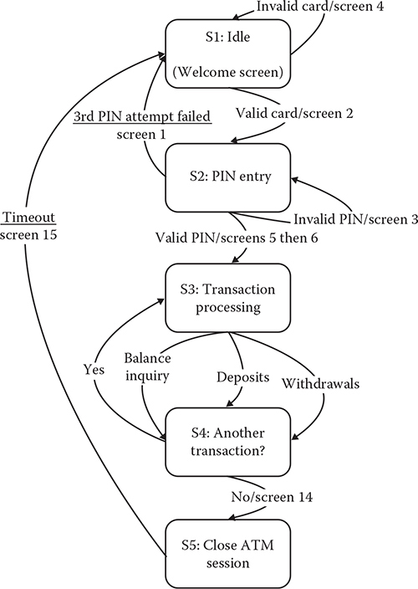

**Uppermost level SATM finite state machine.**

**Task 1: Develop a test plan for testing the ATM terminal**

* What type of tests?
* A minimum number of tested needed?
* Test types?
* What type of test data needed?
* Metric to evaluate the test result?

|  |  |  |  |  |  |
| --- | --- | --- | --- | --- | --- |
| **Type of tests** | **Description** | **Number of tests** | **Test types** | **Test data** | **Test metric** |
| Unit test | Testing each screen to make sure each screen displays according to its specification | At least 15 assertation: S1 – S15 | Whitebox  blackbox | Pin code,  Amount to withdraw | Path coverage  Line coverage  Branch coverage |
| System test/ Use case test | Testing possible different use case scenarios with successful and unsuccessful ATM transactions | At least 25 test cases as below | Blackbox | Pin code,  Amount to withdraw | Requirement coverage  Path coverage |
| Usability test | Evaluate the user experience with the ATM interfaces with the two scenarios with successful and unsuccessful ATM transactions | At least 2 test cases | Blackbox | Tasks to perform  Pin code,  Amount to withdraw | Usability score |
| Performance test | Simulating POS system’s transaction processing under extreme conditions Internet-based transactions | 1 test with 100 transactions and another test with 1000 transactions | Blackbox | Number of transactions  Amount to withdraw | Transaction time  Delayed time |

**Task 2: List use-case based test cases**

Tips: using the list of screens and the state diagram to derive test cases that can cover all the state transition paths.

|  |  |
| --- | --- |
| *Test cases* | *Description* |
| SUC1 | Valid ATM card swipe |
| SUC2 | Invalid ATM card swipe |
| SUC3 | Correct PIN attempt |
| SUC4 | Failed PIN attempt |
| SUC5 | Choose Balance |
| SUC6 | Choose Deposit |
| SUC7 | Choose Withdrawal: valid withdrawal amount |
| SUC8 | Choose Withdrawal: amount not a multiple of $20 |
| SUC9 | Choose Withdrawal: amount greater than account balance |
| SUC10 | Choose Withdrawal: amount greater than daily limit |
| SUC11 | Choose no other transaction |
| SUC12 | Choose another transaction |
| SUC13 | Digit 1 entered |
| SUC14 | Digit 2 entered |
| SUC15 | Digit 3 entered |
| SUC16 | Digit 4 entered |
| SUC17 | Enter with valid PIN |
| SUC18 | Cancel before digit 1 |
| SUC19 | Cancel after digit 1 |
| SUC20 | Cancel after digit 2 |
| SUC21 | Cancel after digit 3 |
| SUC22 | Cancel after digit 4 |
| SUC23 | Enter with invalid PIN |
| SUC24 | Next PIN try |
| SUC25 | Last PIN try |

**Task 3: Describe a concrete test case from the list**

Tips: or giving a concrete test case and ask student to describe it

|  |  |
| --- | --- |
| Test case | SUC3 Correct PIN entry on first try |
| Test description | A customer enters the PIN number correctly on the first attempt. |
| Related screens |  |
| Pre-conditions | 1. The expected PIN is known 2. Screen 2 is displayed |
| Actions | 1. Screen 2 shows ‘- - - - ’  2. Customer touches 1st digit  3. Screen 2 shows ‘- - - * ’  4. Customer touches 2nd digit  5. Screen 2 shows ‘- - * * ’  6. Customer touches 3rd digit  7. Screen 2 shows ‘- * * * ’  8. Customer touches 4th digit  9. Screen 2 shows ‘* * * * ’  10. Customer touches Enter  11. Screen 5 is displayed |
| Inputs | Correct PIN number: 1357 |
| Expected Outputs | Select Transaction screen is active |
| Testing environment | Software interface run in Windows 10 |