**Backup & Restore**

1. There are three tabs in Repository Management.
   1. Backup
   2. Restore
   3. Clear

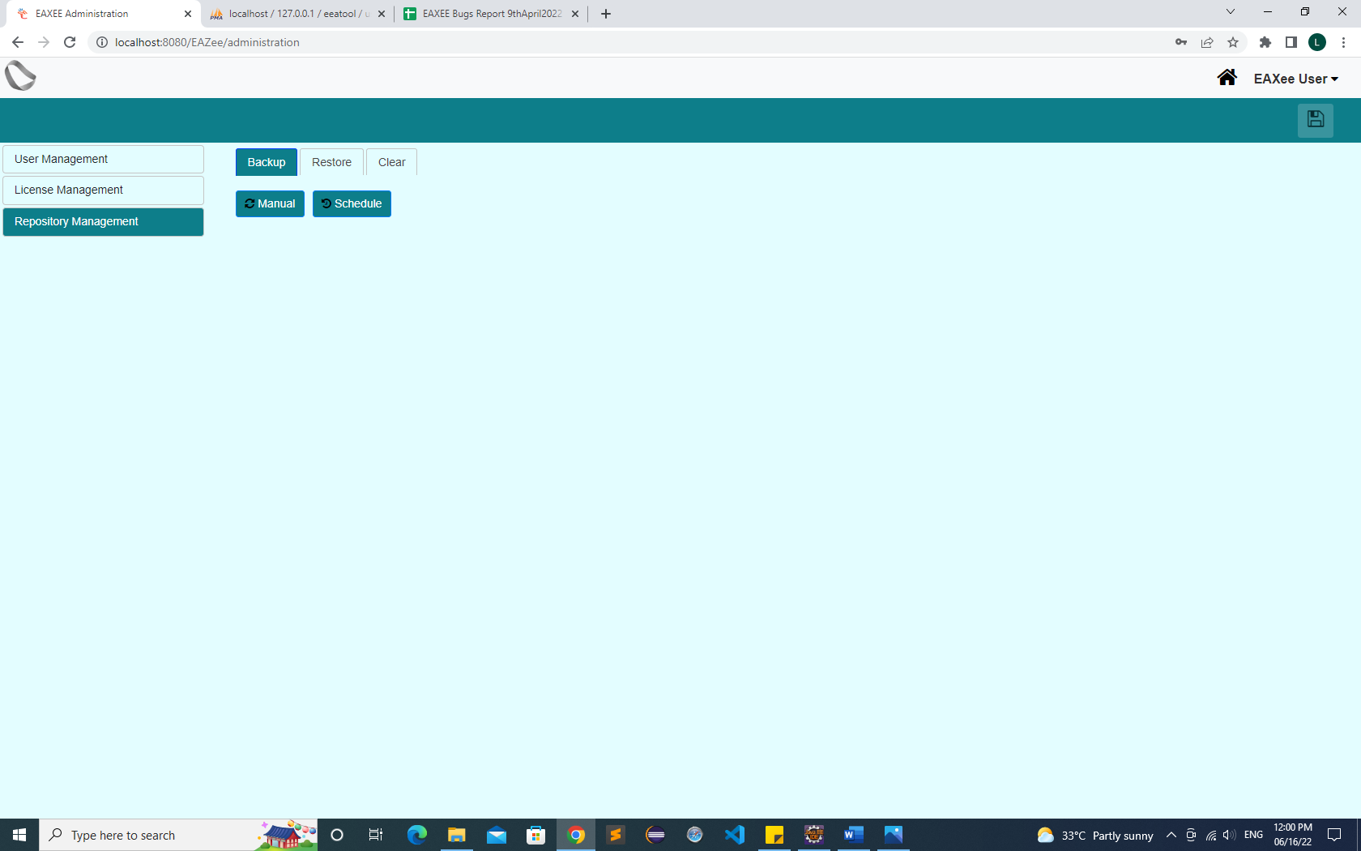

1. **Backup**
   1. Backup of Objects, models and dashboards will be done at once.
   2. In backup there are two types
      1. Manual
      2. Schedule
   3. **Manual:**
      1. In manual backup User just click on the manual button and then automatically the file will be saved on the defined path.
         1. Objects
         2. Models
         3. Dashboards
   4. **Schedule:**
      1. In Scheduled backup User set the backup time whether it will.
         1. Daily
         2. Weekly
         3. Monthly
         4. Yearly
   5. File name will be depending upon date-time.
   6. Backup will be compressed and encrypted.
2. **Restore:**
   1. Restore of Objects, models and dashboards will be done at once.
   2. Restore must show a list of all available backups in a dropdown with date and time. The user should select only one from them for restore.
   3. All existing data will be lost (Alert).
3. **Clear:**
   1. There are three conditions to clear a repository.
   2. In Clear, please also put options for selecting which model types user wants to clear.
   3. Diagrams, Matrices, Catalogs, Roadmaps. We will grow this list when we add more model types.
   4. Either user can clear all models or any combination of them.
      1. If Objects are cleared. Models and dashboard will also clear.
      2. Models can be cleared separately.
      3. Dashboard can be cleared separately.