|  |  |  |  |
| --- | --- | --- | --- |
| **Final Exam Report** | | | |
| **Class** | Database | **Group ID** | 4 |
| **Student ID** | 12161483 | **Name** | 12151336 |
| **Student ID** | 12161417 | **Name** | 12161441 |
| **Student ID** |  | **Name** |  |
| **Student ID** |  | **Name** |  |
| **Lab Topic** | Final Exam | | |

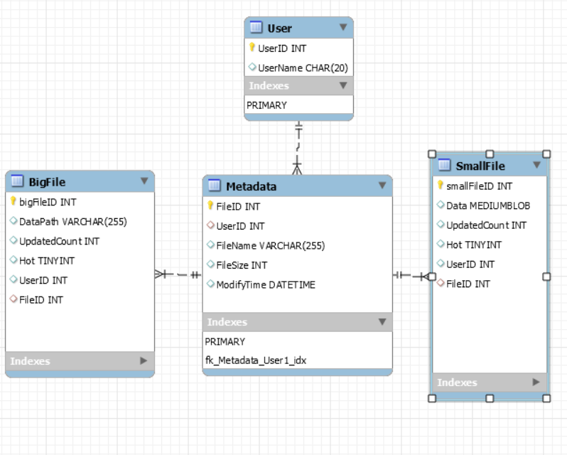

ERD

query in mysql server

-------------------------------------------------------------

-- MySQL Script generated by MySQL Workbench

-- Mon Dec 14 16:06:59 2020

-- Model: New Model Version: 1.0

-- MySQL Workbench Forward Engineering

SET @OLD_UNIQUE_CHECKS=@@UNIQUE_CHECKS, UNIQUE_CHECKS=0;

SET @OLD_FOREIGN_KEY_CHECKS=@@FOREIGN_KEY_CHECKS, FOREIGN_KEY_CHECKS=0;

SET @OLD_SQL_MODE=@@SQL_MODE, SQL_MODE='TRADITIONAL,ALLOW_INVALID_DATES';

-- -----------------------------------------------------

-- Schema SDS_group4

-- -----------------------------------------------------

DROP SCHEMA IF EXISTS `SDS_group4` ;

-- -----------------------------------------------------

-- Schema SDS_group4

-- -----------------------------------------------------

CREATE SCHEMA IF NOT EXISTS `SDS_group4` DEFAULT CHARACTER SET utf8 ;

#SHOW WARNINGS;

USE `SDS_group4` ;

-- -----------------------------------------------------

-- Table `BigFile`

-- -----------------------------------------------------

DROP TABLE IF EXISTS `BigFile` ;

#SHOW WARNINGS;

CREATE TABLE IF NOT EXISTS `BigFile` (`bigFileID` INT NOT NULL AUTO_INCREMENT,`DataPath` VARCHAR(255) NULL,`UpdatedCount` INT NULL,`Hot` TINYINT NULL,`UserID` INT NULL,`FileID` INT NULL,PRIMARY KEY (`bigFileID`))

#ENGINE = InnoDB;

#SHOW WARNINGS;

-- -----------------------------------------------------

-- Table `Metadata`

-- -----------------------------------------------------

DROP TABLE IF EXISTS `Metadata` ;

#SHOW WARNINGS;

CREATE TABLE IF NOT EXISTS `Metadata` (`FileID` INT NOT NULL AUTO_INCREMENT,`UserID` INT NULL DEFAULT NULL,`FileName` VARCHAR(255) NULL,`FileSize` INT NULL,`ModifyTime` DATETIME NULL,PRIMARY KEY (`FileID`))

#ENGINE = InnoDB;

#SHOW WARNINGS;

-- -----------------------------------------------------

-- Table `SmallFile`

-- -----------------------------------------------------

DROP TABLE IF EXISTS `SmallFile` ;

#SHOW WARNINGS;

CREATE TABLE IF NOT EXISTS `SmallFile` (`smallFileID` INT NOT NULL AUTO_INCREMENT,`Data` MEDIUMBLOB NULL,`UpdatedCount` INT NULL,`Hot` TINYINT NULL,`UserID` INT NULL,`FileID` INT NULL,PRIMARY KEY (`smallFileID`))

#ENGINE = InnoDB;

#SHOW WARNINGS;

-- -----------------------------------------------------

-- Table `User`

-- -----------------------------------------------------

DROP TABLE IF EXISTS `User` ;

#SHOW WARNINGS;

CREATE TABLE IF NOT EXISTS `User` (`UserID` INT NOT NULL,`UserName` CHAR(20) NULL,PRIMARY KEY (`UserID`))

#ENGINE = InnoDB;

INSERT INTO `SDS_group4`.`User` (`UserID`, `UserName`) VALUES ('1', 'ChulWoo');

INSERT INTO `SDS_group4`.`User` (`UserID`, `UserName`) VALUES ('2', 'SeonJeong');

INSERT INTO `SDS_group4`.`User` (`UserID`, `UserName`) VALUES ('3', 'SeongJin');

INSERT INTO `SDS_group4`.`User` (`UserID`, `UserName`) VALUES ('4', 'YongMoon');

#SHOW WARNINGS;

ALTER TABLE User MODIFY UserID INT NOT NULL AUTO_INCREMENT;

ALTER TABLE Metadata MODIFY FileID INT NOT NULL AUTO_INCREMENT;

ALTER TABLE BigFile MODIFY bigFileID INT NOT NULL AUTO_INCREMENT;

ALTER TABLE SmallFile MODIFY smallFileID INT NOT NULL AUTO_INCREMENT;

ALTER TABLE Metadata MODIFY ModifyTime TIMESTAMP DEFAULT CURRENT_TIMESTAMP ON UPDATE CURRENT_TIMESTAMP;

SET SQL_MODE=@OLD_SQL_MODE;

SET FOREIGN_KEY_CHECKS=@OLD_FOREIGN_KEY_CHECKS;

SET UNIQUE_CHECKS=@OLD_UNIQUE_CHECKS;----------------------------------------------------------------------------

using Mysql Workbench, create Table and attribute. and add some query for triggers and additional setting for condition.

when create SCHEMA and tables, check already exist. if exist drop it.

And insert group4 member for dummy data.

After create SCHEMA

and Metadata.ModifyTime type change to timestamp for update time.

User’s UserID is fk of Metadata, and

Metadata’s FileID is fk of SmallFile,BigFile

and each Table’s PK is set auto_increment.

--Initialize Function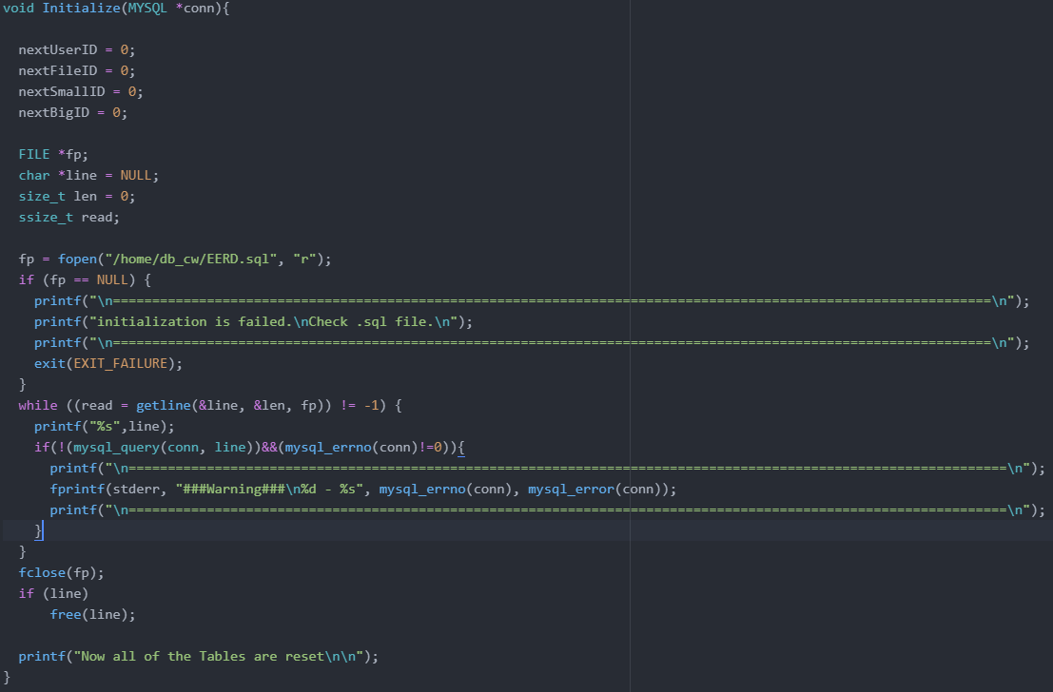

We use ERD sql file to initialize. First, we open sql file and check if it is exist. If it isn’t exist, alert error and exit. If it is exist, we send line by line with mysql_query() function, and check error with mysql_errno() function. Also, I changed sql files’ query that is Multi-line query to Single line query like below.

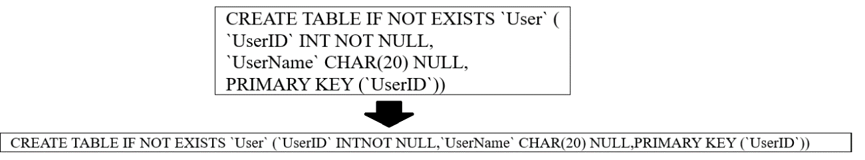

As a result, If we put 0 at program, It starts initialize Database. It remove schema, tables and make those with default settings.

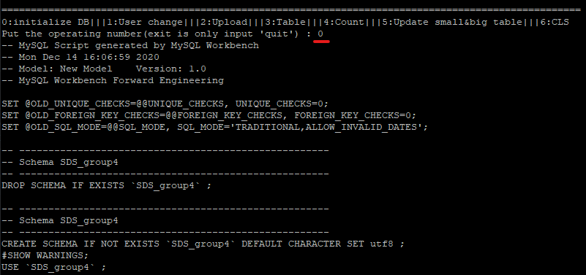

--User Selection & Insertion after Connection to MySQL Server  
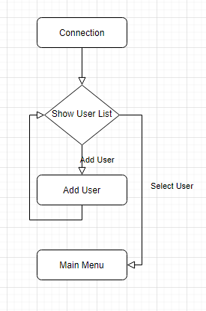  
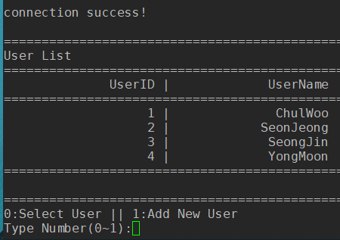  
To get the list of User like the picture above, the program sends a query to the MySQL Server. Query is like this.  
  
If client types wrong number which is neither ‘0’ or ‘1’, it shows error message like this.  
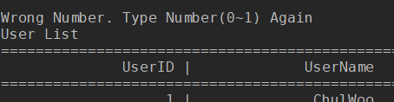  
It shows the list of User again.  
And then, if the client selects ‘0’, which means he wants to select User, the program shows the list of User again. Here, client should type the name of User.  
  
Client can also quit to select and just go back to the selection.  
If the client type the username which is not inside the User table, it shows a message that client just typed wrong name.  
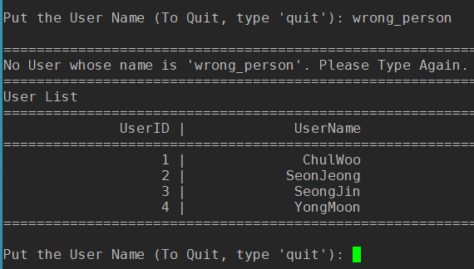  
If, the client types right name of user, the program goes to the main menu.  
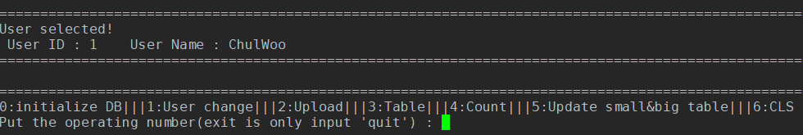  
If the client select ‘1’ to add a new User, he can type a name of new User like this.  
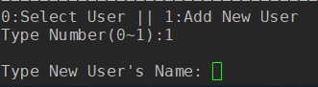  
If he types new name, it goes back to the selection menu and show the list of User which includes the new name just added.  
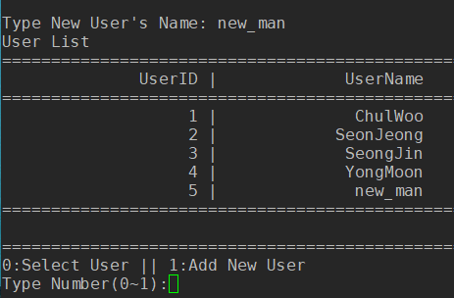

When it connects to MySQL Server, it shows the list of user which are currently inside User table. Client can type number ‘0’ for “Select User and Move to Main Menu” or ‘1’ for “Add New User”. If the client select ‘0’, client can type a name of User as whom the client wants to log in. If the Client select ‘1’, client can type a name of new User. Then, program go back to the list of User. Here, Client can add new User again, or select User and login to the menu.

--Changing User  
When the client select user from the Initialized User Selection menu, the client can also change the user from main menu by selecting operating number ‘1’(User Change).  
  
If the client select operating number ‘1’, the program shows User List using same function with User Selection. If the client types a name of User as which he wants to login, It shows the message like below.  
  
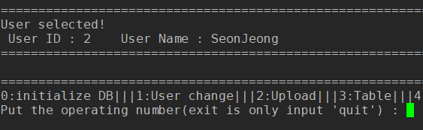

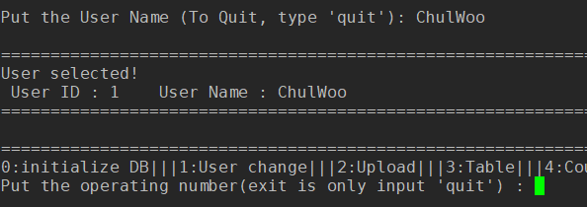

--Uploading a new file.  
If a client selects ‘2’ from the main menu below,  
  
It requires the client to put a path of file. Here, the client should put a RELATIVE PATH from the directory of the program. If we put the path, the UPLOAD function divides it to the file name like this.  
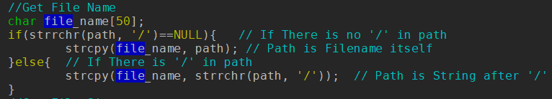  
If the client types a file name which doesn’t exist, it makes error messages like this.  
  
If the program gets input, it calculates the size of file and judges if it is big or not. Here, the benchmark of BIG FILE we set is 1024Bytes. And then, it sends query which inserts values into Metadata table to MySQL server.  
  
Because the FileID attribute has AUTO_INCREMENT feature and program doesn’t put the FileID into the query, client doesn’t know the FileID. To get the FileID from the server client sends query which select FileID from Metadata table to MySQL server.  
  
Using the FileID client just gets, client sends another query which insert into values into SmallFile or BigFile depending on the file size program got before.  
  
After every query, we can check if the file is inserted well by operation number ‘3’(Table).  
  
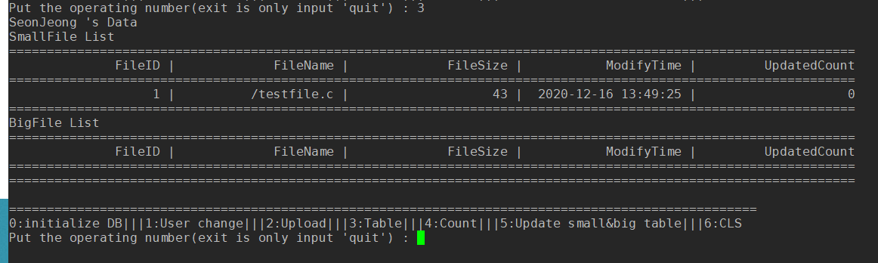  
Because the testfile.c is 43bytes sized, It is inserted into SmallFile table.  
  
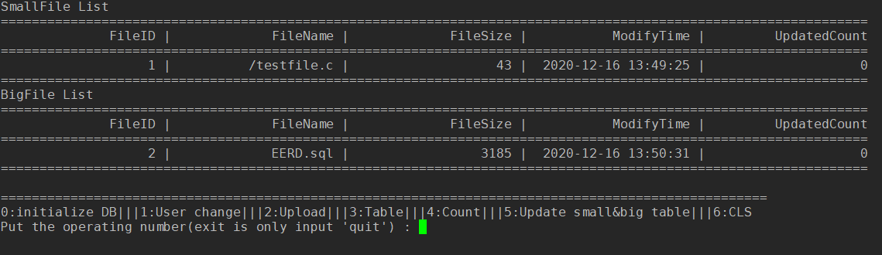  
Because the EERD.sql is 3185bytes sized, It is inserted into BigFile table.

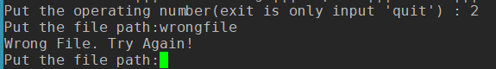

--Table

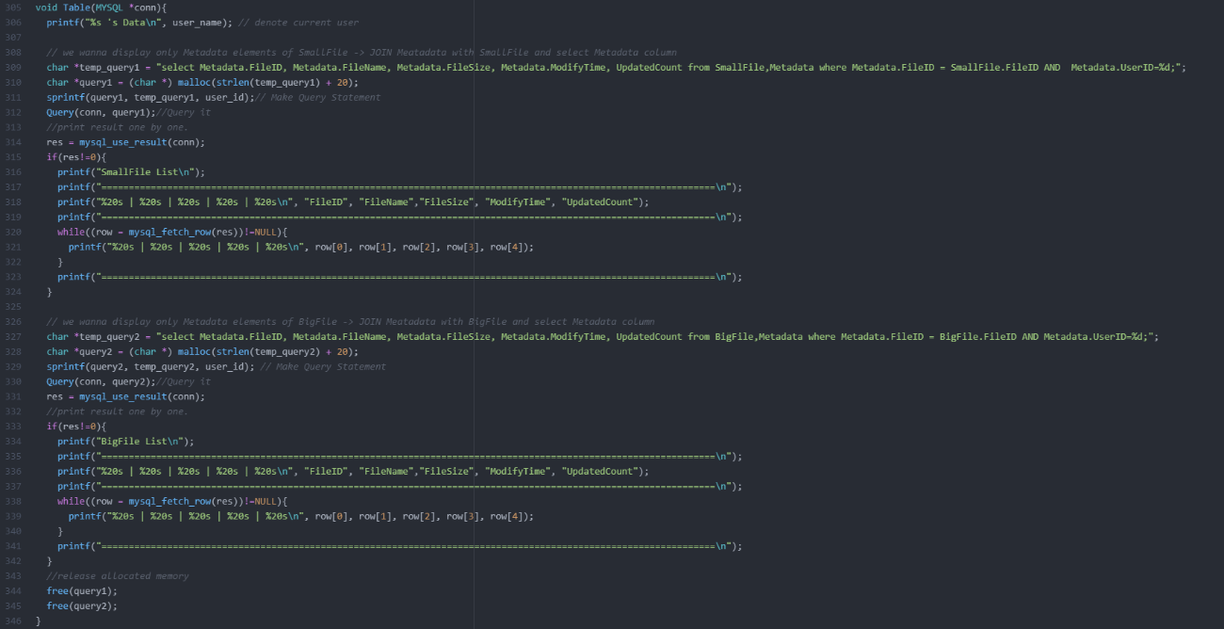

This function is for print FileID, Name, Size and etc from SmallFile and BigFile tables.

So allocate memory resource to char array 'query1(2)' accordingly to the size of query statement(temp_query1(2)) plus extra space for user_id.

But query statement like 'select * from SmallFile' doesn't return element of Metadata.

So, join SmallFile table with Metadata and select elements of Metadata by expressing it explicitly.

Otherwise, It return mediumblob ,hot/cold data and etc.

And, print result caused by our query execution using mysql_fetch_row and printing element of row.

repeat it about BigFile table.

In the end of this function, release memory space allocated to 'query1', 'query2'.

--Count Function

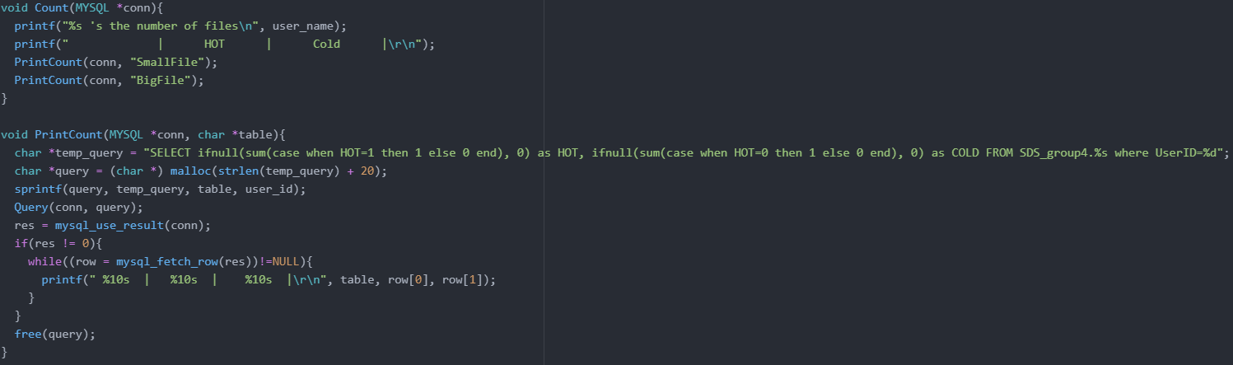

Main function calls Count(MYSQL, *conn) when pressed gets ‘3’. Count Function prints preset of chart, and calls PrintCount for SmallFile table and BigFile Table.

PrintCount funcions get big/small/hot/cold files. We gets file’s count with the below query.

|  |
| --- |
| SELECT  ifnull(sum(case when HOT=1 then 1 else 0 end) as HOT,  ifnull(sum(case when HOT=0 then 1 else 0 end) as COLD  FROM SDS_group4.Big/SmallFIle  WHERE UserID=User’s ID |

We Use sum and case to count HOT files. If File is HOT then HOT will set as 1, and by case phrase it will sum as 1. Also, If file is Cold then HOT will set as 0, and by case phrase it will sum as 1. And by ifnull, If there is no value of HOT files, it will show 0.

If we send query, we can get result from mysql_use_result(). Then, we print it with %10s to print at regular intervals. Below picture is the result when we put count operation.

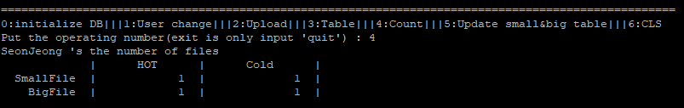

--UPDATE_SB

___________________________________________________________________________

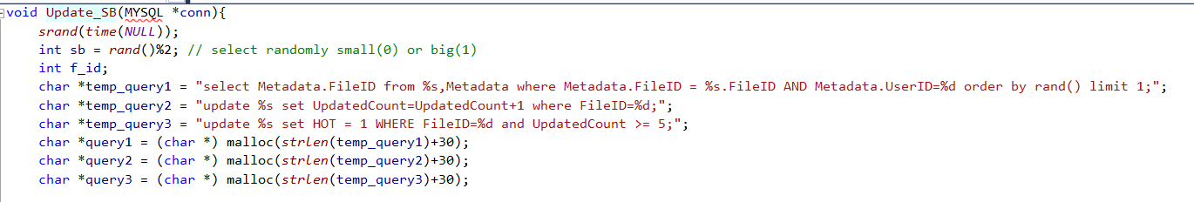

setting for query.

temp_query1, and query1 is export one of record randomaly in SmallFile or BigFile. Where we export data is decide by ‘sb = rand()%2’.

temp_query2, and query2 is query statement about update the record from SmallFile or BigFile, increase its UpdatedCount by one.

temp_query3, and query3 is check the record and set ‘Hot = 1’ if its UpdatedCount bigger than 4.

(Hot variable is means HOT when Hot = 1 and means Cold when Hot = 0.)

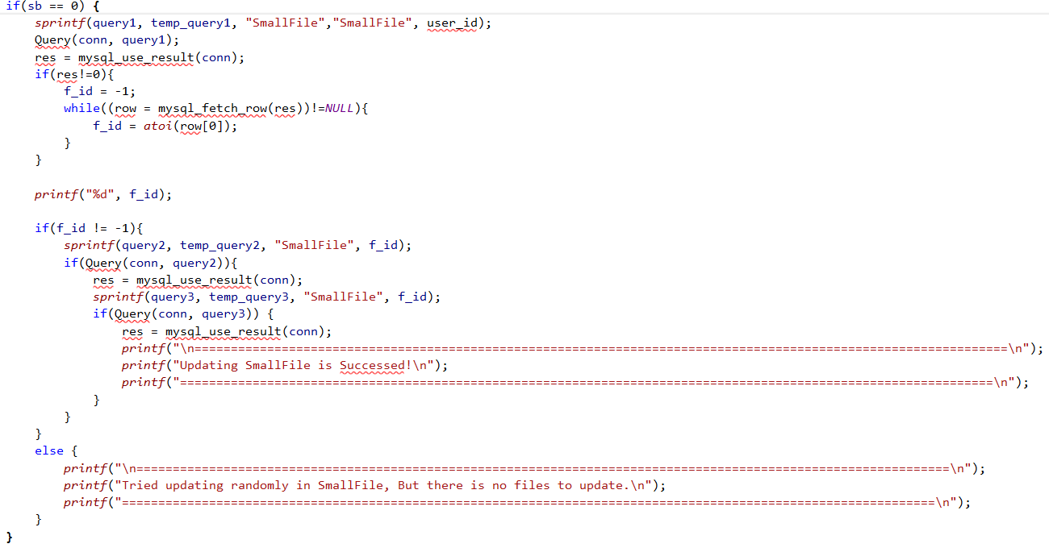

using sb, select randomaly bigFile or SmallFile. above code is when select SmallFile. Query() is execute mysql_query and check error is occurred.

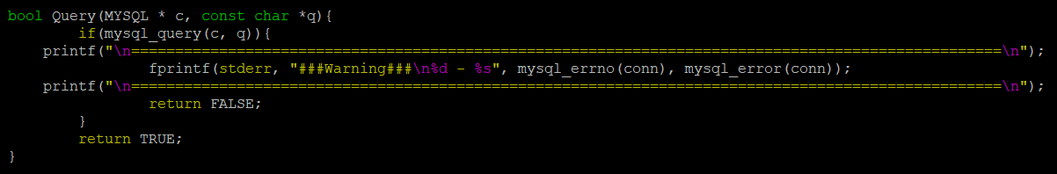

For avoiding segmentation fault, use mysql_use_result. and if there is no error in mysql_use_result, export FileID by using mysql_fetch_row.

The reason of ‘f_id = -1’ is means no record in Metadata to read. so can not export FileID.

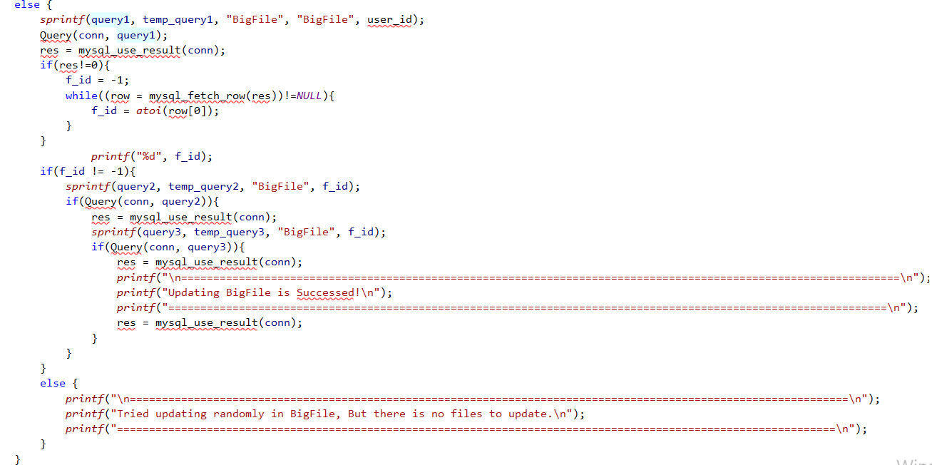

also bigfile same sequence.

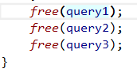

after execute query, release memory.

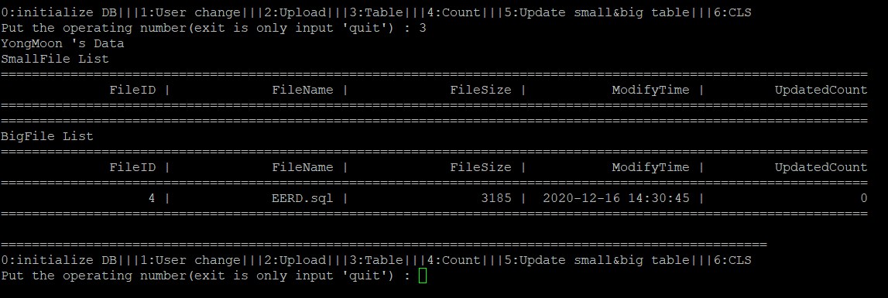

Select operating 2



Input filepath

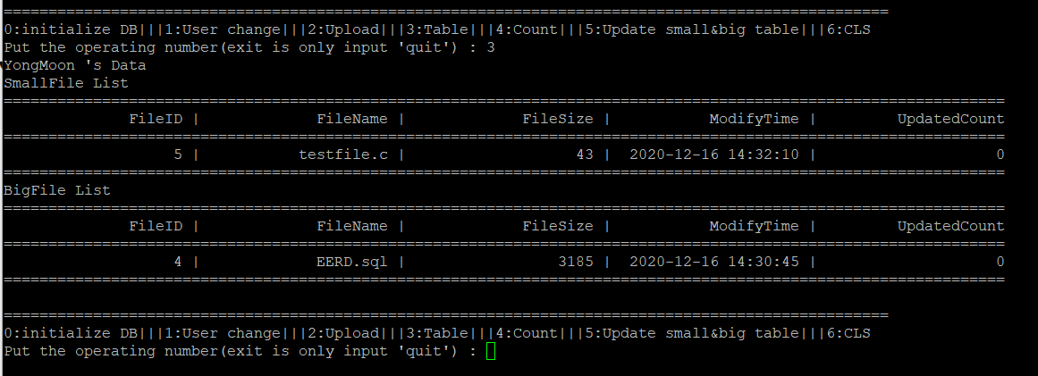

Successfully added to the table

--main & CLS

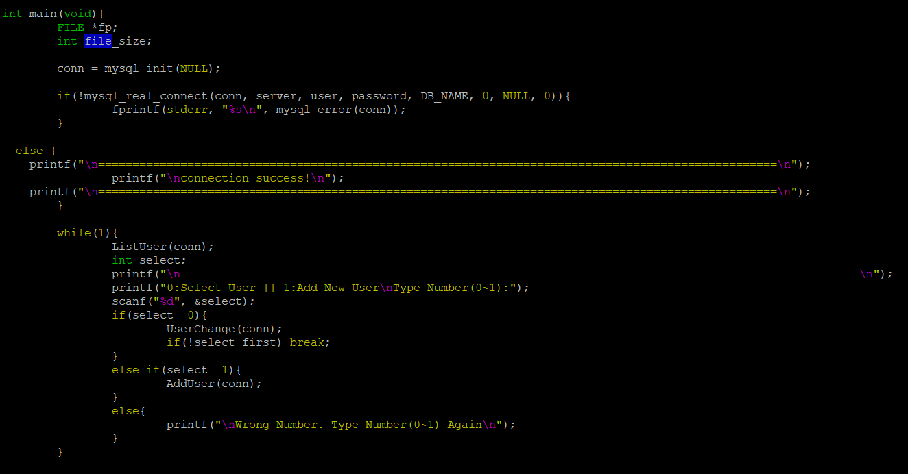

first check connection with Mysql server and select User or add User

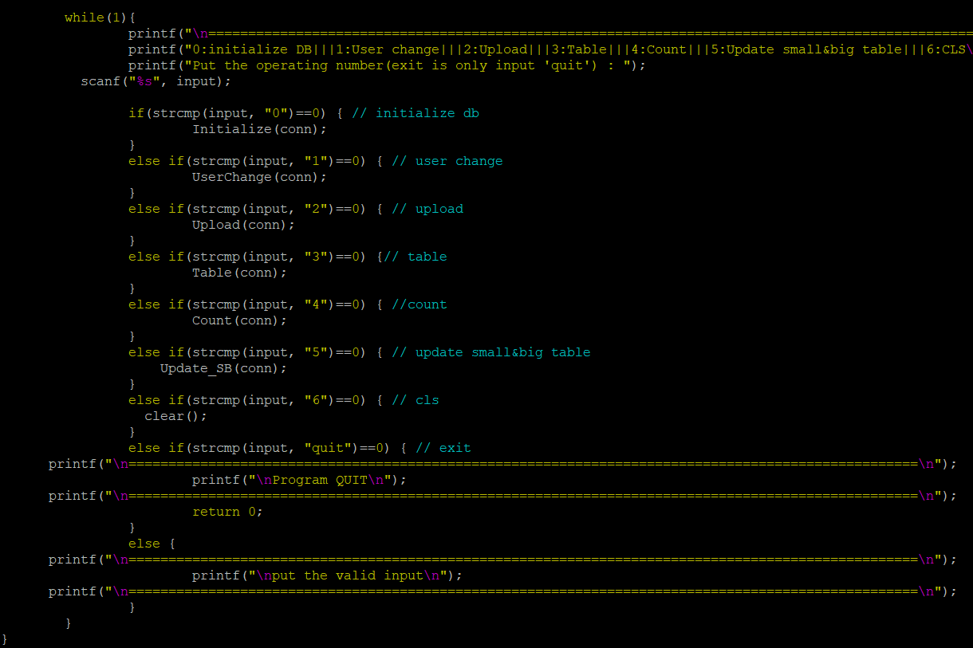

and depending on the input mode, execute Query.

and input mode 6, execute CLS for clear screen using clear().

and input quit, exit program.