**Growing Pains – An Online House Plant Store**

**Systems Analysis, Design & Testing - Project**

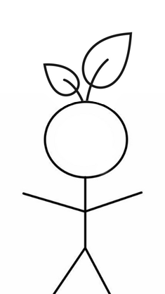

**By: Mark Lambert (C00192497)**

**Course: Software Development (CW_KCSOF_B)**

**Submission Date:**

**Table of Contents Page**

**Summary** 3

**User Stories** 4

**Use Case Diagram** 6

**Use Case Scenarios** 7

**Class Diagram** 13

**Sequence Diagrams** 14

**Test Cases** 23

# **Summary**

A rapidly growing houseplant store wants to expand its business to build an online system in order to manage its expanding business and improve customer engagement. The system should aim to meet the following requirements:–

1. Facilitate the buying of a diverse range of plants and plant accessories
2. A comprehensive marketplace experience, making the interface accessible to the user
3. The store catalogue must have a filter feature to enhance user experience, allowing users to sort items and accessories by price, type etc
4. Users must also be able to set personal reminders, notifying them of when to water their plants

The system should also feature a user-interface which keeps the design aesthetics of the houseplant store in mind.

The system should allow users to browse the store catalogue, which will include filtering options such as plant species, type, price and accessory. Each plant listing will include brief descriptions, care instructions and pricing information, which can be visible when a customer selects a plant.

Once the user selects a plant, they can add it to their cart to proceed with the checkout process.

Another integrated feature should allow users to set a reminder by selecting a date. The reminder will take input on the plant type and species (e.g., succulent, tropical, houseplant) and notify the user of when to next water their plant.

# **User Stories**

|  |  |
| --- | --- |
| **Story ID :** | STK001 |
| **Story Name :** | Select Item |
| **Description :** | As a customer I need to select a plant so that I can then add it to my basket. |
| **Confirmation:** | User successfully selected a plant |

|  |  |
| --- | --- |
| **Story ID :** | STK002 |
| **Story Name :** | Add to Cart |
| **Description :** | As a customer I need to add items to my cart so that I can purchase multiple items at once |
| **Confirmation:** | User has accumulated a basket |

|  |  |
| --- | --- |
| **Story ID :** | STK003 |
| **Story Name :** | Checkout |
| **Description :** | As a customer I need to checkout so that I can get plants to decorate my room |
| **Confirmation:** | User receives their items |

|  |  |
| --- | --- |
| **Story ID :** | STK004 |
| **Story Name :** | Schedule Reminder |
| **Description :** | As a plant owner I would like to be able to set a reminder on when to water so that I don’t forget |
| **Confirmation:** | User received a reminder |

|  |  |
| --- | --- |
| **Story ID :** | STK005 |
| **Story Name :** | Filter Catalogue |
| **Description :** | As a customer I want to filter the catalogue by types so that I can only see plants that are relevant to my interests and climate |
| **Confirmation:** | Store has filtered to relevant tags |

|  |  |
| --- | --- |
| **Story ID :** | STK006 |
| **Story Name :** | Browse Catalogue |
| **Description :** | As a customer I need to browse the catalogue so that I can see all items available to purchase |
| **Confirmation:** | User can interface with the catalogue |

# **Use Case Diagram**

# **Use Case Scenarios**

|  |  |
| --- | --- |
| **Use case name:** Select Item | **UniqueID:** UC001 |
| **Area:** Web store | |
| **Actor(s):** User | |
| **Description:** Allow user to select an item from online store | |
| **Triggering Event:** User clicks on a product | |
| **Trigger type:** **External** **Temporal** | |
| **Steps Performed (Main Path)** | **Information for Steps** |
| 1. User visits online store | URL link |
| 1. User begins browsing catalogue of items | Store database |
| 1. Clicks an item - so as to view more information | User, Store database |
| **Preconditions:** User has internet connection to visit store | |
| **Postconditions:** Store GUI updates to represent the user’s selection | |
| **Assumptions:** User wants to select an item | |
| **Requirements met:** User can select an item from store | |
| **Outstanding issue(s):** Ability to select multiple items | |
| **Priority:** 1 | |
| **Risk:** User wants to go back and select a new item | |

|  |  |
| --- | --- |
| **Use case name:** Add to Cart | **UniqueID:** UC002 |
| **Area:** Web store | |
| **Actor(s):** User | |
| **Description:** Customer may add a selected item to their cart | |
| **Triggering Event:** User selects item to add | |
| **Trigger type:** **External** **Temporal** | |
| **Steps Performed (Main Path)** | **Information for Steps** |
| 1. User visits online store | URL link |
| 1. User logs into the system | User, store database |
| 1. User begins browsing catalogue of items | Store database |
| 1. Clicks an item - so as to view more information | User, Store database |
| 1. User clicks “add to cart” button | User, Store database |
| **Preconditions:** User visits website | |
| **Postconditions:** System updates cart to reflect item added | |
| **Assumptions:** User wants to add items to their cart | |
| **Requirements met:** User can add item to cart | |
| **Outstanding issue(s):** Customer may want to add an item no longer in stock to cart | |
| **Priority:** 2 | |
| **Risk:** Customer must have an account in order to add items to their cart | |

|  |  |
| --- | --- |
| **Use case name:** Checkout | **UniqueID:** UC003 |
| **Area:** Web store | |
| **Actor(s):** User | |
| **Description:** Allow user to checkout their cart | |
| **Triggering Event:** User clicks “proceed to checkout” | |
| **Trigger type:** **External** **Temporal** | |
| **Steps Performed (Main Path)** | **Information for Steps** |
| 1. User visits online store | URL link |
| 1. User logs into the system | User, store database |
| 1. User begins browsing catalogue of items | Store database |
| 1. Clicks an item - so as to view more information | User, Store database |
| 1. User clicks “add to cart” button | User, Store database |
| 1. User clicks “proceed to checkout” | User, Store database |
| 1. User inputs personal information (payment details, address, phone number) | User, Store database |
| 1. User selects confirm order | User, Store database |
| 1. System confirms Order Completed Successfully | Store database |
| **Preconditions:** User has a cart of item(s) | |
| **Postconditions:** System updates to confirm purchase | |
| **Assumptions:** User has money | |
| **Requirements met:** User has successfully purchased item | |
| **Outstanding issues:** Checkout a cart as a gift | |
| **Priority:** 3 | |
| **Risk:** Order may not be successful if user doesn’t input personal details correctly | |

|  |  |
| --- | --- |
| **Use case name:** Filter Catalogue | **UniqueID:** UC004 |
| **Area:** Web store | |
| **Actor(s):** User, Store database | |
| **Description:** A customer may apply filters to specify a more narrow range of items | |
| **Triggering Event:** User applies a filter | |
| **Trigger type:** **External** **Temporal** | |
| **Steps Performed (Main Path)** | **Information for Steps** |
| 1. User visits online store | URL link |
| 1. User begins browsing catalogue of items | Store database |
| 1. User selects “filter” button | User, Store database |
| 1. User selects tags to filter from a dropdown menu | User, Store database |
| 1. User clicks “apply filter(s)” | User, Store database |
| 1. System updates to display all relevant items | Store database |
| **Preconditions:** User is browsing the store catalogue | |
| **Postconditions:** Store GUI updates to reflect the filter | |
| **Assumptions:** User wants to apply a filter | |
| **Requirements met:** User can apply a filter to store catalogue | |
| **Outstanding issues:** Ability to apply multiply filters | |
| **Priority:** 2 | |
| **Risk:** If the user applies too many filters, no items will be displayed | |

|  |  |
| --- | --- |
| **Use case name:** Schedule Reminder | **UniqueID:** UC005 |
| **Area:** Web store | |
| **Actor(s):** User | |
| **Description:** User can schedule plant watering reminders | |
| **Triggering Event:** User wants to schedule a reminder | |
| **Trigger type:** **External** **Temporal** | |
| **Steps Performed (Main Path)** | **Information for Steps** |
| 1. User visits online store | URL link |
| 1. User logs into the system | User, store database |
| 1. User selects “schedule reminder” | User, store database |
| 1. User inputs the date they wish to schedule reminder | User, store database |
| 1. System updates to confirm the reminder has been set | Store database |
| **Preconditions:** User has an account | |
| **Postconditions:** Store GUI updates with confirmation | |
| **Assumptions:** User wants to schedule a reminder | |
| **Requirements met:** User successfully schedule reminder | |
| **Outstanding issues:** Ability to set an audio notification | |
| **Priority:** 5 | |
| **Risk:** Reminder will not be able to be set for a date in the past | |

|  |  |
| --- | --- |
| **Use case name:** Browse Catalogue | **UniqueID:** UC006 |
| **Area:** Web store | |
| **Actor(s):** User | |
| **Description:** Allow user to browse and interface with the catalogue of items | |
| **Triggering Event:** User clicks on home page | |
| **Trigger type:** **External** **Temporal** | |
| **Steps Performed (Main Path)** | **Information for Steps** |
| 1. User visits online store | URL link |
| 1. User begins browsing catalogue of items | Store database |
| **Preconditions:** The catalogue has items available to display | |
| **Postconditions:** Store GUI updates to show catalogue | |
| **Assumptions:** User wants to view catalogue | |
| **Requirements met:** User can browse the catalogue of items | |

# **Class Diagram**

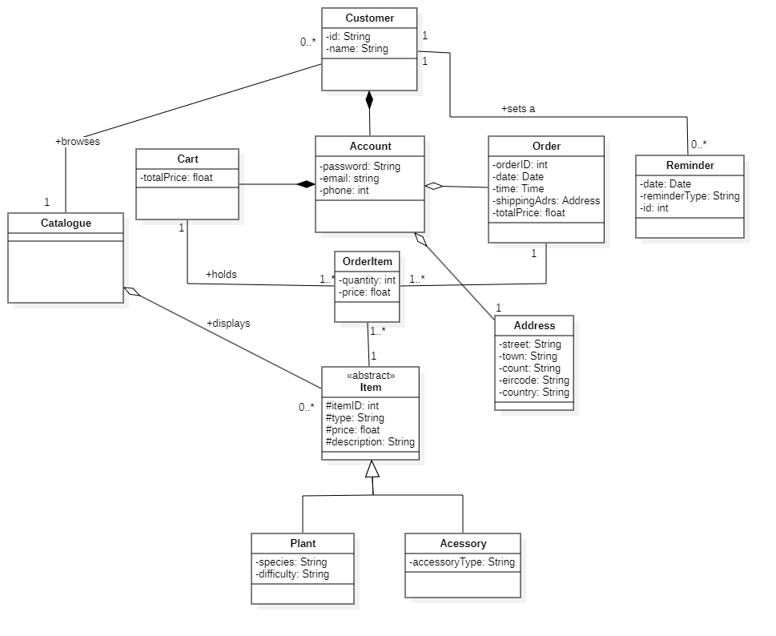

# **Sequence Diagrams**

|  |  |  |  |  |  |  |
| --- | --- | --- | --- | --- | --- | --- |
| **Num** | **Caller** | **Callee** | **Msg Name** | **Msg Type** | **Msg Param** | **Msg Constrain** |
|  | Customer | Catalogue | browseCatalogue | Synchronus |  |  |
|  | Customer | Catalogue | selectItem | Synchronus | Item |  |
|  | StoreDatabase | Customer | displayItem | Synchronus | Item |  |
|  | Catalogue | Customer | goBack | Synchronus |  |  |
|  | Yes/No | Customer | Catalogue | Synchronus | Boolean |  |
|  | Catalogue | Customer | displayCatalogue | Synchronus | - | =true |
|  | Catalogue | Customer | displayItem | Synchronus | Item | =false |

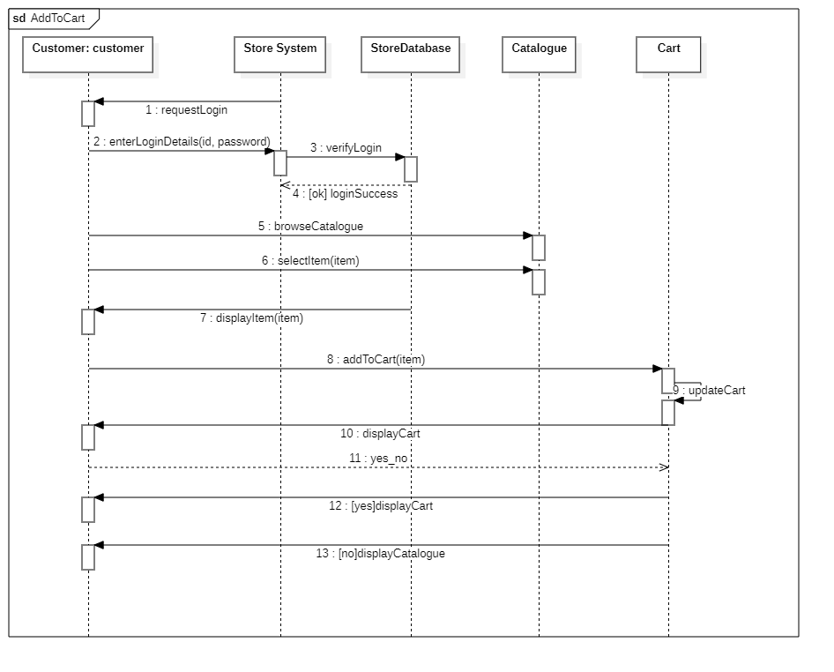

|  |  |  |  |  |  |  |
| --- | --- | --- | --- | --- | --- | --- |
| **Num** | **Caller** | **Callee** | **Name** | **Type** | **Parameter** | **Constraint** |
|  | Store System | Customer | requestLogin | Synchronous |  |  |
|  | Customer | Catalogue | enterLoginDetails | Synchronous | id, password |  |
|  | Store System | StoreDatabase | verifyLogin | Synchronous | id, password |  |
|  | StoreDB | Store System | loginSuccess | Synchronous | id, password | - |
|  | Customer | Catalogue | browseCatalogue | Synchronous | - | - |
|  | Customer | Catalogue | selectItem | Synchronous | Item |  |
|  | StoreDB | Customer | displayItem | Synchronous | Item |  |
|  | Customer | Cart | addToCart | Synchronous | Item |  |
|  | Cart | Cart | updateCart | Synchronous |  |  |
|  | Cart | Customer | displayCart | Synchronous |  |  |
|  | Customer | Cart | Yes/No | Synchronous | Boolean |  |
|  | Cart | Customer | displayCart | Synchronous |  | =true |
|  | Cart | Customer | displayCatalogue | Synchronous |  | =false |

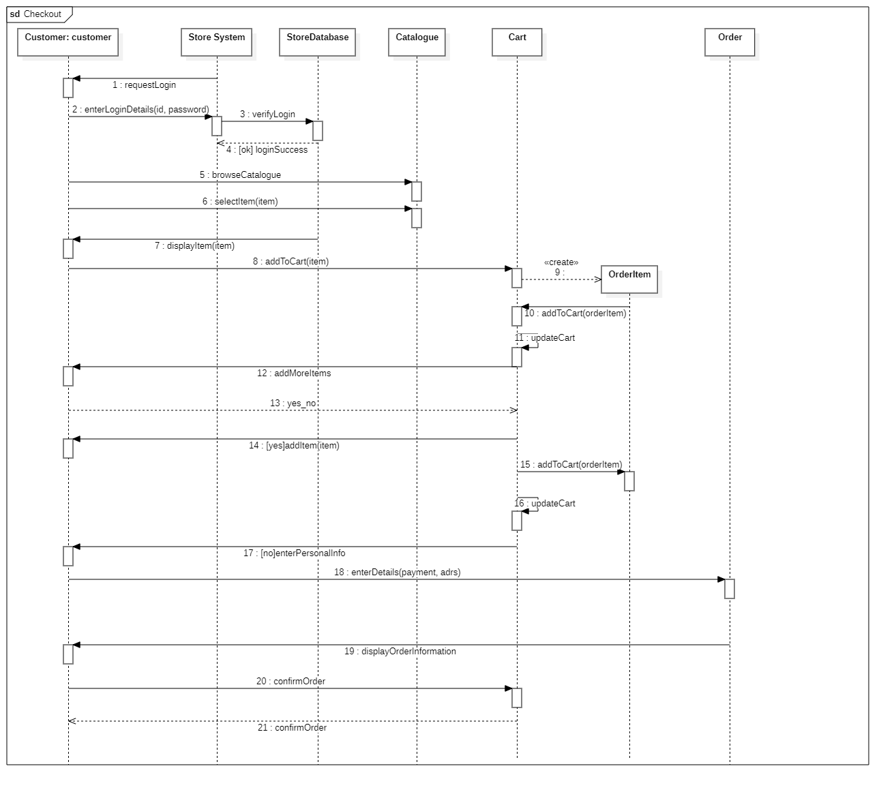

|  |  |  |  |  |  |  |
| --- | --- | --- | --- | --- | --- | --- |
| **Num** | **Caller** | **Callee** | **Name** | **Type** | **Parameter** | **Constraint** |
|  | Store System | Customer | requestLogin | Synchronous |  |  |
|  | Customer | Catalogue | enterLoginDetails | Synchronous | id, password |  |
|  | Store System | StoreDatabase | verifyLogin | Synchronous | id, password |  |
|  | StoreDB | Store System | loginSuccess | Synchronous | id, password |  |
|  | Customer | Catalogue | browseCatalogue | Synchronous |  |  |
|  | Customer | Catalogue | selectItem | Synchronous | Item |  |
|  | StoreDB | Customer | displayItem | Synchronous | Item |  |
|  | Customer | Cart | addToCart | Synchronous | Item |  |
|  | Cart | OrderItem | Create | Synchronous |  |  |
|  | OrderItem | Cart | addToCart | Synchronous | orderItem |  |
|  | Cart | Cart | updateCart | Synchronous |  |  |
|  | Cart | Customer | addMoreItems | Synchronous |  |  |
|  | Customer | Cart | Yes/No | Synchronous | Boolean |  |
|  | Cart | Customer | addItem | Synchronous | Item | =true |
|  | Cart | OrderItem | addToCart | Synchronous | orderItem |  |
|  | Cart | Cart | updateCart | Synchronous |  |  |
|  | Cart | Customer | enterPersonalInfo | Synchronous |  | =false |
|  | Customer | Order | enterDetails | Synchronous | payment, adrs |  |
|  | Order | Customer | displayOrderInformation | Synchronous |  |  |
|  | Customer | Cart | confirmOrder | Synchronous |  |  |
|  | Cart | Customer | confirmOrder | Synchronous |  |  |

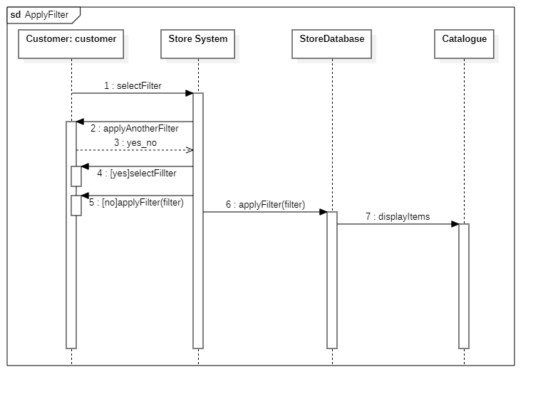

|  |  |  |  |  |  |  |  |
| --- | --- | --- | --- | --- | --- | --- | --- |
| **Num** | | **Caller** | **Callee** | **Name** | **Type** | **Parameter** | **Constraint** |
|  | Customer | | Store System | selectFilter | Synchronous |  |  |
|  | Store System | | Customer | applyAnotherFilter | Synchronous |  |  |
|  | Customer | | Store System | Yes/No | Synchronous | Boolean |  |
|  | Store System | | Customer | selectFilter | Synchronous |  | =true |
|  | Store System | | Customer | applyFilter | Synchronous | Filter | =false |
|  | Store System | | StoreDB | applyFilter | Synchronous | Filter |  |
|  | StoreDB | | Catalogue | displayItems | Synchronous |  |  |

|  |  |  |  |  |  |  |
| --- | --- | --- | --- | --- | --- | --- |
| **Num** | **Caller** | **Callee** | **Name** | **Type** | **Parameter** | **Constraint** |
|  | Store System | Customer | requestLogin | Synchronous |  |  |
|  | Customer | Catalogue | enterLoginDetails | Synchronous | id, password |  |
|  | Store System | StoreDatabase | verifyLogin | Synchronous | id, password |  |
|  | StoreDB | Store System | loginSuccess | Synchronous | id, password |  |
|  | Customer | Store System | scheduReminder | Synchronous |  |  |
|  | Store System | Customer | setReminder | Synchronous |  |  |
|  | Customer | Store System | scheduReminder | Synchronous | date |  |
|  | Store System | Store System | checkDate | Synchronous | date |  |
|  | Store System | Store DB | setReminder | Synchronous | Date |  |
|  | Store DB | Customer | reminderSet | Synchronous |  |  |

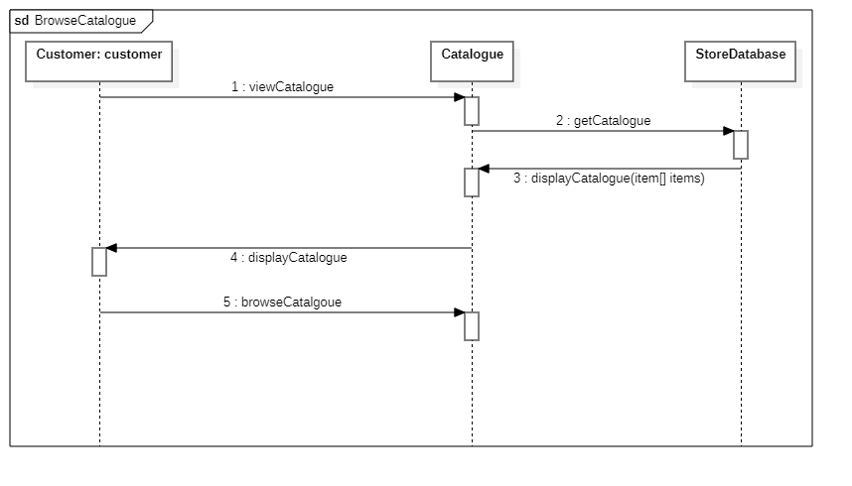

|  |  |  |  |  |  |  |
| --- | --- | --- | --- | --- | --- | --- |
| **Num** | **Caller** | **Callee** | **Msg Name** | **Msg Type** | **Msg Param** | **Msg Constrain** |
|  | Customer | Catalogue | viewCatalogue | Synchronus |  |  |
|  | Catalogue | Store DB | getCatalogue | Synchronus |  |  |
|  | Store DB | Catalogue | displayItems | Synchronus | item[] items |  |
|  | Catalogue | Customer | displayCatalogue | Synchronus |  |  |
|  | Customer | Catalogue | browseCatalogue | Synchronus |  |  |

# **Test Cases**

|  |  |
| --- | --- |
| **Name** | **TC-001:** Select Item |
| **Requirement** | Verify that the system successfully updates to display details of a selected item from a database of items. |
| **Preconditions** | The system is displaying the full catalogue |
| **Steps** | 1. Click on the **image** of the third item. 2. Return to previous page 3. Click on the **name** of the first item. 4. Return to previous page |
| **Expected Results** | 1. The item details window appears, with a larger image and more detailed information 2. Verify that items can be selected by clicking icon **or** thumbnail 3. Return to browsing catalogue |

|  |  |
| --- | --- |
| **Name** | **TC-002:** Add to Cart |
| **Requirement** | Verify that the system successfully allows a user to enter item(s) to cart. |
| **Preconditions** | The user is viewing the catalogue |
| **Steps** | 1. Click on the **second** product 2. Click the “Add to Cart” button 3. Return to catalogue 4. Click on the **fourth** product 5. Change **quantity** to 2, add to cart |
| **Expected Results** | 1. The item details window appears, with a larger image and more detailed information 2. The system alerts the user to the fact that the item has been added successfully 3. Return to browsing catalogue |

|  |  |
| --- | --- |
| **Name** | **TC-003:** Checkout |
| **Requirement** | Verify that the store system successfully allows the user to checkout their items |
| **Preconditions** | The customer has items in their cart |
| **Steps** | 1. Click on the **View Cart** button 2. Click on the **Proceed to Checkout** button 3. Enter your **login details** 4. Input **personal information** 5. Click on the **Confirm Order** button |
| **Expected Results** | 1. The system displays the users Cart 2. The system begins the Checkout process 3. System prompts user for login details 4. System prompts user for shipping & billing information 5. System updates to confirm to the user that their order has been successfully placed |

|  |  |
| --- | --- |
| **Name** | **TC-004:** Filter Catalogue |
| **Requirement** | Verify that the system allows the user to apply filter(s) to the Catalogue of Items |
| **Preconditions** | The system is displaying the full catalogue |
| **Steps** | 1. Click on the **Filter** button 2. Select **one** filter 3. Click the **Apply Filter** button 4. Click on the **Filter** button 5. Select **another** filter 6. Click on the **Apply Filter** button |
| **Expected Results** | 1. The system updates to show a list of filters to choose from 2. When applied, the system displays just items matching the filter tag 3. Applying another filter will result in a more specific list of items |

|  |  |
| --- | --- |
| **Name** | **TC-005:** Schedule Reminder |
| **Requirement** | Verify that the system successfully sets and alerts the user when a Reminder is Scheduled |
| **Preconditions** | The user is logged in |
| **Steps** | 1. Click on the **Schedule Reminder** button 2. Input **todays date** 3. Click on the **Set Reminder** button to confirm |
| **Expected Results** | 1. The system will display the Schedule Reminder page 2. The system will update to display the reminder the user has just input |

|  |  |
| --- | --- |
| **Name** | **TC-006:** Browse Catalogue |
| **Requirement** | Verify that the system allows the user to browse the catalogue of items |
| **Preconditions** | The user is on the page displaying the catalogue |
| **Steps** | 1. Click on the **Home** page 2. Scroll to browse the catalogue |
| **Expected Results** | 1. The system will update in real time to display the catalogue – containing items - for the user |