

Project Specification

Software Development Year 4 – Project

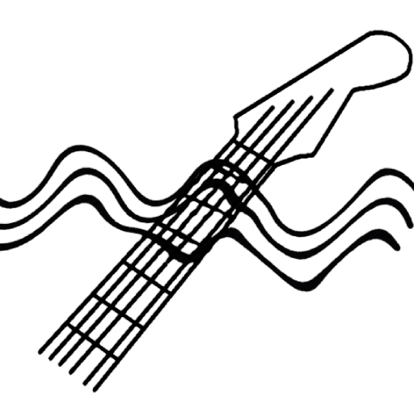

Author: Mark Lambert
Student ID: C00192497
Supervisor: Paul Barry
Start Date: 9th September 2026
Submission Date: 9th October 2026

Project Title
Guitar Chord & Skill Analysis Tool (Chroma OR Fretwave OR Signical)

Project Summary
A mobile application that performs analysis on guitar audio to identify chords being played, measure the timing of transitions between chord changes, and use that data to estimate a player’s skill level. The system should display the chord information in a format that is common to guitar players (tab, guitar neck with finger positioning overlay)

Functionality
- Detect chords played from audio input and use audio processing libraries and techniques
- Measure the time taken between chord transitions
- Assign a skill estimate based on chord difficulty and transition times (barre chords much more difficult than open cowboy chords)
- The application should run on a smartphone
- An in-app guitar tuner, ensuring not to force users away from the app to use an external tuner

Features
- Audio Input – User provides a recording/records with phone mic live
- Chord Detection – the system identifies the chords being played throughout recording
- Analysis – the system measures the time between chord changes
- Skill Assigning – based on chord difficulty and transition speed, a skill score is calculated
- Mobile UI – mobile based interface for recording and uploading audio
- Progress Tracking – user can track previous practice history and recommendations
- Tuner – From using similar apps on the market, every one of them had a built in tuner. Considering the target audience for this project is beginners, not having a tuner built in may cause some of the user-base to leave

Tech Stack
Audio processing – Python, librosa, noisereduce | librosa has chroma feature and note onset detection [1]
Backend - Flask
Frontend – Flutter (cross platform in one codebase) | Handle the audio input and displays results
Database – MariaDB | Store user practice history and skill scores
IDE – Jupyter Lab, PyCharm, VsCode (Flutter)
Version Control – GitHub
Data – Kaggle/GuitarSet [2], chord-db [3]
LLM Integration – Ollama | Could query Ollama’s local REST API on small models like llama3/phi3

The chord detection approach implemented in my prototype follows the standard chroma matching baseline highlighted by Snyder [4], by comparing a frame’s chroma vector against a bank of major/minor templates.

Why?
Existing guitar learning applications such as Yousician and Fender Play do provide feedback, however, the user must follow a predefined curriculum via video/lesson and exercises. The application then checks their playing against a set of targets. This forces the user into a restricted set of rules/exercises they must follow.

This application will generate feedback from the guitarists own unscripted playing. A user can play a single chord change of their choosing, and the system will analyse and provide feedback based on the transitions. This freedom will in-turn provide a more realistic insight on the guitarists ability. Other apps force the guitarist into following a lesson slightly above their skill level, resulting in them “overplaying” and making mistakes due to tension in the body. The objective of this application is to encourage good form over speed. Sloppy chords, with bad notes can be detected via the output of the chroma vectors.

Feedback is generated from the following

- Transition Speed – Relative to the difficulty of chord (open-to-open chord? Open-to-barre? Barre-to-barre? Diminished/augmented? Relative to current hand position?)
- Consistency – Each chord is made up of a set of notes played together. A C chord consists of C E and G. The notes must be clean and consistent for a good score. If more than one chord change, the users average transition time will have an affect on their score

These parameters will be queried against the expected transition speed benchmarks for practical, bad-habit free improvement from established beginner guitar teacher JustinGuitar [5]

He states that a guitarist should choose two chords that they find tricky to switch between, and play for 60 seconds, see how quickly they can transition while focusing on quality over speed. By repeating the exercise and logging the data, the results will build a profile on the users progress.

Sandercoe states that the long term goal is “60 changes in a minute”. And that to pass a first grade level guitar exam “thirty changes in a minute” would be expected. [6]

Using these numbers, we can assume an Advanced guitarist can perform a chord transition in one second, depending on difficulty. A beginner guitarist would be expected to transition from easier chords in roughly two seconds.

What’s Required From the User
The user is required to select one of three options as their own interpretation of their skill level, Beginner | Intermediate | Advanced. This will be used as a baseline for their expected skill results.
The user is required to have a mobile device with Android or iOS.
The user is required to have an acoustic OR electric guitar and a functioning mobile microphone.

Targets (MoSCoW)
- MUST – Chord detection and timing measurement works on a small set of defined open chords, basic scoring, detection algorithm works on a clip recorded in-app
- SHOULD – Larger set of chords (barre, diminished, triads), ability to save data and track progression
- COULD – Built in guitar tuner for beginners that lack a tuner
- WOULD – Deployed as a mobile application to app stores. Chord processing performed in real-time on live audio

References

[1] Lynn Zheng (2021) “How to use Python to Detect Music Onsets” [freeCodeCamp] https://www.freecodecamp.org/news/use-python-to-detect-music-onsets/#:~:text=Finally,above%20for%20Aubio (Accessed: 06th October 2026)

[2] Vinci, F (2021) Guitar Chords V4 [Kaggle] Available at: https://www.kaggle.com/datasets/fabianavinci/guitar-chords-v3 (Accessed: 12th September)

[3] tombatossals (2025) “chords-db” [github] Available at: https://github.com/tombatossals/chords-db (Accessed: 06th October 2026)

[4] Snyder, W (2021) “CS 583 – Computational Audio: Lecture 10 – Chroma, Chord Recognition by Template Matching, Problems with Chord Recognition, Coding the Algorithm” [Boston University] Available At: https://www.cs.bu.edu/fac/snyder/cs583/Lectures/Lecture 18.pdf (Accessed: 12th September 2026)

[5] Sandercoe, J (2020) “Perfect Fast Changes” Available at: https://www.justinguitar.com/guitar-lessons/perfect-fast-changes-b2-802 (Accessed: 11th September 2026)

[6] Sandercoe, J (2020) “Perfect Fast Changes” [Video] Youtube. Available at: https://www.youtube.com/watch?v=xSFHgeJUuIs (Accessed: 11th September 2026)

