

First Release - Report

Software Development Year 4 – Project

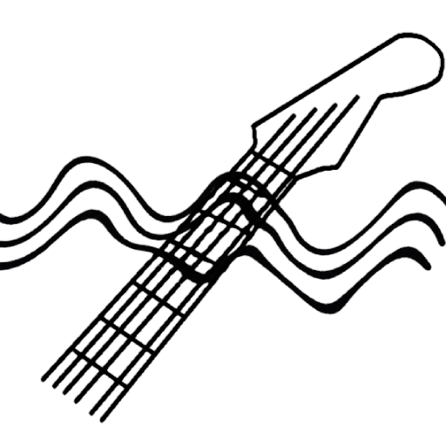

Author: Mark Lambert
Student ID: C00192497
Supervisor: Paul Barry
Submission Date: 30th October 2026

Introduction

The goal of the project is to build a practice tool that helps beginner guitarists change cleanly between chords. The aim is to have a mobile application that can be used with any guitar, strum some chords and get instant feedback.

This first release covers the chord and note onset detection algorithms and continuous recording within a Jupyter Notebook. This release does not implement a GUI, mobile functionality or meaningful feedback besides the chord detected and a similarity score of the algorithm.

A final release goal was set: In a notebook prompt the user with three chords and initiate recording. Then perform analysis on the recording and return a true/false result for whether each detected chord matches the prompted chord.

Release Targets

- Chord detection on a raw pre-recorded clip
- In-notebook recording functionality
- Onset detection to enable more than one chord detection per clip
- Display a bank of three chords represented as chord diagrams, prompt the user to play them by initiating a recording and when stopped, detecting the chords strummed
- Report whether each detected chord matches the prompted chord

Research

The following applications within the same domain were researched:

- Chordify: Haskell, clean UI that is understandable for beginners. Chord detection on a small bank of chords for free users. Displays results dynamically, mapped onto a fretboard, as you strum chords. In-app tuner. [1]
- Yousician: Python, uses librosa, tensorflow and pytorch libraries. Curriculum based learning, user takes set courses via video and gamification of exercises. In-app tuner. [2]
- Fender Play: Video lesson focused, no active participation with app besides videos. [3]
- Guitariz: Python, uses librosa and demucs libraries. Web based application. Uses cosine similarity. [4]
- Brizm.dev: Web based application, detects chords from real time recording. Displays chords graphically and as a table with timestamps. Uses cosine similarity. [5]
- Chord Mini: Python, librosa and chords-db for chord data. Onset detection filters strums by down vs up-strumming. [6]

Findings
Obtaining a chroma vector by using librosa and performing cosine similarity on the vector against chord templates is the common method used by similar applications.

All applications which perform chord detection or rely on guitar input, also include an in-app tuner. This helps keep the user’s attention on the application.

Design

Chord and Onset Detection [7]

Chord Detection
- librosa.feature.chroma_cqt represents an audio file in a 2D numpy array, with a set amount of 12 rows and n cols, where n = number of frames in audio clip
- Calculate the average chroma across a set of frames with np.mean(axis=1)
- Template chords are represented as 12 value vectors, to represent the pitch classes. A 1 signals a note, a 0 shows its absence
- Cosine similarity between the average chroma and each chord template is used to detect chords, the highest similarity score of the cosine similarity wins

Onset Detection
- librosa.onset.onset_detect returns frame indices where a spike in audio energy is marked as an onset
- Chord detection on more than one onset:
- Multi-dimensional array slicing the chroma between each consecutive onset using [:, prev:cur] where [:, preserves the 12 rows representing the pitch classes
- Output of onset_detect is sensitive. Solution: Using librosa.frames_to_time and establishing a buffer (buffer=0.5 # seconds) enables the filtering of onsets to extract only primary strums

Audio Recording [8]
- sounddevice InputStream with a callback function allows for a continuous flow of recording that ends on termination, rather than the set recording length method when using sounddevice.record()
- A time.sleep(1) at the start of the record() function allows the user some time to get ready to strum before recording begins
- A Queue is used to store chunks of audio between the callback thread and main thread (producer-consumer)
- soundfile.write() to write result to a WAV file
- sd.query_devices queries the user’s system for the channel count on their input, rather than hard-coding the channels to 2
- Hardware tested on: AT2020 microphone through a Scarlett 2i2 for acoustic, electric guitar through Scarlett 2i2. Plus laptop microphone (Thinkpad x230)

Chord Prompt [9]
- A chord diagram of the 9 standard open chords is split into 1 image per chord
- Three chords are shown to the user using random.sample()
- Chords are displayed to the user using IPython.display()
- The record() function mentioned in 4.2 is used to prompt the user to begin strumming the three chords
- Each chord .jpg file is named with the same name as the chord stored in the chords dictionary
- get_chords() in ChordDetect.py performs the onset detection and multi-dimensional array slicing to isolate each chord strum
- check_chords(detected, prompted) in ChordDetect.py compares each detected chord against the prompted chord, returns a list of tuples (chord, is_correct)

Limitations

- The current bank of template chords is very small. For a meaningful app, need many more chords stored.
- Onset detection is still sensitive, especially when trying to play exactly three chords when prompted
- No real-time detection and feedback on transition timestamps

Testing

All recorded clips used when testing the application are found in the ‘Iteration 1/clips’ folder of the project directory. I used various guitar models on different pickup positions, both electric and acoustic recorded via microphone. My wife, as a novice guitar player also interfaced with the chord prompt notebook.

A bug was highlighted by my supervisor in the record() function of ChordDetect.py. The bug was found while he was testing the code, the channels value was hardcoded to 2. The solution was to use sounddevice.query_devices() to get the system’s input device information. [10]

Problems Faced

When having a novice guitarist demo the prompt notebook, there were consistent additional chord detections occurring when a novice fails to mute strings.

Example 1: The D chord’s first two strings should be muted, the novice mutes the first (E) string but fails to mute the second string (A). An A major is detected, then the D major chord
Output: Chord: A, Score:53.34%
Chord: D, Score:81.25%
Example 2: The D chord’s first two strings should be muted, the novice fails to mute both the first and second strings. An E minor is detected, then the D major chord
Output: Chord: Em, Score:64.32%
Chord: D, Score:73.11%
The extra chord detected results in the misalignment of chord to prompt chord comparisons, so a lookahead was added to the check_chords algorithm, allowing the user one mistake for the recording. This introduces a level of fairness for a novice guitarist.

Plans for Next Release
- Fix the extra detections from unmuted strings (section 7) Possible solution:
- Ignore detections below a similarity threshold
- Chord transition timing: measure how long a change takes. Already convert frames to time, so the time between consecutive primary strums can be used to build on this
- Expand the template bank of chords
- Explore GUI and mobile implementation
__________________________________________________________________________________

References

[1] Inna Logunova (2023). Haskell in production: Chordify. [online] Serokell. Available at: https://serokell.io/blog/haskell-in-production-chordify [Accessed 3rd Oct. 2026]
[2] Yousician (2026) Yousician [online] Available at: https://yousician.com/company [Accessed: 3rd October 2026]
[3] FenderPlay (2026) FenderPlay [online] Available at: https://www.fender.com/play [Accessed: 3rd October 2026]
[4] Vaidya, A. (2026). Chord AI - guitariz. [online] Available at: https://guitariz.studio/chord-ai [Accessed: 3rd October 2026]
[5] Chord detector - BRIZM. (2026) Brizm.Dev [online] Available at: https://brizm.dev/chord-detector/ [Accessed: 3rd October 2026]
[6] ChordMini (2026) ChordMini [online] Available at: https://chordmini.me/, https://github.com/ptnghia-j/ChordMiniApp#:~:text=librosa [Accessed: 3rd October 2026]

[7] librosa.org. (n.d.). Librosa — Librosa 0.8.0 documentation [online] Available at: https://librosa.org/doc/latest/index.html [Accessed 4th Oct. 2026]
[8] ReadTheDocs.io (n.d.). Example programs — Python-sounddevice, version 0.3.15 [online] Available at: https://python-sounddevice.readthedocs.io/en/0.3.15/examples.html [Accessed: 10th Oct. 2026]
[9] user1269942 (2014) Importing images from a directory (Python) to a list or dictionary [online] Available at: https://stackoverflow.com/a/26392492 [Accessed: 21st Oct. 2026]
[10] ReadTheDocs.io (n.d.). Checking available hardware. [online] Available at: https://python-sounddevice.readthedocs.io/en/0.4.1/api/checking-hardware.html [Accessed: 26th Oct. 2026]

