**Description**

As we are entering an advanced age many people have moved away from traditional forms of entertainment in favor of digital entertainment. 3-D Tic-Tac-Toe was inspired by the classical, yet obvious game of Tic-Tac-Toe. To bring back this classic game into the modern era, we decided to take advantage of the growing mobile and PC industry. Users will be able to play on 3D shaped boards, the main 3D shape being a cube which consist of 6 3x3 grids. Having a bigger game board allows the addition of more players in a game as opposed to a traditional two player Tic-Tac-Toe game. Our product will support up to 4 players in a single game. Like how the original game plays, players will be able to choose custom icons to represent their spaces on the game board. To place their icons on the board, players will rotate the cube any desired direction and pick a space to place their corresponding icon. As players continue playing, there will be a live score updated showing the top two or three players. The game ending when a player connects their three pieces either horizontally, vertically, or diagonally.

**Requirements**

3-D Tic-Tac-Toe will have several requirements that are categorized into eleven categories including functional, data, performance, dependability, maintainability/supportability, security, usability/humanity, look/feel, operational/environmental, cultural/political, and legal. Listing a requirement from every category in order: The system should be able to accept all the inputs from the user. The system will have different kinds of input by different users which is supposed to be saved by the system. The system shall be able to minimize the lag between the user input and the system output. The system must be able to handle the long-term usability of the game. The system shall offer a game tutorial to users. The system’s records shall only be visible and altered by the game management. The system shall be easy for 12-year-old children to use. The game appearance should be attractive to anyone over the age of 3 interested in this game. The product should have different light modes. The product should not be offensive to anyone’s culture. The game should comply with data privacy requirements for all countries the game is offered in.

**Testing**

To complete the requirements from above, unit tests and inspections are to be conducted. The game will be tested on its basic functionalities as well as testing all the requirements 3-D Tic-Tac-Toe states.

**Design Goals**

The interface must intuitive and easy for our target audience. Our product will allow third party accounts through API’s and allow purchases through those third-party accounts. The game will be able to play online and offline. Also, we want to ensure the gameplay is logical and smooth from start to end of a game.

**System Design**

3-D Tic-Tac-Toe’s system design can be divided among 3 packages. The game and in-game shop singleton classes will correspond to an Interface package. The Board, Match, Offline Match, and Online Match classes will correspond to a Match package. The Player, AI, and Difficulty classes will correspond to a Player package.

Our system design below incorporates the following design patterns: Singleton, observer, and strategy. The game and in-game shop were chosen to be Singletons because we only need one instance throughout the application’s runtime. For the observer pattern, we have our players as the observers and the subject as the match. The players are observing the match. When a player places a piece on the board, the match is going to notify all the players about the move so that their own version of the game is updated. The strategy design pattern is utilized by the AI’s in the game. At run-time, the AI, depending on the level of difficulty that the user selects for it, will select an algorithm that will determine its game move.

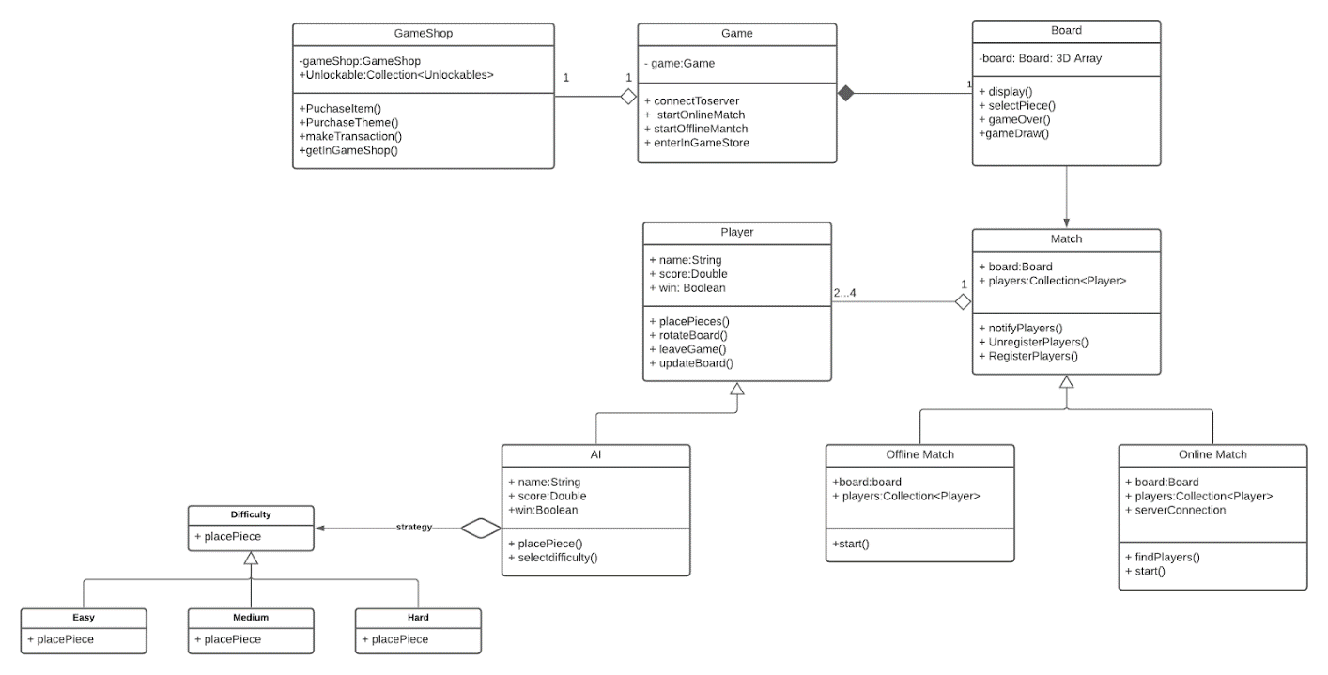

**Project Issues**

Various issues can come up during the development process, during testing, or even after the product is released. As of now, our product is available on Windows, Android, iOS, and macOS. We are currently asking ourselves if it is worth making the game available on Linux since there is not a huge market of Linux users. Also, different users run different hardware components on their machine. We fear that some users might not have the minimum hardware components necessary to run the product and perform optimally. Another issue is how we are going to capture more than our target audience. Having a bigger audience helps sustain the existence of the product. We will be following up with our marketing analysts to obtain a solution.