**3D Tic-Tac-Toe Project Report**

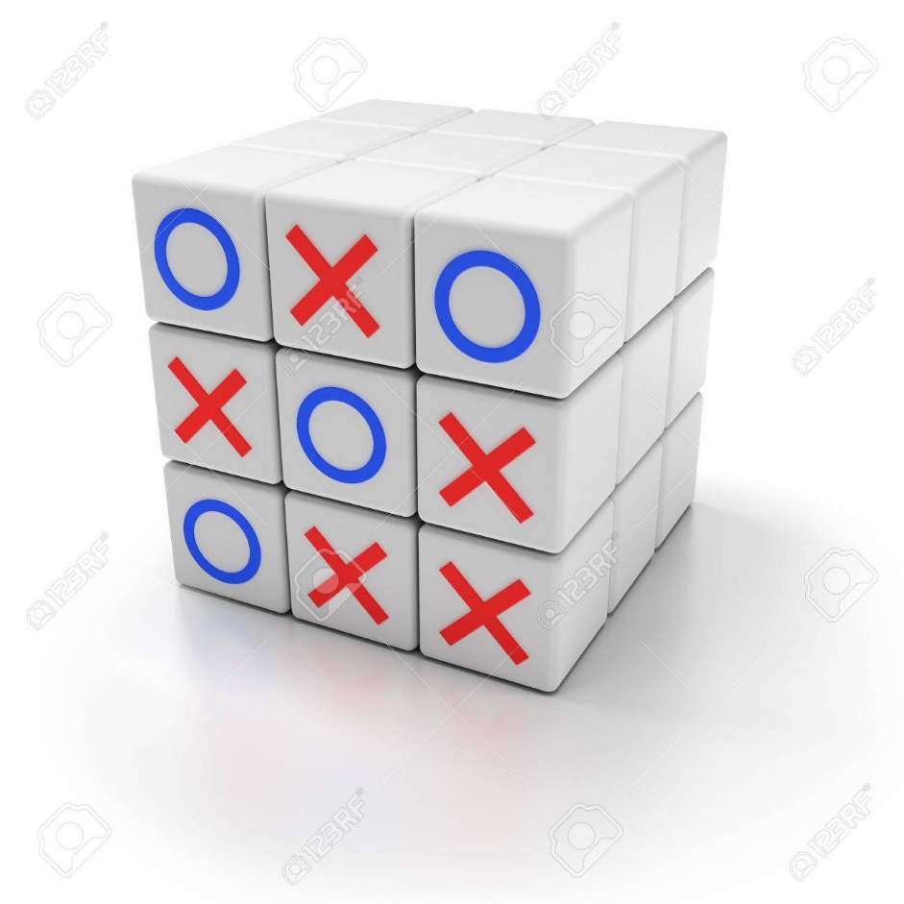

**Prepared by**

**Nick Toledo, Omar Flores,**

**Stephen Lambert, Yash Shah**

**at the**

**University of Illinois Chicago**

**October 2019**

**Table of Contents**

List of Figures 6

List of Tables 7

I Project Description 8

1 Project Overview 8

2 The Purpose of the Project 8

2a The User Business or Background of the Project Effort 8

2b Goals of the Project 8

2c Measurement 8

3 The Scope of the Work 9

3a The Current Situation 9

3b The Context of the Work 10

3c Work Partitioning 10

3d Competing Products 10

4 The Scope of the Product 11

4a Scenario Diagram(s) 11

4b Product Scenario List 11

4c Individual Product Scenarios 12

5 Stakeholders 12

5a The Client 12

5b The Customer 12

5c Hands-On Users of the Product 12

5d Maintenance Users and Service Technicians 12

5e Other Stakeholders 13

5f User Participation 14

5g Priorities Assigned to Users 14

6 Mandated Constraints 14

6a Solution Constraints 14

6b Implementation Environment of the Current System 15

6c Partner or Collaborative Applications 15

6d Off-the-Shelf Software 15

6e Anticipated Workplace Environment 15

6f Schedule Constraints 15

6g Budget Constraints 15

7 Naming Conventions and Definitions 16

7a Definitions of Key Terms 16

7b UML and Other Notation Used in This Document 16

7c Data Dictionary for Any Included Models 16

8 Relevant Facts and Assumptions 17

8a Facts 17

8b Assumptions 17

II Requirements 18

9 Product Use Cases 18

9a Use Case Diagrams 18

9b Product Use Case List 18

9c Individual Product Use Cases 18

10 Functional Requirements 27

11 Data Requirements 28

12 Performance Requirements 28

12a Speed and Latency Requirements 28

12b Precision or Accuracy Requirements 28

12c Capacity Requirements 29

13 Dependability Requirements 29

13a Reliability Requirements 29

13b Availability Requirements 29

13c Robustness or Fault-Tolerance Requirements 30

13d Safety-Critical Requirements 31

14 Maintainability and Supportability Requirements 32

14a Maintenance Requirements 32

14b Supportability Requirements 32

14c Adaptability Requirements 33

14d Scalability or Extensibility Requirements 33

14e Longevity Requirements 34

15 Security Requirements 34

15a Access Requirements 34

15b Integrity Requirements 34

15c Privacy Requirements 35

15d Audit Requirements 36

15e Immunity Requirements 36

16 Usability and Humanity Requirements 36

16a Ease of Use Requirements 36

16b Personalization and Internationalization Requirements 37

16c Learning Requirements 38

16d Understandability and Politeness Requirements 39

16e Accessibility Requirements 39

16f User Documentation Requirements 39

16g Training Requirements 40

17 Look and Feel Requirements 40

17a Appearance Requirements 40

17b Style Requirements 40

18 Operational and Environmental Requirements 41

18a Expected Physical Environment 41

18b Requirements for Interfacing with Adjacent Systems 41

18c Productization Requirements 41

18d Release Requirements 41

19 Cultural and Political Requirements 42

19a Cultural Requirements 42

19b Political Requirements 42

20 Legal Requirements 42

20a Compliance Requirements 43

20b Standards Requirements 43

21 Requirements Acceptance Tests 43

21a Requirements – Test Correspondence Summary 44

21b Acceptance Test Descriptions 44

III Design 48

22 Design Goals 48

23 Current System Design 49

24 Proposed System Design 49

24a Initial System Analysis and Class Identification 49

24b Dynamic Modelling of Use-Cases 49

24c Proposed System Architecture 49

24d Initial Subsystem Decomposition 49

25 Additional Design Considerations 50

25a Hardware / Software Mapping 50

25b Persistent Data Management 50

25c Access Control and Security 50

25d Global Software Control 50

25e Boundary Conditions 50

25f User Interface 51

25g Application of Design Patterns 51

26 Final System Design 51

27 Object Design 51

27a Packages 51

27b Subsystem I 51

27c Subsystem II 52

27d etc. 52

IV Project Issues 52

28 Open Issues 52

29 Off-the-Shelf Solutions 52

29a Ready-Made Products 52

29b Reusable Components 52

29c Products That Can Be Copied 52

30 New Problems 53

30a Effects on the Current Environment 53

30b Effects on the Installed Systems 53

30c Potential User Problems 53

30d Limitations in the Anticipated Implementation Environment That May Inhibit the New Product 53

30e Follow-Up Problems 53

31 Migration to the New Product 53

31a Requirements for Migration to the New Product 54

31b Data That Has to Be Modified or Translated for the New System 54

32 Risks 54

33 Costs 54

34 Waiting Room 54

35 Ideas for Solutions 54

36 Project Retrospective 55

V Glossary 55

VI References / Bibliography 55

VII Index 55

### ****List of Figures****

Figure 1- Work Context Diagram 10

Figure 2 – User Scenario Digram 11

Figure 3- Application Use Case Diagram 18

### ****List of Tables****

Table 1 – Work Partitioning  10

Table 2 – Acceptance Tests Correspondence  44

# Project Description

## Project Overview

3D Tic Tac Toe is a multiplayer game available on a PC and a mobile device, similar to the original tic tac toe game. The game board is designed on a 3x3 cube, each player can rotate the board in any direction, place their characters, and see a live update of the game. The goal of the game is to connect three characters on any side of the board. The game is designed to be fun for every player and create income for the developers.

## The Purpose of the Project

The purpose of this project is to extend a single player game into a multiplayer game that has multiple dimensions. We plan to create a user-friendly application that gives live updates of the gameboard and detects the top three players that connect their characters.

### The User Business or Background of the Project Effort

Our main client’s business is the gaming industry. The gaming industry allows for a lot of creativity and new development projects. This allows us to turn a two-dimensional game into a three-dimensional game that we are interested in developing but could also be interesting to the gaming community.

Our plan is to produce a new multi-dimensional tic tac toe game that is significantly different from the original, with live updates of the game board. We were inspired to create this game, because we all enjoy playing video games, and thought it would be challenging to create a new game, that is significantly different from the original.

### Goals of the Project

The goal of this project is to make a new multiplayer and multi-dimensional game that is significantly different from the original, and that is profitable. The game aims to be fun and enjoyable for anyone over the age 3 and must be able to attract new customers and keep current customers. The game must be profitable, covering the cost of development, and future improvements.

### Measurement

The enjoyment of this game will be measured using different methods, for example, customer reviews, number of downloads, and user activity. It is important to gather this information, because then the developers can determine the success, or failure of the product, and find ways to improve it.

Customer reviews will help improve the game, because it shows the developers how the users feel about the product, and if they are happy with the game. This will help the developers determine whether or not users will keep playing the game, and help developers determine other games that users would enjoy playing. The user activity measurement will determine how many users are playing the game weekly or monthly, and if they are most likely to continue playing the game. This will help developers find ways to keep new and existing users, because not every player will submit reviews.

## The Scope of the Work

The main purpose of this game would be to entertain people on a regular basis and make an income from this game.

### The Current Situation

Tic-Tac-Toe is a classic game that can be traced back to ancient Egypt. This simple yet timeless game has managed to survive the test of time thanks to it is easy to setup and play nature. All somebody needs to play the original game is pen, paper, and a friend. However, now that we are entering a more advanced age many people have moved away from traditional forms of entertainment in favor digital entertainment. One of which is mobile games, according to an article by Medium, almost a third of the world’s population will play a mobile game by the end of 2019.

As our entertainment interests grow more advanced, so should our entertainment. For this reason, we want to take advantage of the growing mobile game industry and bring back the classic game Tic-Tac-Toe as a more modern update, 3D Tic-Tac-Toe.

Although the original required only pen, paper, and a friend to play, 3D Tic-Tac-Toe will only require a mobile phone or pc running our product which will find other players to play with. Most, if not a majority of the population has a smart phone, so we will be hitting a very large demographic. No longer will people need to scrounge for pen and paper to play Tic-Tac-Toe with their friends.

### The Context of the Work

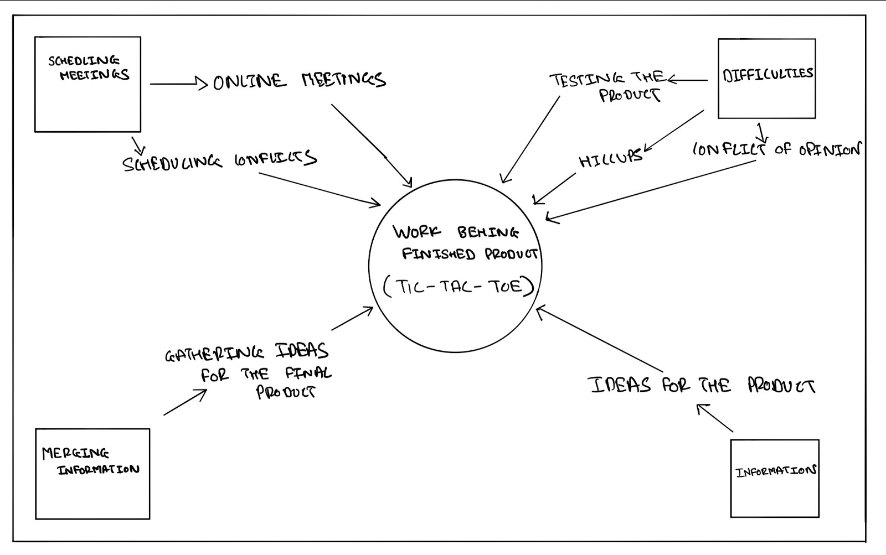  
**Figure 1 – Work Context Diagram**

### Work Partitioning

|  |  |  |
| --- | --- | --- |
| Event Name | Input /Output | Summary |
| Ideas | Getting Ideas of peers  (input) | Gathering all the ideas |
| Working on product | Applying all the ideas for the product (output) | Testing all ideas for the development of the final product |
| Problems in the development phase | dealing with opinion conflicts and issues (input) | Solving all the issues before the release of the final product |

**Table 1 – Work Partitioning**

### Competing Products

When we think of the direct competitors of the current product, there are no other products like this. But the original Tic tac Toe will be the direct competitor to this product. The only shortcoming of this product will be to understand the entire game due to its complicated working methodology.

## The Scope of the Product

User’s will be able to find and install our product either through the App/Play store for both Android and IOS as well as on Steam for PCs. The product will allow for account creation as well as linking pre-existing accounts from Steam, Play Games, or Game Center. Upon logging in users will be able to choose from one of the pre-existing game pieces to use in game.

Afterwards user’s will be able to start the game by choosing which game mode they would like to play, which will put the user I a queue to find an opponent. As user’s continue playing, they will level up and gain experience points which can be used to unlock in game rewards.

### Scenario Diagram(s)

*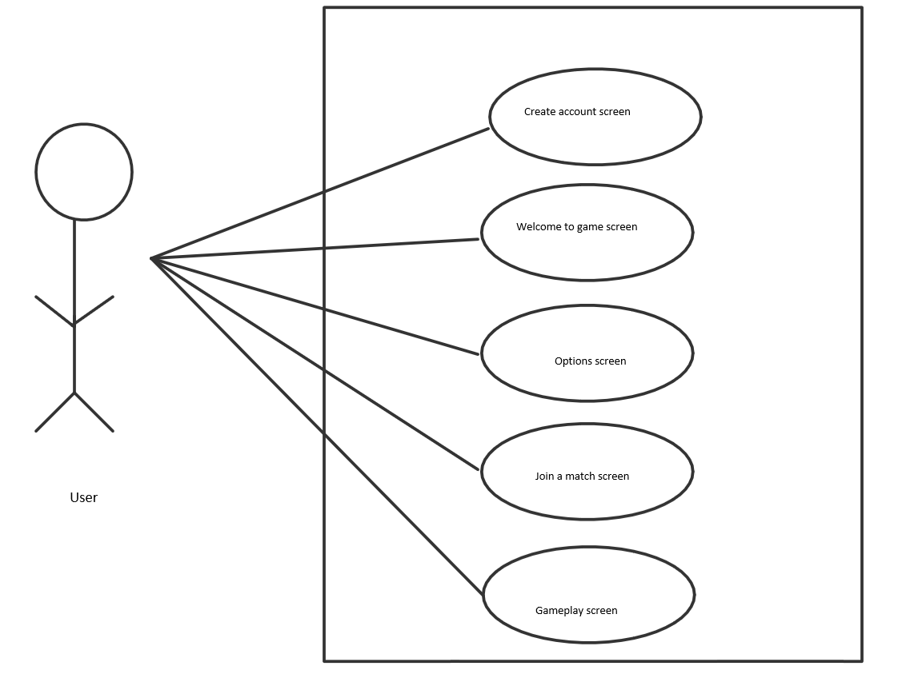***Figure 2- User Scenario Diagram**

### Product Scenario List

PC Game

1. Create/Login account screen.
2. Welcome screen.
3. Options screen.
4. Join a match screen.
5. Gameplay screen.

Mobile Game

1. Create/Login account screen.
2. Welcome screen.
3. Options screen.
4. Join a match screen.
5. Gameplay screen.

### Individual Product Scenarios

Users will start the application on the respective device. Once the application starts, the user will be prompted to create an account if the user doesn’t have one already or sign in using a pre-existing account. When the user signs in, their online profile will display on the screen.

Users will have the ability to mess with the game settings such as audio, key configurations, and other options that lead to a better user experience. Users will have the opportunity to join an online match or play with a friend. Both options will lead to the game populating.

## Stakeholders

### The Client

We are the client. The goal is to make a product that will sell. Stakeholders/investors are clients too.

### The Customer

The customer will be anyone who is into strategic games and those seeking a tougher challenge than the traditional Tic-Tac-Toe game.

### Hands-On Users of the Product

Our main hands-on users for the product are going to be gamers. Specifically gamers that like strategic games/games in general. However, it doesn't necessarily mean that it’s just limited to gamers as the product will be accessible by anyone who can operate a computer. There will be no discrimination within the users. Users can be any gender with the age range being open.

### Maintenance Users and Service Technicians

Server administrators will be needed to make sure the servers are working properly so that there are no issues when it comes to users playing. Game developers will be needed to improve the user experience such as the visuals, game animations, etc. Software developers will be needed to help keep the game up to date and performing with no issues/bugs.

### Other Stakeholders

**Tester**

Testers will have a small stake in the whole development of the game. Testing is important for companies who are on the verge of releasing a new product. As a creator of a product, proper testing must be done so there’s no bugs or issues come release date. The knowledge needed by the testers will be the logical aspect of the game.

Testers must know the rules of the game and the proper outputs of different moves. Aside from logic, testers must also inspect the visual aspect of the game. Do all components on the screen give a proper response, the transition from screens, etc. Any conflict between stakeholders who have an interest in the same knowledge will be handled by a meeting with other stakeholders and the clients.

**Marketing Experts**

Marketing experts will have a small stake in the whole development of the game. Marketing is important for companies who are on the verge of releasing a new product. Exposure will lead to success for products. The knowledge needed by marketing experts is our target audience. Based on our target audience, the marketing experts will offer suggestions for improvements, plan and implement social media or other marketing campaigns to help lure that audience.

Aside from our target audience, marketing experts will be able to gather information on certain groups of people that aren’t being attracted by the product and offer suggestions on how to attract those groups. Any conflict between stakeholders who have an interest in the same knowledge will be handled by a meeting with other stakeholders and the clients.

**Business Analysts**

Business analysts will have a small stake. Business analysts will help facilitate solutions for stakeholders. They are responsible for bridging the gap between IT and the business using data analytics to assess processes, determine requirements and deliver data-driven recommendations and reports to executives and stakeholders.

Growth is what every company looks for and business analysts will be there to advance the company’s future. Any conflict between stakeholders who have an interest in the same knowledge will be handled by a meeting with other stakeholders and the clients.

### User Participation

A couple of months before the product releases, there will be a beta. During this time, 100 users will be selected to participate in the beta. Selected users will be allowed to interact with the product and provide user feedback. Through this, we hope to address any issues or suggestions to enhance the user experience.

### Priorities Assigned to Users

**Key Users** - Gamers/Younger Audience

Gamers will be our key users. Preferably the younger gamers. Typically, this audience is already exposed to a variety of different games and won’t mind adding another game to the collection. After marketing the product, it should be easier to attract this group of users.

**Secondary Users** - Strategic enthusiasts/Older Adults

Given that the product is based on the traditional Tic-Tac-Toe game, we expect that anybody who loves strategic games will come to appreciate a challenge. Doesn’t necessarily have to be a hard core gamer. Older adults tend to have more time and are known to play more strategic games in their free time.

**Unimportant Users** - Children

Given that the product is a more complex game than the traditional Tic-Tac-Toe game, we don’t expect infant children to grasp a full understanding of the product. Therefore, infants won’t be much of a focus compared to our key users and secondary users.

.

## Mandated Constraints

### Solution Constraints

**Description:** Product shall run on average mobile specs.

**Rationale:** The client will not pay for a new mobile device to play 3D-Tic Tac Toe.

**Fit Criterion:** Mobile version of the game shall be playable on most if not all modern phones.

**Description:** Product shall run on both Android and IOS.

**Rationale:** The client will not switch phone OS just to play 3D Tic-Tac-Toe

**Fit Criterion:** Game will be available to download from both the Apple App Store, and the Android Play Store.

### Implementation Environment of the Current System

Our product will be available for both Android and IOS devices through their respective app stores as well as for PCs through Steam. The 3D graphics of the game would be designed using the cross-platform game engine Unity with C# as the scripting language. Using a Unit will allow us to design our product for both mobile and PC operating systems using most if not all of the same code base. This will help reduce the cost of development by avoiding having to develop our product for IOS, Android, and PCs natively.

### Partner or Collaborative Applications

The mobile version of our application will allow for users to log and save their data using both Google and Apple accounts. Likewise, PC users will also be able to log in using corresponding online retailers such as Steam.

### Off-the-Shelf Software

The PC version of the application will be taking advantage of the already existing online network for online distributors such as steam. Doing so users will be able to log in with their online distributor credentials and access their already existing friends list as well as gain achievements towards their account while using our application.

Likewise, the mobile version of the game will take advantage of Play Games on Android, and Game Center on IOS to provide user’s access to their friends lists and achievements while using the application

### Anticipated Workplace Environment

The mobile version could be used in both quiet and loud environments; it must provide both audio and visual cues.

The application will be aimed towards all age demographics, it must be easy enough to be casually played by an older audience as well as children

### Schedule Constraints

Game must be released prior to the next major Android and IOS updates to avoid the application from becoming obsolete during production

### Budget Constraints

For the development of our product, we expect our budget to stay within our budget of $400,000. Most of our budget will go towards the initial development of our product, as well as future product support. However, we will also need to budget for app testing to ensure that we are not releasing a buggy and faulty product into the market which could give our company a bad reputation. We will also need to pay for marketing to ensure we gain a big enough audience for our product.

## Naming Conventions and Definitions

### Definitions of Key Terms

PC: Personal computer, referring to both laptop and desktop computers.

IOS: iPhone Operating System used for mobile Apple devices.

Android: An open source mobile operating system, used by most mobile manufacturers.

Steam: A cloud boused game library which allows consumers to buy and download pc games using their steam account.

Android Play Store: An Android app equivalent to the Apple app store for Iphones.

### UML and Other Notation Used in This Document

This report adheres to the Version 2.0 OMG UML standard which is detailed by Fowler in  [1].

### Data Dictionary for Any Included Models

User account info will consist of

* Username
* Email
* Password
* Possible linked third party account (Steam/Apple/Google)

Games will have the following data

* Record of icons for each player.
* State of the board.
* Score for each player.

## Relevant Facts and Assumptions

### Facts

-Possible rating for our product would be E for everyone.

### Assumptions

-User’s should be familiar with using product platforms such as phones, tablets, and Pcs.

# Requirements

## Product Use Cases

### Use Case Diagrams

****Figure 3 – Application Use Case Diagram**

### Product Use Case List

1. Log In
2. Authenticate Login
3. Log Out
4. Play Game
5. Connect to Public Game
6. Connect to Private Game
7. Enter In-Game Shop
8. Add Funds
9. Purchase Icons
10. Purchase Boards
11. Verify Sufficient Funds
12. Manage Settings

### Individual Product Use Cases

|  |
| --- |
| Use case ID: 1 Name: Log In  pre-conditions: None  post-conditions: Login Credentials are authenticated  Initiated by: User  Triggering Event: Starting application  Additional Actors: None |
| Sequence of Events:  User enters login username/email and password.   1. System stores credentials   User presses login button.   1. System authenticates login credentials. |
| Alternatives: User can also login by connecting 3rd party accounts (Facebook, google, etc.)  Exceptions: Will display an error when no internet connection is available. |

|  |
| --- |
| Use case ID: 2 Name: Authenticate  pre-conditions: User has attempted to log in.  post-conditions: User is logged into account.  Initiated by: User  Triggering Event: User attempts to log in.  Additional Actors: None |
| Sequence of Events:   1. User attempts to log in 2. System authenticates log in credentials.   User is logged into account.   1. System shows user ais online. |
| Alternatives: In the case of incorrect credentials an error message is shown, and user is not logged into account.  Exceptions: Will display an error when no internet connection is available. |

|  |
| --- |
| Use case ID: 3 Name: Log Out  pre-conditions: User Must be logged in.  post-conditions: User is no longer logged in.  Initiated by: User  Triggering Event: User pressed log out button.  Additional Actors: None |
| Sequence of Events:   1. User presses log out button. 2. System logs out user from account. |
| Alternatives: None  Exceptions: None |

|  |
| --- |
| Use case ID: 4 Name: Play Game  pre-conditions: User must be logged in.  post-conditions: User will join a game.  Initiated by: User  Triggering Event: User presses Play Game button.  Additional Actors: None |
| Sequence of Events:   1. Primary user presses play game button. 2. System will show two additional options, “Public Match” and “Private Match” |
| Alternatives: None  Exceptions: None |

|  |
| --- |
| Use case ID: 5 Name: Connect to Public game  pre-conditions: User has chosen to play a game  post-conditions: User will join a public game with random players.  Initiated by: User  Triggering Event: User presses Public Match option.  Additional Actors: Other Users to play with. |
| Sequence of Events:   1. Primary User presses Public Match option 2. System puts User into a queue.   Other users also press Public Match option   1. System starts a public match when enough users are in the queue.   Users take turns each round.   1. System reflects game state for each user. |
| Alternatives: None  Exceptions: None |

|  |
| --- |
| Use case ID: 6 Name: Connect to Private Game  pre-conditions: User has chosen to play a game  post-conditions: User will join a private game.  Initiated by: User.  Triggering Event: User presses Private Match option.  Additional Actors: Other Users to play with. |
| Sequence of Events:   1. Primary User presses Private Match option 2. System puts user into private game lobby.   User sends invites to friends.   1. System directs invites to other users   User chooses to start private game   1. System starts a game with players present in the lobby.   Users take turns each round.   1. System reflects game state for each user. |
| Alternatives: None  Exceptions: None |

|  |
| --- |
| Use case ID: 7 Name: Enter In-Game Shop  pre-conditions: User must be logged in.  post-conditions: User is in in-game shop menu.  Initiated by: User  Triggering Event: User presses In-Game Shop button on menu.  Additional Actors: None |
| Sequence of Events:   1. User press In-Game shop button. 2. System shows in game shop items.   User choose shop category.   1. System shows categories items. |
| Alternatives: None  Exceptions: None |

|  |
| --- |
| Use case ID: 8 Name: Add funds  pre-conditions: User is logged in, and in shop menu.  post-conditions: User will have additional funds.  Initiated by: User  Triggering Event: User presses Add Funds option from shop menu.  Additional Actors: None |
| Sequence of Events:   1. User presses add funds option. 2. System requests payment option.   User enters payment option and info.   1. System executes transaction and adds funds User’s account. |
| Alternatives: System offers different payment options such as Credit Card, PayPal, Apple Pay, etc.  Exceptions: If payment information is incorrect, will display an error and fail to add funds. |

|  |
| --- |
| Use case ID: 9 Name: Purchase Icons  pre-conditions: User has sufficient funds.  post-conditions: User unlocks new icons to use in-game.  Initiated by: User  Triggering Event: User purchases icon from shop using purchase option.  Additional Actors: None |
| Sequence of Events:   1. User chooses Purchase option for an icon. 2. System asks for purchase confirmation.   User confirms purchase.   1. System deducts funds and unlocks icon for User. |
| Alternatives: None  Exceptions: If user has insufficient funds, he will be prompted to add funds. |

|  |
| --- |
| Use case ID: 10 Name: Purchase Boards  pre-conditions: User has sufficient funds.  post-conditions: User unlocks new game boards to be used in-game.  Initiated by: User  Triggering Event: User attempts to purchase a board from shop using purchase option.  Additional Actors: None |
| Sequence of Events:   1. User chooses Purchase option for a game board. 2. System asks for purchase confirmation.   User confirms purchase.   1. System deducts funds and unlocks new game board for User. |
| Alternatives: None  Exceptions: If user has insufficient funds, he will be prompted to add funds. |

|  |
| --- |
| Use case ID: 11 Name: Verify Sufficient Funds  pre-conditions: User is logged in, with available funds,  post-conditions: Allows user to complete a purchase.  Initiated by: User  Triggering Event: User attempts to make a purchase.  Additional Actors: None |
| Sequence of Events:   1. User attempts to make a purchase 2. System checks for sufficient funds, allowing user to complete purchase |
| Alternatives: If user has insufficient funds, he will be prompted to add funds.  Exceptions: None |

|  |
| --- |
| Use case ID: 12 Name: Manage Settings  pre-conditions: User is logged in  post-conditions: User settings will be changed.  Initiated by: User  Triggering Event: Users presses options button from menu.  Additional Actors: None |
| Sequence of Events:   1. User choose Options button from main menu. 2. System displays option menu.   User changes options.   1. System reflects new settings.   User exits options menu.   1. System saves newly changed options. |
| Alternatives: None  Exceptions: None |

*.*

## Functional Requirements

**Requirement #1-Functional requirement- acceptance system**

**Description:** The system should be able to accept all the inputs from the user.

**Rationale:** acceptance of inputs is necessary for the gameplay.

**Fit Criterion:**  The system shall accept the inputs from the user.

**Acceptance Tests:** accept inputs for gameplay.

## Data Requirements

**Requirement #2 -Data- user input**

**Description:** System will have different kinds of input by different users which is supposed to be saved by the system.

**Rationale:** different data should be handled by the system to support the gameplay.

**Fit Criterion:**  data handler of the system should be at its best when in use.

**Acceptance Tests:** Large amounts of data have to be stored in the system.

## Performance Requirements

### Speed and Latency Requirements

**Requirement #3 - speed-lag**

**Description:** The system shall be able to minimize the lag between the user input and the system output.

**Rationale:** Reduced game lag is really important in improving the user experience and gameplay responses.

**Fit Criterion:**  input and output responses should be lag free

**Acceptance Tests:** refresh rate and gameplay should be lag free.

### Precision or Accuracy Requirements

**Requirement #4 - Accuracy- detailed user interface**

**Description:** The user interface should have real world graphics with detailed GUI.

**Rationale:** The real game GUI should replicate some high end graphics from popular games.

**Fit Criterion:**  The game GUI should be pinpoint precise without any glitches.

**Acceptance Tests:** try using the interface on high graphics to real test the accuracy of GUI.

### Capacity Requirements

**Requirement #5 -Capacity-high refresh rate and storage**

**Description:** The gameplay should run on high intensity graphics and should store the data of gameplay.

**Rationale:** The capacity should be to the point to store all the data of the user’s progress.

**Fit Criterion:**  The game should handle the data and refresh rate at constant intervals.

**Acceptance Tests:** At the end of each gameplay, the data should be updated with the new one.

## Dependability Requirements

### Reliability Requirements

**Requirement #6 - reliability-long term usability**

**Description:** The system must be able to handle the long term usability of the game.

**Rationale:** Long term usability is mandatory for the longevity of the game.

**Fit Criterion:**  Long term usability is compulsory to maintain the value of the game to the public.

**Acceptance Tests:** Regularly test the game on high graphics to make sure the usability is up to the point.

### Availability Requirements

**Requirement #7 - availability-24hrs running**

**Description:** The system should be available for use for the most part of the time the game is online .

**Rationale:** All time available for the system is necessary for the users for enjoying the gameplay.

**Fit Criterion:**  System should be online for 24hrs in a day.

**Acceptance Tests:** availability for 24hrs.

### Robustness or Fault-Tolerance Requirements

**Requirement #8 - Fault-Tolerance-No-Internet**

**Description:** The system shall be able to support offline gameplay.

**Rationale:** Offline gameplay is necessary for users to still have something to do when there’s not an established online connection.

**Fit Criterion:**  The product shall work for users without an internet connection.

**Acceptance Tests:** Play an offline game without an internet connection.

**Requirement #9 - Fault-Tolerance-Saved-Data**

**Description:** The system shall store user’s offline game data on their local machine.

**Rationale:** Storing user’s game data is necessary so users don’t lose their progress while playing offline.

**Fit Criterion:**  User’s game data shall be saved to the local machine automatically every time a user hits save or quits the game.

**Acceptance Tests:** Play an offline game, hit save and quit, then return back to the offline game continuing from the saved point.

**Requirement #10 - Fault-Tolerance-Update-Failure**

**Description:** The system shall notify users if an update fails to install.

**Rationale:** Notifying users about an update failing is necessary so users shall be aware that their version is not up to date.

**Fit Criterion:**  Within twenty seconds a pop up message shall display when update fails to install.

**Acceptance Tests:** Disconnect from an internet connection, try to update, and look for the pop up message to appear as updates require an internet connection.

**Requirement #11 - Fault-Tolerance-Report-Errors**

**Description:** The system shall give users the ability to report an error in the product.

**Rationale:** Allowing users to report an error in the product is necessary as it’ll allow developers to tackle those errors and allow the product to be a great experience for users.

**Fit Criterion:**  When an error occurs, players will have the option to report and submit the error that’s ongoing to the developers from a pop-up.

**Acceptance Tests:** Force a game crash and check for pop-up to report an error.

### Safety-Critical Requirements

**Requirement #12 - Game-Crash-Safety**

**Description:** The system shall not cause harm to the user's local machine when game crashes occur.

**Rationale:** Causing no harm to the user’s local machine when the game crashes is necessary since we do not want to mess up their local machine which will result in unhappy customers.

**Fit Criterion:**  One hundred percent of game crashes shall not affect any data or information on a user’s local machine.

**Acceptance Tests:** Force the game to crash multiple times while verifying that no data or information of the user’s local machine was affected.

**Requirement #13 - Customer-Safety**

**Description:** The system shall encrypt and protect all personal/sensitive information of all users.

**Rationale:** Encrypting and protecting all personal/sensitive information of all users is necessary as we want to ensure that their information is safe and not vulnerable to potential hackers.

**Fit Criterion:**  All user information in the system’s database shall be inaccessible to all but the pertaining user.

**Acceptance Tests:** All potential attempts to access information stored in the database will fail.

## Maintainability and Supportability Requirements

### Maintenance Requirements

**Requirement #14 - Maintenance-Update**

**Description:** The system shall force users to download a software update if available.

**Rationale:** Forcing the users to download a software update if available is necessary as it shall ensure an updated version of the game not containing bugs that were located in the previous version.

**Fit Criterion:**  The user shall have to download the software update to play our game.

**Acceptance Tests:** When an update is available, users shall not be able to play the game. Once the update is installed and the system detects it, the user will have access to play the game.

**Requirement #15 - Game-Maintenance-Users**

**Description:** The system shall address reports made by the users.

**Rationale:** Addressing reports made by the users is necessary so that users shall enjoy a great experience.

**Fit Criterion:** Developers shall be notified by the reports and will work immediately to address the issues.

**Acceptance Tests:** Report an issue. The developers shall be notified and shall be given a time table to resolve the issue. Once the issue seems to be resolved, a software update shall be pushed out to all the users.

### Supportability Requirements

**Requirement #16 - Tutorial**

**Description:** The system shall offer a game tutorial to users.

**Rationale:** Offering a game tutorial to users is necessary especially for new users who are trying to gain an understanding of how the game works.

**Fit Criterion:**  Users shall be able to get a tutorial first time logging in as well at any time after.

**Acceptance Tests:** Upon completion of account creation and logging in for the first time, users shall be loaded into tutorial mode. Tutorial mode shall also be accessible at any point in the game.

### Adaptability Requirements

**Requirement #17 - Platforms**

**Description:** The system shall be able to operate on iOS, Android, Linux, Mac, and Windows.

**Rationale:** Having the system available on multiple platforms is necessary as it allows for more exposure amongst customers.

**Fit Criterion:**  Users who operate on iOS, Android, Mac, Linux, and Windows shall have access to the game at any time.

**Acceptance Tests:** The server shall check connectivity on all the supported platforms on a 24-hour basis.

### Scalability or Extensibility Requirements

**Requirement #18  - Scalability**

**Description:** The system shall be capable of processing 50,000 customers initially. This number is expected to grow to 200,000 within three years and the system shall be ready to support the extra growth.

**Rationale:** Being able to handle more than the initial expectation is necessary as it shows the growth of the product.

**Fit Criterion:**  Upon passing the initial expectation of 50,000 users, the servers shall be ready to handle another 20,000 users without crashing.

**Acceptance Tests:** Upon passing the initial expectation, the servers shall be tested to ensure proper functionality within the game.

**Requirement #19 - Microtransactions**

**Description:** The system shall be capable of processing 10,000 microtransactions per hour within the first year of launch.

**Rationale:** Being able to handle a good amount of microtransactions is necessary because that’s how as a company we profit.

**Fit Criterion:**  Upon passing the initial expectation of 10,000 microtransactions, the system shall be ready to increase the amount of microtransactions being done per hour in 10,000 increments.

**Acceptance Tests:** Self-made transactions shall be made to test the amount of microtransactions being done.

### Longevity Requirements

**Requirement #20 - Longevity**

**Description:** The system shall be up at least 4 years after initial launch.

**Rationale:** The system lasting at least 4 years is necessary as it will allow a good period of time for users to enjoy the product and allow developers to plan a successor to this product.

**Fit Criterion:**  System will continue to receive updates for the first 4 years to keep all gameplay functionality consistent.

**Acceptance Tests:** Users will be able to access and play the product 24/7 for the first 4 years without fail.

## Security Requirements

### Access Requirements

**Requirement #21 - Game-Records**

**Description:** The system’s records shall only be visible and altered by the game management.

**Rationale:** Having game management be the only group to see and alter users’ records prevents other users to manipulate their own records.

**Fit Criterion:** One hundred percent of users shall be prevented from changing their own game records in the system.

**Acceptance Tests:** Attempts to alter personal game records will allow in users being reported.

### Integrity Requirements

**Requirement #22 - Self-Abuse**

**Description:** The system shall protect itself from accidental corruption.

**Rationale:** Having protection from accidental corruption is necessary as it won’t impact data that the system has collected.

**Fit Criterion:**  Databases will be kept intact from all accidental corruptions.

**Acceptance Tests:** Purposeful accidental corruption will result in no damage to the system.

**Requirement #23 - User-Security**

**Description:** The system shall not reveal data of other users.

**Rationale:** The system not disclosing data of other users is necessary as it shall let users trust the system and its security of their personal information.

**Fit Criterion:** All user information shall be kept confidential at all times of the lifetime of the system.

**Acceptance Tests:** Potential hackers shall receive gibberish information.

### Privacy Requirements

**Requirement #24 - Privacy**

**Description:** The system shall make its users aware of its information practices before collecting data from them.

**Rationale:** Notifying users of the system’s information practices will educate the users on what the system will do.

**Fit Criterion:**  Users will see a popup window containing a message of the system’s information practices.

**Acceptance Tests:** Upon educating users of the system’s information practices, users will have to click “Accept” in order to continue using the product.

**Requirement #25 - Privacy-Update**

**Description:** The system shall notify customers of changes to its information policy.

**Rationale:** Notifying users of the system’s change of information policy is necessary as it will keep the users up to date on what the system will do.

**Fit Criterion:**  Users will see a popup window containing a message of the updated system’s information practices.

**Acceptance Tests:** Upon educating users of the updated system’s information practices, users will have to click “Accept” in order to continue using the product.

### Audit Requirements

**Requirement #26 - Transaction-Audit**

**Description:** The system and team shall be ready for an audit.

**Rationale:** Being prepared for an audit is necessary as it will update the team on the profitability of the business.

**Fit Criterion:**  Team shall be ready to change and adjust things where need be according to the audit result.

**Acceptance Tests:** Audit score of 90% will be passing.

### Immunity Requirements

**Requirement #27 - Immunity**

**Description:** The system will not be vulnerable to viruses.

**Rationale:** The system not being vulnerable to viruses is necessary as it will allow users to feel safe when downloading and using our product.

**Fit Criterion:**  Users shall be able to download and use our product without endangering their local machine with viruses, trojans, etc.

**Acceptance Tests:** System shall be scanned and checked before release and daily to ensure the cleanliness of the system.

## Usability and Humanity Requirements

### Ease of Use Requirements

**Requirement #28 - 12-Year-Old-Friendly**

**Description:** The system shall be easy for 12 year old children to use.

**Rationale:** Having the system be easy for a 12 year old child to use is necessary as it will expand our community to wide age ranges and display that someone at a younger age can understand the product.

**Fit Criterion:**  Eighty percent of a test panel of 12 year old children shall understand how to use the product within an hour.

**Acceptance Tests:** More than eighty percent of 12 year old children from the test panel understanding how to use the product within an hour results in acceptance.

**Requirement #29 - Customized-To-User**

**Description:** The system shall make users want to use it.

**Rationale:** Having customers coming back to use the system is necessary as it shall increase popularity within the system and drive success.

**Fit Criterion:** Seventy percent of users shall log in at least twice a day.

**Acceptance Tests:** More than seventy percent of users logging in twice a day results in acceptance.

**Requirement #30 - Customer-Satisfaction**

**Description:** The system shall introduce great customer satisfaction.

**Rationale:** Having the system providing great customer satisfaction is necessary as it shall drive users to continue using the system and spreading the word to friends/family about the system.

**Fit Criterion:** An anonymous survey shall show that ninety percent of users are happy with the system.

**Acceptance Tests:** More than ninety percent of users reporting a positive experience about the system shall result in acceptance.

### Personalization and Internationalization Requirements

**Requirement #31 - Language-Preference**

**Description:** The system shall allow the user to select a chosen language.

**Rationale:** Having the system allowing a user to choose a language is necessary as it shall diversify our fanbase and allows for more users around the world to be a part of the community.

**Fit Criterion:**  At launch, our system shall be able to support up to eight different languages.

**Acceptance Tests:** Upon launching the system, users shall be able to choose a language. From the list, there shall be at least eight different languages that the user can choose from.

**Requirement #32 - Personal-Configurations**

**Description:** The system shall allow the user to customize the system to how they want.

**Rationale:** Having the system allowing a user to customize the system to how they would like is necessary as it will increase the user’s chance of returning to use the system. Users shall like that they’ll be able to tailor the system to their liking.

**Fit Criterion:**  Users shall be able to customize the system to their liking within twenty minutes of using the system.

**Acceptance Tests:** Anonymous report shall be sent to users asking how long it took them to uncover that the system was customizable. Thirty percent of users reporting more than twenty minutes results in failure.

### Learning Requirements

**Requirement #33 - Tutorial**

**Description:** The system shall provide a tutorial for users.

**Rationale:** Having a tutorial is necessary as it shall provide users with intuition on how to use the product.

**Fit Criterion:**  Ninety percent of users shall complete the tutorial within 20 minutes.

**Acceptance Tests:** At least ninety percent of users shall complete the tutorial within 20 minutes.

**Requirement #34 - Ease-Of-Use**

**Description:** The game shall be easy for the average gamer to use.

**Rationale:** Having the product easy for the average gamer to use is necessary as it shall not discourage users from attempting the product.

**Fit Criterion:**  Gamers will rate the system on a scale of 0-5. Eighty percent of gamers shall rate the system a score of 4 or greater on ease of use.

**Acceptance Tests:** At least eighty percent of gamers shall rate the system a score of 4 or above.

### Understandability and Politeness Requirements

**Requirement #35 - No-Explicit-Language**

**Description:** The system shall not condone explicit language.

**Rationale:** Having the system prohibit use of explicit language is necessary as it’ll promote a positive community.

**Fit Criterion:**  One hundred percent of explicit language will be filtered out from the system.

**Acceptance Tests:** Explicit language by players will be filtered out through the lifetime of the system.

### Accessibility Requirements

**Requirement #36 - Captions**

**Description:** Subtitles of dialog in the game should be properly displayed on the game screen.

**Rationale:** This will allow people that have hearing impairments to still be able to play the game.

**Fit Criterion:**  People that have hearing impairments.

**Acceptance Tests:** Subtitles should appear on the screen whenever a character is talking, or there is sound.

### User Documentation Requirements

**Requirement #37 - Manual**

**Description:** A manual should come with the game, that tells the users the rules of the game, and provides information that would be important to the users.

**Rationale:** Users will be able to read the manual for information about the game.

**Fit Criterion:** The users can read the manual to learn the rules of the game.

**Acceptance Tests:**  The manual should properly display the rules of the game.

### Training Requirements

**Requirement #38 - Trainings**

**Description:** There will be no training for the game.

**Rationale:** Players can learn the game by playing.

**Fit Criterion:**  3D Tic Tac Toe is an easy game to learn.

## Look and Feel Requirements

### Appearance Requirements

**Requirement #39 - Key Users**

**Description:** The game appearance should be attractive to anyone over the age of 3, interested in this game.

**Rationale:** The appearance of the game should be easy to use and understand when users play the game.

**Fit Criterion:**  This requirement will pass if the game is visually appealing.

### Style Requirements

**Requirement #40 - Theme**

**Description:** The theme of the game should be inline with similar tic tac toe games.

**Rationale:** The game should be easy to use and understand, while being visually appealing.

**Fit Criterion:**  This requirement will pass if the game theme is visually appealing.

## Operational and Environmental Requirements

### Expected Physical Environment

**Requirement #41 - Lights**

**Description:** The product should have different light modes.

**Rationale:** Users can play this game anywhere, therefore, the product should be able to conform to different levels of lights.

**Fit Criterion:**  Users can play the game in different levels of lights.

**Acceptance Tests:** Test the game with different light settings.

### Requirements for Interfacing with Adjacent Systems

**Requirement #42 - Online**

**Description:** The game will be able to play online, therefore, the internet is needed so players can play together.

**Rationale:** The game will be sharing data online.

**Fit Criterion:**  The game should be multiplayer.

**Acceptance Tests:** This test will pass if players can play together, with separate devices.

### Productization Requirements

**Requirement #43 - Deployment**

**Description:** Users should be able to have access to the Apple app store, Google play store, or the internet in order to download and play.

**Rationale:** Users should have access to these platforms in order to play.

**Fit Criterion:** The game should be deployed on these platforms.

**Acceptance Tests:** This test will pass when the games are deployed on the platforms.

### Release Requirements

**Requirement #44 - Errors**

**Description:** Each release should not have errors, or cause errors.

**Rationale:** New releases should have new features that help improve the game and experience for the users.

**Fit Criterion:**  Each new release should not cause past features to have errors.

**Acceptance Tests:** This test will pass when there is a new release and no errors with that release.

## Cultural and Political Requirements

### Cultural Requirements

**Requirement #45 - Cultures**

**Description:** The product should not be offensive to anyone's culture.

**Rationale:** Our game is not intended to be offensive to anyone’s culture.

**Fit Criterion:** Anything that appears in the game, should not be offensive to anyone’s culture.

**Acceptance Tests:** Check that there is no offensive language.

### Political Requirements

**Requirement #46 - Politics**

**Description:** The product should meet the requirements of the Apple app store, Google play store, or the internet.

**Rationale:** In order for our game to be deployed it should meet the platforms requirements.

**Fit Criterion:**  The game should follow the requirements of the platforms.

**Acceptance Tests:** This test will pass as long as the requirements for the platforms are met.

## Legal Requirements

### Compliance Requirements

**Requirement #47 - Data-Privacy**

**Description:** The game should comply with data privacy requirements for all countries the game is offered in.

**Rationale:** Breaking data privacy will open the company up to lawsuits.

**Fit Criterion:**  The product should follow data privacy for each country that the game is offered in.

**Acceptance Tests:** This test will pass as long as data privacy requirements are met for all countries the game is offered in.

### Standards Requirements

**Requirement #48 - Ethics**

**Description:** The product should comply with game development ethics.

**Rationale:** Our product aims to be ethical to the game development standards.

**Fit Criterion:**  This requirement will be met when our game is approved to be deployed, based on the game development ethics.

## Requirements Acceptance Tests

### Requirements – Test Correspondence Summary

Table 2 - Acceptance Tests Correspondence

### Acceptance Test Descriptions

**Requirement #1-Functional requirement- acceptance system**

**Description:** The system should be able to accept all the inputs from the user.

**Requirement #2 -Data- user input**

**Description:** System will have different kinds of input by different users which is supposed to be saved by the system.

**Requirement #3 - speed-lag**

**Description:** The system shall be able to minimize the lag between the user input and the system output.

**Requirement #4 - Accuracy- detailed user interface**

**Description:** The user interface should have real world graphics with detailed GUI.

**Requirement #5 -Capacity-high refresh rate and storage**

**Description:** The gameplay should run on high intensity graphics and should store the data of gameplay.

**Requirement #6 - reliability-long term usability**

**Description:** The system must be able to handle the long term usability of the game.

**Requirement #7 - availability-24hrs running**

**Description:** The system should be available for use for the most part of the time the game is online.

**Requirement #8 - Fault-Tolerance-No-Internet**

**Description:** The system shall be able to support offline gameplay.

**Requirement #9 - Fault-Tolerance-Saved-Data**

**Description:** The system shall store user’s offline game data on their local machine.

**Requirement #10 - Fault-Tolerance-Update-Failure**

**Description:** The system shall notify users if an update fails to install.

**Requirement #11 - Fault-Tolerance-Report-Errors**

**Description:** The system shall give users the ability to report an error in the product.

**Requirement #12 - Game-Crash-Safety**

**Description:** The system shall not cause harm to the user's local machine when game crashes occur.

**Requirement #13 - Customer-Safety**

**Description:** The system shall encrypt and protect all personal/sensitive information of all users.

**Requirement #14 - Maintenance-Update**

**Description:** The system shall force users to download a software update if available.

**Requirement #15 - Game-Maintenance-Users**

**Description:** The system shall address reports made by the users.

**Requirement #16 - Tutorial**

**Description:** The system shall offer a game tutorial to users.

**Requirement #17 - Platforms**

**Description:** The system shall be able to operate on iOS, Android, Linux, Mac, and Windows.

**Requirement #18  - Scalability**

**Description:** The system shall be capable of processing 50,000 customers initially. This number is expected to grow to 200,000 within three years and the system shall be ready to support the extra growth.

**Requirement #19 - Microtransactions**

**Description:** The system shall be capable of processing 10,000 microtransactions per hour within the first year of launch.

**Requirement #20 - Longevity**

**Description:** The system shall be up at least 4 years after initial launch.

**Requirement #21 - Game-Records**

**Description:** The system’s records shall only be visible and altered by the game management.

**Requirement #22 - Self-Abuse**

**Description:** The system shall protect itself from accidental corruption.

**Requirement #23 - User-Security**

**Description:** The system shall not reveal data of other users.

**Requirement #24 - Privacy**

**Description:** The system shall make its users aware of its information practices before collecting data from them.

**Requirement #25 - Privacy-Update**

**Description:** The system shall notify customers of changes to its information policy.

**Requirement #26 - Transaction-Audit**

**Description:** The system and team shall be ready for an audit.

**Requirement #27 - Immunity**

**Description:** The system will not be vulnerable to viruses.

**Requirement #28 - 12-Year-Old-Friendly**

**Description:** The system shall be easy for 12 year old children to use.

**Requirement #29 - Customized-To-User**

**Description:** The system shall make users want to use it.

**Requirement #30 - Customer-Satisfaction**

**Description:** The system shall introduce great customer satisfaction.

**Requirement #31 - Language-Preference**

**Description:** The system shall allow the user to select a chosen language.

**Requirement #32 - Personal-Configurations**

**Description:** The system shall allow the user to customize the system to how they want.

**Requirement #33 - Tutorial**

**Description:** The system shall provide a tutorial for users.

**Requirement #34 - Ease-Of-Use**

**Description:** The game shall be easy for the average gamer to use.

**Requirement #35 - No-Explicit-Language**

**Description:** The system shall not condone explicit language.

**Requirement #36 - Captions**

**Description:** Subtitles of dialog in the game should be properly displayed on the game screen.

**Requirement #37 - Manual**

**Description:** A manual should come with the game, that tells the users the rules of the game, and provides information that would be important to the users.

**Requirement #38 - Trainings**

**Description:** There will be no training for the game.

**Requirement #39 - Key Users**

**Description:** The game appearance should be attractive to anyone over the age of 3, interested in this game.

**Requirement #40 - Theme**

**Description:** The theme of the game should be inline with similar tic tac toe games.

**Requirement #41 - Lights**

**Description:** The product should have different light modes.

**Requirement #42 - Online**

**Description:** The game will be able to play online, therefore, the internet is needed so players can play together.

**Requirement #43 - Deployment**

**Description:** Users should be able to have access to the Apple app store, Google play store, or the internet in order to download and play.

**Requirement #44 - Errors**

**Description:** Each release should not have errors, or cause errors.

**Requirement #45 - Cultures**

**Description:** The product should not be offensive to anyone's culture.

**Requirement #46 - Politics**

**Description:** The product should meet the requirements of the Apple app store, Google play store, or the internet.

**Requirement #47 - Data-Privacy**

**Description:** The game should comply with data privacy requirements for all countries the game is offered in.

**Requirement #48 - Ethics**

**Description:** The product should comply with game development ethics..