Machine Learning Clustering Handbook

Affinity Propagation
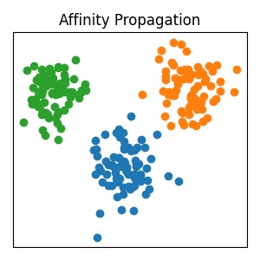
What does it do? Finds important example points and builds clusters around them.
Real-life Example: Grouping students around the best team leader.
Python Code:
from sklearn.cluster import AffinityPropagation
model = AffinityPropagation()
labels = model.fit_predict(X)
Advantages | Disadvantages
No need to choose cluster count | Slow for large datasets
Accurate clustering | Uses more memory

Mean Shift
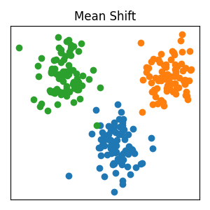
What does it do? Moves points toward crowded areas to form groups.
Real-life Example: People walking toward the busiest shop in a market.
Python Code:
from sklearn.cluster import MeanShift
model = MeanShift()
labels = model.fit_predict(X)
Advantages | Disadvantages
Finds clusters automatically | Slow on large data
Works for odd shapes | Difficult in high dimensions

Spectral Clustering
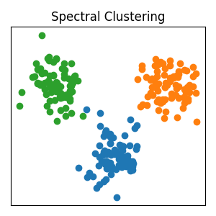
What does it do? Uses graph connections to separate related data.
Real-life Example: Finding friend groups in social media.
Python Code:
from sklearn.cluster import SpectralClustering
model = SpectralClustering(n_clusters=3)
labels = model.fit_predict(X)
Advantages | Disadvantages
Good for complex patterns | Needs cluster number
Works with graph data | Computationally expensive

DBSCAN
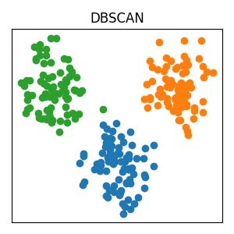
What does it do? Finds dense groups and removes noisy points.
Real-life Example: Detecting crowded areas in a city map.
Python Code:
from sklearn.cluster import DBSCAN
model = DBSCAN(eps=0.5, min_samples=5)
labels = model.fit_predict(X)
Advantages | Disadvantages
Detects noise | Sensitive to settings
Works for irregular shapes | Bad for varying densities

OPTICS
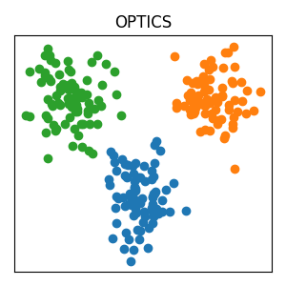
What does it do? An advanced DBSCAN that handles different densities better.
Real-life Example: Finding both villages and cities on a map.
Python Code:
from sklearn.cluster import OPTICS
model = OPTICS(min_samples=5)
labels = model.fit_predict(X)
Advantages | Disadvantages
Handles varying densities | More complex
Flexible clustering | Slower than DBSCAN

BIRCH
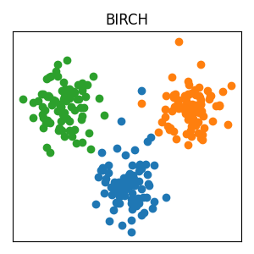
What does it do? Compresses big datasets into summaries before clustering.
Real-life Example: Studying short notes instead of a huge textbook.
Python Code:
from sklearn.cluster import Birch
model = Birch(n_clusters=3)
labels = model.fit_predict(X)
Advantages | Disadvantages
Fast for big datasets | Works mainly with numeric data
Memory efficient | Less effective for complex shapes

Quick Summary Table
Algorithm | Best Used For
Affinity Propagation | Automatic cluster finding
Mean Shift | Finding dense regions
Spectral Clustering | Complex graph-like data
DBSCAN | Noise detection
OPTICS | Different density clusters
BIRCH | Large datasets

