**Project: Local Library**

Your neighborhood has decided to put together a local library where people can lend and borrow books. One of the most important features to organize this is a dashboard that will show which books are available, which are currently out, and other general statistics about the program.

Others are taking care of the logistics and and design, but they need you to build the algorithms!

1:1

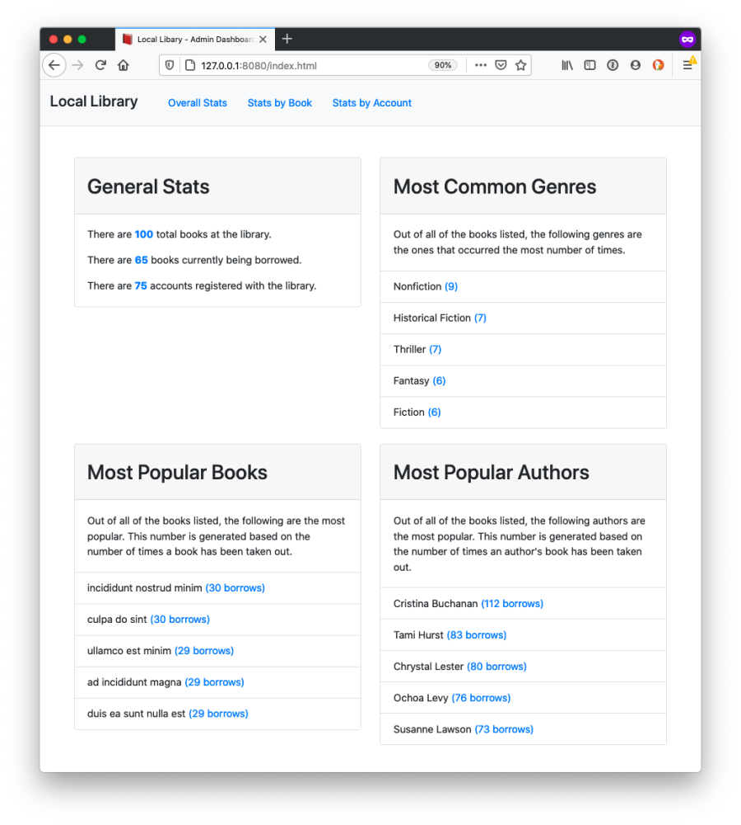

This project is designed to test your ability to work with large datasets and build algorithms based on those datasets. Before taking on this module, you should be comfortable with the learning objectives listed below. You will not need to make any edits to HTML or CSS for this project.

**Learning Objectives**

This project will assess the following learning objectives, in addition to many others:

* Use Visual Studio Code as a text editor.
* Differentiate between the three most common JavaScript error types.
* Solve bugs by using error messages.
* Differentiate between let, const, and var, and use each appropriately.
* Create an array from a string based on particular criteria and join arrays into strings.
* Write strings that embed expressions using template literals.
* Access all the values and keys of an object.
* Use .find(), .filter(), .map(), .some(), and .every() to solve different problems.
* Use .reduce() to solve different problems.
* Use .sort() to sort arrays in various ways.

**Project Setup**

Click on the "USE YOUR IDE" button at the top of this page and follow the instructions to use the qualified-attach application to download and edit your code using your Visual Studio Code editor.

Additionally, if you wish to run the code or run the tests on your own machine you may take the following steps after using the qualified-attach application.

After running qualified-attach you can open a new terminal and cd into the folder with the project code. By default the name of that folder is _Project_Local_Library*1*.

To install dependencies locally run the command:

npm i

To run the tests, you can run the following command:

npm test

To watch how the code you write affects the application website, you can run the following command. This command will start a server and take over your terminal window. To stop the server from running, you can press Ctrl + C.

npm start

**Instructions**

You are tasked with building a number of different algorithms that will help complete the an administrative site for a local library. All of the functions will work on three common datasets. The datasets are related and at times you will need to work with multiple datasets to solve the problem at hand.

While working on these problems, you have both the tests and the live site to act as a guide. You can solve the tasks in any order and are encouraged to organize your code how you like.

All of the files you need to edit are inside of the public/src/ directory.

While working on this project you *should:*

* Use well-named variables, in particular avoiding any single letter variables that lack meaning.
* Use native array methods like .find(), .filter(), .map(), and .reduce().
* Make use of both function declarations and arrow functions.
* Build helper functions when appropriate.
* Make use of advanced JavaScript features like ternary operators, the spread operator, object shorthand, array and object destructuring, and for/in loops.

While working on this project you *should not:*

* Change the names of the functions.
* Edit any of the files outside of the public/src/ directory.

If you feel as though one of your solutions is working but something isn't showing up right on the site or in the tests, reach out for help.

**Datasets**

There are three datasets that are a part of this project: accounts, authors, and books.

**Accounts**

You can view all of the accounts data inside of the public/data/ directory. Each account is an object with the following shape:

{

"id": "5f446f2ecfaf0310387c9603",

"name": {

"first": "Esther",

"last": "Tucker"

},

"picture": "https://api.adorable.io/avatars/75/esther.tucker@zillacon.me",

"age": 25,

"company": "ZILLACON",

"email": "esther.tucker@zillacon.me",

"registered": "Thursday, May 28, 2015 2:51 PM"

}

An account represents a person who is registered with the library. Accounts can take out and return books.

**Authors**

You can view all of the authors data inside of the public/data/ directory. Each author is object with the following shape:

{

"id": 0,

"name": {

"first": "Lucia",

"last": "Moreno"

}

}

An author represents someone who wrote one or more books in the library.

**Note:** Author's IDs are set to be numbers instead of strings, like the other two data sets.

**Books**

You can view all of the books data inside of the public/data/ directory. Each book is object with the following shape:

{

"id": "5f4471327864ee880caf5afc",

"title": "reprehenderit quis laboris adipisicing et",

"genre": "Poetry",

"authorId": 20,

"borrows": [

{

"id": "5f446f2e2a4fcd687493a775",

"returned": false

},

{

"id": "5f446f2ebe8314bcec531cc5",

"returned": true

},

{

"id": "5f446f2ea508b6a99c3e42c6",

"returned": true

}

]

}

Each book represents a physical book but also contains additional information. In particular:

* The authorId matches up with an author. It represents who wrote the book.
* The borrows array is a list of transactions that have ocurred with this book. For example, in the example above the book has been borrowed three times.
  + The id for each "borrow" record matches with an account ID. In the above example, the account with an ID of "5f446f2e2a4fcd687493a775" has not yet returned the book, meaning they still are in possession of it.

**Functions**

You are tasked with writing the following functions that work with the above datasets. The instructions for the functions can be found in the docs/ folder.

**Note:** In addition to needing to pass the tests and requirements in the instructions here, please review the Rubric Requirements for the human-graded part of this project in your Thinkful curriculum page.