the-cdr-gap-analysis

William F. Lamb

## Prep current CDR data

## Scale for fill is already present.  
## Adding another scale for fill, which will replace the existing scale.

## Warning: The `size` argument of `element_line()` is deprecated as of ggplot2 3.4.0.  
## ℹ Please use the `linewidth` argument instead.  
## This warning is displayed once every 8 hours.  
## Call `lifecycle::last_lifecycle_warnings()` to see where this warning was  
## generated.

## Warning: The `size` argument of `element_rect()` is deprecated as of ggplot2 3.4.0.  
## ℹ Please use the `linewidth` argument instead.  
## This warning is displayed once every 8 hours.  
## Call `lifecycle::last_lifecycle_warnings()` to see where this warning was  
## generated.

## Scale for fill is already present.  
## Adding another scale for fill, which will replace the existing scale.  
## Scale for fill is already present.  
## Adding another scale for fill, which will replace the existing scale.

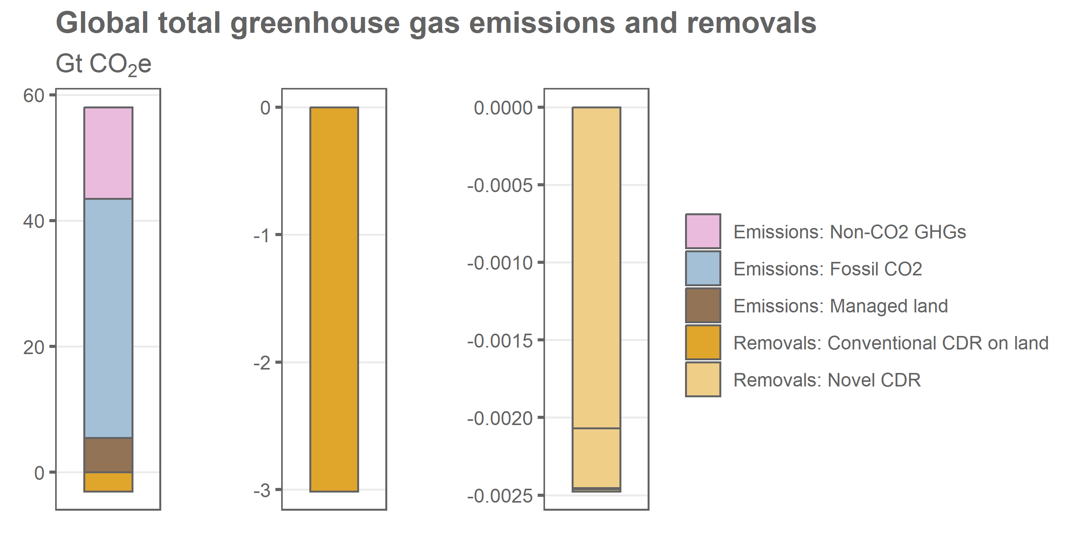

## Prep scenario data

## Analysis

### What are the gross emissions reductions from 2020-2030/2050 in C1,C3 scenarios?

## `summarise()` has grouped output by 'model', 'scenario', 'cat'. You can  
## override using the `.groups` argument.  
## `summarise()` has grouped output by 'model', 'scenario', 'cat'. You can  
## override using the `.groups` argument.

### What are the gross emissions reductions from 2020-2030/2050 in the focus scenarios?

### What is the cumulative CDR by 2100, split by technology?

## `summarise()` has grouped output by 'model', 'scenario'. You can override using  
## the `.groups` argument.

### What is the cumulative CDR by 2100, split by technology and focus scenario?

## What is the change in total CDR from 2020 to 2030 and 2050?

## `summarise()` has grouped output by 'model', 'scenario'. You can override using  
## the `.groups` argument.  
## `summarise()` has grouped output by 'model', 'scenario'. You can override using  
## the `.groups` argument.  
## `summarise()` has grouped output by 'year'. You can override using the  
## `.groups` argument.

### Table 2 differences

## `summarise()` has grouped output by 'model', 'scenario', 'cat'. You can  
## override using the `.groups` argument.  
## `summarise()` has grouped output by 'model', 'scenario', 'cat'. You can  
## override using the `.groups` argument.

## `summarise()` has grouped output by 'year'. You can override using the  
## `.groups` argument.  
## `summarise()` has grouped output by 'model', 'scenario', 'year', 'cat'. You can  
## override using the `.groups` argument.

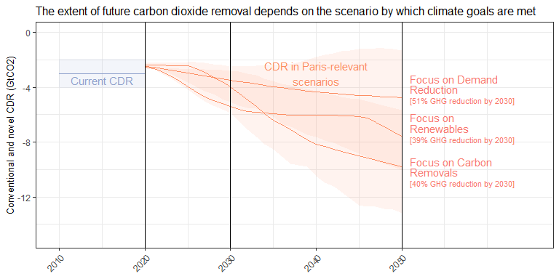

## `summarise()` has grouped output by 'year'. You can override using the  
## `.groups` argument.

## Scale for fill is already present.  
## Adding another scale for fill, which will replace the existing scale.

## Warning: Removed 3 rows containing missing values (`geom_hline()`).

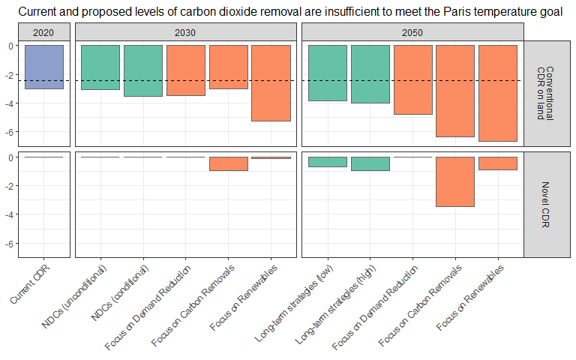

## Warning: Removed 3 rows containing missing values (`geom_hline()`).

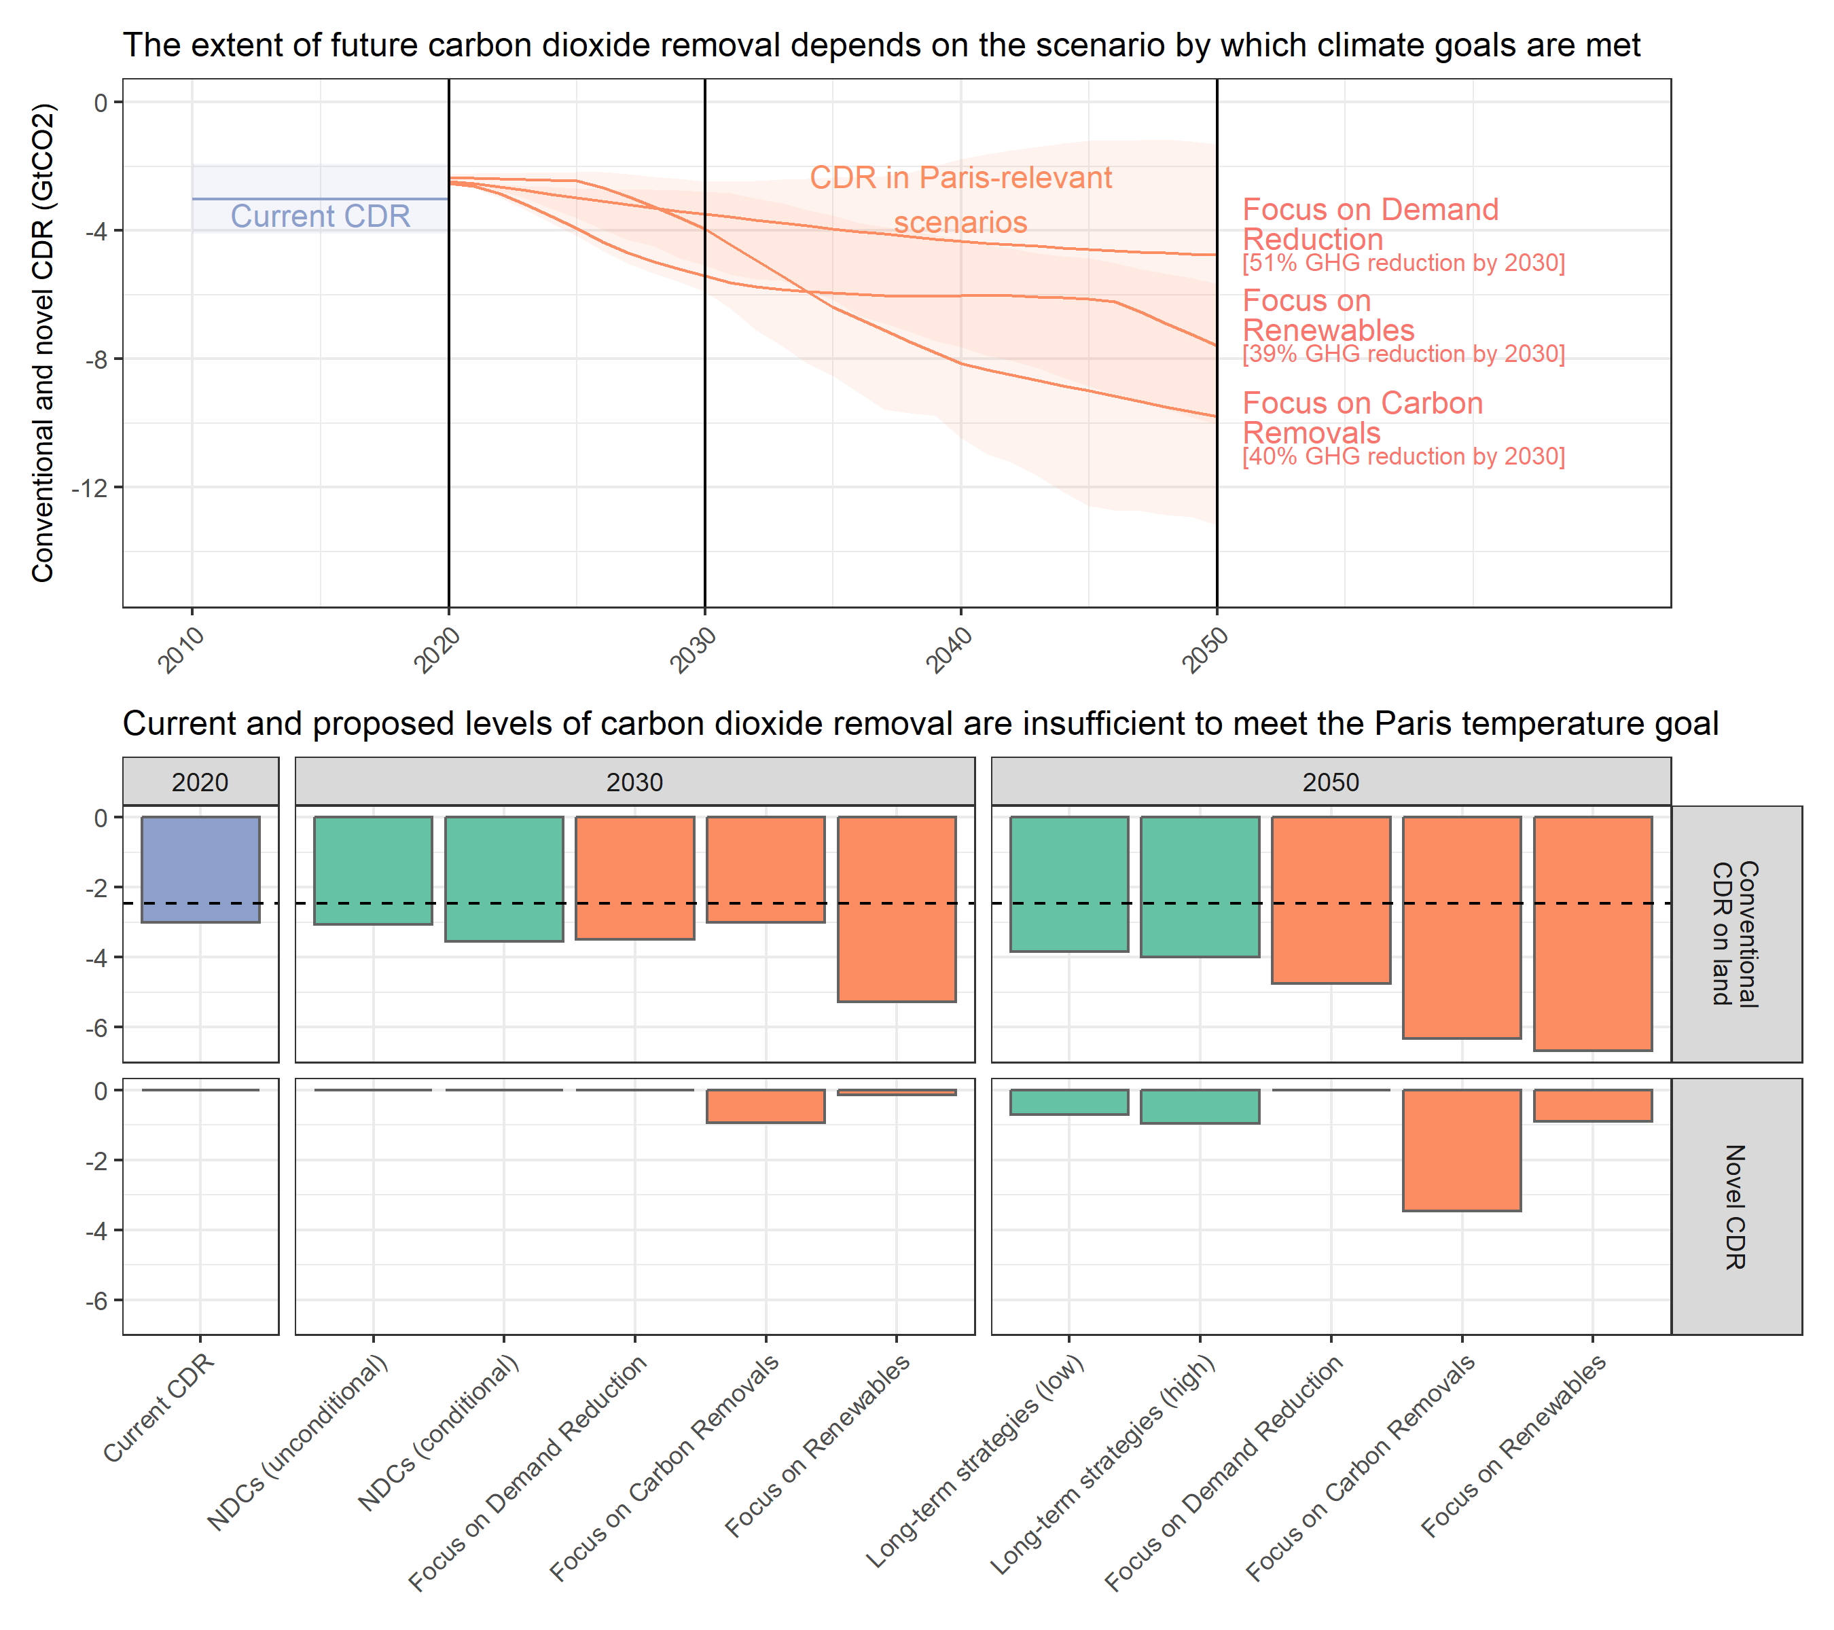

## `summarise()` has grouped output by 'imp'. You can override using the `.groups`  
## argument.  
## `summarise()` has grouped output by 'model', 'scenario'. You can override using  
## the `.groups` argument.  
## `summarise()` has grouped output by 'model', 'scenario'. You can override using  
## the `.groups` argument.

## Warning: attributes are not identical across measure variables; they will be  
## dropped

## Scale for fill is already present.  
## Adding another scale for fill, which will replace the existing scale.  
## Scale for fill is already present.  
## Adding another scale for fill, which will replace the existing scale.

## Warning: Removed 2 rows containing missing values (`geom_hline()`).

## Warning: Removed 1 rows containing missing values (`geom_hline()`).

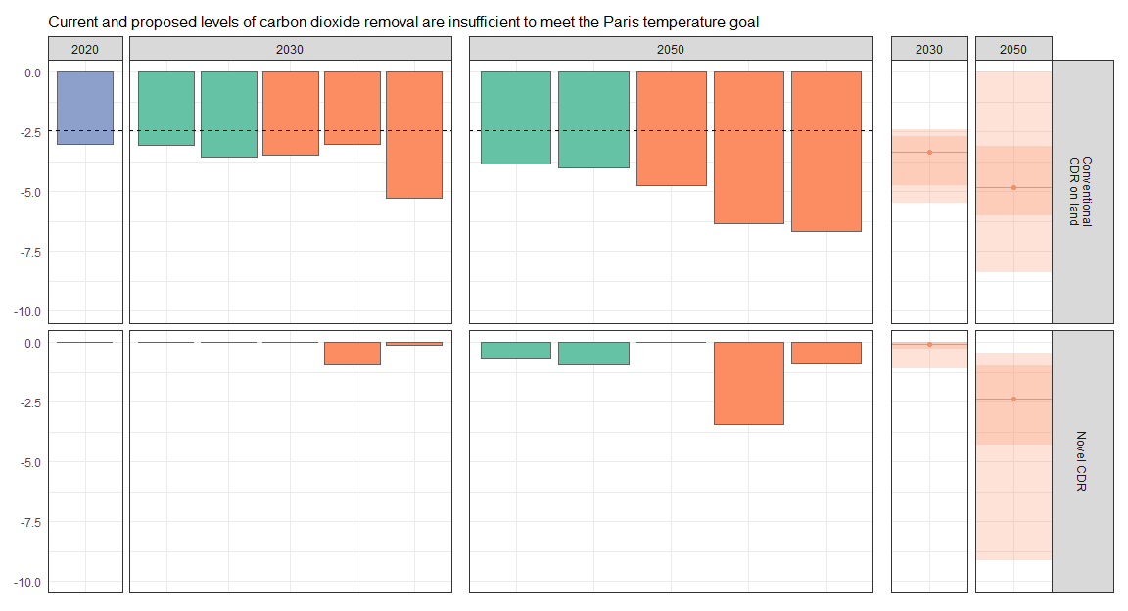

## Warning: Removed 2 rows containing missing values (`geom_hline()`).

## Warning: Removed 1 rows containing missing values (`geom_hline()`).

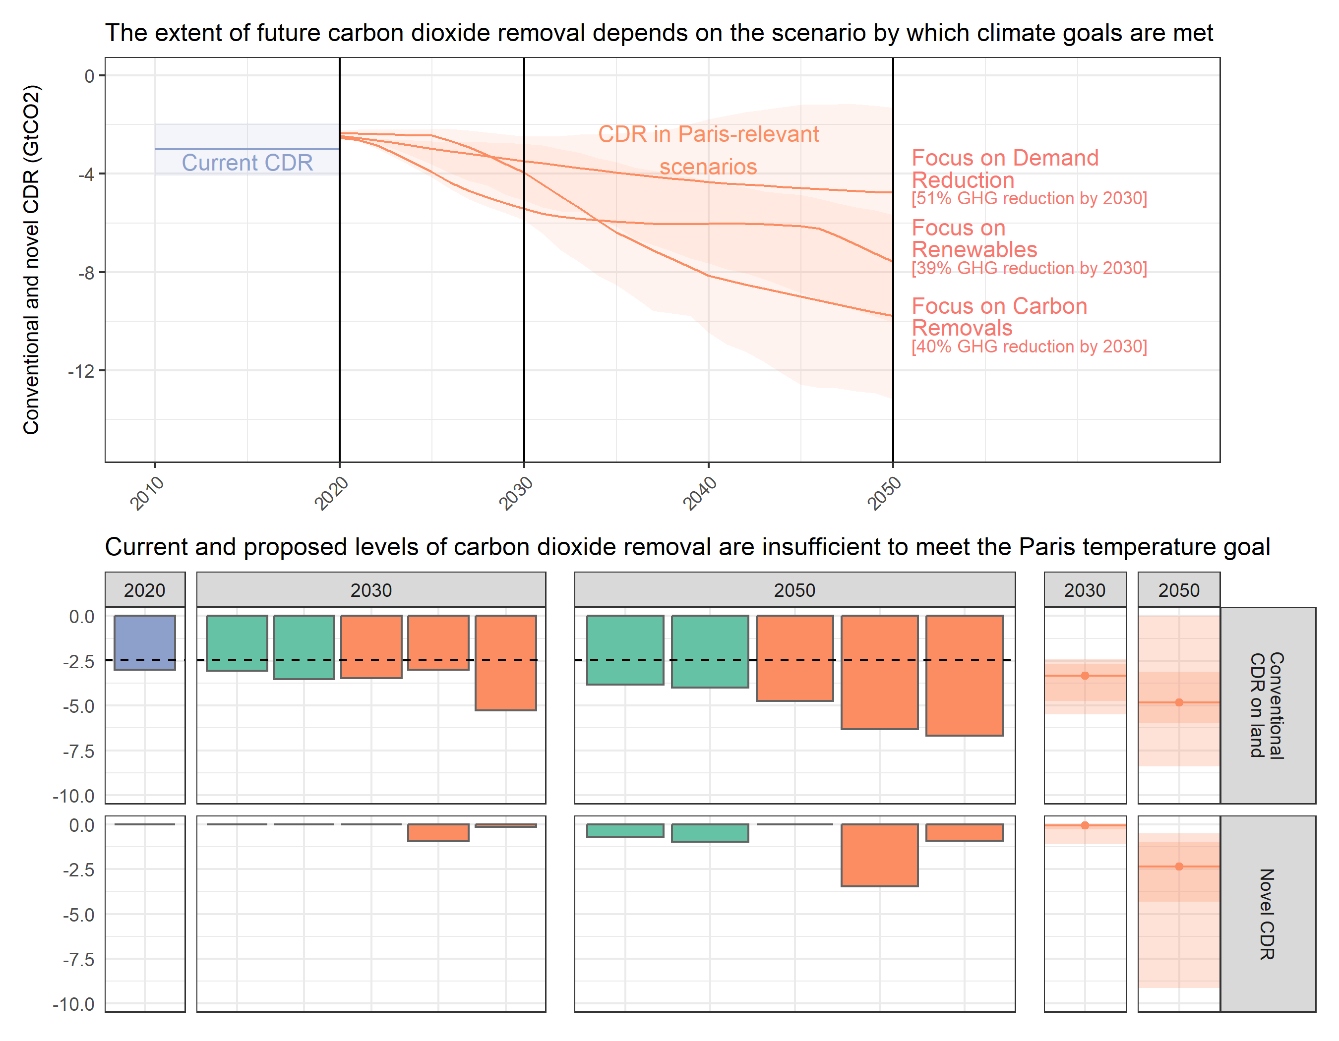

## Scale for fill is already present.  
## Adding another scale for fill, which will replace the existing scale.

## Warning: Using alpha for a discrete variable is not advised.

