UNEP 2023 Emissions Gap Report

Chapter 2: Global emissions trends

03-20-2023

## Lead Authors

* William F. Lamb (MCC Berlin, Germany)
* X

## Contributing Authors

* Giacomo Grassi (JRC, Italy)
* Monica Crippa (JRC, Italy)
* Julia Pongratz (U. Munich, Germany)
* Diego Guizzardi (JRC, Italy)
* Lucas Chancel (Paris School of Economics, France)
* Glen Peters (CICERO, Norway)
* Jing Meng (University College London, China)

## Scope and key questions

This chapter assesses the latest trends in greenhouse gas (GHG) emissions. It analyses global GHG emissions by gas, sector and high emitting countries from 1990-2022, and discusses the main drivers of these trends. An important thematic issue this year is different equity perspectives on historic contributions to climate change. Another topic is the influence of the war in Ukraine on global and regional emissions in 2022.

* What were total global GHG emissions in 2022, what are the main trends by gas, sector and top emitters?
* Which countries and global sectors have peaked in GHG emissions and reduced for at least 10 years? Which countries and global sectors so far show no sign of peaking?
* Who has contributed to climate change, based on different perspectives of equity and responsibility?

Length: 4-5 pages, 2700-3500 words, 3 figures

## Annotated outline

1. Introduction

* Purpose of chapter, scope of the reporting (total net anthropogenic GHG emissions)
* Introduce two focal points on the war in Ukraine and equity issues

1. Global emissions trends

* Report total net anthropogenic GHG emissions with a focus on the latest year(s) of data, split by CO2-FFI, CO2-LULUCF, CH4, N2O, F-gases [Figure 1 here]
* Report differences in CO2-LULUCF between global bookkeeping estimates and national GHG inventories
* Table of global emissions estimates and their uncertainties
* Report total net anthropogenic GHG emissions split by major economic sector and subsector. Focus on trends in the largest or fastest growing global sectors, and any that have seen sustained declines over a 10 year period

1. Emissions trends of major emitters

* Highlight 8 high emitters (China, USA, India, EU, Indonesia, Russia, Brazil, Intl. transport) and report net and gross GHG emissions trends [Bookkeeping LULUCF data now available for countries. Which perspective do we use? Both?], including trends in per capita emissions. [Figure 2 here]
* Assess the literature on drivers of recent national emissions trends, including the literature on the war in Ukraine and the resulting energy crisis.
* Describe different equity perspectives in the literature and assess relative contributions to climate change. Might include: current GHG emissions, historic CO2 emissions, historic warming contributions, proportion of global top emitters by region [Figure 3 – option A here].
* Assess recent literature on the links between emissions, energy consumption and human well-being. Assess the marginal contribution of carbon to well-being across countries and underline the large global differences in consumption based emissions at a household level [Figure 3 – option B here].

## Figure 1

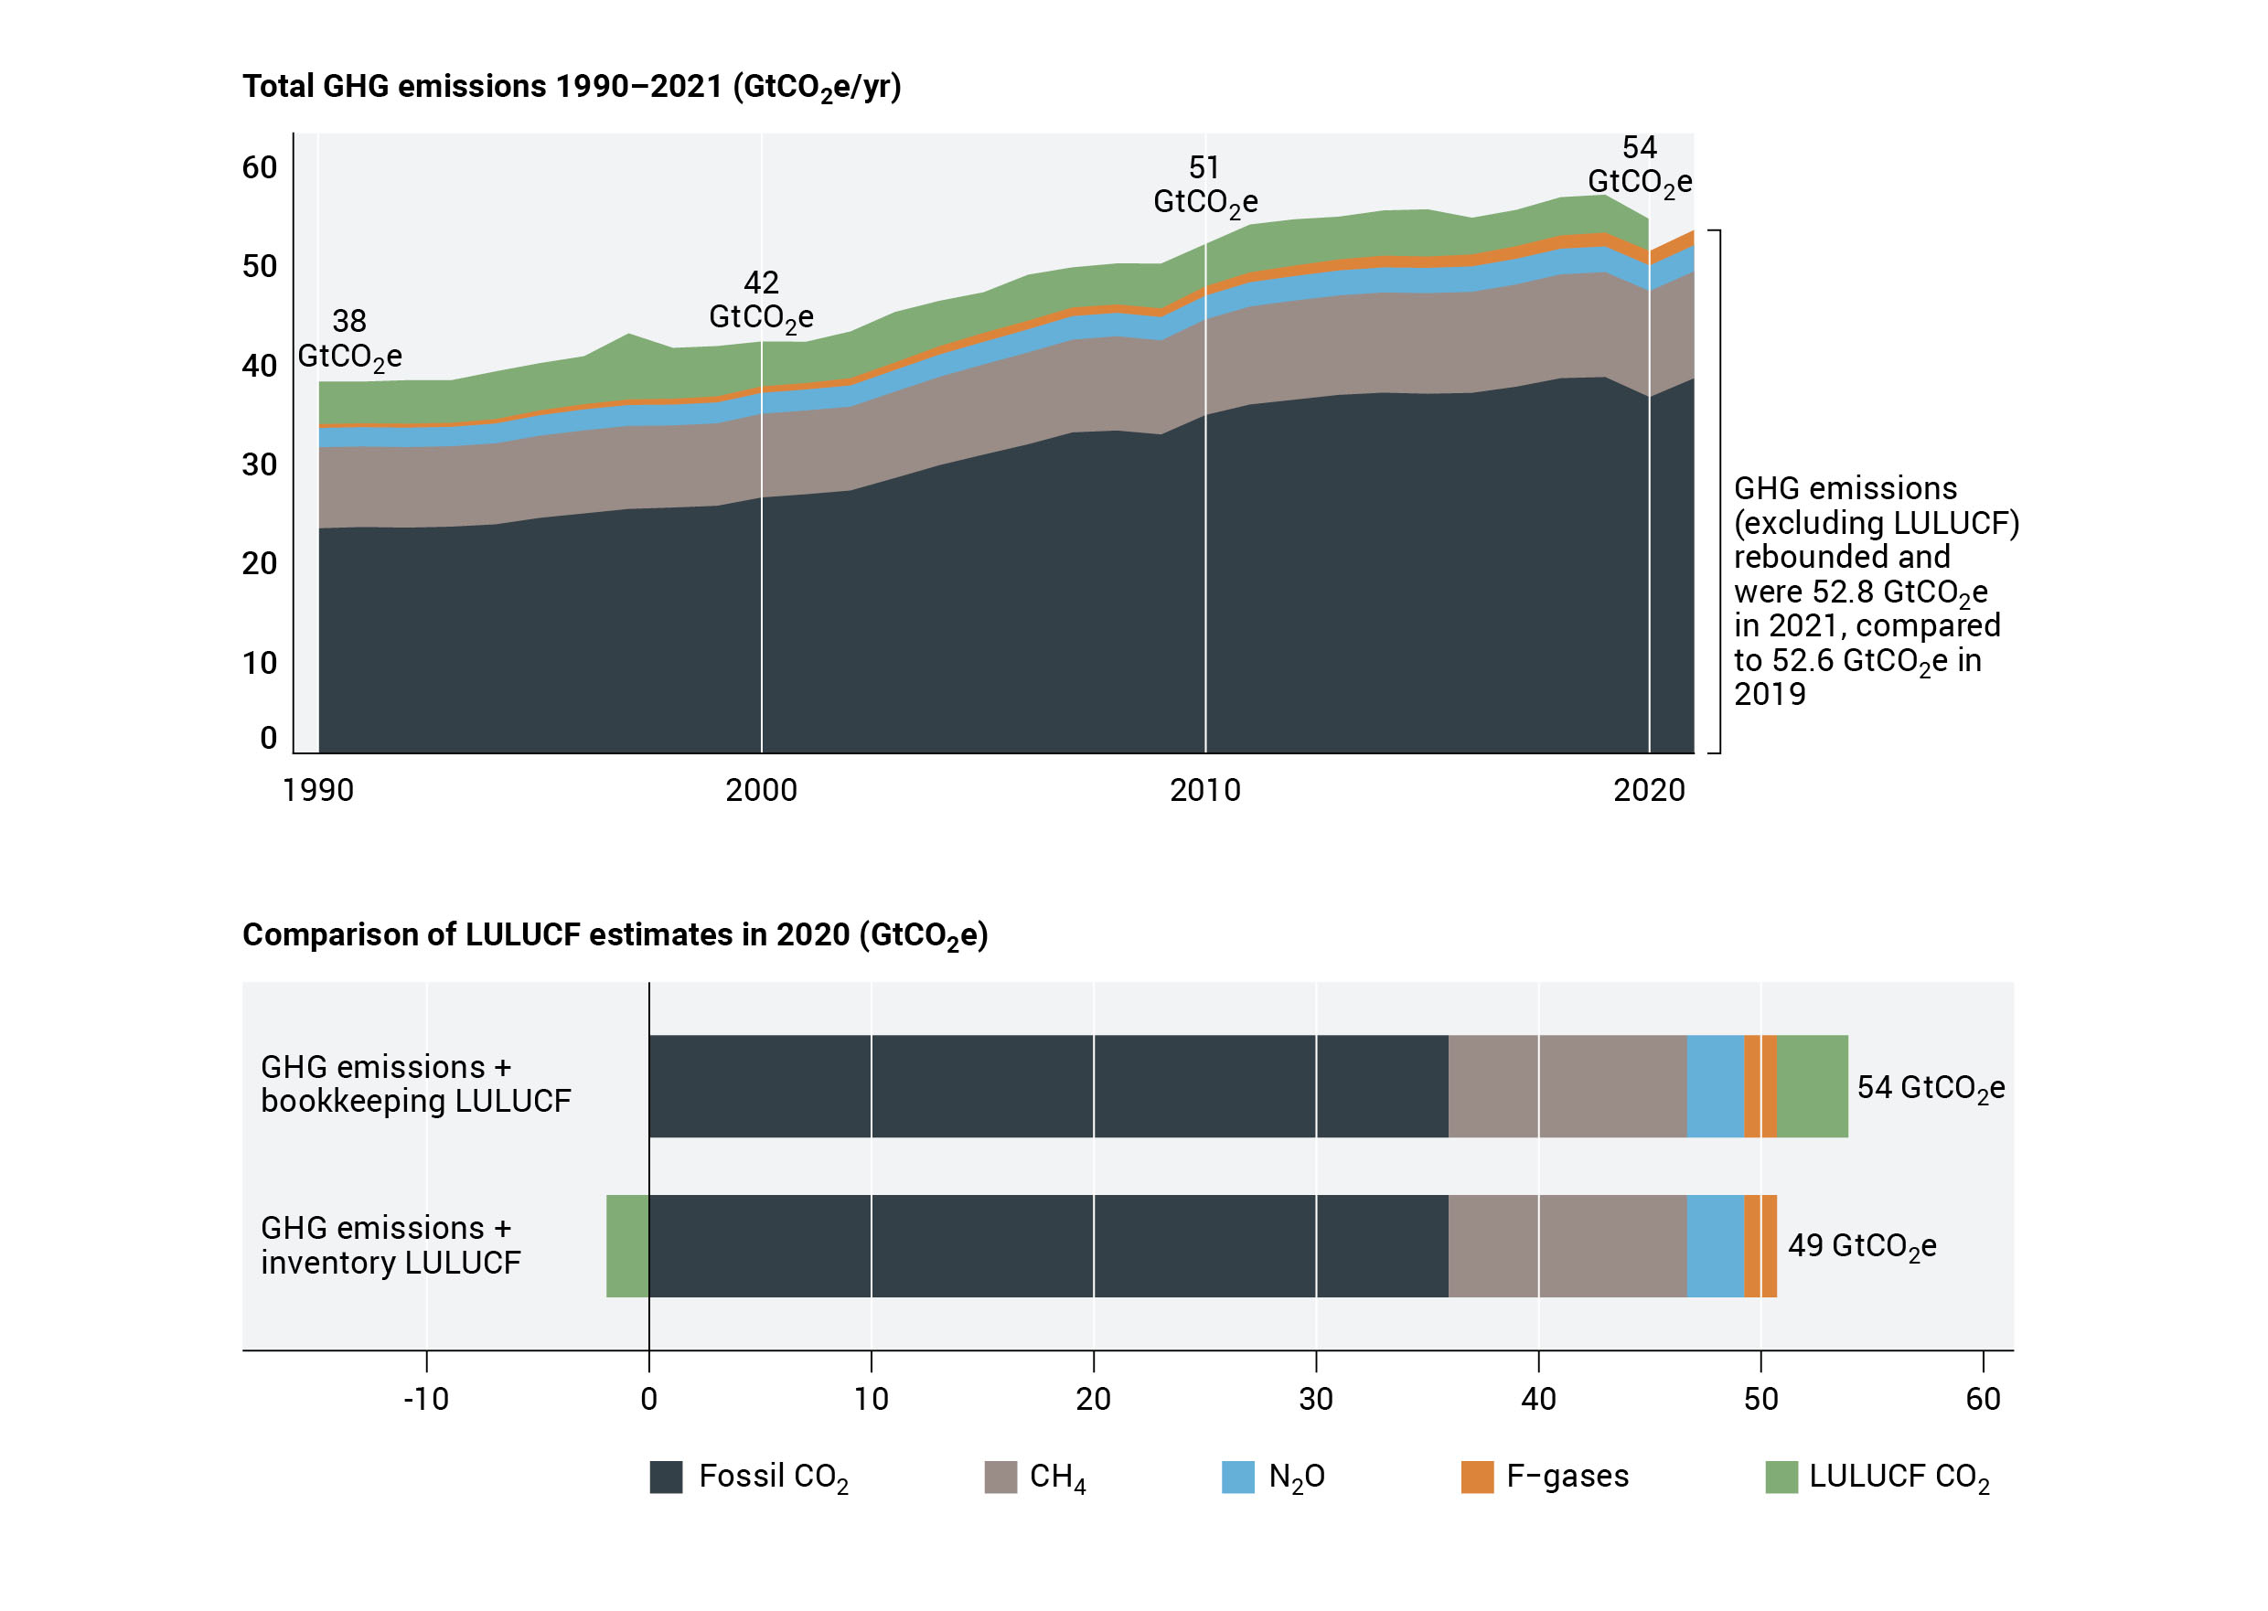

* Include an assessment of uncertainty in this figure or caption

## Figure 2

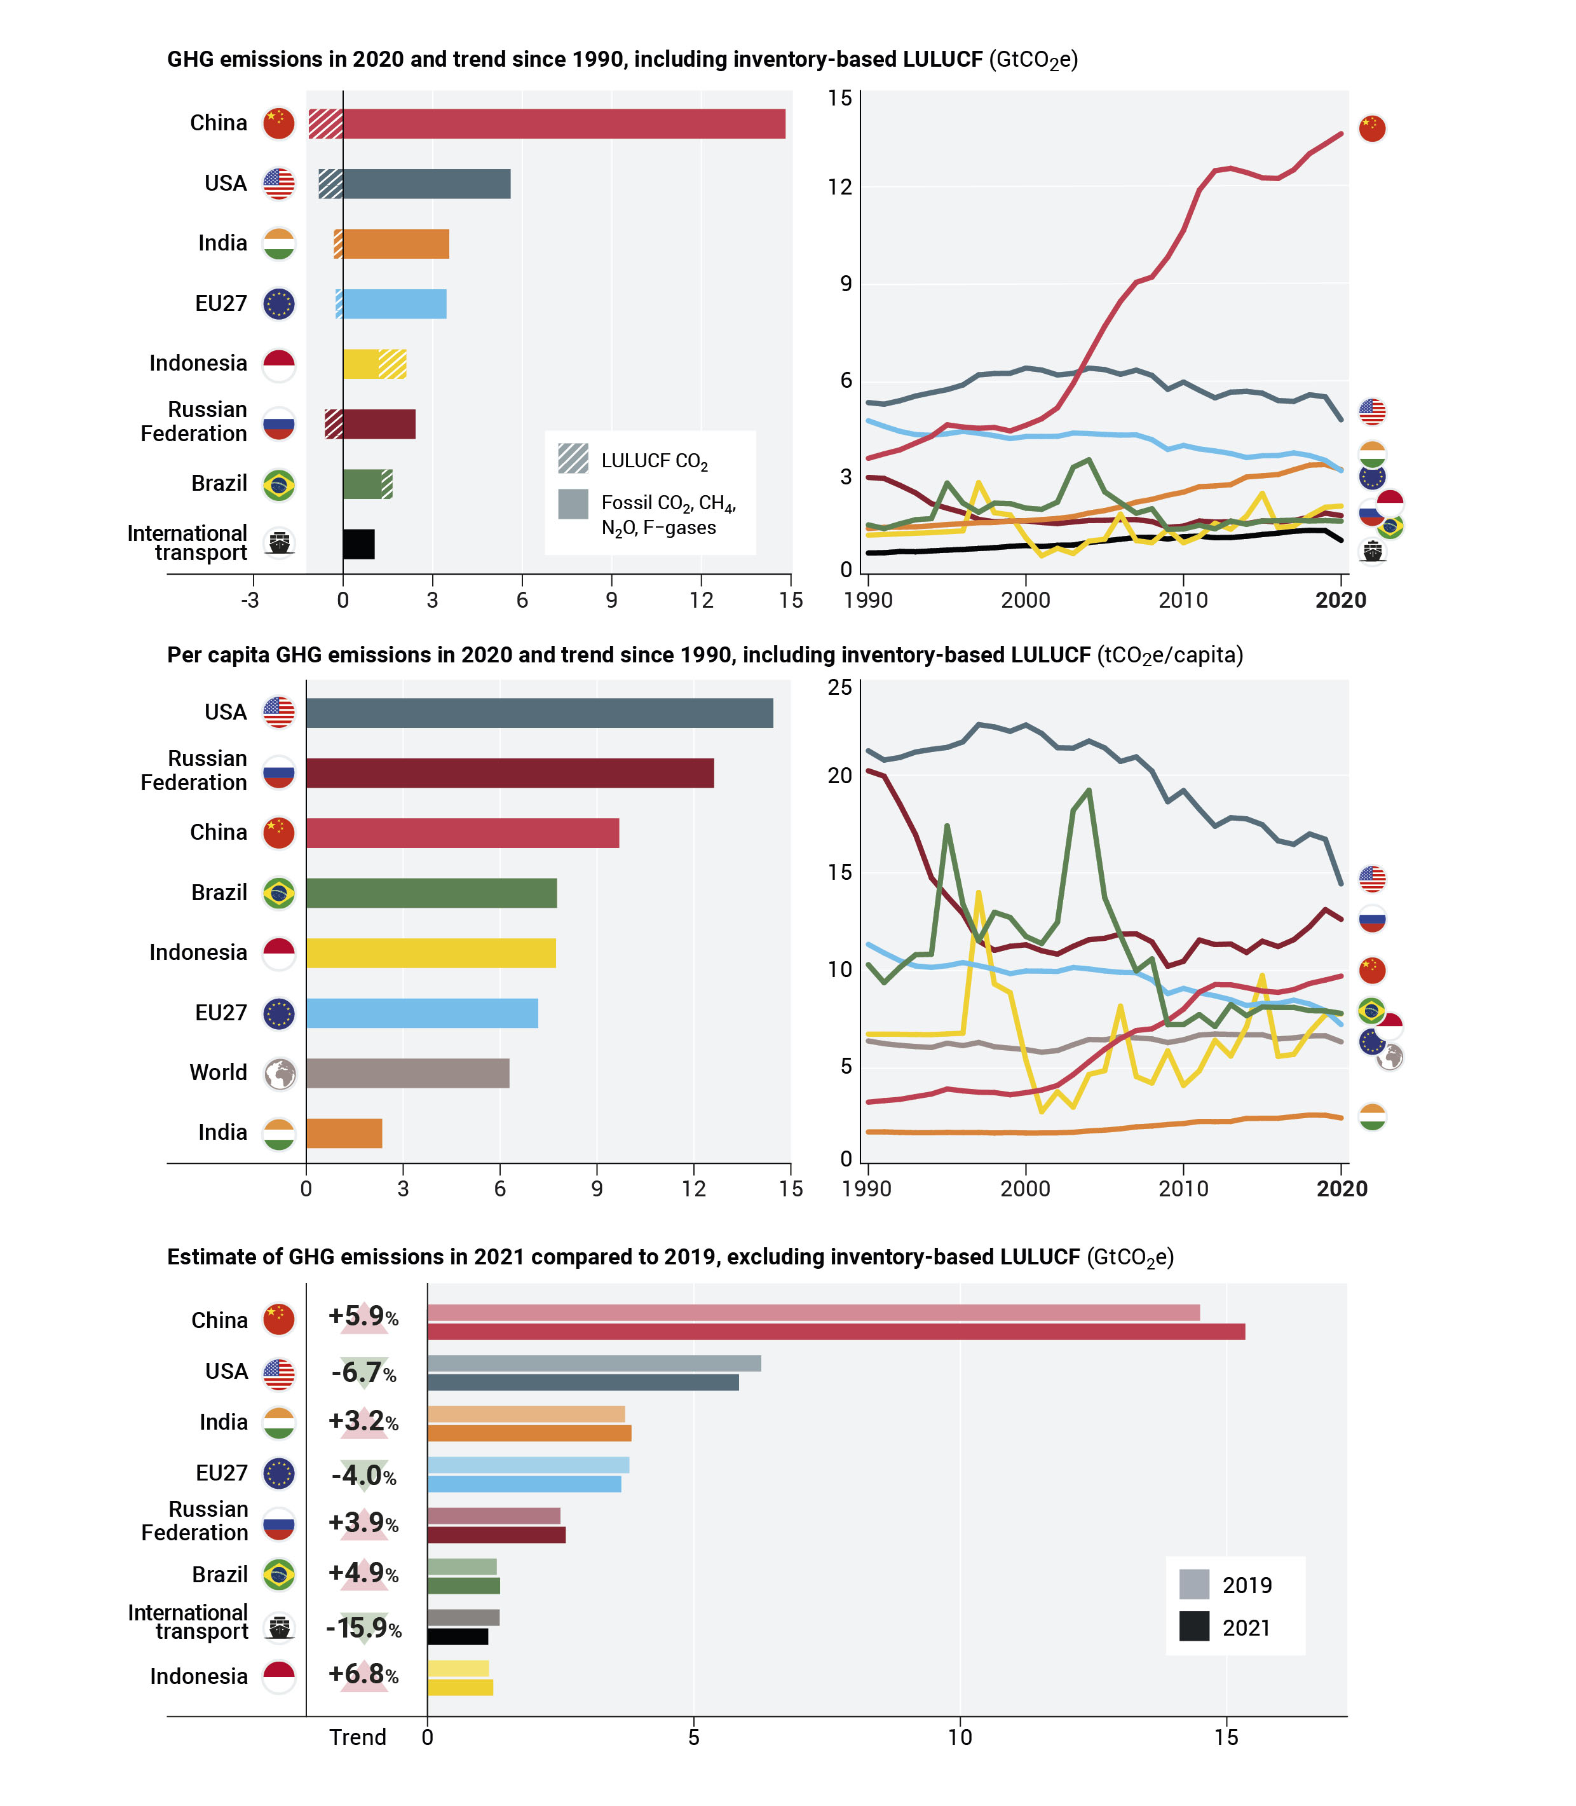

* Simplify this figure by removing the lower panel and indicating the rate of change in the top two panels

## Figure 3 – option A

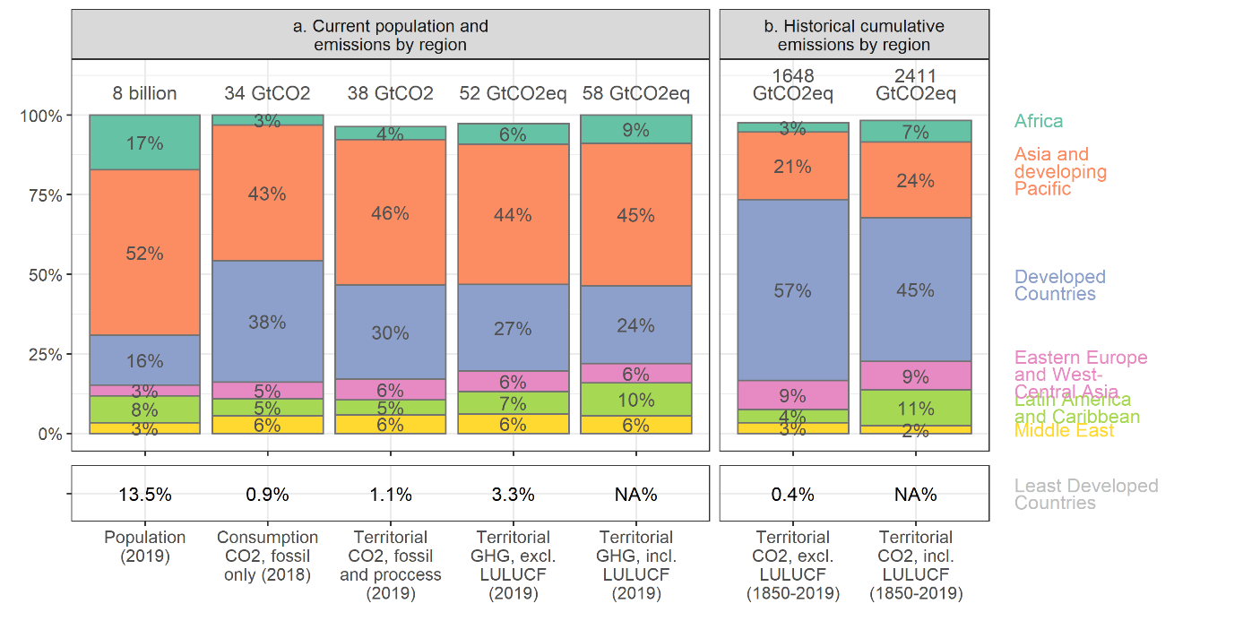

* Figure from IPCC AR6 Chapter 2. Show the 8 top emitters and “rest of world”. Include a different set of indicators based on chapter and SC discussions.

## Figure 3 – option B

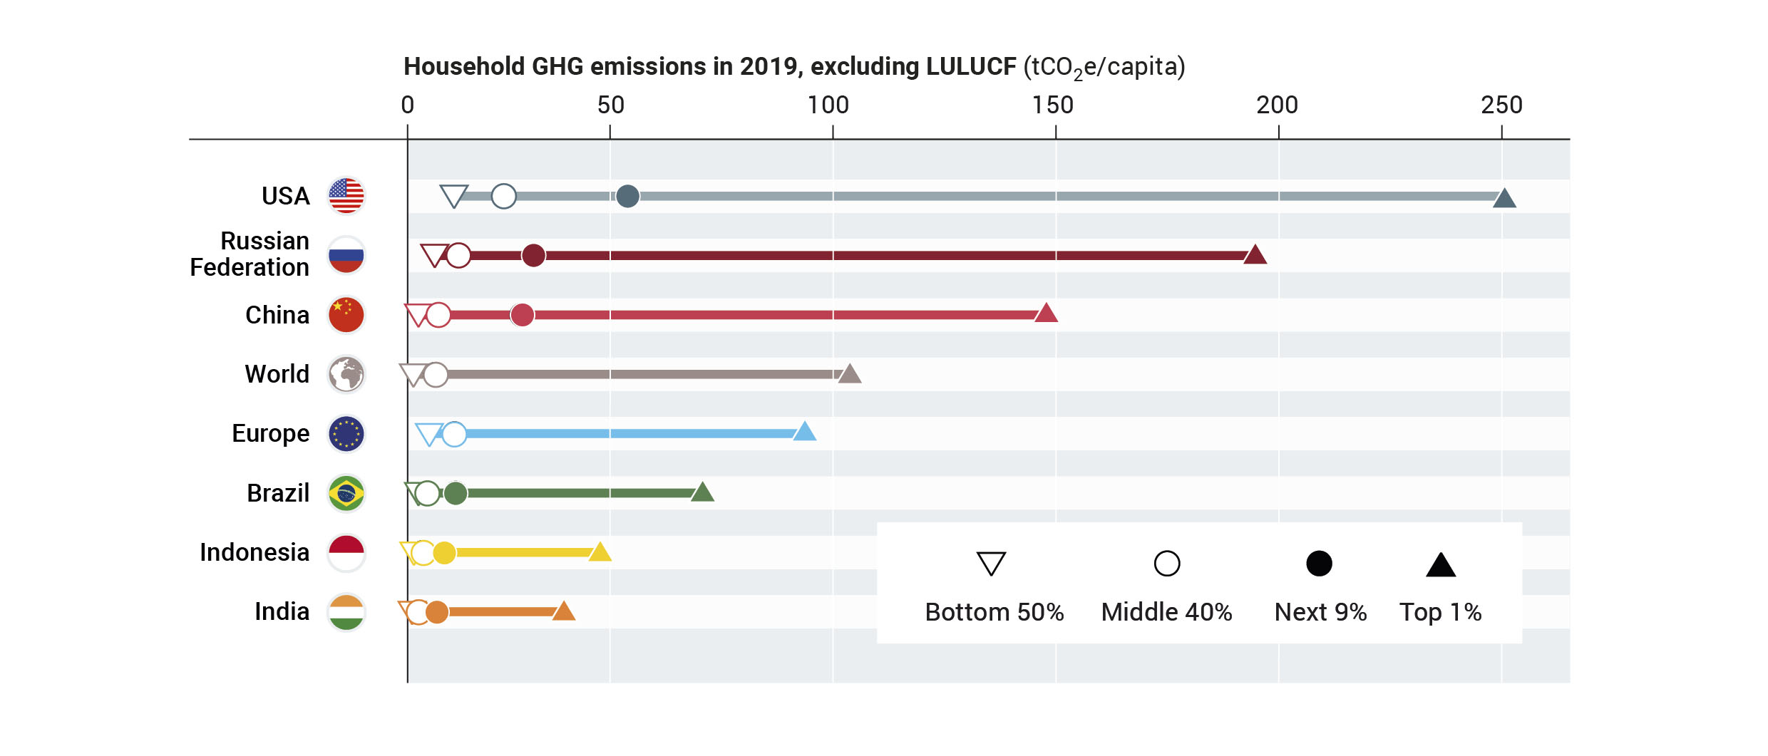

* Retain and update this figure, which was popular.