UNEP-Gap-Report-2024-Countries

William F. Lamb

30 4 2024

## Joining with `by = join_by(gas)`  
## `summarise()` has grouped output by 'iso', 'country', 'code',  
## 'code_description', 'gas'. You can override using the `.groups` argument.

## Warning: There was 1 warning in `mutate()`.  
## ℹ In argument: `iso = countrycode(country, "country.name", "iso3c")`.  
## Caused by warning in `countrycode_convert()`:  
## ! Some values were not matched unambiguously: Annex I, Micronesia, Non Annex I, World

## Warning: There was 1 warning in `mutate()`.  
## ℹ In argument: `year = as.numeric(year)`.  
## Caused by warning:  
## ! NAs durch Umwandlung erzeugt

## Warning: There was 1 warning in `mutate()`.  
## ℹ In argument: `newname = countrycode(iso, "iso3c", "country.name")`.  
## Caused by warning in `countrycode_convert()`:  
## ! Some values were not matched unambiguously: AIR, ANT, SCG, SEA

## `summarise()` has grouped output by 'iso', 'country', 'sector_tier_1',  
## 'sector_tier_2', 'sector_tier_2_codes', 'sector_tier_3', 'gas'. You can  
## override using the `.groups` argument.  
## `summarise()` has grouped output by 'iso', 'country', 'sector_tier_1',  
## 'sector_tier_2', 'sector_tier_2_codes', 'sector_tier_3', 'gas'. You can  
## override using the `.groups` argument.

## Warning: There was 1 warning in `mutate()`.  
## ℹ In argument: `iso = countrycode(country, "country.name", "iso3c")`.  
## Caused by warning in `countrycode_convert()`:  
## ! Some values were not matched unambiguously: DISPUTED, EU27, Global, OTHER, Türkiye

## `summarise()` has grouped output by 'iso'. You can override using the `.groups`  
## argument.  
## Joining with `by = join_by(iso)`  
## Joining with `by = join_by(iso)`

## Warning: attributes are not identical across measure variables; they will be  
## dropped

## `summarise()` has grouped output by 'iso'. You can override using the `.groups`  
## argument.

## Warning: Using an external vector in selections was deprecated in tidyselect 1.1.0.  
## ℹ Please use `all_of()` or `any_of()` instead.  
## # Was:  
## data %>% select(gather_cols)  
##   
## # Now:  
## data %>% select(all_of(gather_cols))  
##   
## See <https://tidyselect.r-lib.org/reference/faq-external-vector.html>.  
## attributes are not identical across measure variables; they will be dropped  
## This warning is displayed once every 8 hours.  
## Call `lifecycle::last_lifecycle_warnings()` to see where this warning was  
## generated.

## `summarise()` has grouped output by 'iso', 'country', 'sector'. You can  
## override using the `.groups` argument.  
## Joining with `by = join_by(sector)`

## Warning: The `size` argument of `element_line()` is deprecated as of ggplot2 3.4.0.  
## ℹ Please use the `linewidth` argument instead.  
## This warning is displayed once every 8 hours.  
## Call `lifecycle::last_lifecycle_warnings()` to see where this warning was  
## generated.

## Warning: The `size` argument of `element_rect()` is deprecated as of ggplot2 3.4.0.  
## ℹ Please use the `linewidth` argument instead.  
## This warning is displayed once every 8 hours.  
## Call `lifecycle::last_lifecycle_warnings()` to see where this warning was  
## generated.

## Scale for fill is already present.  
## Adding another scale for fill, which will replace the existing scale.  
## Scale for fill is already present.  
## Adding another scale for fill, which will replace the existing scale.  
## `summarise()` has grouped output by 'iso', 'country', 'sector'. You can override using the `.groups` argument.  
## Joining with `by = join_by(sector)`  
## Scale for fill is already present.  
## Adding another scale for fill, which will replace the existing scale.  
## Scale for fill is already present.  
## Adding another scale for fill, which will replace the existing scale.  
## `summarise()` has grouped output by 'iso', 'country', 'sector'. You can override using the `.groups` argument.  
## Joining with `by = join_by(sector)`  
## Scale for fill is already present.  
## Adding another scale for fill, which will replace the existing scale.  
## Scale for fill is already present.  
## Adding another scale for fill, which will replace the existing scale.  
## `summarise()` has grouped output by 'iso', 'country', 'sector'. You can override using the `.groups` argument.  
## Joining with `by = join_by(sector)`  
## Scale for fill is already present.  
## Adding another scale for fill, which will replace the existing scale.  
## Scale for fill is already present.  
## Adding another scale for fill, which will replace the existing scale.

## Warning in countrycode_convert(sourcevar = sourcevar, origin = origin, destination = dest, : Some values were not matched unambiguously: EU27

## `summarise()` has grouped output by 'iso', 'country', 'sector'. You can  
## override using the `.groups` argument.  
## Joining with `by = join_by(sector)`  
## Scale for fill is already present. Adding another scale for fill, which will  
## replace the existing scale.  
## Scale for fill is already present. Adding another scale for fill, which will  
## replace the existing scale.  
## `summarise()` has grouped output by 'iso', 'country', 'sector'. You can  
## override using the `.groups` argument.  
## Joining with `by = join_by(sector)`  
## Scale for fill is already present. Adding another scale for fill, which will  
## replace the existing scale.  
## Scale for fill is already present. Adding another scale for fill, which will  
## replace the existing scale.

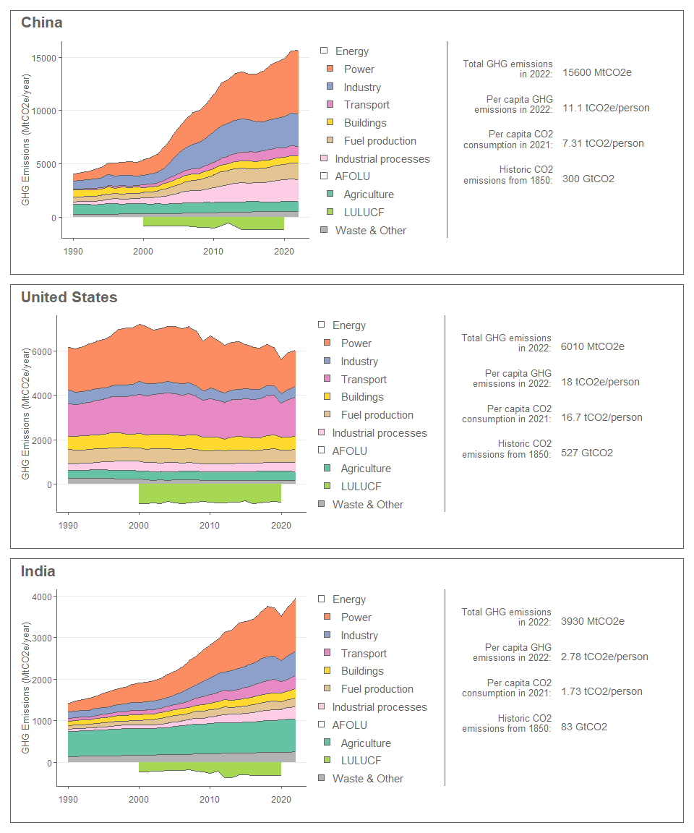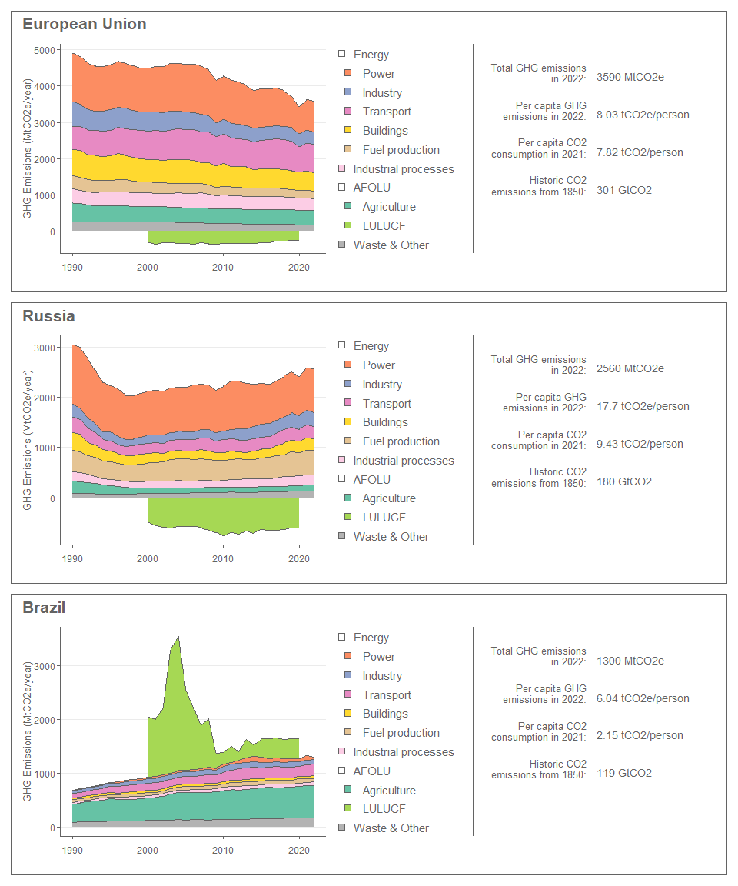

## `summarise()` has grouped output by 'sector'. You can override using the  
## `.groups` argument.  
## Joining with `by = join_by(sector)`  
## Scale for fill is already present. Adding another scale for fill, which will  
## replace the existing scale.  
## Scale for fill is already present. Adding another scale for fill, which will  
## replace the existing scale.

