UNEP-Gap-Report-2024-Global-Totals

William F. Lamb

## Load data

## Joining with `by = join_by(gas)`  
## `summarise()` has grouped output by 'iso', 'country', 'code',  
## 'code_description', 'gas'. You can override using the `.groups` argument.  
## `summarise()` has grouped output by 'code', 'code_description', 'gas'. You can  
## override using the `.groups` argument.

## [1] 53018275477

## Warning: There was 1 warning in `mutate()`.  
## ℹ In argument: `iso = countrycode(country, "country.name", "iso3c")`.  
## Caused by warning:  
## ! Some values were not matched unambiguously: DISPUTED, EU27, Global, OTHER

## Plot a figure showing global emissions by gas

## `summarise()` has grouped output by 'gas'. You can override using the `.groups`  
## argument.  
## Scale for fill is already present. Adding another scale for fill, which will  
## replace the existing scale.

## Warning: The `size` argument of `element_line()` is deprecated as of ggplot2 3.4.0.  
## ℹ Please use the `linewidth` argument instead.  
## This warning is displayed once every 8 hours.  
## Call `lifecycle::last_lifecycle_warnings()` to see where this warning was  
## generated.

## Warning: The `size` argument of `element_rect()` is deprecated as of ggplot2 3.4.0.  
## ℹ Please use the `linewidth` argument instead.  
## This warning is displayed once every 8 hours.  
## Call `lifecycle::last_lifecycle_warnings()` to see where this warning was  
## generated.

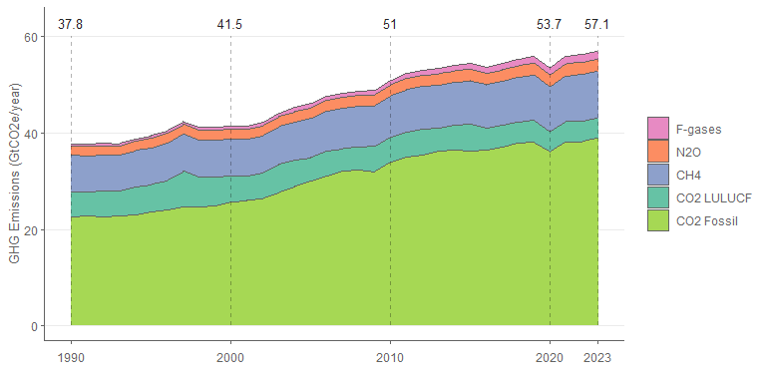

## Tables of total emissions by gas

## Warning: There was 1 warning in `mutate()`.  
## ℹ In argument: `year = as.numeric(year)`.  
## Caused by warning:  
## ! NAs durch Umwandlung erzeugt

## `summarise()` has grouped output by 'year'. You can override using the  
## `.groups` argument.  
## `summarise()` has grouped output by 'gas'. You can override using the `.groups`  
## argument.  
## `summarise()` has grouped output by 'cut', 'gas'. You can override using the  
## `.groups` argument.

## Table of total emissions by year (for data file)

## `summarise()` has grouped output by 'gas'. You can override using the `.groups`  
## argument.

## Warning: There was 1 warning in `mutate()`.  
## ℹ In argument: `year = as.numeric(year)`.  
## Caused by warning:  
## ! NAs durch Umwandlung erzeugt

## Warning: 1 unknown level in `f`: CO2 Fossil (excl. cement carbonation)

## Table of total emissions by sector (for data file)

## `summarise()` has grouped output by 'sector_lv1', 'sector_lv2', 'sector_lv3'.  
## You can override using the `.groups` argument.

## Plot figure showing the share of global emissions in each sector

## `summarise()` has grouped output by 'sector_lv2', 'sector_lv2_colours'. You can  
## override using the `.groups` argument.  
## Scale for fill is already present. Adding another scale for fill, which will  
## replace the existing scale.  
## `summarise()` has grouped output by 'sector_lv2', 'sector_lv2_colours'. You can  
## override using the `.groups` argument.  
## Scale for fill is already present. Adding another scale for fill, which will  
## replace the existing scale.

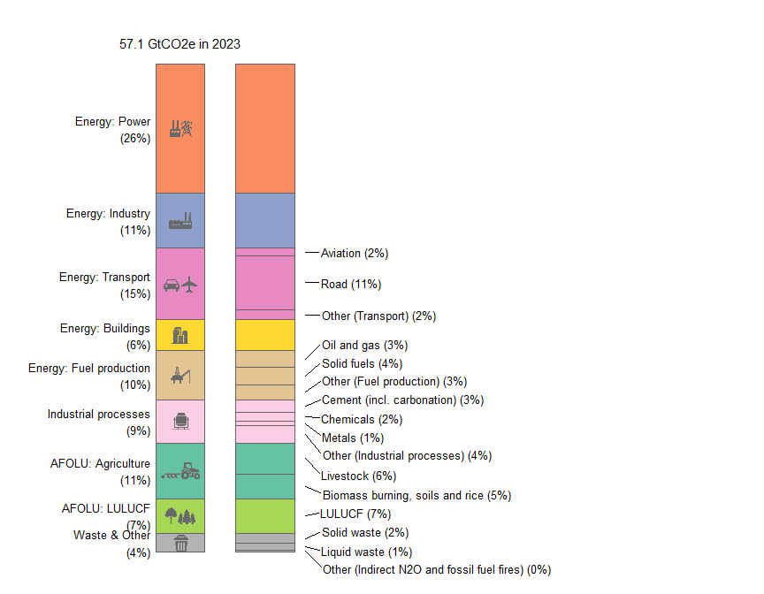

## `summarise()` has grouped output by 'year', 'sector_lv2'. You can override  
## using the `.groups` argument.  
## `summarise()` has grouped output by 'year', 'sector_lv2'. You can override  
## using the `.groups` argument.  
## Adding missing grouping variables: `year`  
## Scale for fill is already present. Adding another scale for fill, which will  
## replace the existing scale.

