UNEP-Gap-Report-2024-Sectors

William F. Lamb

17 4 2024

## `summarise()` has grouped output by 'country', 'sector', 'category', 'units'.  
## You can override using the `.groups` argument.

## `summarise()` has grouped output by 'country', 'sector', 'product'. You can  
## override using the `.groups` argument.  
## Joining with `by = join_by(sector, product)`  
## `summarise()` has grouped output by 'country', 'sector', 'category', 'units'.  
## You can override using the `.groups` argument.

## Warning: There was 1 warning in `mutate()`.  
## ℹ In argument: `iso = countrycode(country, "country.name", "iso3c")`.  
## Caused by warning in `countrycode_convert()`:  
## ! Some values were not matched unambiguously: Former Yugoslavia (if no detail), Kosovo, Middle East, Republic of Turkiye, World, World aviation bunkers, World marine bunkers

## Warning: There was 1 warning in `mutate()`.  
## ℹ In argument: `name = countrycode(iso, "iso3c", "country.name")`.  
## Caused by warning in `countrycode_convert()`:  
## ! Some values were not matched unambiguously: WLD

## Joining with `by = join_by(iso)`  
## `summarise()` has grouped output by 'country', 'iso', 'sector', 'category',  
## 'units'. You can override using the `.groups` argument.

## Warning: Using `size` aesthetic for lines was deprecated in ggplot2 3.4.0.  
## ℹ Please use `linewidth` instead.  
## This warning is displayed once every 8 hours.  
## Call `lifecycle::last_lifecycle_warnings()` to see where this warning was  
## generated.

## Warning: The `size` argument of `element_line()` is deprecated as of ggplot2 3.4.0.  
## ℹ Please use the `linewidth` argument instead.  
## This warning is displayed once every 8 hours.  
## Call `lifecycle::last_lifecycle_warnings()` to see where this warning was  
## generated.

## Warning: The `size` argument of `element_rect()` is deprecated as of ggplot2 3.4.0.  
## ℹ Please use the `linewidth` argument instead.  
## This warning is displayed once every 8 hours.  
## Call `lifecycle::last_lifecycle_warnings()` to see where this warning was  
## generated.

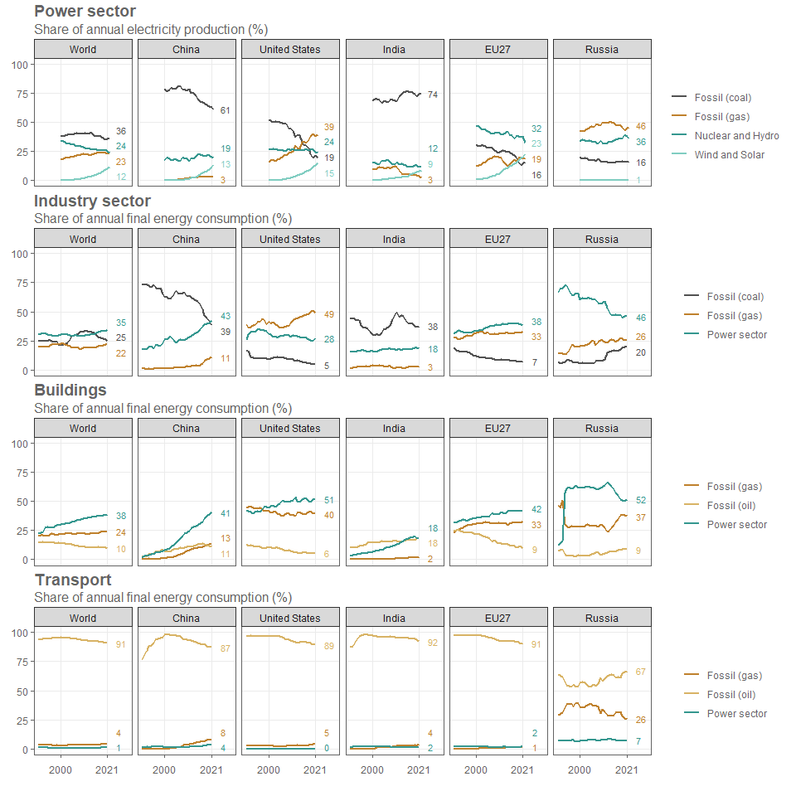

## `summarise()` has grouped output by 'country', 'iso', 'sector', 'units'. You  
## can override using the `.groups` argument.